First Name:______________________________ Last Name:______________________________
L08 – Worksheet – Radioactive Decay Formula
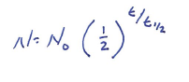
Textbook Questions
Pg 817 #1: What fraction of a radioactive material remains after four half-lives?

Pg 817 #4: Analysis of a rock sample shows that only $\frac{1}{16}$ of the original amount of chlorine-36 remains in the rock. Estimate the age of the rock given that the half-life of chlorine-36 is 3.0 x 10⁵ years.

Pg 817 #5: A radioactive tracer used in a medical test has a half-life of 2.6 h. What proportion of this tracer will remain after 24 h?

Pg 817 #6: An archeologist finds a wooden arrow shaft with a proportion of carbon-14 that is about 25% of that in a living tree branch. Estimate the age of the arrow, given that the half-life of carbon-14 is 5730 years.

Pg 817 #7: A radioactive sample has an activity of 2.5 MBq and a half-life of 12 h. What will the activity of the sample a week later be?

Diploma Worksheet – Radioactive Decay Formula (Basic Half-Life Calculations)
Use the following information to answer Q911:
In a number of nuclear power stations, the reaction material is Uranium 235. The ${}_{92}^{235}U$ will spontaneously decay to produce Thorium 231 plus at least one other particle. The half-life of ${}_{92}^{235}U$ is 7.0 x 10⁸ years.

Q911: How long would it take 10.0 g of ${}_{92}^{235}U$ to decay to 1.25 g in a nuclear reactor?
- 9.9 x 10⁻² y
- 1.8 x 10⁸ y
- 1.4 x 10⁹
- 2.1 x 10⁹ y

Use the following information to answer Q913 – Q914:
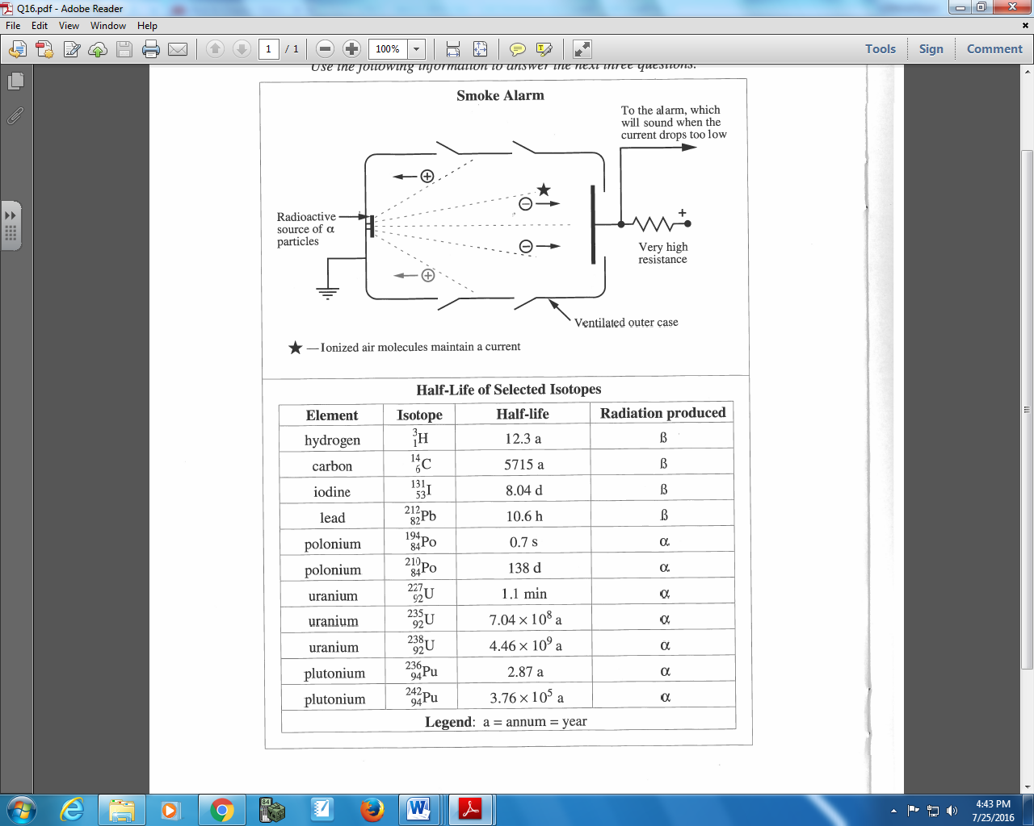

Q913: Given the specifications of this smoke alarm, which of the following isotopes could be used as the radioactive source?
- ${}_{1}^{3}H$
- ${}_{6}^{14}C$
- ${}_{84}^{194}{Po}$
- ${}_{94}^{236}{Pu}$

Q914: The product of the alpha decay of ${}_{92}^{238}U$ is
- ${}_{90}^{234}{Th}$
- ${}_{90}^{232}{Th}$
- ${}_{92}^{232}U$
- ${}_{90}^{234}U$

Use the following information to answer Q916:
Mass spectrometers are used in archeological studies to help date ancient artifacts. The relative amounts of carbon-12 and carbon-14 isotopes in a sample of organic material may be used to determine the age of the sample. Carbon-14 is a radioactive isotope that undergoes beta-negative decay and has a half-life of 5730 years.

Q916: An archeological sample is dated using the carbon-14 dating process and is found to be 2865 years old,. What percentage of the original carbon-14 remains?
- 25.0%
- 29.3%
- 70.7%
- 75.0%

Diploma Worksheet – Radioactive Decay Formula (Interpreting Graphs)
Use the following information to answer Q925:
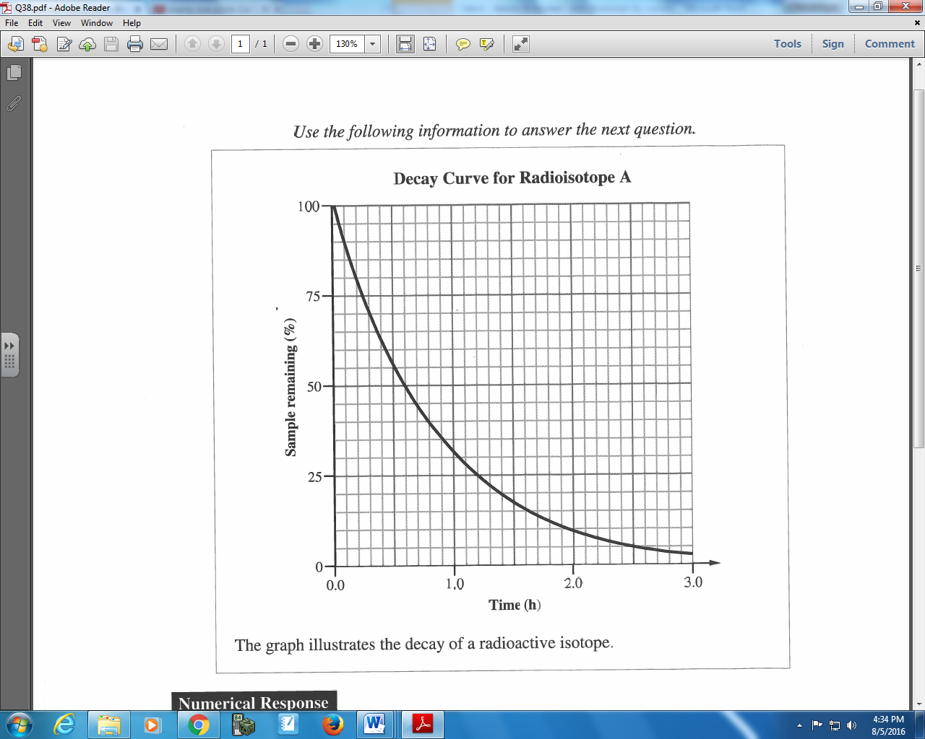

Q925: The time required for a 40.0 g sample to decay to 1.25 g is ____ h.
(Record your two digit answer in the Numerical Response boxes below)

Use the following information to answer Q926:
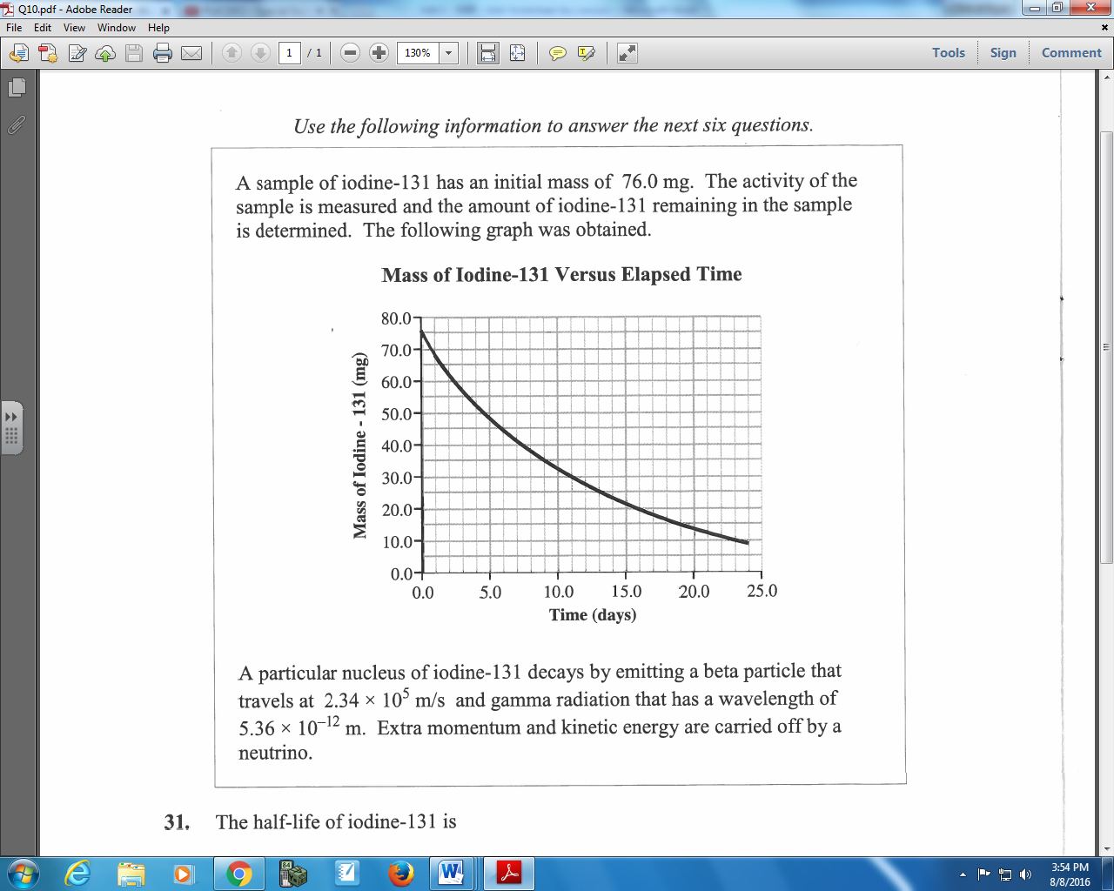

Q926: The half-life of iodine-131 is
- 8.0 days
- 12.0 days
- 16.0 days
- 24.0 days

Cumulative Review
Use the following information to answer Q1:
An In-Depth Understanding of Energy Level Diagrams
Energy level diagrams are a means of analyzing the energies electrons can accept and release as they transition from one accepted orbital to another. These energies differences correspond to the wavelengths of light in the discreet spectral lines emitted by an atom as it goes through de-excitation or by the wavelengths absorbed in an absorption spectrum.

Using Bohr's formula, a hypothetical, doubly-ionized atom¹ with Z = 3 could have the following energy level diagram.

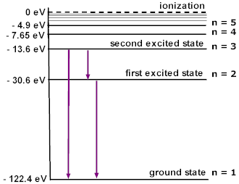
Notice how each energy level closer and closer to the nucleus is more and more negative. This signifies that the electron is trapped in an “energy well.” To ionize a ground-state electron (to take it from -122.4 eV to 0 eV in our example), you would have to irradiate the gas with photons having energies of 122.4 eV or greater. This is the ONLY instance where the incident energy does not have to EXACTLY match the different in two energy levels. Any excess energy would remain in the form of the ionized electron’s kinetic energy.
¹Doubly-ionized simply means that it has lost two electrons. So this atom (Z=3; Lithium) has 3p⁺ and 1e⁻.

Q1: As an electron transitions from the second excited state (n=3) to the ground state (n=1), the wavelength of the photon emitted is a.bc x 10^{-d} m, where a, b, c, and d are ___, ___, ___, and ___.
(Record your four digit answer in the Numerical Response boxes)

Use the following information to answer Q2:
There are two possible sequences through which the unstable radioactive nucleus Polonium-218 can decay. They are shown below. The daughter nuclei are labelled 1, 2, 3, and 4.
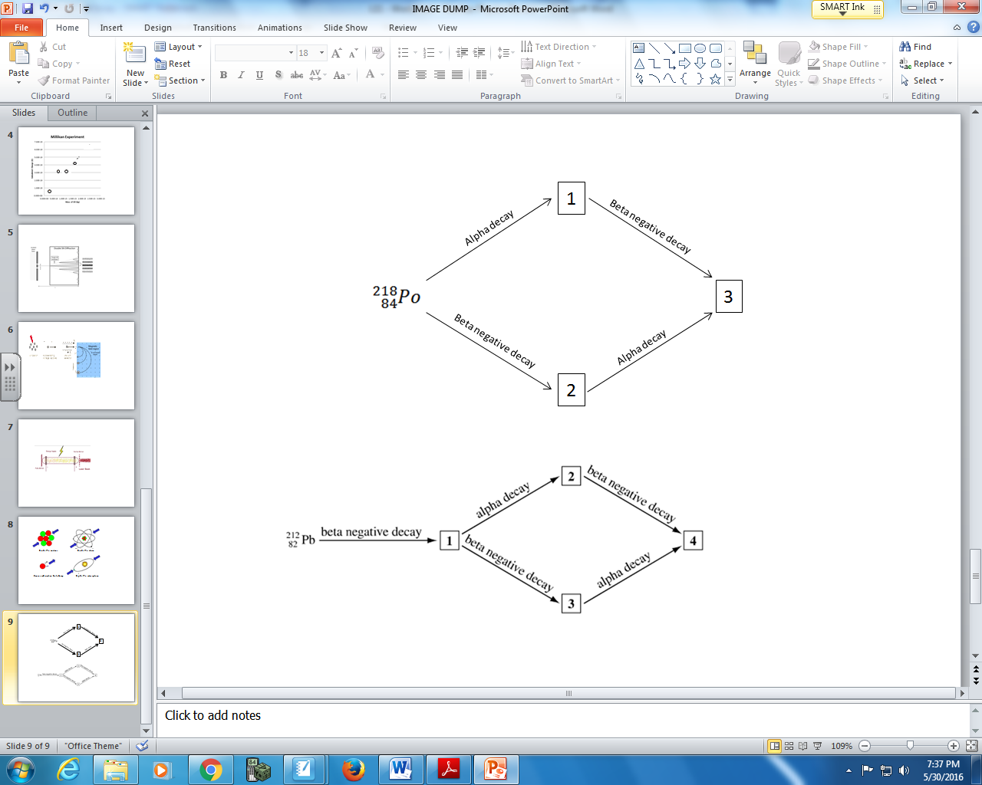

Q2: Match each of the boxed numbers above to the daughter nucleus that it represents, below.
Number: __________ __________ __________
Daughter Nucleus: ²¹⁸ At ²¹⁴ Bi ²¹⁴ Pb
(Record your three digit answer in the Numerical Response boxes)

Use the following information to answer Q3-Q4:
An electron enters a cloud chamber, passing into a 0.100 T magnetic field. The initial curvature radius is 1.00 cm. The electron spirals inwards in a clockwise direction, as shown below.
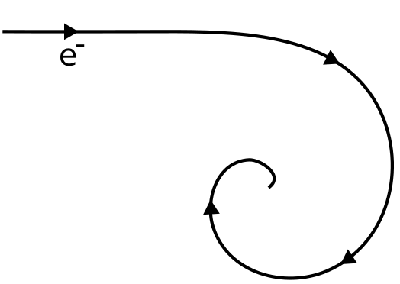

Q3: What is the direction of the magnetic field?
- Into the page
- Out of the page
- Towards the top of the page
- Towards the bottom of the page

Q4: The electron entered the cloud chamber at an initial speed of b x 10^{w} m/s.
(Record your three digit answer in the Numerical Response boxes)

