First Name:_____________________________ Last Name:______________________________

L08 – Worksheet – Systems with Pulleys
Section #1: Systems with Pulleys (no friction)
Q1: A 5kg block is sitting on a frictionless table. The 12kg block is released.
a) What is the force of gravity on the 12kg block?
b) What is the acceleration of the system of masses?
c) Draw a Free-Body-Diagram for the 5kg mass.
d) What is the tension in the rope?
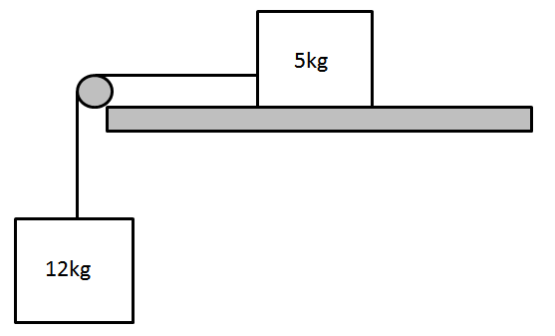

Q2: A 50kg block is sitting on a frictionless surface. The system of masses is released.
a) How quickly will the system of masses accelerate?
b) What is the tension in Rope A?
c) What is the tension in Rope B?
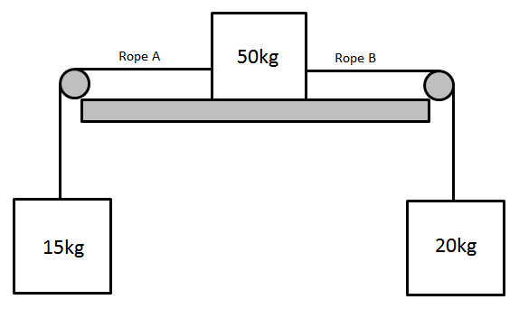

Q3: If m_{A} = 20kg and m_{B} = 35kg, and a person at the top is pulling the blocks upward with a force of 800N, what is the tension in the rope connecting the two blocks?
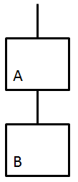

Q4: A person is gently lowering two blocks to the ground by applying a force of 200N [upward]. If the system is accelerating downward at 2.3 m/s², and m_{A} = 10kg, what is tension in the rope connecting the two blocks?

Q5: If m_{A} = 150kg, m_{B} = 10kg, and there is no friction between block A and the table, what is the acceleration of the system?
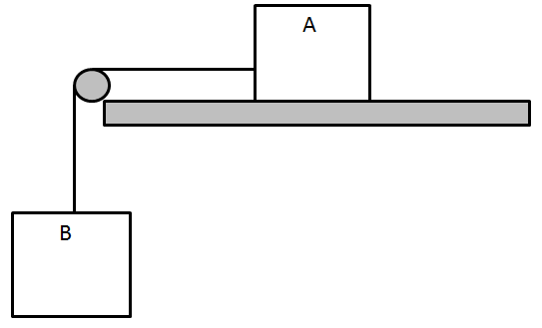

Q6: If the tension between block A (100kg) and block B (unknown mass) is 196.2N, and the system accelerates at 1.962m/s², what is the mass of block B, m_{B}?

Q7: If m_{A} = 10kg, m_{B} = 5kg, and m_{C} = 20kg, what is the tension in each rope?
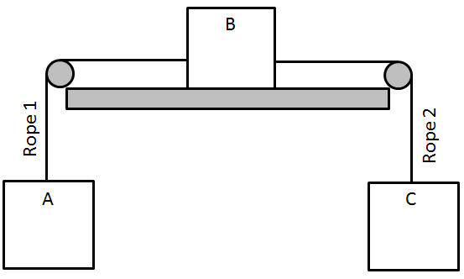

Section #2: Systems with Pulleys (with friction)
Q8: A series of blocks are connected via cables. The 20kg block is allowed to fall, which in turn drags the 8kg block sideways. If the coefficient of kinetic friction is 0.42, what is the tension in the rope? (4 marks)
1 mark – Force of Gravity
1 mark – Force of Friction
1 mark – Acceleration
1 mark – Tension on Rope
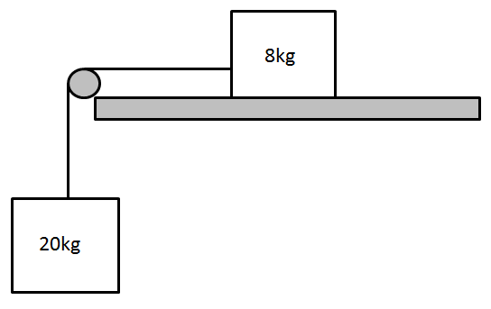

Q9: A series of blocks are connected via cables. The blocks are released and the system starts to accelerate. If the coefficient of kinetic friction between the 20kg block and the table is 0.35, what is the tension in the LEFT rope? (5 marks)
1 mark – Force of Friction
1 mark – Force of Gravities on 15kg and 6kg
1 mark – Net Force
1 mark – Acceleration of System
1 mark – Tension on LEFT Rope
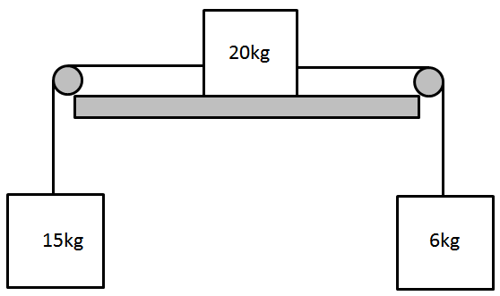

Q10: If m_{A} = 50kg, m_{B} = 20kg, and µ_{s} = 0.8, and µ_{k} = 0.25, under what conditions would the system accelerate? Explain.

Q11: If m_{A} = 30kg, m_{B} = 60kg, and µ_{k} = 1.2, what is the tension in the rope?

