First Name:__________________________________ Last Name:______________________________

L09 – FQ – Projectile Motion
Use the following information to answer Q1:
Two parallel plates are 1.35m apart, with a Potential Difference of 40.5V, as shown below.
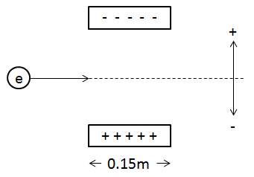
An electron is fired horizontally at 2.40 x 10⁵ m/s through the plates.

Q1: Upon exiting the plates, the electron will have experienced a vertical deflection of ____ m. (5 marks)
(Record your three digit answer in the Numerical Response boxes below)

MARKING:
Beginning 0.0 – 2.0
Progressing 2.5 – 3.5
Competent 4.0 – 4.5
Exemplary 5.0

