First Name:_____________________________ Last Name:_____________________________

L09 – FQ – Systems with Pulleys

Q1: In this frictionless system, what is the tension in the rope? (2 marks)

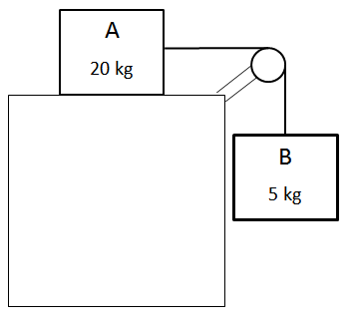

Q2: The coefficient of friction between the 10kg block and the table is 0.65. What is the acceleration of the system? (3 marks)

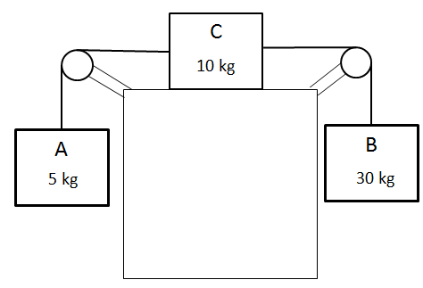

MARKING:
Beginning 0.0 – 2.0
Progressing 2.5 – 3.0
Competent 3.5 – 4.5
Exemplary 5.0

