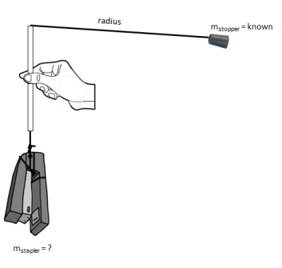
L09&10 – Physics 20 – Circular Motion Lab /24 marks
Purpose: Students will spin a rubber stopper of known mass in circles and calculate centripetal force acting on the stopper in order to determine the unknown mass of the hanging object.
Initiating and Planning
Complete all of the following items before beginning:
Free-Body Diagram of Rubber Stopper
Free-Body Diagram of Hanging Object
List of Equations involving Circular Motion

Develop a procedure to use centripetal force to determine the mass of the hanging object. Include the following in your plan:
- Procedure
  - Controlled and manipulated variables.
  - Quantities measured.
  - Calculations required.
- Materials list
- Safety considerations
Procedure

 | Total | Weighting Multiplier | 3 | 2 | 1 | 0
Evaluate and select appropriate procedures and instruments for collecting evidence and information, including appropriate sampling procedures. |  | x2 | Student has included a detailed procedure and complete materials list. | Student has neglected minor steps or equipment, or has included an incorrect step in their procedure. | Student did not include important procedural steps or critical pieces of equipment necessary for the completion of the lab. | Not included in write-up.

Performing and Recording
Recorded Values

 | Total | Weighting Multiplier | 3 | 2 | 1 | 0
Organize and integrate data, using a format that is appropriate to the task or experiment. |  | x1 | Student has chosen a clear method of recording and presenting their data. | Student has provided evidence of complete data collection. | Student's data is vague or misses the main purpose of the experiment. | Not included in write-up.
Select and use apparatus safely, and apply WHMIS standards to handle and dispose of materials. |  | x1 | Student required no prompts from the teacher to conduct themselves safely in the lab. | Student rarely needed prompts from the teacher to conduct themselves safely in the lab. | Student needed frequent prompts from the teacher to conduct themselves safely in the lab. | Student was unsafe, resulting in them not being able to complete the experiment.
Analyze and Interpret
Calculations and Conclusion

Sources of Error and their Impact on Accuracy

 | Total | Weighting Multiplier | 3 | 2 | 1 | 0
Compile and display calculations, and state a conclusion. |  | x3 | Student’s mass calculation is within 30% of the actual mass. | Student’s mass calculation is within 60% of the actual mass. | Student’s mass calculation is within 90% of the actual mass. | Student’s mass calculation is over 90% of the actual mass.
Identify and explain sources of error; and evaluate the relevance, reliability and adequacy of data and data collection methods. |  | x1 | Student is able to identify and categorize sources of error as either major or minor sources, and state their impact on accuracy. | Student is able to identify major sources of error only, and state their impact on accuracy. | Student is not aware of any significant sources of error that are indeed present, or is unable to state the impact on accuracy. | Not included in write-up.

