First Name:______________________________ Last Name:______________________________

Physics 30 – Lab 1b – Ballistic Pendulum /18 marks

Students will examine a Ballistic Pendulum and the Physics Principles (per the Physics 30 data sheet) necessary to calculate the initial velocity of the shot as it leaves the spring-loaded mechanism depicted below. Students will record (1) which shot they used (Aluminum, Steel, or Brass) and (2) which notch setting it they chose to shoot it from (numbered 1 to 4, as per the diagram below).
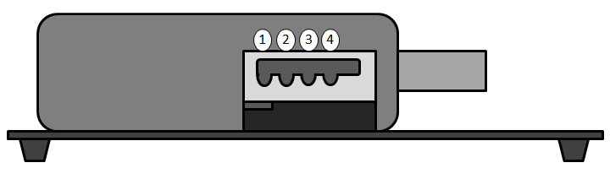
Calculations will be submitted via Google Forms, which will range-check student calculations, carry through mistakes, and automatically assign a mark for the computational section of this lab.
Initiate and Plan
Determine which Physics Principles will be used to determine the initial velocity of the shot, and specify the order in which they will be used.

 | Total | Weighting Multiplier | 3 | 2 | 1 | 0
State a prediction and a hypothesis based on available evidence, background information or theory. |  | x1 | Student is able to articulate and justify a possible result, and/or includes both positive and null result possibilities. | Student is able to articulate a possible result. | Student's hypothesis is vague or misses the main purpose of the experiment. | Not included in write-up.

Perform and Record
Record your experimental decisions and measurements in the table below.
Shot’s Material | Shot’s mass  (kilograms) | Notch Setting  (per diagram on  the first page) | Angle of Pendulum  (degrees) | Height of Pendulum  (meters)
Reference 1: Mass of Objects
Aluminum ball | Steel ball | Brass ball | Empty bob
2.8 grams | 8.3 grams | 8.5 grams | 35 grams
Reference 2: Angle to Height Conversion Tables.
Calculated using trigonometry and the diagram below:
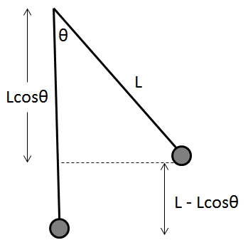
Angle on Scale (deg) | Height of Pendulum (mm) |  | Angle on Scale (deg) | Height of Pendulum (mm) |  | Angle on Scale (deg) | Height of Pendulum (mm)
1 | 0.05 |  | 16 | 12.40 |  | 31 | 45.71
2 | 0.19 |  | 17 | 13.98 |  | 32 | 48.62
3 | 0.44 |  | 18 | 15.66 |  | 33 | 51.63
4 | 0.78 |  | 19 | 17.43 |  | 34 | 54.71
5 | 1.22 |  | 20 | 19.30 |  | 35 | 57.87
6 | 1.75 |  | 21 | 21.25 |  | 36 | 61.11
7 | 2.39 |  | 22 | 23.30 |  | 37 | 64.44
8 | 3.11 |  | 23 | 25.44 |  | 38 | 67.84
9 | 3.94 |  | 24 | 27.67 |  | 39 | 71.31
10 | 4.86 |  | 25 | 29.98 |  | 40 | 74.87
11 | 5.88 |  | 26 | 32.39 |  | 41 | 78.49
12 | 6.99 |  | 27 | 34.88 |  | 42 | 82.19
13 | 8.20 |  | 28 | 37.46 |  | 43 | 85.97
14 | 9.51 |  | 29 | 40.12 |  | 44 | 89.81
15 | 10.90 |  | 30 | 42.87 |  | 45 | 93.73
Analyze and Interpret
The ballistic pendulum releases a shot at velocity (Diagram 1). That shot then collides with a stationary pendulum (Diagram 2), and the combined mass swings upward (Diagram 3).
Diagram 1 Diagram 2 Diagram 3
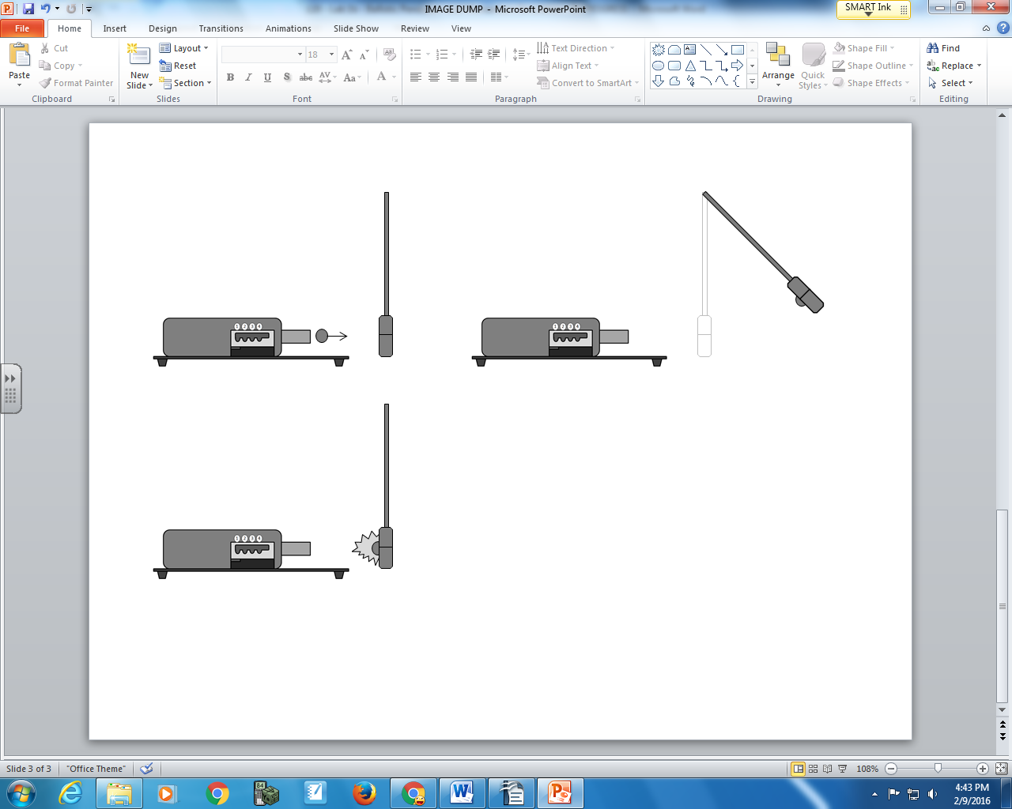
Students will need to calculate the following values:
Diagram 3 | Gravitational Potential Energy of shot and bob.
Diagram 2 | Kinetic Energy of shot and bob.
Diagram 2 | Momentum of shot and bob.
Diagram 1 | Momentum of shot.
Diagram 1 | Speed of shot.
Diagram 1 | Kinetic energy of shot.
All calculated values need to be entered into the Google Forms.
Total | Weighting Multiplier | Google Form Calculations Mark /6
 | x2

Was this collision elastic? Explain.

 | Total | Weighting Multiplier | 3 | 2 | 1 | 0
State a conclusion, based on experimental data; and explain how evidence gathered supports or refutes a hypothesis, prediction or theory. |  | x1 | Student is able to draw an educated conclusion that references both their hypothesis and their findings. | Student is able to draw a reasonable conclusion from their experiment. | Student's conclusion is vague or misses the main purpose of the experiment. | Not included in write-up.

