First Name:______________________________ Last Name:______________________________

Physics 30 – Lab 1c – Collision Simulations /15 marks

Students will need to go to the Colorado PhET Collision Lab, located at: https://phet.colorado.edu/en/simulation/legacy/collision-lab

Setting Requirements:
- Toggle on “More Data”
- Toggle off “Velocity Vectors”
- Toggle on “Momentum Vectors”, “Momenta Diagrams”, “Kinetic Energy”, and “Show Values”

When on the “Introduction” tab, students should now be seeing the following:
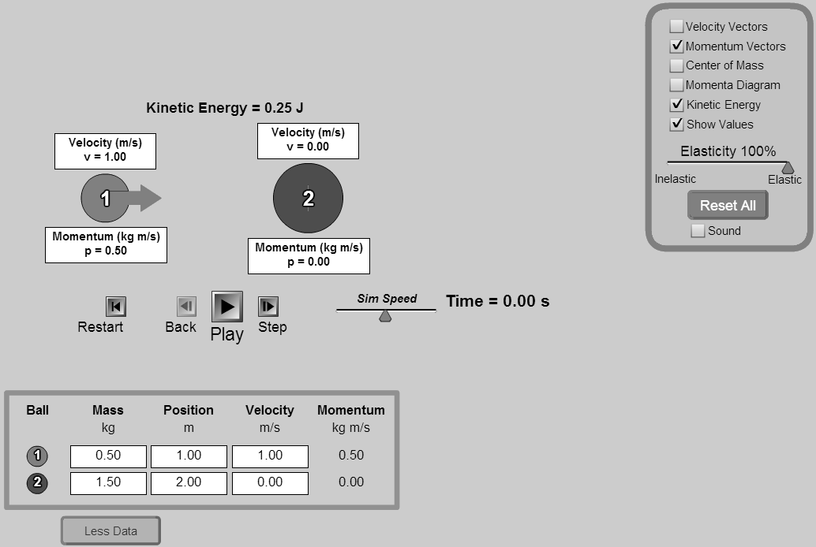

Situation #1: Per settings on first page.
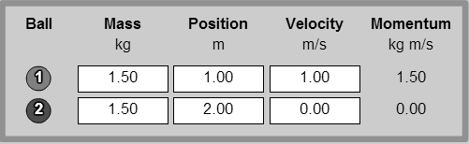
How does the collision change as we vary the Elasticity from 100% to 0%?
_________________________________________________________________________________________________________________________________________________________________________________________________________________________________________________________________________________________________________________________________________________________________________________________________________________________________________
 | Total | Weighting Multiplier | 3 | 2 | 1 | 0
State a conclusion based on experimental data. |  | x2 | Student is able to draw an educated and detailed conclusion that references a range of simulated tests. | Student is able to draw a simplified conclusion from their simulation. | Student's conclusion is vague or misses the main purpose of the simulation. | Not included in write-up.

Situation #2: Per settings on first page.
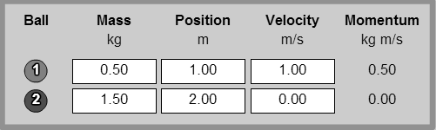
At 100% Elasticity, how does the collision change as we vary m₁ from 0.50 kg to 2.50 kg?
_________________________________________________________________________________________________________________________________________________________________________________________________________________________________________________________________________________________________________________________________________________________________________________________________________________________________________
 | Total | Weighting Multiplier | 3 | 2 | 1 | 0
State a conclusion based on experimental data. |  | x1 | Student is able to draw an educated and detailed conclusion that references a range of simulated tests. | Student is able to draw a simplified conclusion from their simulation. | Student's conclusion is vague or misses the main purpose of the simulation. | Not included in write-up.
Situation #3: Per diagram below.
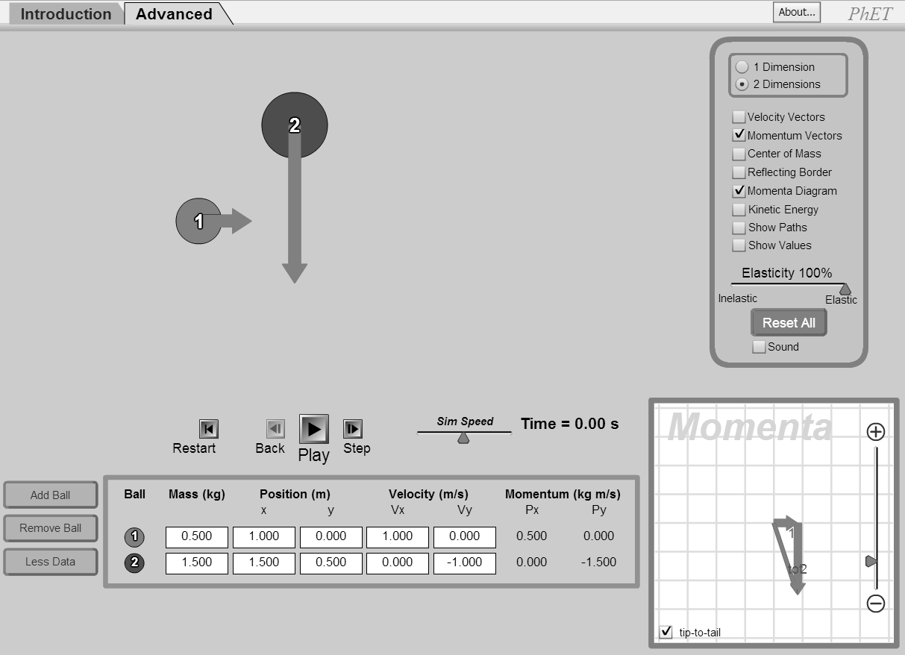
How does the net momentum in the Momenta Diagram change during the collision? Explain why.
________________________________________________________________________________________________________________________________________________________________________________________________________________________________________________________________________________________________________________________________________________________________________________________________________________________________________________________________________________________________________________________________________________________________________________________________________________________________________________________________________________________________________
 | Total | Weighting Multiplier | 3 | 2 | 1 | 0
State a conclusion based on experimental data. |  | x2 | Student is able to draw an educated and detailed conclusion that references a range of simulated tests. | Student is able to draw a simplified conclusion from their simulation. | Student's conclusion is vague or misses the main purpose of the simulation. | Not included in write-up.

