First Name:____________________________ Last Name:______________________________

L09 – Practice Quiz #2
Momentum Collisions in 1-Dimension and 2-Dimensions

PART 1 – MULTIPLE CHOICE (1 mark each; Possible half marks for work)
Q1: A 9000 kg rail flatcar moving at 0.256 m/s [N] encounters a stationary 15 000 kg boxcar on the same track. Based on the information in the above narrative, if the cars couple upon impact, what will be their combined velocity?

- 0.0960 m/s [N]
- 0.154 m/s [N]
- 0.192 m/s [N]
- 0.128 m/s [N]

Q2: Two boys, Ted and Larry, initially at rest, push each other apart on a frictionless surface. Ted has a mass of 40kg and Larry has a mass of 60kg. After the boys push each other apart, Ted has a speed of 6m/s. As the boys move apart, Larry has

- More momentum than Ted
- Less momentum than Ted
- More kinetic energy than Ted
- Less kinetic energy than Ted

Q3: An empty freight car of mass m coasts along a track at 2.00 m/s until it couples to a stationary freight car of mass 2m. The final speed of the two freight cars immediately after collision is

- 1.50 m/s
- 1.33 m/s
- 1.15 m/s
- 0.667 m/s

Q4: In a movie stunt, a car and a train locomotive intentionally crash. The collision is illustrated in the diagram below.
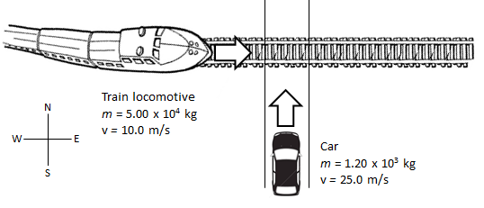
Immediately before the collision, the momentum of the locomotive-car system is

- 5.01 x 10⁵ kg*m/s, 68.2° north of east
- 5.01 x 10⁵ kg*m/s, 3.43° north of east
- 5.30 x 10⁵ kg*m/s, 68.2° north of east
- 5.30 x 10⁵ kg*m/s, 3.43° north of east

Q5: A 115g arrow travelling east at 20 m/s imbeds itself in a 57g tennis ball moving north at 42 m/s. The direction of the ball-and-arrow combination after impact is
- 46° N of E
- 46° E of N
- 25° E of N
- 25° N of E

PART 2– NUMERIC RESPONSE (3 marks)
Q6: A 10kg ball travelling at 4.583 m/s [49.1° S of E] strikes a 20kg ball travelling 1.000 m/s [E], as depicted below. The 10kg ball rebounds at 3.000 m/s [E]. What is the speed of the 20kg ball immediately after the collision? Show all of your work.
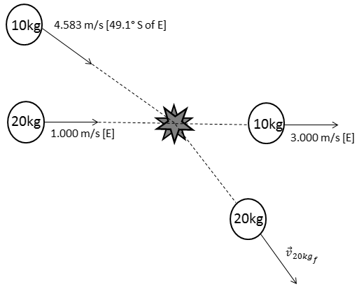

Answer:

