First Name:_____________________________ Last Name:______________________________

L09 – Worksheet – Blocks pushing Blocks
Section #1: Blocks pushing Blocks (no friction)
Q1: The Force of the 6kg block on the 8kg block is 100N. What is the applied force (F_{app}) on the 8kg block? (3 marks)
1 mark – Free-Body Diagram of 6kg block
1 mark – Acceleration of System
1 mark – Applied Force
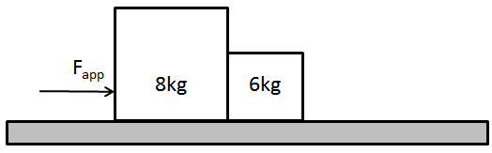

Q2: If m_{A} = 15kg, m_{B} = 30kg, and F_{app} = 100N, what is the acceleration of the system?
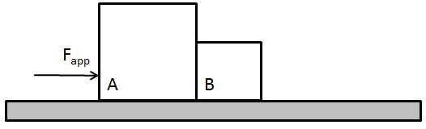

Q3: If m_{A} = 15kg, m_{B} = 30kg, and F_{app} = 100N, what is the force of block B on block A (magnitude and direction)?

Q4: If F_{B on A} = 300N [left], m_{A} = 30kg, and the acceleration of the system is 15m/s², what is the mass of block B?

Section #2: Blocks pushing Blocks (with friction)
Q5: A 20kg block is pushed by a force of 240N, which in turn pushes against a 6kg block. If the coefficient of kinetic friction between the blocks and the surface is 0.63, what is the force that the 6kg block applies on the 20kg block? (4 marks)
1 mark – Force of Friction on System
1 mark – Acceleration of System
1 mark – Free-Body Diagram on 6kg Block
1 mark – Force of 6kg Block on 20kg Block
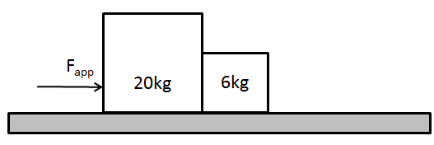

Q6: If m_{A} = 200kg, m_{B} = 75kg, µ_{k} = 0.75, and a = 3.5m/s², what is the tension in the towing cable?
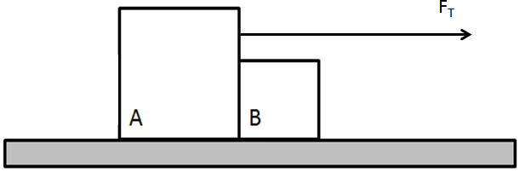

Q7: If m_{A} = 20kg, m_{B} = 80kg, m_{C} = 75kg, F_{C on B} = 380N [left], and µ_{k} = 0.4, what is the acceleration of the system?
