First Name:______________________________ Last Name:______________________________
L09 – Worksheet – Diffraction, Interference, and Polarization
Textbook Questions
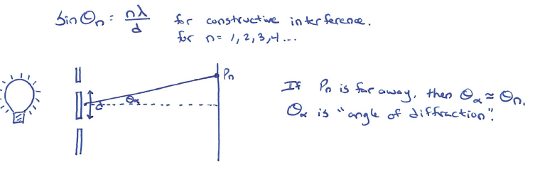
Pg 689 #1: Light of an unknown wavelength is incident on two slits separated by 0.20 mm. The second bright fringe is located at an angle of 0.26⁰ from the central antinode. What is the light’s wavelength?

Pg 689 #2: Blue light of 460 nm is incident on two slits that are 0.55 mm apart. What is the angle of diffraction for the third antinodal line?

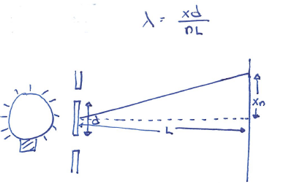
Pg 691 #2: Monochromatic light is incident on two slits separated by 3.00 x 10⁻⁵ m. The distance between antinodes is 3.10 x 10⁻² m. If the screen is 1.50 m from the slits, what is the light’s color and wavelength?

Pg 697 #6: In an experiment similar to Young’s, how far apart are two slits if the 3rd antinode is measured to be 20⁰ from the central antinode, when light with a wavelength of 650 nm is used?

Pg 697 #8: Light with a wavelength of 700 nm is diffracted by a diffraction grating with
5.00 x 10³ lines/cm. If the screen is positioned 1.00 m away from the grating, what is the distance between the 1st and central antinodes?

Pg 697 #11: Light emitted from an unknown gas sample is incident on a diffraction grating with
5.00 x 10² lines/cm. The antinodes appear on a screen 1.50 m away and are separated by 3.10 x 10⁻² m. What is the wavelength and frequency of the light?

Diploma Questions – Diffraction and Interference (Basic Concepts)
Q577: To explain both the interference and diffraction of light scientists use
- A wave model
- A particle model
- Dispersion phenomena
- Polarization phenomena

Q578: The wave theory of light is REQUIRED to explain
- The Compton effect
- Reflection in a mirror
- The photoelectric effect
- Interference and diffraction of light

Q586: The alternate dark and bright bands that are produced when light passes through a double slit are caused by
- Polarization
- Interference
- Dispersion
- Refraction

Diploma Questions – Diffraction and Interference (Constructive and Destructive Interference)
L08 - Diffraction and Interference (Constructive and Destructive Interference) #587,589
Use the following information to answer Q587:
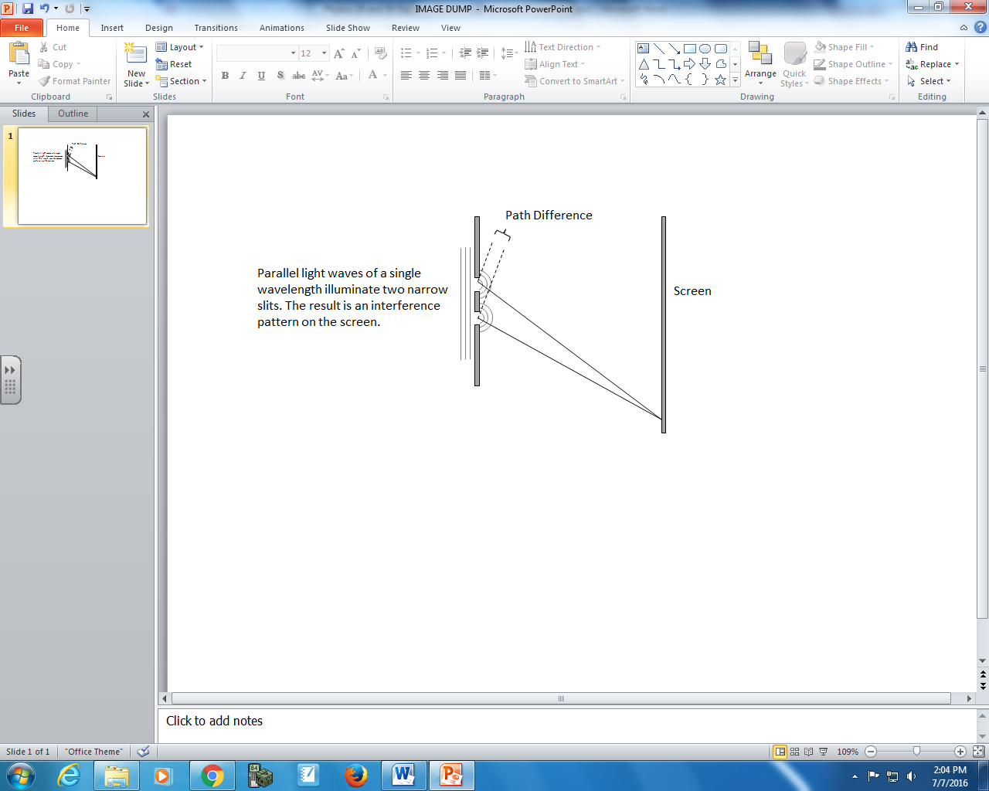

Q587: The path difference that results in destructive interference (minima) is
- ½ λ
- λ
- 2λ
- 3λ

Q589: The overlapping of two waves will result in constructive interference if they meet
- Out of phase
- Sinusoidally
- Crest to trough
- Trough to trough

Diploma Questions – Diffraction and Interference (Algebra)
Q611: A beam of monochromatic light passes through two slits, producing an interference pattern. For the distance between adjacent fringes to be doubled, the slit separation distance must be
- Quartered
- Halved
- Doubled
- Quadrupled

Q612: One of the observations of a double-slit experiment is an interference pattern in which the distance from the central maximum to the first-order image is X. If the wavelength of the light and the slit separation were both doubled, what would be the distance between the central maximum and the first-order image?
- 4X
- 2X
- X
- X/4

Diploma Questions –Polarization (Basic Concepts)
Q617: A red light beam passes through two transparent plates of glass with no apparent loss of brightness. When one of the plates is rotated 90⁰, however, no light gets through. This observation can be explained by the concept of
- Reflection
- Refraction
- Interference
- Polarization

Q618: A polarizing filter is set so that the light passing through it has MAXIMUM brightness. How far must the filter be rotated so that the light passing through it will be of MINIMUM brightness?
- 360⁰
- 180⁰
- 135⁰
- 90⁰
Diploma Questions –Polarization (Diagrams)
L09 - Polarization (Diagrams) #633,634,635
Use the following information to answer Q633:
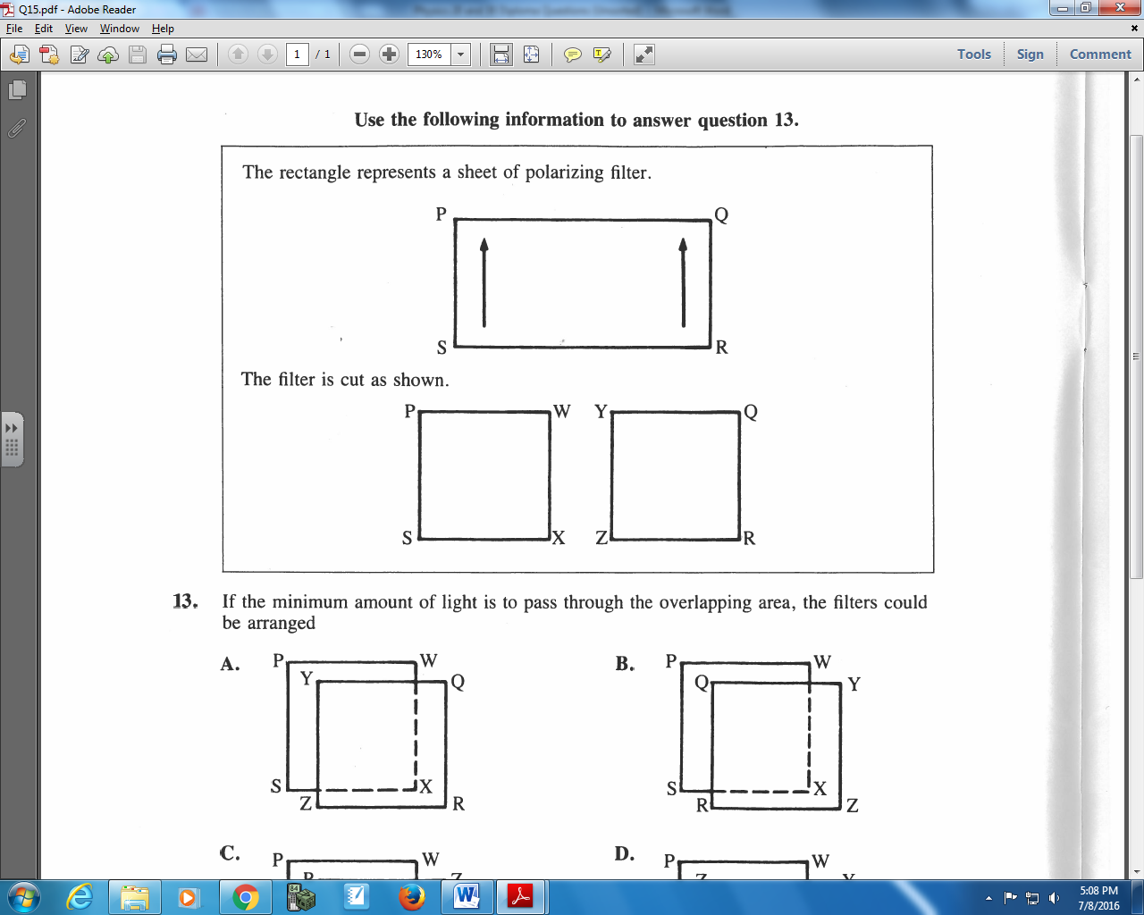

Q633: If the minimum amount of light is to pass through the overlapping area, the filters could be arranged
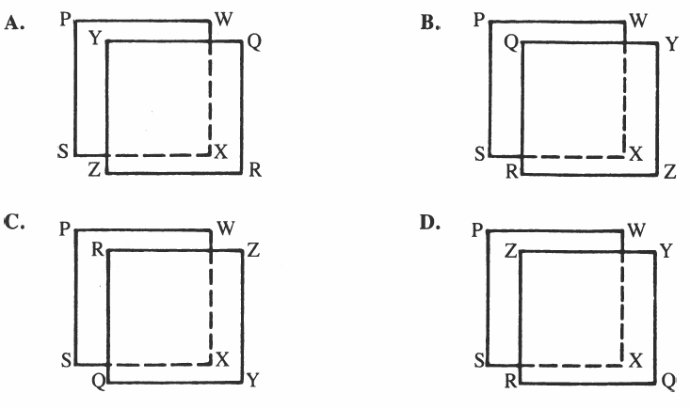

Use the following information to answer Q634:
Transmission of Light through Two Polarizing Filters
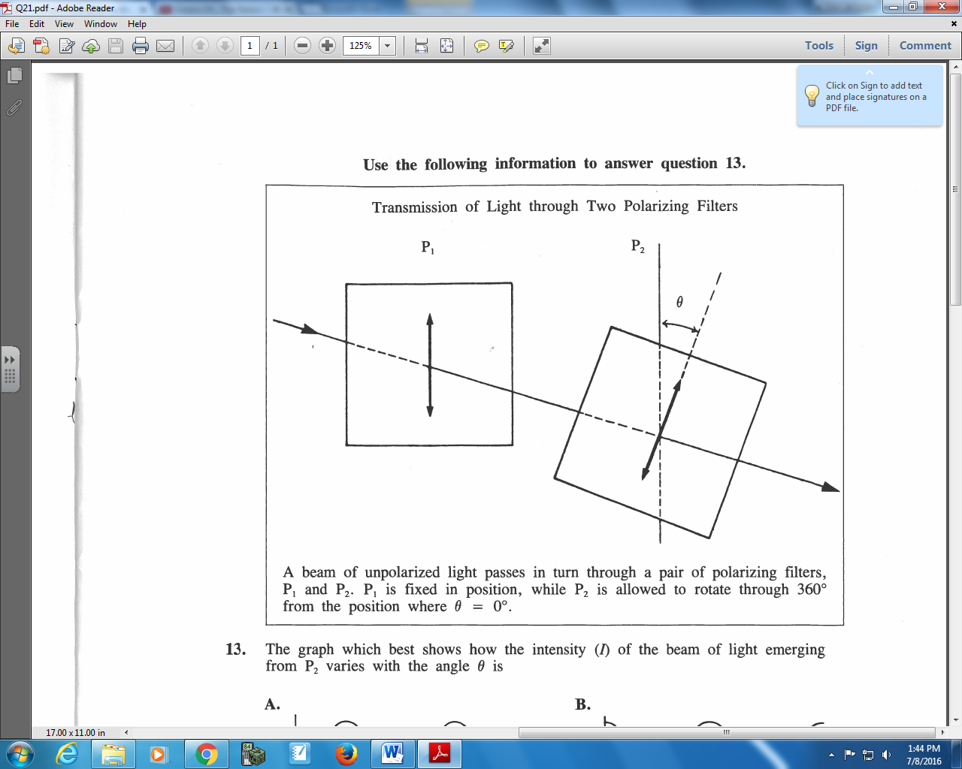
A beam of unpolarized light passes in turn through a pair of polarizing filters, P₁ and P₂. P₁ is fixed in position, while P₂ is allowed to rotate through 360⁰ from the position where θ = 0⁰.

Q634: The graph which best shows how intensity (I) of the beam of light emerging from P₂ varies with the angle θ is
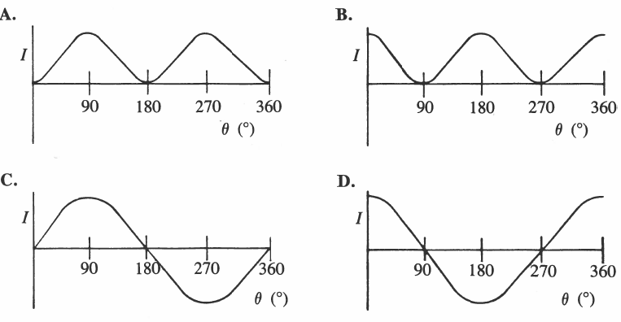

Use the following information to answer Q635:
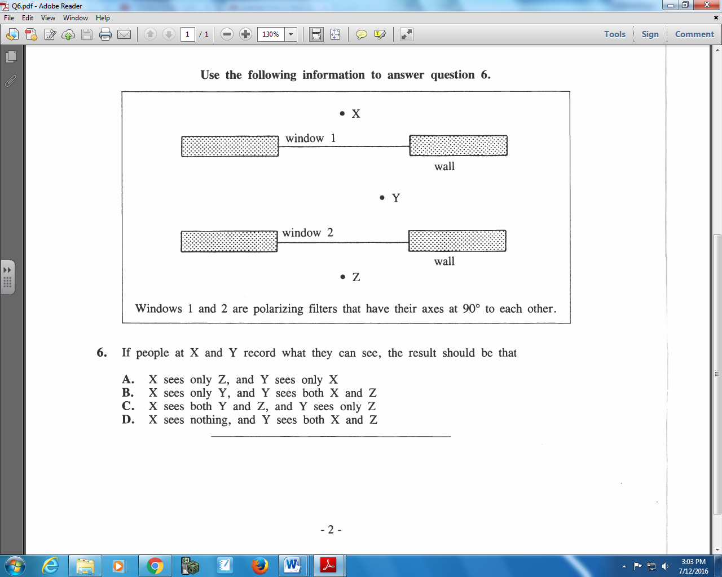

Q635: If people at X and Y record what they can see, the result should be that
- X sees only Z, and Y sees only X
- X sees only Y and Y sees both X and Z
- X sees both Y and Z, and Y sees only Z
- X sees nothing, and Y sees both X and Z

Challenge Questions
Pg 689 #3: The second nodal line of an interference pattern occurs at 0.095⁰ relative to the central antinode. The two slits are separated by 0.40 mm. What is the wavelength and color of light producing this pattern?

Cumulative Review from Previous Units
Use the following information to answer Q1:
The strength of an electric field is measured at various distances from a negatively charged sphere, and graphed below.
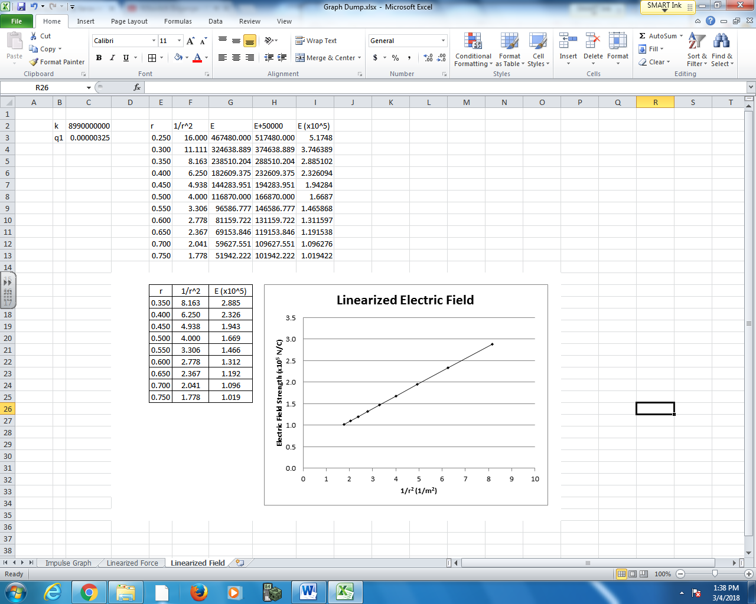

Q1: The negatively charged sphere has a charge of a.bc x 10^{-d} C, where a, b, c, and d are ___, ___, ___, and ___.
(Record your four digit answer in the Numerical Response boxes below)

