First Name:______________________________ Last Name:______________________________
L09 – Worksheet – Parallel Plates and Conservation of Energy
Textbook Questions
Pg 573 #1: An alpha particle with a charge of +3.20 x 10⁻¹⁹ C and a mass of 6.65 x 10⁻²⁷ kg is placed between two oppositely charged parallel plates with an electric potential difference of 4.00 x 10⁴ V between them. The alpha particle is injected at the positive plate with an initial speed of zero, and it accelerates toward the negative plate. Determine the final speed of the alpha particle just before it strikes the negative plate.

Pg 573 #2: If a charge of -6.00 x 10⁻⁶ C gains 3.20 x 10⁻⁴ J of kinetic energy as it accelerates between two oppositely charged plates, what is the potential difference between the two parallel plates?

Pg 575 #4: Calculate the speed of an electron and a proton after each has accelerated from rest through an electric potential of 220 V.

Pg 575 #5: Electrons n a TV picture tube are accelerated by a potential difference of 25 kV. Find the maximum speed the electrons would reach if relativistic effects are ignored.

Pg 575 #6: A charge gains 1.92 x 10⁻¹⁴ J of electric potential energy when it moves through a potential difference of 3.20 x 10⁴ V. What is the magnitude of the charge?

Pg 575 #7: How much work must be done to increase the electrical potential of a charge of 2.00 x 10⁻⁶ C by 120 V?

Pg 575 #8: A deuterium ion (H¹⁺), a heavy isotope of hydrogen, has a charge of 1.60 x 10⁻¹⁹ C and a mass of 3.34 x 10⁻²⁷ kg. It is placed between two oppositely charged plates with a voltage of 2.00 x 10⁴ V. Find the final maximum speed of the ion if it is initially placed at rest
- At the positive plate.
- Midway between the two plates.

Diploma Worksheet Questions – Conservation of Energy
Q210: The potential difference through which an electron must be accelerated to increase its speed from rest to 1.9 x 10⁷ m/s is
- 5.4 x 10⁻⁵ V
- 1.1 x 10⁻⁴ V
- 1.0 x 10³ V
- 2.1 x 10³ V

Q211: An average force of 6.00 x 10⁻³ N is required to move a 4.50 x 10⁻⁴ C charge from one point to another point that is 0.750 m away. The potential difference between the two points is
- 2.03 V
- 10.0 V
- 13.0 V
- 18.0 V

Q213: What will be the speed of an electron that accelerates from rest through a potential difference of 5.0 x 10² V?
- 9.4 x 10⁶ m/s
- 1.3 x 10⁷ m/s
- 1.8 x 10¹⁴ m/s
- 3.3 x 10¹⁶ m/s

Use the following information to answer Q217 and Q218:
A particle with a mass of 3.60 x 10⁻¹⁸ kg acquires 3.00 x 10⁵ eV of kinetic energy when it accelerates from rest through a potential difference of 1.00 x 10⁴ V.

Q217: The charge on the particle is
- 4.80 x 10⁻¹⁸ C
- 3.33 x 10⁻² C
- 3.00 x 10¹ C
- 2.08 x 10¹⁷ C

Q218: The speed that the particle acquires, expressed in scientific notation, is b x 10^{w} m/s. The value of b is _____.
(Record your three digit answer in the Numerical Response boxes below)

Diploma Worksheet Questions - Algebra
Use the following information to answer Q222 and Q223:
An alpha particle, of mass m and charge q, undergoing an acceleration because of an external potential difference of V has a physical quantity S associated with it. The formula for S is
$$S=\sqrt{2qVm}$$

Q222: When the potential difference is 7.62 x 10⁴ V, the numerical value of S in SI units is
- 3.2 x 10⁻⁴⁰
- 1.8 x 10⁻²⁰
- 4.5 x 10⁻¹¹
- 4.4 x 10⁻⁷

Q223: The appropriate SI unit for S is equivalent to the SI unit for
- Force
- Energy
- Momentum
- Magnetic field intensity

Q224: An electron accelerates from rest across the gap between charged parallel plates and reaches a final speed of v. If the potential difference across the plates is tripled, the final speed of an electron accelerating from rest across the gap will be
- $\frac{1}{3}v$
- $\frac{1}{\sqrt{3}}v$
- $\sqrt{3}v$
- $9v$

Diploma Worksheet Questions – Case Studies
Use the following information to answer Q227 – Q230:
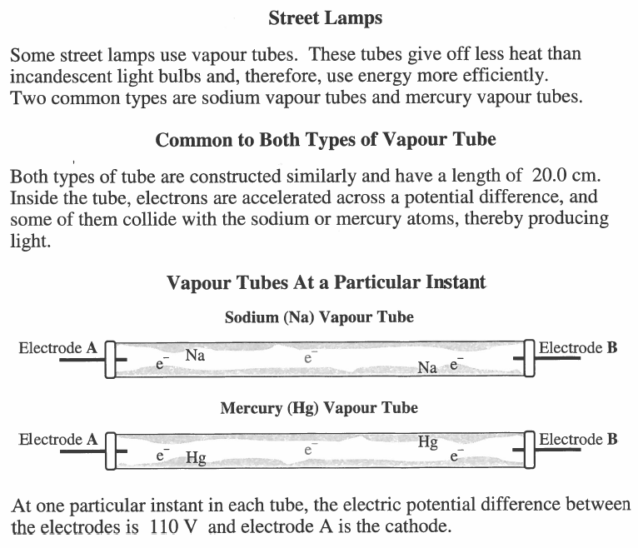

Q227: At the particular instant described, if an electron does not collide with any mercury atoms inside the tube, then the electron’s maximum speed will be
- 1.45 x 10⁵ m/s
- 4.40 x 10⁶ m/s
- 6.22 x 10⁶ m/s
- 3.86 x 10¹³ m/s

Q228: If an electron does not collide with any mercury atoms inside the tube, then the impulse given to the electron by the accelerating voltage, expressed in scientific notation, is _____ x 10^{-w} N*s.
(Record your three digit answer in the Numerical Response boxes below)

Q229: At the particular instant described, the magnitude of the electric field between the two electrodes is
- 550 N/C
- 550 J/C
- 5.50 N/C
- 5.50 J/C

Q230: At the particular instant described, the electrons in the vapor tube will accelerate
- Toward the bottom of the tube
- Toward electrode A
- Toward electrode B
- In all directions

Challenge Questions
Use the following information to answer Q1:
Cyclotrons
A cyclotron is a type of particle accelerator invented by Ernest O. Lawrence in 1934 in which charged particles accelerate outwards from the center along a spiral path. The particles are held to a spiral trajectory by a static magnetic field and accelerated by a rapidly varying (radio frequency) electric field.
A proton leaves one of the “dees” travelling at 2.50 x 10⁶ m/s, and is subject to an electric field created by a 2.00 x 10⁴ V power supply, as diagrammed below.
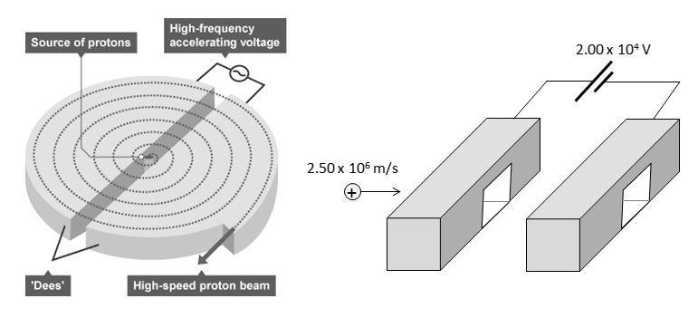

Q1: After being accelerated, the proton is now travelling at a speed of a.bc x 10^{d} m/s, where a, b, c, and d are ___, ___, ___, and ___.
(Record your three digit answer in the Numerical Response boxes below)

Cumulative Review from Previous Units
Use the following information to answer Q1:
A 2kg object is subject to the following impulse.
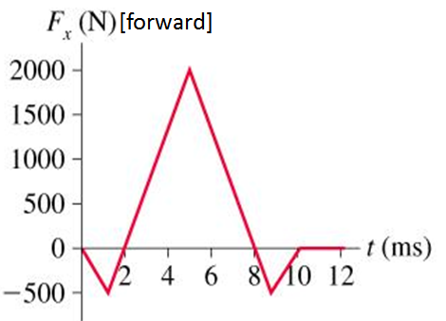

Q1: If the object were originally travelling 2.5 m/s [backward], what is the final velocity of the object?

