First Name:_____________________________ Last Name:______________________________

L09 – Worksheet – Practice Summative Quiz /12 marks

Use the following information to answer Q1-Q2:
An archer is using a recurve bow of spring constant 480 N/m, and pulls the bow back 0.85m.
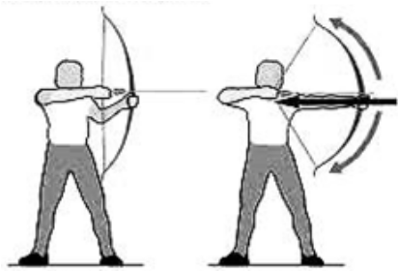

Q1: The archer is applying a force of a.bc x 10^{d} Newtons to the bow, where a, b, c, and d are ___, ___, ___, and ___.
(Record your four digit answer in the Numerical Response boxes below)

Q2: If the archer pulls back an additional 0.15m, how much additional work does this take?
- 66.6 J
- 72.0 J
- 173.4 J
- 240.0 J

Use the following information to answer Q3:
A person applying a force of 8.00 N moves a cat a distance of 30.0 meters. The person does 200J of work.
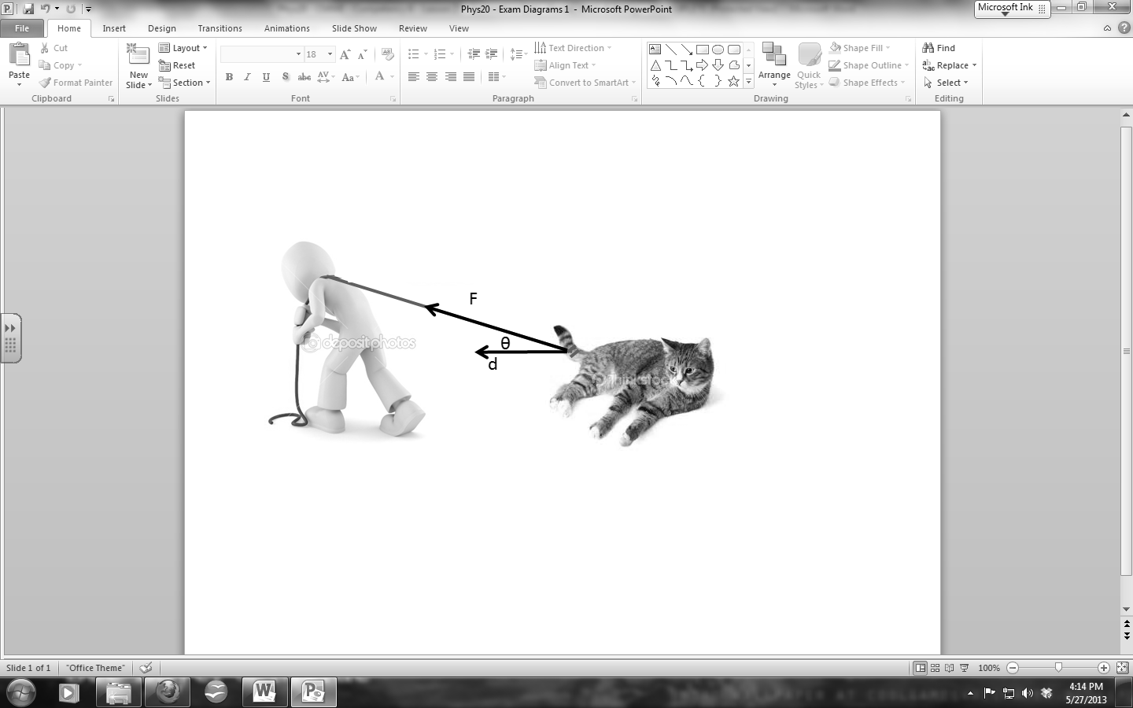

Q3: At what angle above the horizontal was the force applied?
(Record your three digit answer in the Numerical Response boxes below)

Use the following information to answer Q4:
The Vitamix © 5200 Blender, depicted below, is rated at 1380W. It has a blade of radial length 3.8cm (0.038m), where the tip of the blade can spin up to 240mph (107m/s).
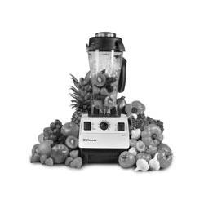

Q4: If it takes 30 seconds to crush ice, how much energy is being used?
- 4.60 x 10¹ J
- 1.73 x 10² J
- 4.14 x 10⁴ J
- 1.56 x 10⁵ J
Use the following information to answer Q5-Q6:
Depicted below is the “Kingda Ka” rollercoaster, located in Jackson, New Jersey. The cars are initially accelerated up to 206 km/h (57.2 m/s) while at the base of the rollercoaster, then travel vertically up a 139m tall track.
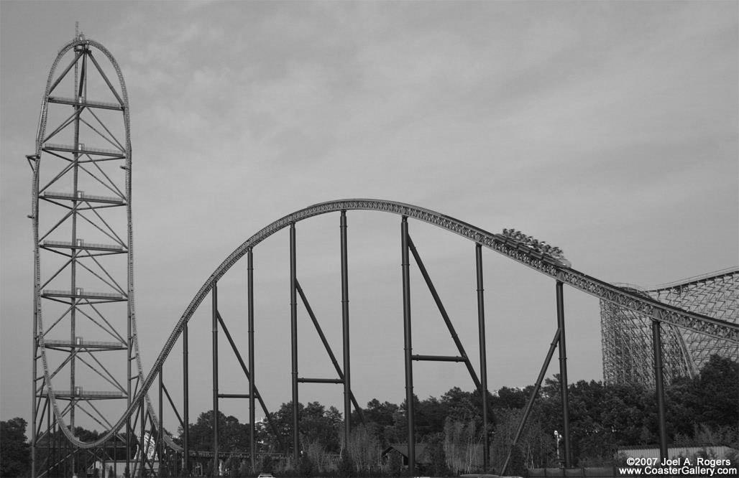

Q5: How fast are the cars going at the top of the track?
- 11.7 m/s
- 23.3 m/s
- 43.7 m/s
- 57.2 m/s

Q6: If the cars were actually only going 18.0 m/s at the top, what is the energy efficiency? (2 marks)

Use the following information to answer Q7-Q8:
An archer does 117 Joules of work to stretch a bow backward 0.85m, then releases a 28 gram arrow, shooting it vertically. Assume that the bow & arrow is 100% energy efficient.
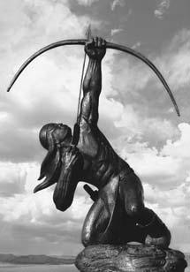

Q7: The initial speed of the arrow after it is release is a.bc x 10^{d} m/s, where a, b, c, and d are ___, ___, ___, and ___.
(Record your four digit answer in the Numerical Response boxes below)

Q8: What is the spring constant of the bow?
- 81.0 N/m
- 137.6 N/m
- 169.1 N/m
- 323.9 N/m

Use the following information to answer Q9:
A 200kg block sitting on a rough surface has a 981 N force applied to it.
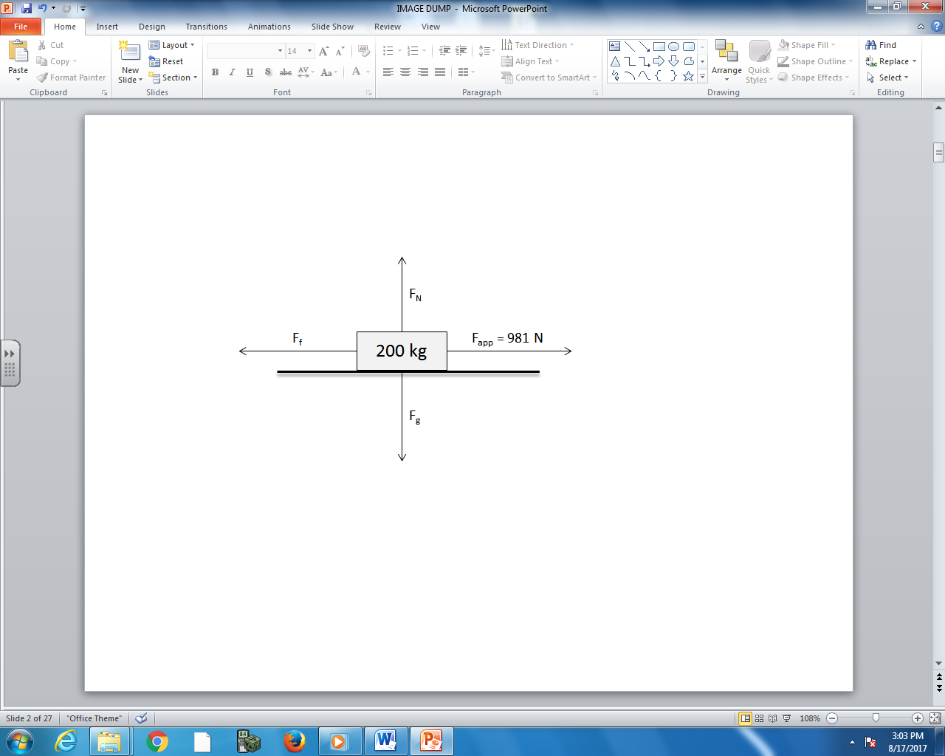
The position of the block and the force acting on the block are both graphed as a function of time.
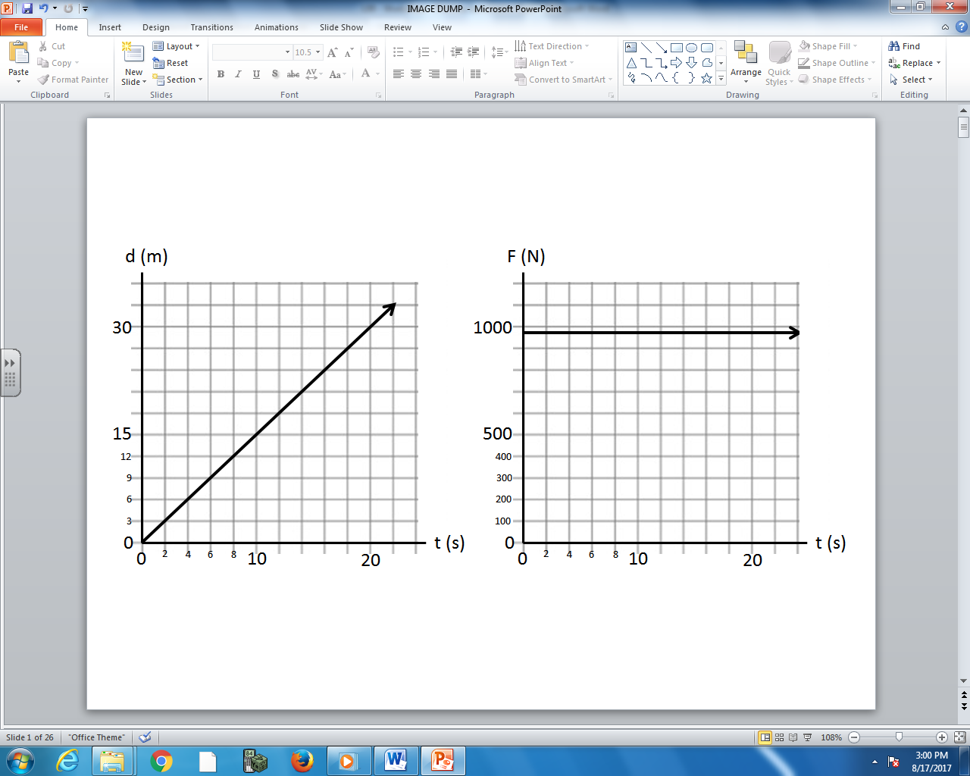

Q9: How many watts of power were required to push the object for 20 seconds? (2 marks)

Use the following information to answer Q10:
A motor is used to accelerate a 10kg object, as depicted below.
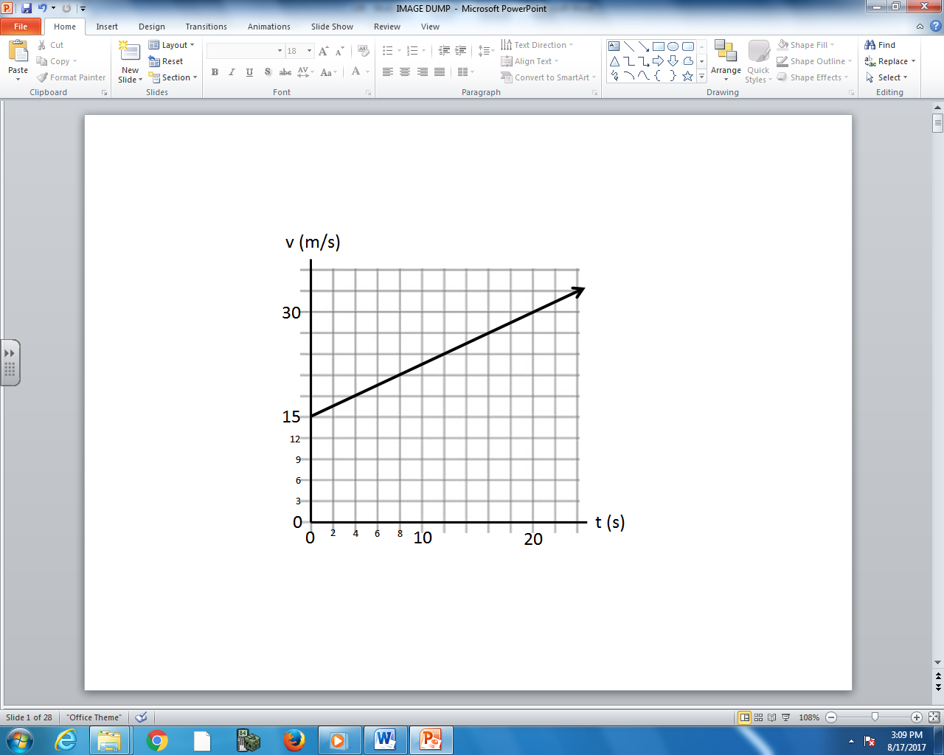

Q10: How much work was done to accelerate the object over the first 20 seconds?
- 450 J
- 1125 J
- 3375 J
- 4500 J

