First Name:____________________________ Last Name:______________________________

L09 – Worksheet – Radioactivity /20 marks

PART 1 – Fundamental Forces
Use the following information to answer Q1:
The Four Fundamental Forces
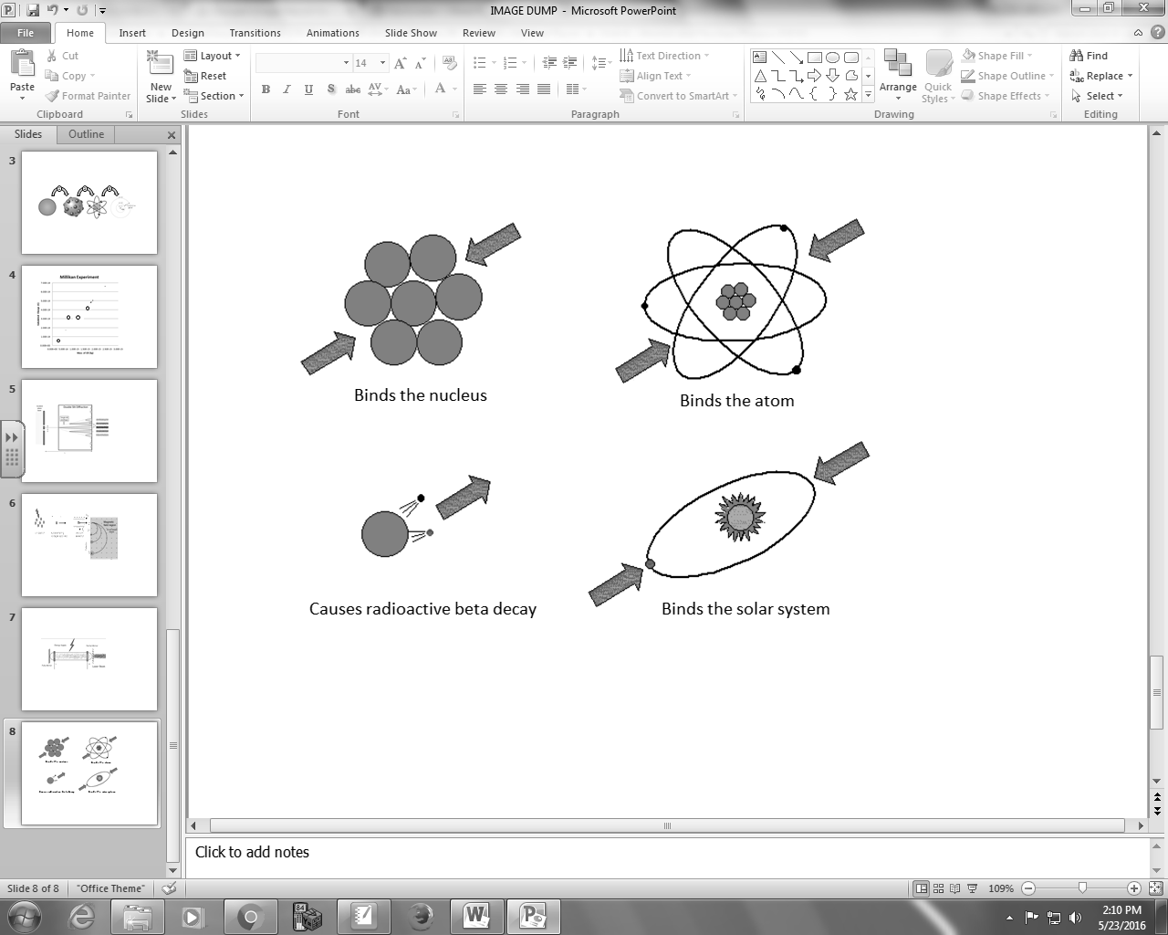
The Four Fundamental Forces
1 – Electromagnetic Force
2 – Gravitational Force
3 – Strong Nuclear Force
4 – Weak Nuclear Force

Q1: Use the Numerical Response numbers above to assign the fundamental force with its major contribution below.
________ ________ ________ ________
Binds the nucleus Binds the atom Causes radioactive Binds the solar
Beta decay system
(Record your four digit answer in the Numerical Response boxes below)

Use the following information to answer Q2-Q4:
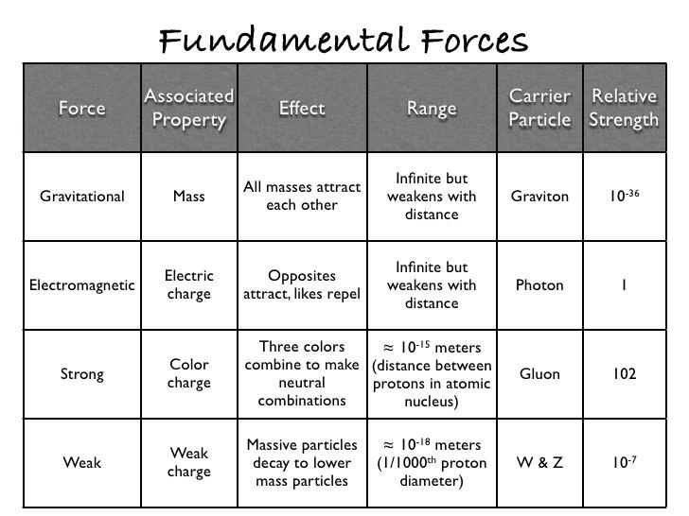

Q2: Which fundamental force has the smallest effective range?
- Gravitational
- Electromagnetic
- Strong
- Weak
Q3: Which fundamental force is the strongest?
- Gravitational
- Electromagnetic
- Strong
- Weak
Q4: Which fundamental force is the weakest?
- Gravitational
- Electromagnetic
- Strong
- Weak
Q5: Which fundamental force is suspected of being attractive, but repulsive at extremely close distances?
- Electromagnetic force
- Gravitational force
- Strong nuclear force
- Weak nuclear force

Q6: Which best describes the balance of attractive and repulsive forces acting inside the nucleus?
- F_{Strong} + F_{Gravity} ≥ F_{Electromagnetic}
- F_{Strong} + F_{Electrostatic} ≥ F_{Gravity}
- F_{Gravity} ≥ F_{Strong} + F_{Electromagnetic}
- F_{Strong} ≥ F_{Electromagnetic} + F_{Gravity}

Question: How much do you actually need to know about these fundamental forces?
Answer:
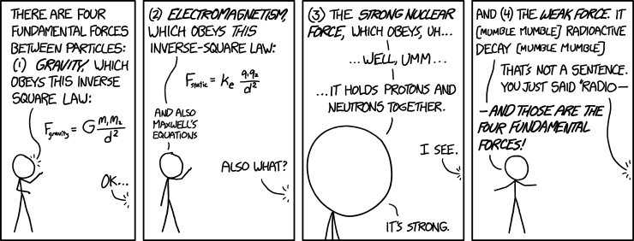
PART 2 – Alpha, Beta+, Beta-, and Gamma Decay
Q7: Uranium-238 decays via alpha decay. Write the equation.

Q8: Carbon-14 decays via beta-negative decay. Write the equation.

Q9: Fluorine-18 decays via beta-positive decay. Write the equation.

Q10: Barium-137 decays via gamma decay. Write the equation.

Q11: The Physics Principles necessary to solve a radioactive decay question are:
(Record your two digit answer in the Numerical Response boxes below)

PART 3 – Cloud Chambers and Magnetic Fields
Use the following information to answer Q12:
Cloud Chambers
The cloud chamber, also known as the Wilson chamber, is a particle detector used for detecting ionizing radiation.
In its most basic form, a cloud chamber is a sealed environment containing a supersaturated vapor of water or alcohol. When a charged particle (for example, an alpha or beta particle) interacts with the mixture, the fluid is ionized. The resulting ions act as condensation nuclei, around which a mist will form (because the mixture is on the point of condensation).
The high energies of alpha and beta particles mean that a trail is left, due to many ions being produced along the path of the charged particle. These tracks have distinctive shapes (for example, an alpha particle's track is broad and shows more evidence of deflection by collisions, while an electron's is thinner and straight).
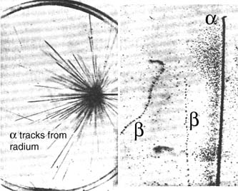
When any uniform magnetic field is applied across the cloud chamber, positively and negatively charged particles will curve in opposite directions, according to the Lorentz force law with two particles of opposite charge.

Q12: Which type of radiation will produce tracks in a cloud chamber?
- Alpha radiation only
- Beta radiation only
- Alpha and beta radiation only
- Alpha, beta, and gamma radiation
Use the following information to answer Q13-Q16:
An electron enters a cloud chamber, passing into a 0.100 T magnetic field. The initial curvature radius is 1.00 cm. The electron spirals inwards in a clockwise direction, as shown below.
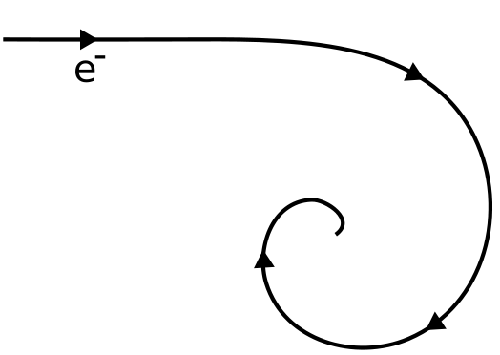

Q13: What is the direction of the magnetic field?
- Into the page
- Out of the page
- Towards the top of the page
- Towards the bottom of the page
Q14: The electron entered the cloud chamber at an initial speed of b x 10^{w} m/s.
(Record your three digit answer in the Numerical Response boxes below)

Q15: What would the path of a positron, moving with an identical speed, look like?
- Same radius, spiraling clockwise.
- Same radius, spiraling counter-clockwise.
- Larger radius, spiraling clockwise.
- Larger radius, spiraling counter-clockwise.
Q16: Using a 2.00 T magnetic field, an electric field of strength a.bc x 10^{d} N/C must be used to get a velocity selector to select only particles which are moving at 100 m/s. The values of a, b, c, and d are ___, ___, ___, and ___.
(Record your four digit answer in the Numerical Response boxes below)

PART 4 – Half-Life Equations
Q17: A radioactive substance has a half-life of 30 minutes. What percentage of the atoms will not have decayed after 1 hour?
(Record your three digit answer in the Numerical Response boxes below)

Q18: The half-life of Zn-71 is 2.4 minutes. If one had 100.0 grams at the beginning, how many grams would be left after 7.2 minutes have elapsed?
(Record your three digit answer in the Numerical Response boxes below)

Q19: Pd-100 has a half-life of 3.6 days. If one had 6.02 x 10²³ atoms at the start, then a.b x 10^{cd} would be present after 20.0 days, where a, b, c, and d are ___, ___, ___, and ___.
(Record your four digit answer in the Numerical Response boxes below)

Q20: Fermium-253 has a half-life of 0.334 seconds. A radioactive sample is considered to be complete decayed after 10 half-lives. How much time will elapse for this sample to be considered gone?
(Record your three digit answer in the Numerical Response boxes below)

