First Name:__________________________________ Last Name:______________________________
L10 – FQ – Blocks Pushing Blocks
Use the following information to answer Q1 and Q2:
In a frictionless system, a force is applied to the masses below, and the entire system accelerates at 2.40 m/s².
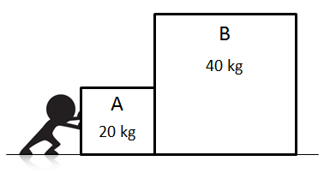

Q1: What is the force of object B acting on object A (${\vec{F}}_{B on A}$)?

Q2: If the mass of B is doubled, then what is the new acceleration of the system?
(Record your three digit answer in the Numerical Response boxes below)

Use the following information to answer Q3:
A force of 1000N is applied to a system of blocks, as depicted below. The coefficient of kinetic friction between the blocks and the ground is 0.85.
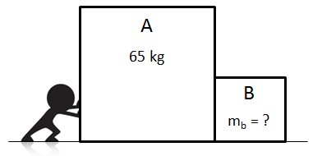

Q3: If the entire system accelerates at 2.00 m/s², what is the mass of B?
- 16.25 kg
- 31.73 kg
- 96.73kg
- 229.00 kg

MARKING:
Beginning 0 – 0.5
Progressing 1 – 1.5
Competent 2 – 2.5
Exemplary 3

