First Name:___________________________ Last Name:______________________________

L10 - FQ – Diffraction, Interference, and Polarization

Use the following diagram to answer Q1:
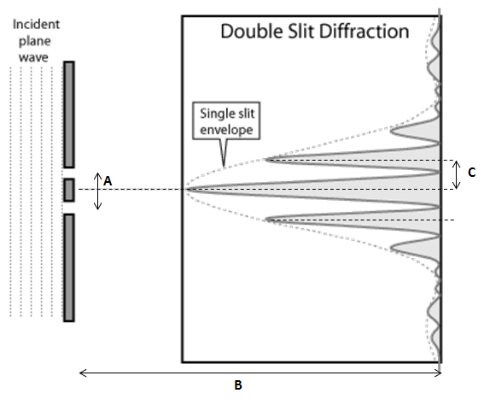
$$λ=\frac{dsinθ}{n}$$

$$λ=\frac{xd}{nl}$$

Interference Variables
1 – d 2 – L 3 – n 4 – x 5 – θ

Q1: For the given diagram above, the best labels for A, B, and C are ____, ____, and ____.
(Record you three-digit answer in the numerical response boxes below.)

Q2: A light of wavelength 480nm is incident on two slits separated by 0.2mm. The first bright fringe is located at an angle of a.bc x 10^{-d} degrees from the central antinode. The values of a,b,c, and d are ____, ____, ____, and ____.
(Record you four-digit answer in the numerical response boxes below.)

Use the following information to answer Q3-Q4:
A monochromatic wave is incident on two slits separated by 1.40 x 10⁻⁶ m. The first antinode is measured to be 20.0 cm from the central antinode.
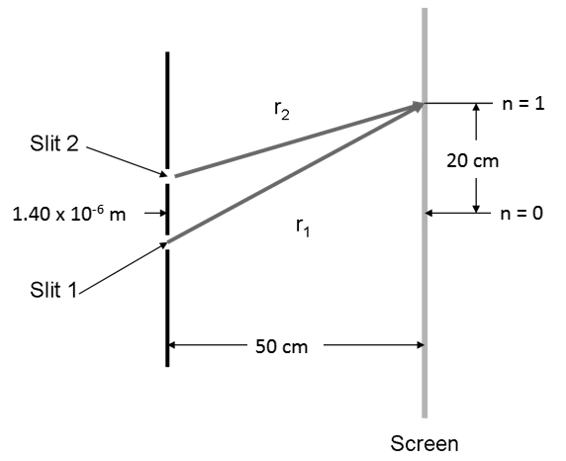

Q3: The waves from Slit 1 and Slit 2, when meeting at the first antinode, are how many degrees out of phase?
- 90⁰
- 180⁰
- 270⁰
- 360⁰
Q4: The wavelength of the incident light is _____ nm.
(Record you three-digit answer in the numerical response boxes below.)

Use the following to answer Q5:
Unpolarized light is shown through both Polarizing Filter #1 and Polarizing Filter #2, per the diagram below.
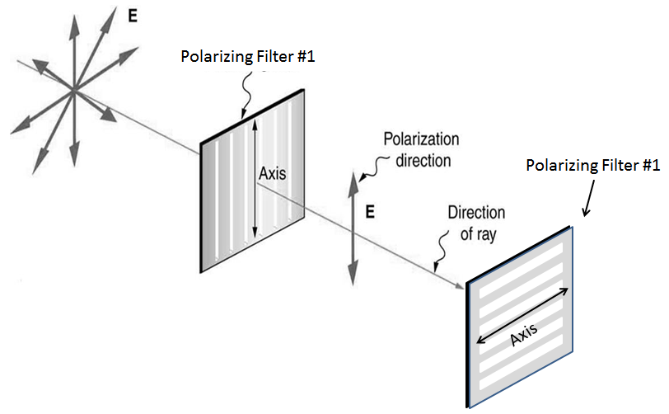
Polarizing Filter #2 is slowly rotated until its axis is vertically oriented.

Q5: As Polarizing Filter #2 is rotated, the intensity of the light seen by an observer would
- increase
- decrease
- stay the same
- none of the above

MARKING:
Beginning 0.0 – 2.0
Progressing 2.5 – 3.5
Competent 4.0 – 4.5
Exemplary 5.0

