First Name:____________________________ Last Name:______________________________

L10 - Lab – EMR as Waves at Colorado PhET /15 marks

_____ _____ _____ _____
Part 1 Part 2 Part 3 Part 4
2 marks 6 marks 3 marks 4 marks

Part 1: Radio Waves & Electromagnetic Fields /2
Instructions:
- Go to http://phet.colorado.edu/en/simulation/radio-waves
- Program Settings:
  - Transmitter Movement: Oscillate
  - Frequency and Amplitude: Don’t change
  - Field Display Type: Curve with vectors
  - Field Sense: Force on electron
  - Field Display: Radiated field
  - Electron positions: Off (not toggled on)
Q1: How is the radiating electric field (or electromagnetic signal) produced when radio stations broadcast? Include a description of what is producing the signal as well as the reasoning behind how this could produce a signal. (1 mark)

Q2: How does your antenna work to detect this electromagnetic signal produced when radio stations broadcast? Include the physics principles that support your description of how this signal is detected.
(1 mark)

Part 2: Bending Light /6
Instructions:
- Go to http://phet.colorado.edu/en/simulation/bending-light

Q3: Using the tools available in the “Intro” tab, what is the critical angle necessary for total internal reflection between Water and Mystery A? (1 mark)

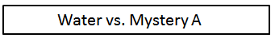
Q4: Using the tools available in the “Intro” tab, which has the higher index of refraction, Water or Mystery A? Explain. (1 mark)

Q5: Using the tools available in the “More Tools” tab, develop two different experiments for determining the index of refraction of Mystery B. Mathematically calculate the index of refraction using both methods. (4 marks)
Experiment #1:

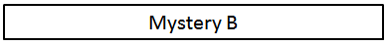

Experiment #2:

Part 3: Geometric Optics /3
Instructions
- Go to http://phet.colorado.edu/en/simulation/geometric-optics
- Program Settings:
  - Rays: Principal rays
  - Curvature radius = 0.5m
  - Refractive index = 1.53
  - Diameter = 1.3m
  - Change Object: Yellow Arrow
  - Virtual Image: Toggle to “on”.
Q6: When is the image produced real? When is the image produced virtual? (1 mark)

Q7: Explain what is occurring when the object is placed at the primary focal point. (1 mark)

Q8: Using the simulation for help, draw the ray diagrams and the formation of the image when it is placed 1.0m from the lens. (1 mark)
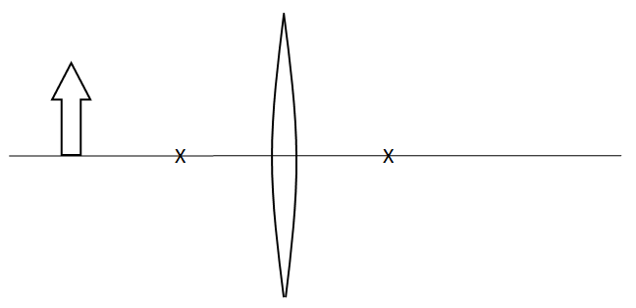

Part 4: Wave Interference /4
Instructions:
- Go to http://phet.colorado.edu/en/simulation/wave-interference
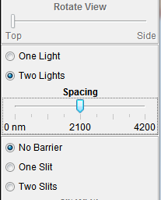
- Program Settings:
  - Tab: Light
  - Show Screen: Toggle “on”
  - Intensity Graph: Toggle “on”
  - Lights: Select “Two Lights”
  - Spacing: 2100nm
  - Barrier: No Barrier
  - Do NOT change the light color.
Q9: Using the “Measuring Tape” feature, (a) measure the distance between nodes, (b) measure the distance between the central bright spot and the first antinode, and (c) measure the distance between the lights and the screen. (1 mark)

Q10: Record all of your measurements on the diagram below. (1 mark)
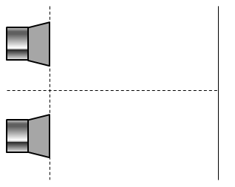

Q11: Which equation would we use to calculate the wavelength of the emitted light? Explain why.
(1 mark)
$λ=\frac{dsinθ}{n}$ or $λ=\frac{xd}{nl}$

Q12: Calculate the wavelength of the emitted light. (1 mark)

