First Name:______________________________ Last Name:______________________________
L10 – Worksheet – Electrostatics Review
L01 – Electrical Interactions and Electroscopes
Use the following to answer Q1:
An electroscope is charged via induction, per the diagram below.
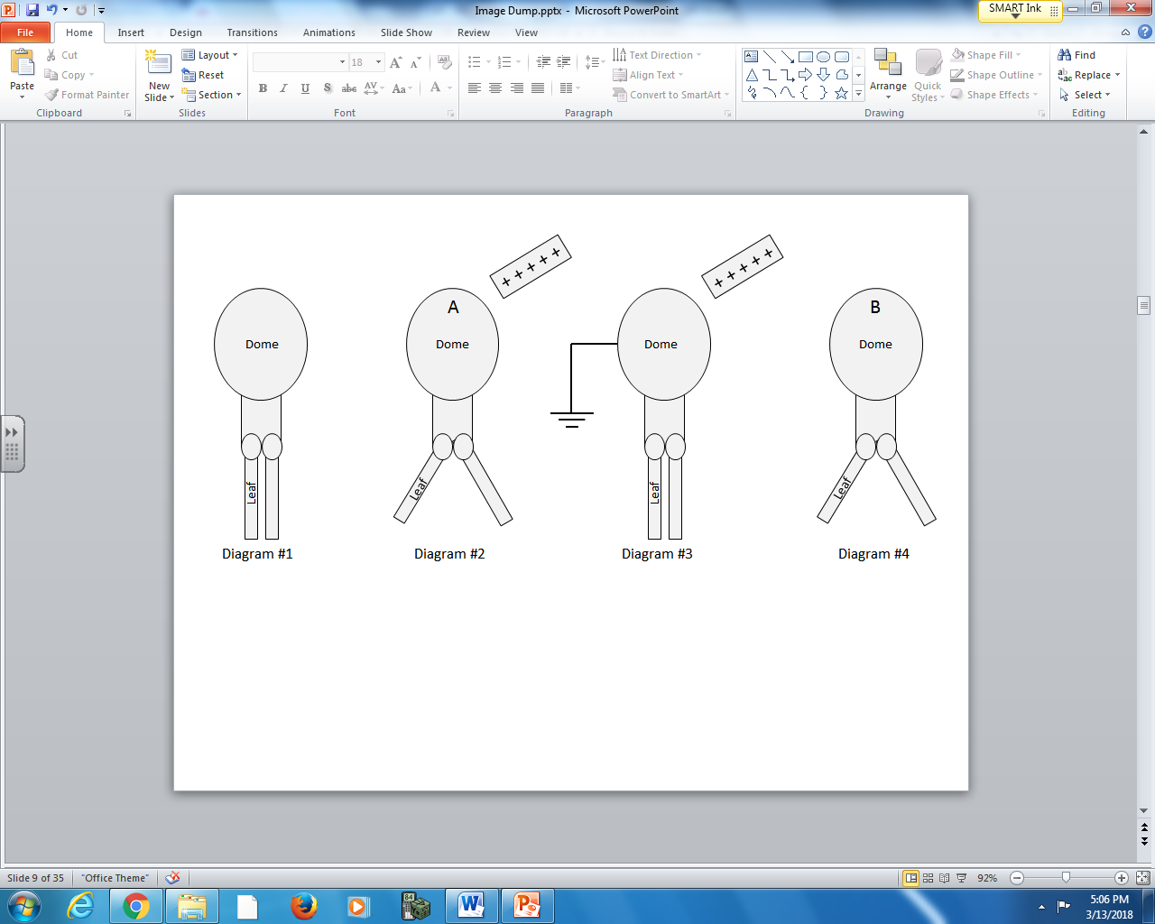
Nature of Charge Subatomic Particle
1 – Positive 4 – Protons
2 – Negative 5 – Electrons
3 – Neutral 6 – Neutrons

Q1: In Diagram #2, the net charge at Point A is ___________ due to the movement of ____________.
Nature of Charge Subatomic Particle
In Diagram #4, the net charge at Point B is ___________.
Nature of Charge
(Record your three digit answer in the Numerical Response boxes below)

Use the following information to answer Q2-Q3:
Van Der Graff Generator
The VDG in the diagram below has a positively charged dome.
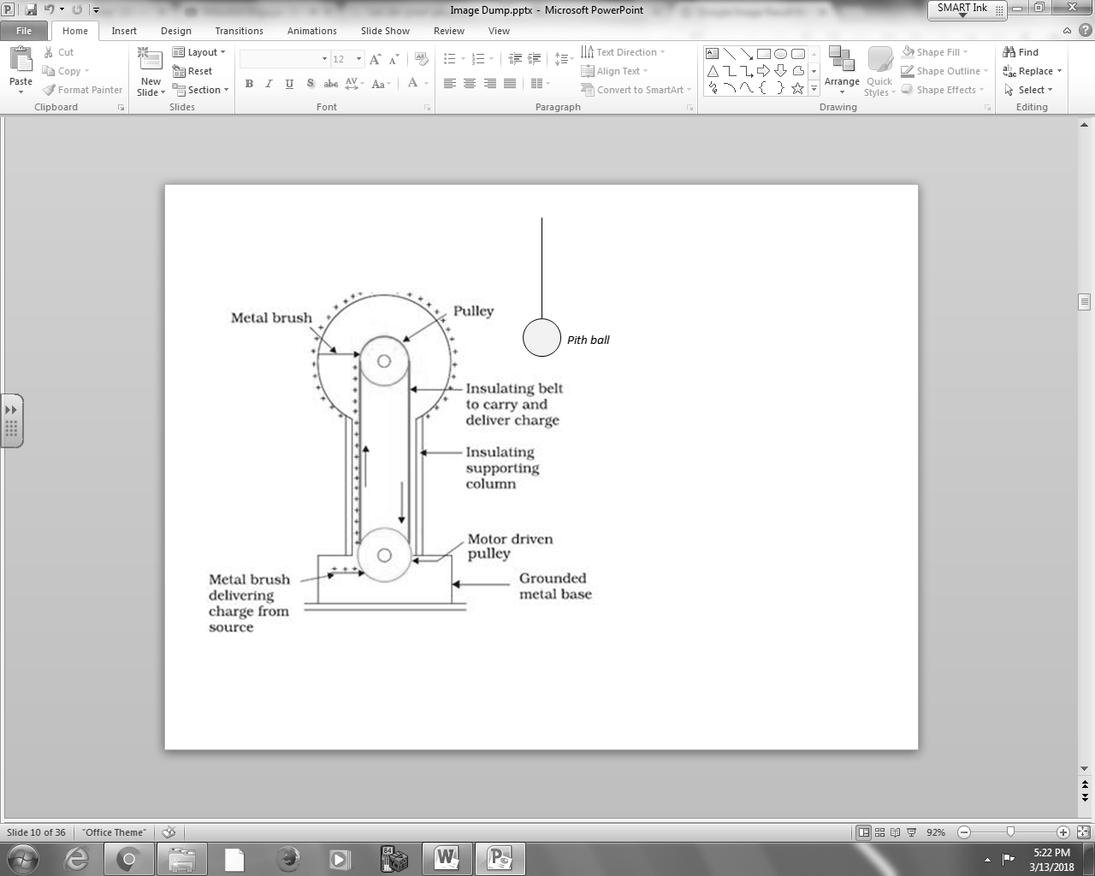

Q2: In the diagram above, when the Van Der Graff generator is initially turned on, the pith ball will be __i__ the dome due to __ii__.
 | i. | ii.
A. | attracted to | conduction
B. | attracted to | induction
C. | repelled from | conduction
D. | repelled from | induction

Q3: The moment the Van Der Graff generator is turned on, the left side of the pith ball becomes __i__ charged and the right side becomes __ii__ charged.
 | i. | ii.
A. | positively | positively
B. | positively | negatively
C. | negatively | positively
D. | negatively | negatively

L02 – Coulomb’s Law in 1-D
Use the following information to answer Q4-Q5:
Two charges, depicted below, have an electrostatic force of attraction of 5.00 N.
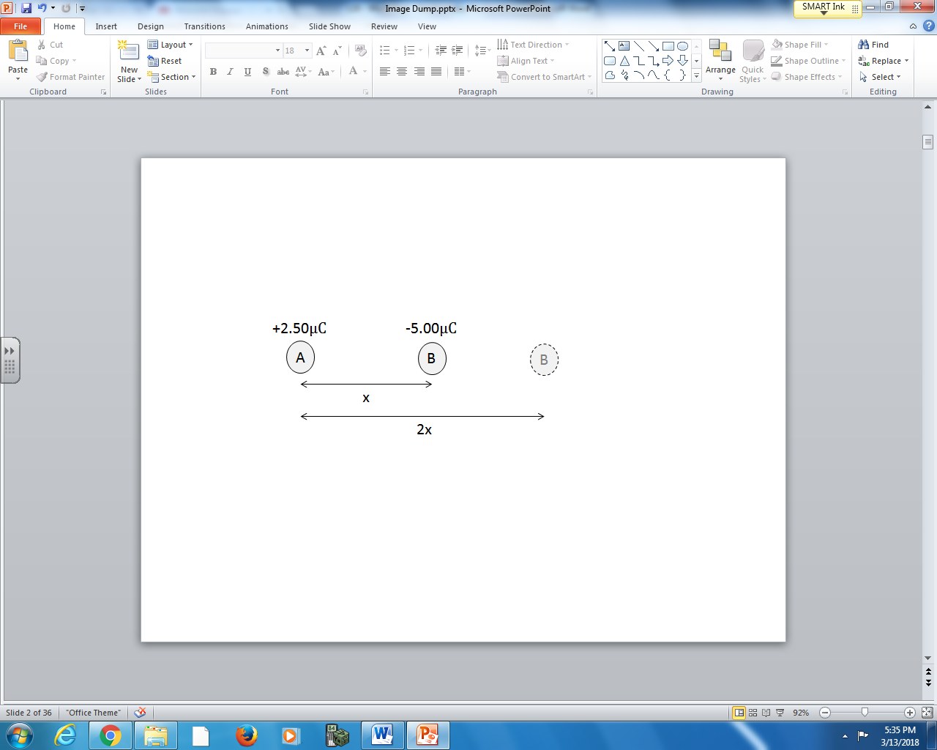

Q4: If Charge B is moved from x to 2x, what is the force of attraction between the two items, measured in Newtons?
(Record your three digit answer in the Numerical Response boxes below)

Q5: At what distance, in meters, will the charges have an electrostatic attraction of 2.00 x 10⁻³ N?
(Record your three digit answer in the Numerical Response boxes below)

Use the following information to answer Q6:
A 20g pith ball hanging on an insulated thread is placed near an electroscope, and the following observation is made:
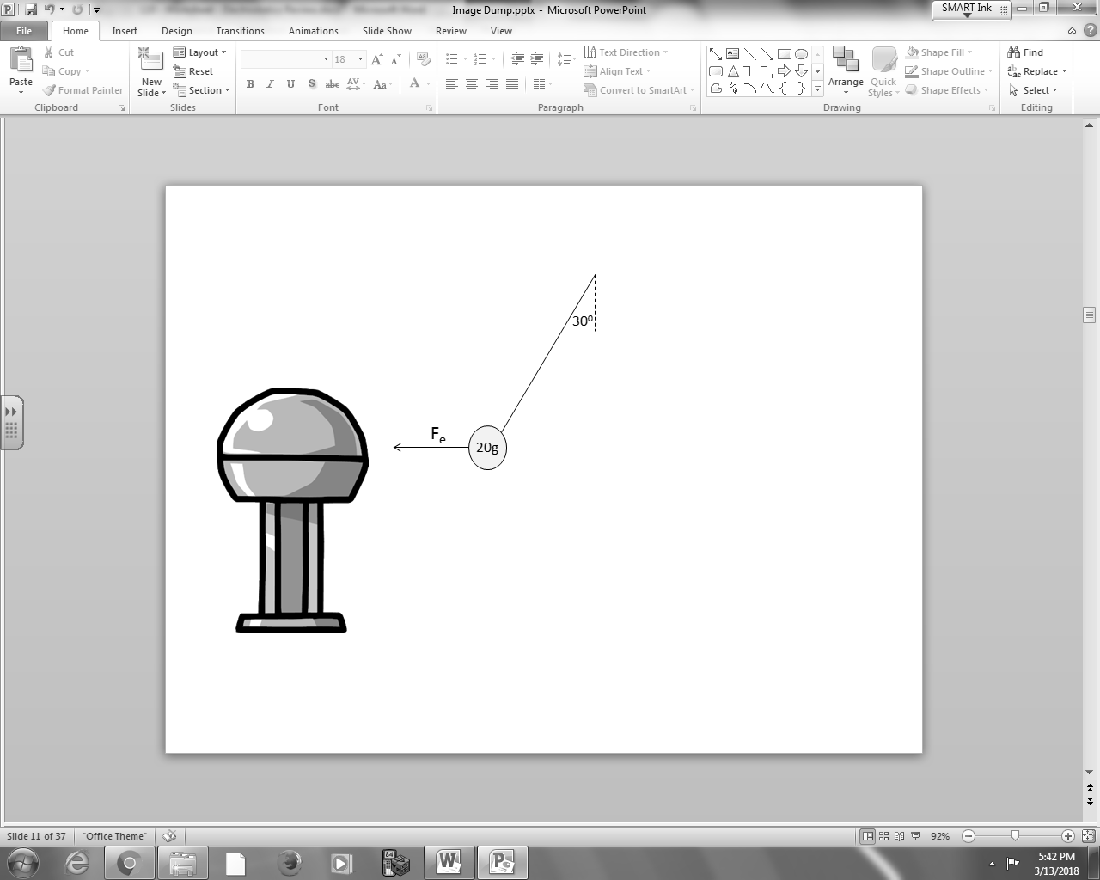

Q6: The electrostatic force of attraction is
- 1.13 x 10⁻¹ N
- 1.96 x 10⁻¹ N
- 2.27 x 10⁻¹ N
- 3.40 x 10⁻¹ N

Use the following information to answer Q7-Q9:
Two conductive spheres are arranged per the diagram below.
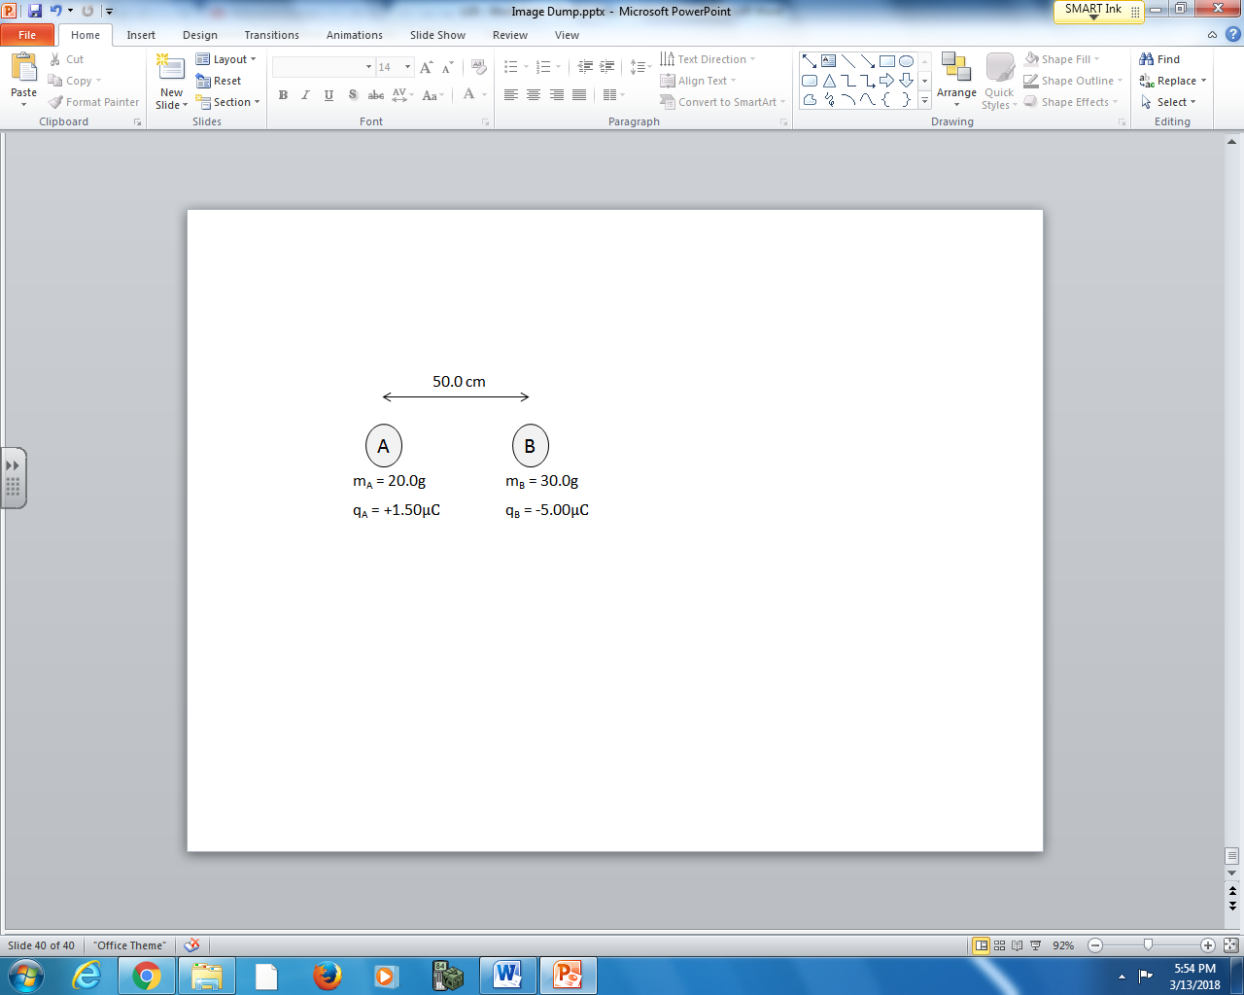
The conductive spheres are momentarily brought into contact, and then returned to their original position. Both items are then released simultaneously.

Q7: The acceleration of Object B is
- 3.67 m/s² [Right]
- 3.67 m/s² [Left]
- 8.99 m/s² [Right]
- 8.99 m/s² [Left]

Q8: When predicting the acceleration of Object B, state the two physics principles you used, in the order you used them.
(Record your two digit answer in the Numerical Response boxes below)

Q9: (Unit 1 question… these won’t be on your Unit 2 summative assessments) Which situation best describes the relative impulses experienced by each object at the moment of release?
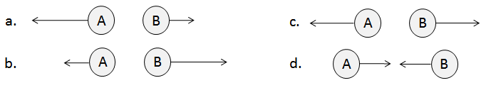
L03 – Coulomb’s Law in 2-D
Use the following to answer Q10:
Three point charges are arranged per the diagram below:
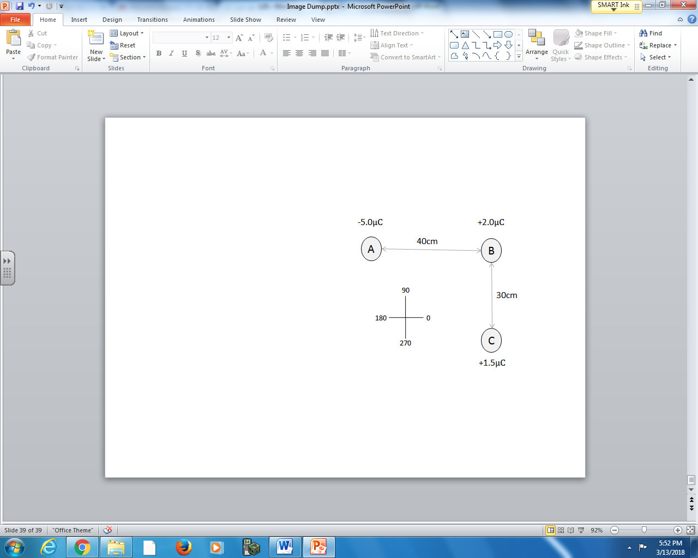

Q10: Charge B will experience a net force at _____ degrees.
(Record your three digit answer in the Numerical Response boxes below)

L04 – Coulomb’s Law Examined Graphically
Use the following information to answer Q11:
A charge of +4.50μC is placed at various distances from another charge of unknown magnitude. The electrostatic attraction between the two charges was graphed as a function of inverse distance squared.
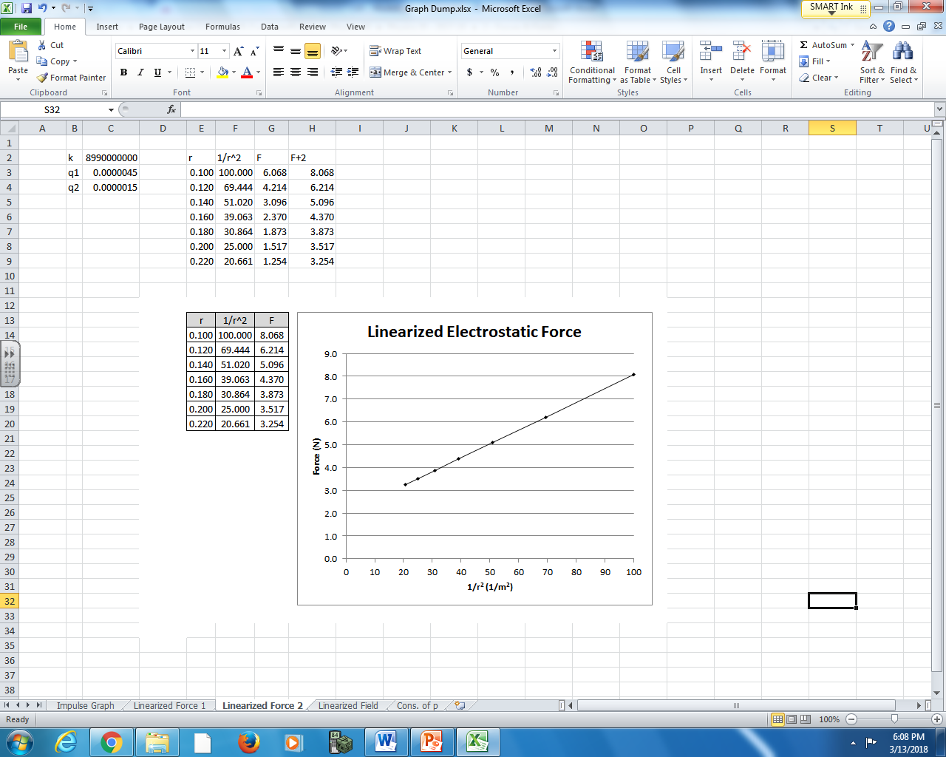

Q11: What is the magnitude and nature of the unknown charge?
- +1.50μC
- -1.50μC
- +1.98μC
- -1.98μC

L05 – Electric Fields
Q12: What is the magnitude and direction of the electric field 12cm from a +8.0μC charge?
- 5.99 x 10⁵ N/C [toward source]
- 5.99 x 10⁵ N/C [away from source]
- 4.99 x 10⁶ N/C [toward source]
- 4.99 x 10⁶ N/C [away from source]

Use the following information to answer Q13-Q14:
Two charges are oriented per the diagram below.
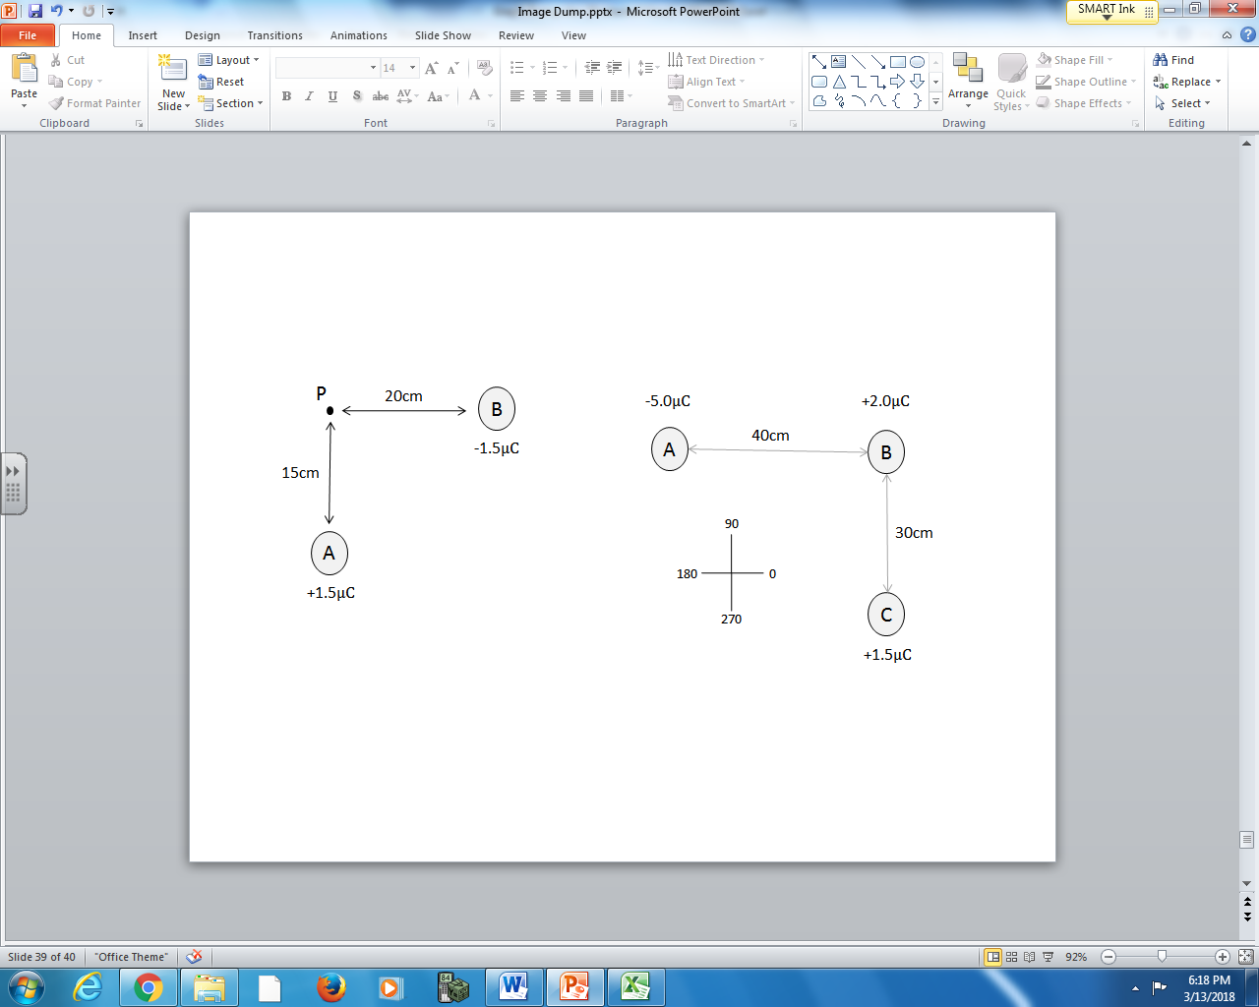
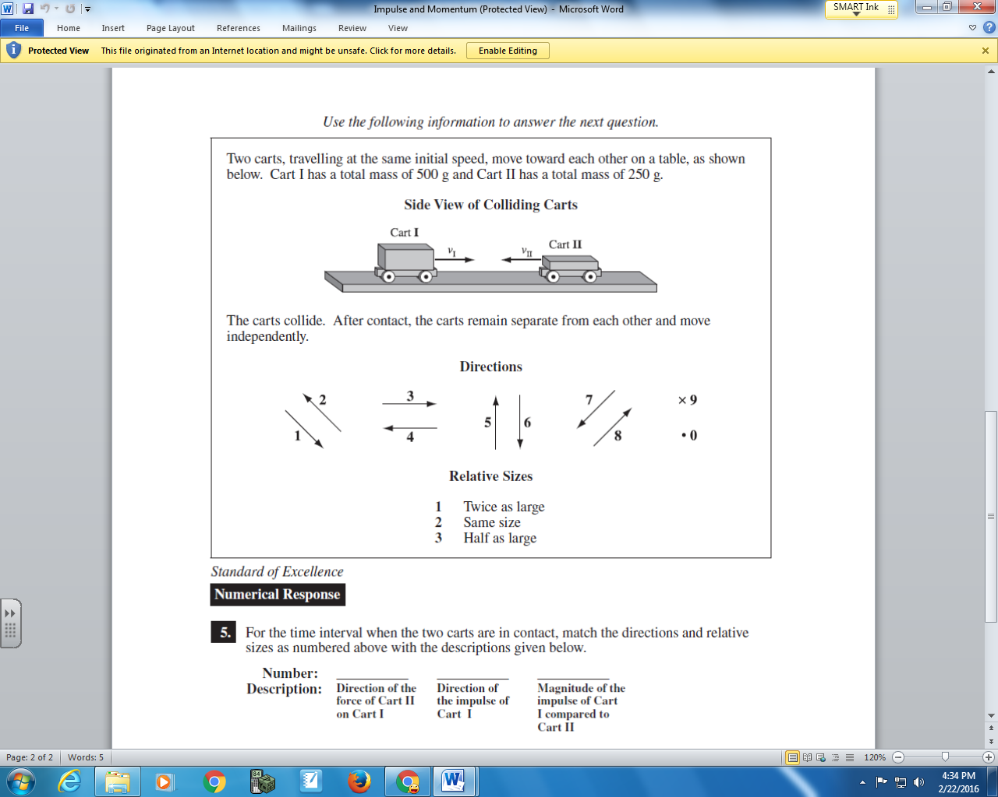

Q13: Match the directions as numbered above with the descriptions given below.
Number: __________ __________ __________
Description: Direction of Direction of Direction of
electric field electric field net electric
due to Charge A due to Charge B field at Point P
(Record your three digit answer in the Numerical Response boxes below)

Q14: The magnitude of the net electric field at Point P is a.bc x 10^{d} N/C, where a, b, c, and d are ___, ___, ___, and ___.
(Record your four digit answer in the Numerical Response boxes below)

L07 – Parallel Plates
Use the following information to answer Q15-Q16:
Parallel Plates
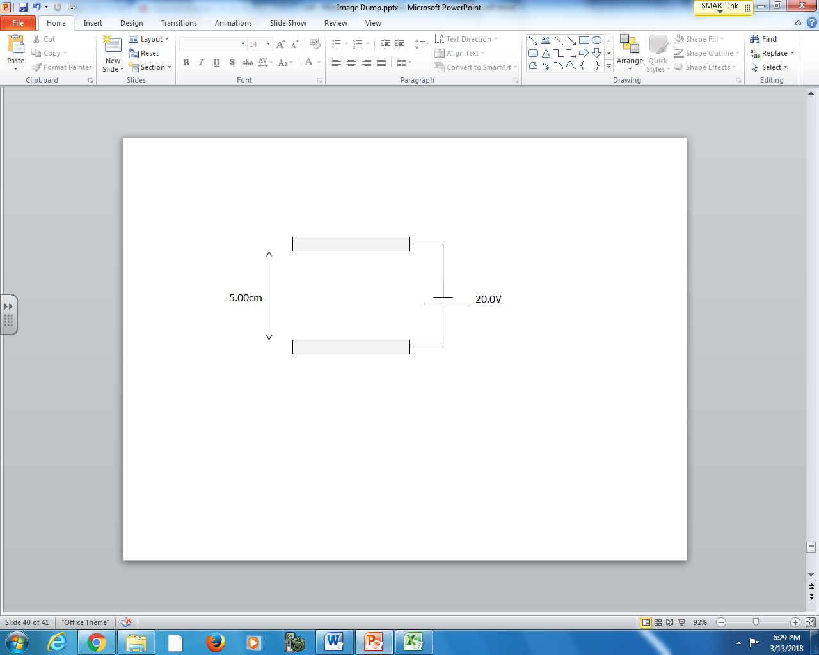

Q15: Match the directions as numbered above with the descriptions given below.
Number: _____________ __ _____________ __ _______________
Description: Direction of electric Direction of force Direction of force
field lines between acting on a proton acting on an electron
the plates between the plates between the plates
(Record your three digit answer in the Numerical Response boxes below)

Q16: The magnitude of the electric field between the plates is a.bc x 10^{d} N/C, where a, b, c, and d are ___, ___, ___, and ___.
(Record your four digit answer in the Numerical Response boxes below)

L08 – Parallel Plates and Projectile Motion
Use the following information to answer Q17:
A proton is injected into parallel plates with an initial velocity of 2.50 x 10⁶ m/s, as depicted below.
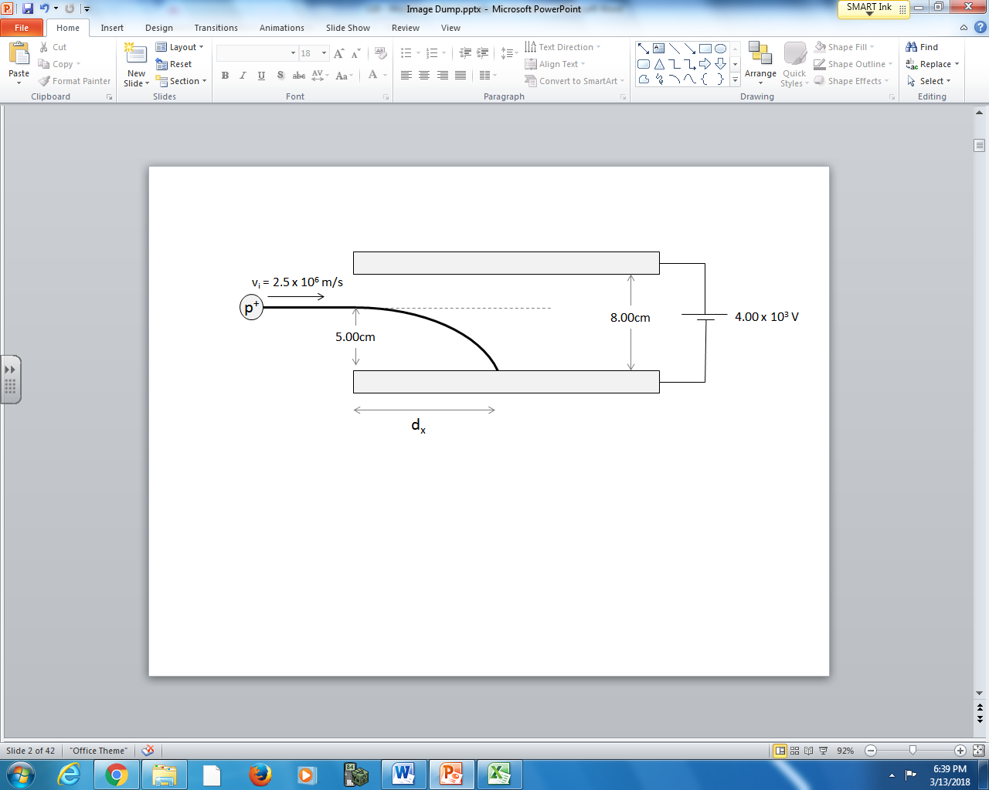

Q17: The proton travels a horizontal distance of a.bc x 10^{-d} m before colliding with the lower plate, where a, b, c, and d are ___, ___, ___, and ___.
(Record your four digit answer in the Numerical Response boxes below)

L09 – Parallel Plates and Conservation of Energy
Use the following information to answer Q18-Q19:
A proton is placed on the positive plate of a set of parallel plates. When released, it accelerates downward and collides with the lower plate.
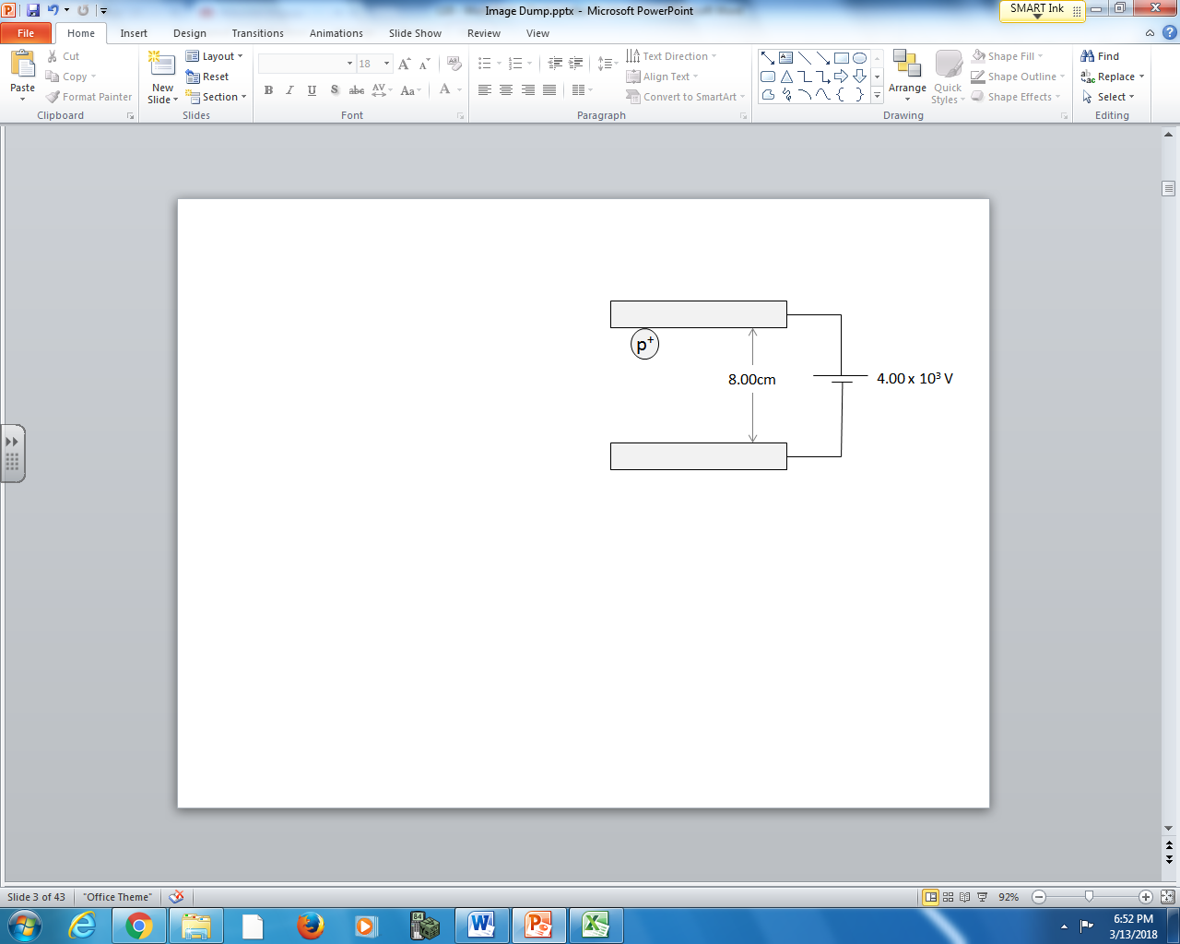

Q18: The proton has a speed of a.bc x 10^{d} m/s when it collides with the lower plate, where a, b, c, and d are ___, ___, ___, and ___.
(Record your four digit answer in the Numerical Response boxes below)

Q19: The distance between the plates is doubled, while keeping the accelerating voltage the same. The new speed of the proton when colliding with the lower plate is a.bc x 10^{d} m/s, where a, b, c, and d are ___, ___, ___, and ___.
(Record your four digit answer in the Numerical Response boxes below)

