First Name:______________________________ Last Name:______________________________
L10 – Worksheet – Fission and Fusion
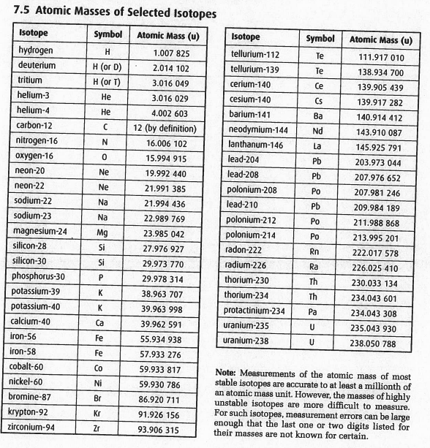

Textbook Questions
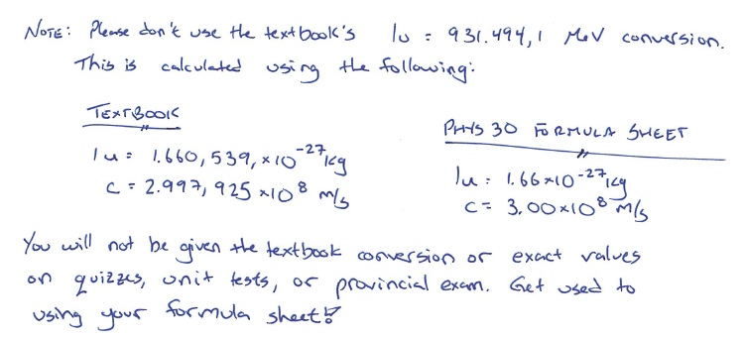
Pg 819 #1: Calculate the energy released by the reaction ${}_{92}^{235}U+{}_{0}^{1}n→{}_{40}^{94}{Zr}+{}_{52}^{139}{Te}+3{}_{0}^{1}n$.

Pg 819 #2: A uranium-235 nucleus absorbs a neutron and then splits into a bromine nucleus (${}_{35}^{87}{Br}$), a lanthanum nucleus (${}_{57}^{146}{La}$), and additional neutrons. How many neutrons are released in this fission reaction? Express this reaction as a balanced equation.

Pg 819 #3: How much energy is released in the reaction in question 2?

Pg 824 #1: (a) Complete this nuclear reaction: ${}_{92}^{235}U→{}_{54}^{140}{Xe}+?+2{}_{0}^{1}n$
(b) Does this reaction involve fission or fusion? Justify your answer.

Pg 824 #2: What happens to the binding energy per nucleon in a nuclear reaction that releases energy?

Pg 824 #5: A neutron is emitted when aluminium-27 absorbs an alpha particle.
- What isotope does this reaction create?
- Write the process for the reaction.

Pg 824 #7: (a) What particle is emitted when deuterium (${}_{1}^{2}H$) and tritium (${}_{1}^{3}H$) fuse to form helium?
(b) How much energy does this reaction release?

