First Name:__________________________________ Last Name:______________________________

L10 – Worksheet – Pulleys and Blocks /12 marks

Part 1: Systems with Pulleys
Use the following information to answer Q1:
An observer notices that the 10kg block is moving downward at a constant speed.

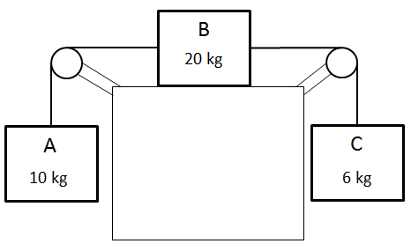

Q1: (Long Answer) What is the coefficient of kinetic friction between the 20kg block and the table? (3 marks)
Use the following information to answer Q2 – Q4:
System of Masses with a Pulley

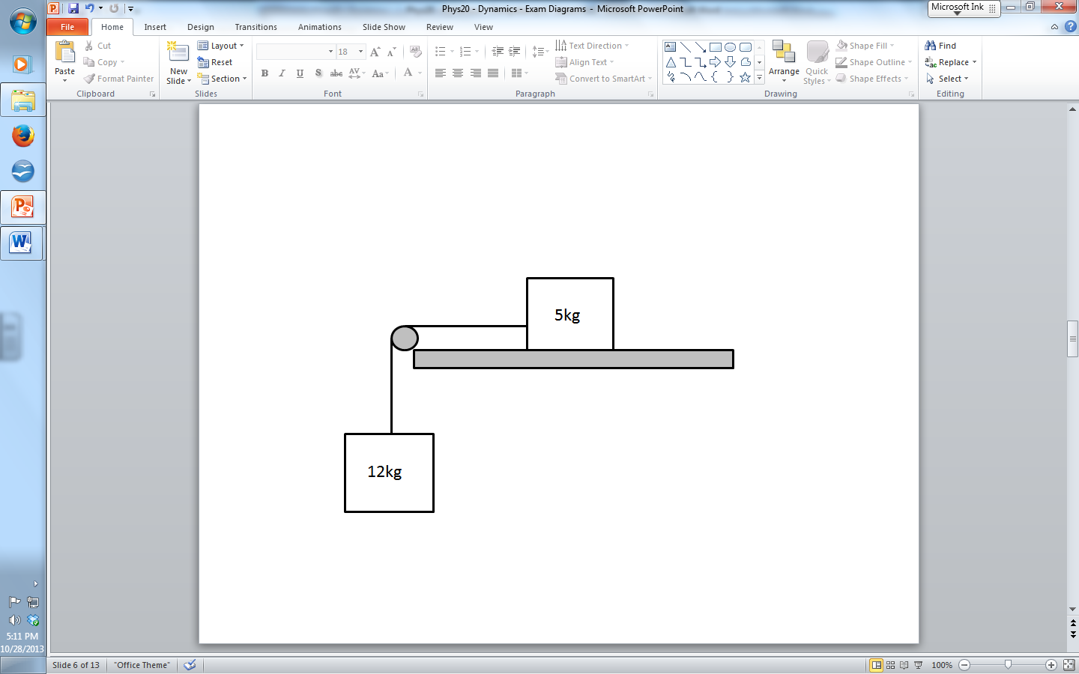

The coefficient of kinetic friction between the blocks and the table is 1.20.
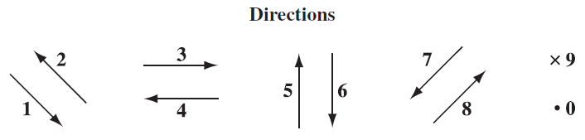

Q2: The directions of force and force components can be described using the numbers given above.
Direction: __________ __________ __________ __________
Force: Normal Force Friction on 5kg Direction of Direction of Force
on 5kg Box acceleration of of Tension on
the 12kg block 12kg block
(Record your four digit answer in the Numerical Response boxes below)

Q3: What is the acceleration of the system?
- 3.46 m/s²
- 4.91 m/s²
- 6.92 m/s²
- 11.8 m/s²

Q4: The tension in the rope is a.bc x 10^{d} N, where a, b, c, and d are ___, ___, ___, and ___.
(Record your four digit answer in the Numerical Response boxes below)

Part 2: Blocks Pushing Blocks
Use the following information to answer Q5 and Q6:
A person applies an unknown force to Block A, accelerating the entire system at a rate of 0.65 m/s². Block A has a mass of 50kg, and Block B has a mass of 120kg, and the coefficient of friction between the blocks and the floor is 0.38.
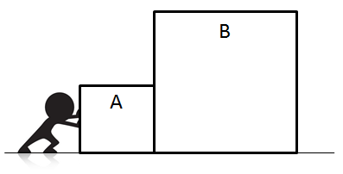

Q5: In order to accelerate the system at a rate of 0.65 m/s², the person must have applied a force of
- 110.5 N
- 296.9 N
- 523.2 N
- 744.2 N

Q6: The force that Block B applies to Block A is
- 78.0 N
- 369.3 N
- 525.3 N
- 711.7 N

Use the following information to answer Q7:
Contrasting Systems of Masses
Systems with Pulleys  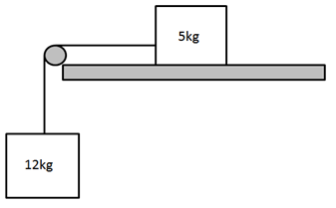 | Blocks pushing Blocks
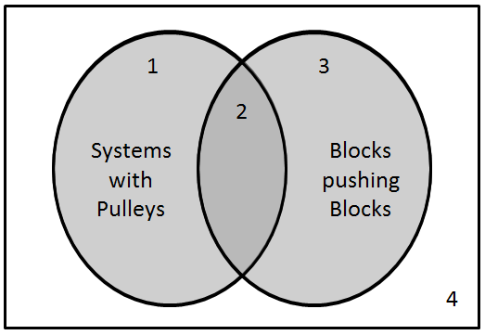

Q7: Match the numbers of the regions in the Venn diagram above with the descriptions given below.
Region: __________ __________ __________ __________
Description: The entire system The entire system Friction acts on Internal forces
and individual items and individual items all items in the between items can accelerate at the accelerate in the system. be described as
same rate. same direction. “pulls” rather than
“pushes”.
(Record your four digit answer in the Numerical Response boxes below)

Use the following information to answer Q8:
A person pushes a series of boxes with a force of 200 N [Right]. Assume that the surface is frictionless.
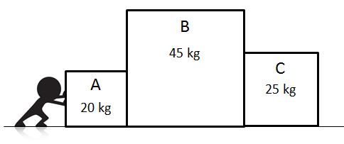

Q8: (Long Answer) What is the force (magnitude and direction) that Block A applies to Block B? (3 marks)

