First Name:___________________________ Last Name:_____________________________

L11 - Adding Vectors in 2-Dimensions – Formative Quiz

Use the following information to answer Q1-Q3:

A bank robber sprints 50m [40⁰ N of E] through a park, then turns and runs 200m [E]
down an alley before being tackled by Batman.

Q1: When running through the park, which best describes the x- and y-component of the robber’s displacement?
 | x-component | y-component
A. | +0 | +200
B. | +200 | +0
C. | +32.14 | +38.30
D. | +38.30 | +32.14

Q2: The total distance the robber ran is
- 240.5 m
- 250.0 m
- 260.8 m
- 270.4 m

Q3: If Batman had glided from the robber’s initial position directly to the robber’s final position, then Batman would have to glide at an angle of ___ degrees North of East.
(Record your three-digit answer in the Numerical Response boxes below)

Use the following information to answer Q4:
A swimmer needs to cross a river as quickly as possible. The swimmer’s speed in still water is 1.35m/s. The river’s current speed is 0.60m/s and the river is 106.68m wide. The swimmer swims so that his body is pointed horizontally while crossing, and the current carries him downstream.
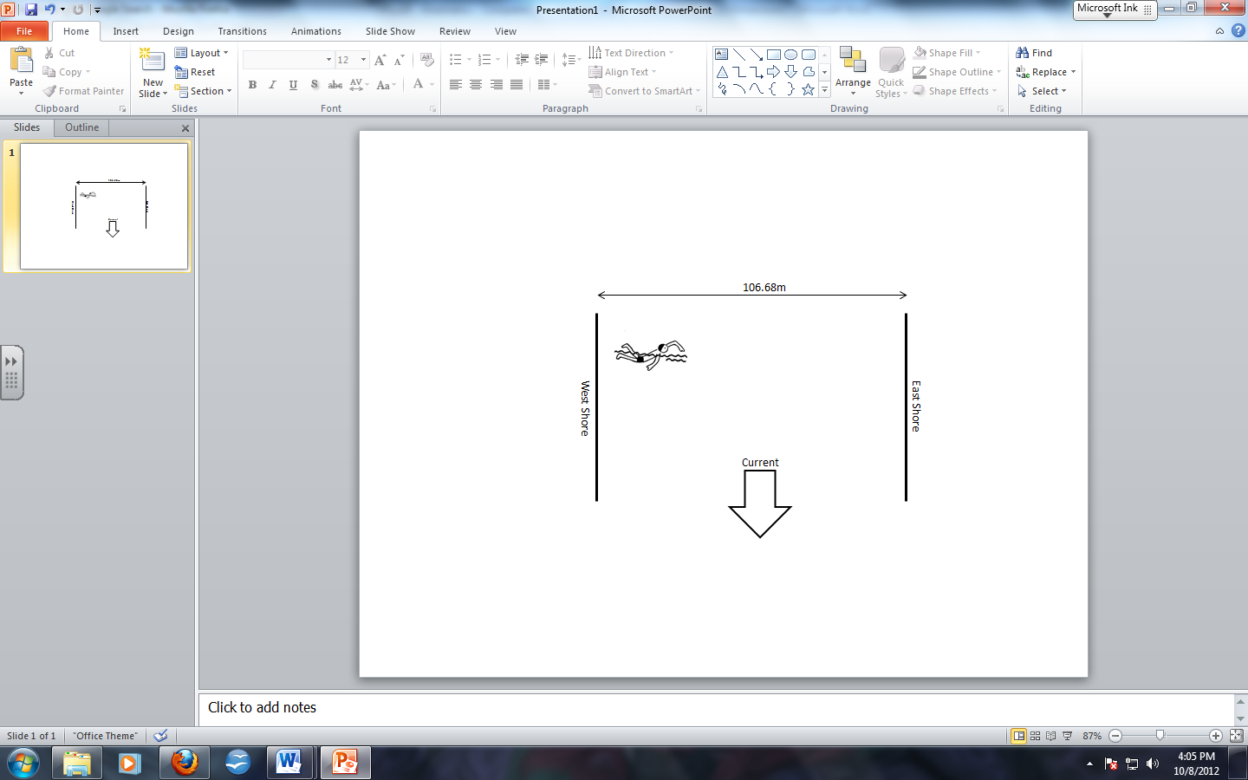

Q4: The swimmer’s net velocity, relative to the shore, is a.b m/s [ef ⁰ S of E], where a, b, e, and f are ___, ___, ___, and ___.
(Record your four-digit answer in the Numerical Response boxes below)

Q5: John jogs at 2.6 m/s [30⁰ N of E] for 100 seconds, then turns and runs at 5.4 m/s [80⁰ N of E] for 60 seconds. What is John’s total displacement? (2 marks)

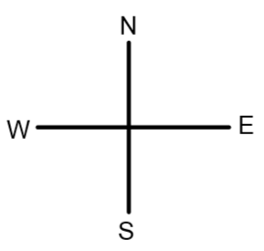



MARKING
Beginning 0.0 – 3.0
Progressing 3.5 – 4.5
Competent 5.0 – 6.5
Exemplary 7.0

