First Name:_______________________________ Last Name:______________________________

L11 - FQ – Circular Motion (Horizontal Systems)

Use the following information to answer Q1-Q3:
A toy car is on a horizontal circular track of radius 3.80 meters, travelling at a constant 1.75 m/s. If the car speeds up even a little, it flies off of the track.

Q1: The coefficient of friction between the toy car’s tires and the track is a.bc x 10^{-d}, where a, b, c, and d are ___, ___, ___, and ___.
(Record your four digit answer in the Numerical Response boxes below)

Q2: The acceleration of the toy car is
- 0.00 m/s²
- 0.46 m/s²
- 0.81 m/s²
- 2.17 m/s²

Q3: The frequency of rotation of the car is a.bc x 10^{-d} Hz, where a, b, c, and d are ___, ___, ___, and ___.
(Record your four digit answer in the Numerical Response boxes below)

Use the following information to answer Q4-Q5:
A rubber stopper is spun around a pen tube in a horizontal circle, as depicted below. The period of rotation is 0.65 seconds.
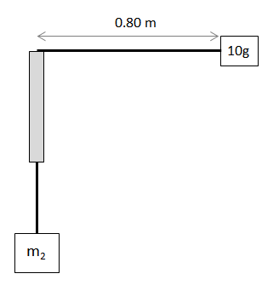

Q4: Text

Q4: What is the mass of the hanging object, in grams? (2 marks)

MARKING:
Beginning: 0.0 – 2.0
Progressing 2.5 – 3.0
Competent 3.5 – 4.5
Exemplary 5.0

