First Name:____________________________ Last Name:______________________________

L11 – FQ – Fission and Fusion

Use the following information to answer Q1-Q2:
Binding Energy per Nucleon
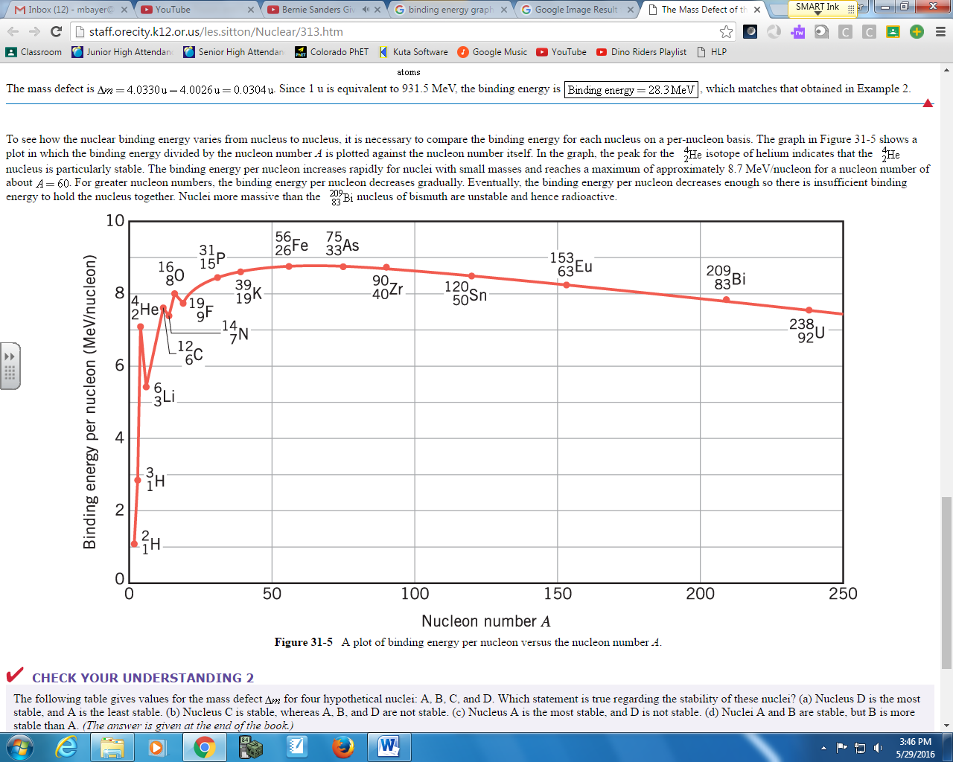

Q1: Using the graph above, what is the approximate binding energy per nucleon for Iron-56?
- 1.2 MeV
- 8.8 MeV
- 67.2 MeV
- 492.8 MeV

Q2: Which of the following nuclei is the most tightly bound?
- Hydrogen-2
- Lithium-6
- Bismuth-209
- Uranium-238
Q3: Which isotope below has the highest nuclear binding energy per nucleon?
- ${}_{2}^{4}{He}$ b. ${}_{16}^{32}S$ c. ${}_{25}^{55}{Mn}$ d. ${}_{56}^{137}{Ba}$

Q4: Which of the following statements is incorrect?
- Mass defect is the amount of matter that would be converted into energy if a nucleus were formed from initially separated protons and neutrons.
- Nuclear binding energy is the energy released in the formation of an atom from subatomic particles.
- Nuclei with the highest binding energies are the most stable nuclei.
- Mass number is the sum of all protons and electrons in an atom.

Q5: Which of the following describes what occurs in the fission process?
- A heavy nucleus is fragmented into lighter ones.
- Two light nuclei are combined into a heavier one.
- A proton is split into three quarks.
- A particle and anti-particle appear in the area of high energy density.

Q6: When ²³⁵U is bombarded with one neutron, fission occurs and the products are three neutrons, ⁹⁴Kr, and which of the following?
- ¹³⁹Ba
- ¹³⁹Ce
- ¹³⁹Xe
- ¹⁴¹Ce

MARKING:
Beginning 0 - 2
Progressing 3 - 4
Competent 5
Exemplary 6

