First Name:____________________________ Last Name:______________________________

Physics 30 - Momentum – Practice Unit Test

Part 1: Momentum and Impulse ___ / 8 * 1.25 = ___ / 10
Part 2: Collisions in 1-Dimension and 2-Dimensions ___ / 8

IMPORTANT:
- Show work for MULTIPLE CHOICE questions for a possible part mark.
- Show work for NUMERIC RESPONSE questions to get the full 2 or 3 marks.
Part 1: Momentum and Impulse – 8 marks
Q1: Which of the following statements best describes an isolated system?
(MULTIPLE CHOICE – 1 mark)
- No external forces act on an isolated system
- Only gravitational forces act on an isolated system
- Momentum is always conserved in an isolated system
- Kinetic energy is always conserved in an isolated system

Use the following information to answer questions Q2 and Q3:
As a child catches a ball, he exerts a force , F, on the moving ball for a time interval, ∆t. The mass of the ball is 250g and its velocity changes from +5.00 m/s to +1.00 m/s as a result of the force.

Q2: The magnitude of the impulse that the child applies to the ball is:
(MULTIPLE CHOICE – 1 mark)
- 1.00 Ns
- 1.25 Ns
- 2.50 x 10² Ns
- 1.00 x 10³ Ns

Q3: If, when catching the ball, the child had applied triple the force, then the length of time that it would have taken to slow the ball would have been:
(MULTIPLE CHOICE – 1 mark)
- 9∆t
- 3∆t
- $\frac{1}{3}∆t$
- $\frac{1}{9}∆t$
Use the following information to answer question Q4.
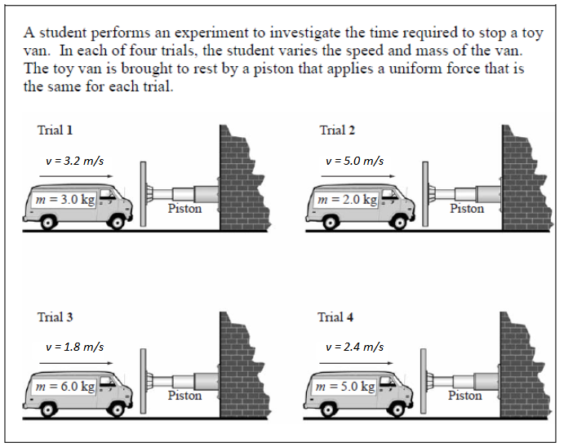
Q4: When the trials above are listed in order from the trial that has the longest stopping time to the trial that has the shortest stopping time, the order is
__________, __________, __________, __________
LONGEST SHORTEST
(Record all four digits of your answer in the numerical-response section below)
(NUMERIC RESPONSE – 2 marks)

Use the following Force-Time graph to answer question Q5.
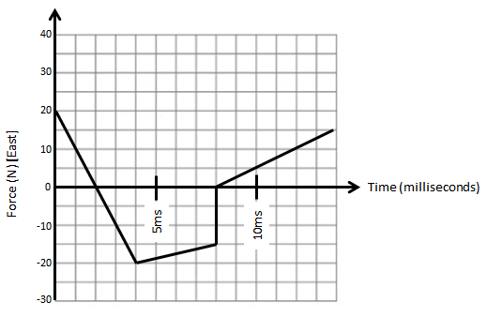
Q5: What is the magnitude of the impulse acting on this object?
(MULTIPLE CHOICE – 1 mark)
- - 20 Ns [E]
- 5 Ns [W]
- 1.15 x 10⁻¹ Ns [E]
- 2.50 x 10⁻² Ns [W]
Use the following information to answer question Q6.
A particular supertanker is fully loaded with oil and has a mass of 1.00 x 10⁹ kg. The supertanker has a cruising speed of 20km/h. One way to stop the ship is to reverse its engines. At maximum reverse thrust, the ship takes 32.0 min to stop.

Q6: The momentum of the supertanker at cruising speed, expressed in scientific notation, is b x 10^{w} kg*m/s. The value of b is _____________.
(Record your three-digit answer in the numerical-response section below)
(NUMERIC RESPONSE – 2 marks)

Part 2: Collisions in 1-Dimension and 2-Dimensions – 8 marks
Use the following diagram of an AK-47 assault rifle firing a bullet into a ballistic pendulum to answer questions Q7, Q8, and Q9.
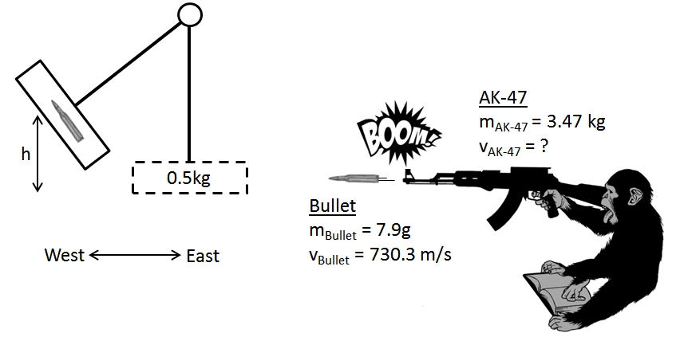
Q7: The AK-47 recoils backward at what speed? (NUMERIC RESPONSE - 2 marks)

Q8: The bullet embeds itself into the 0.5kg block. At the moment of impact, momentum is _i__ and kinetic energy is _ii__. (MULTIPLE CHOICE – 1 mark)
 | i | ii
A | Conserved | Conserved
B | Conserved | Not Conserved
C | Not Conserved | Conserved
D | Not Conserved | Not Conserved

- A b) B c) C d) D

Use the following diagram of an AK-47 assault rifle firing a bullet into a ballistic pendulum to answer questions 1-3.
Q9: After impact, the pendulum swings forward and rises to what height?
(NUMERIC RESPONSE – 2 marks)

Use the following diagram and information to answer question Q10.
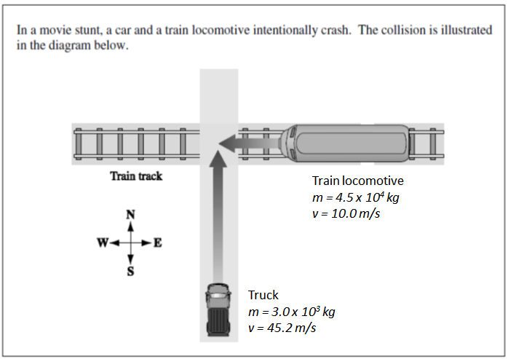
Q10: The magnitude of the momentum of the car-train system immediately before the collision, expressed in scientific notation, is a.b x 10^{C} kg*m/s. You will need to record the values of a and b.
The direction of the momentum of the car-train system immediately before the collision is ef degrees, north of west. You will need to record the values of e and f.
The values of a, b, e, and f are ____, ____, ____ and ____.
a b e f
(Record all four digits of your answer in the numerical-response section below)
(NUMERIC RESPONSE – 3 marks)

Q10: Room for students to show work.

