First Name:______________________________ Last Name:______________________________
L11 – Worksheet – EMR as Waves
L01 - EMR
Q1: An electromagnetic wave travels vertically upward, perpendicular to Earth’s surface. If the magnetic field component of the wave oscillates in a north-south direction, then the electric field component will oscillate in
- An east-west direction
- A north-south direction
- A vertically upward direction
- A vertically downward direction.

Use the following information to answer Q2:
Types of EMR
1 Blue light
2 Gamma radiation
3 Radio waves
4 Ultraviolet radiation

Q2: When the types of EMR above are listed in order from the lowest frequency to the highest frequency, the order is ___, ___, ___, ___.
(Record you four-digit answer in the numerical response boxes below.)

Use the following information to answer Q3-Q4:
Radio Telescopes
Radio telescopes detect radio waves emitted by objects throughout the universe. They do not detect the visible light from stars and galaxies.
The Dominion Radio Astrophysical Observatory (DRAO), located in Penticton, BC, has a seven-antenna radio telescope. Using signals from this telescope, DRAO produces detailed wide-angle pictures of the radio sky.
One of the radio waves that this telescope can detect has a frequency of 1.420 MHz that comes from an arm of the Milky Way Galaxy that is 7.00 x 10¹⁸ km away.

Q3: The amount of time, in days, that it takes the radio waves detected by the telescope to reach Earth is
- 2.7 x 10⁸ days
- 6.5 x 10⁹ days
- 2.3 x 10¹³ days
- 2.0 x 10¹⁸ days

Q4: DRAO is located in a basin surrounded by mountains, which shield it from manmade radio waves that interfere with astronomical signals. Manmade radio waves are produced by
- Radioactive decay
- Electron transitions in atoms
- Oscillating charges in a linear antenna
- High speed electrons stopped suddenly by a metal surface

Use the following information to answer Q5:
In 1991, the 18.0 GHz region of the electromagnetic spectrum was used to provide communication links in local area networks (LANs). This led to a dramatic expansion of this region’s commercial use.

Q5: The wavelength of an 18.0 GHz wave, expressed in scientific notation, is a.bc x 10^{-d} m, where a, b, c, and d are ___, ___, ___, and ___.
(Record you four-digit answer in the numerical response boxes below.)

Q6: The correct order of electromagnetic radiation, listed in order of lowest to highest frequency, is
- Radio waves, x-rays, infrared
- Visible, ultraviolet, radio waves
- Microwaves, ultraviolet, x-rays
- Radio waves, ultraviolet, infrared

Q7: The direction of electromagnetic wave propagation is
I | parallel to the electric field
II | perpendicular to the electric field
III | parallel to the magnetic field
IV | perpendicular to the magnetic field
The correct combination of choices is
- I only
- III only
- I and III only
- II and IV only

L02 – Speed of Light
Use the following information to answer Q8:
Michelson used a rotating octagonal mirror to measure the speed of light. Below is a smaller scale version of this experiment.
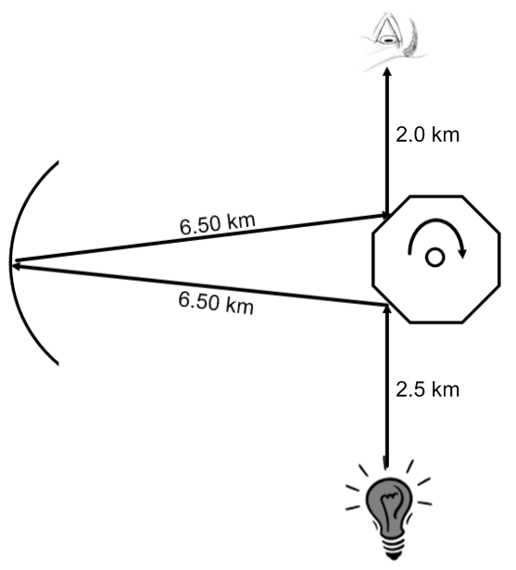

Q8: In the diagram above, light is first observed when the minimum rotational frequency of the octagonal mirror, written in scientific notation, is b x 10^{w} Hz. The value of b is _______.
(Record you three-digit answer in the numerical response boxes below.)

L03&04 – Reflection Ray Diagrams and Equations
Use the following information to answer Q9:
A concave mirror, its central axis, and an object are shown in the diagram below.
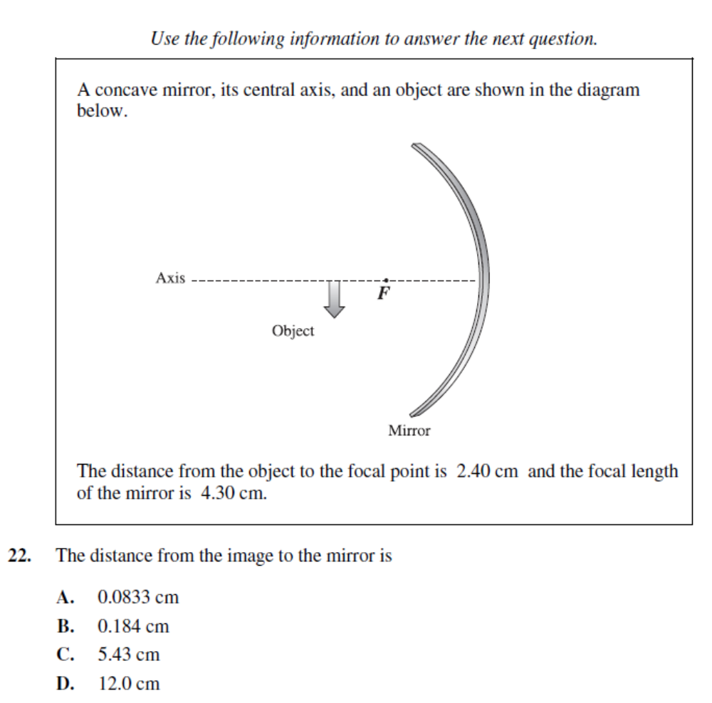
The distance from the object to the focal point is 2.40 cm and the focal length of the mirror is
4.30 cm.

Q9: The distance from the image to the mirror is
- 0.0833 cm
- 0.184 cm
- 5.43 cm
- 12.0 cm

Use the following information to answer Q10:
An object is places 1.5f from a convex mirror, as depicted below.
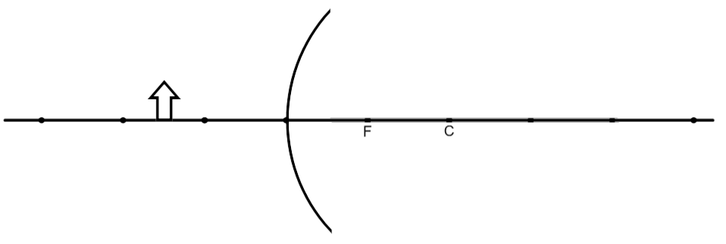

Q10: Which of the following statements best describe the image?
I | The image is real
II | The image is virtual
III | The image is enlarged
IV | The image is diminished
V | The image is erect
VI | The image is inverted

- I, III, V
- II, IV, VI
- I, III, VI
- II, IV, V

L05 - Refraction
Use the following information to answer Q11:
The properties of diamond and popular diamond substitutes are listed in the table below.
Stone | Cubic zirconia | Synthetic corundum | Zirconium silicate | Diamond
Hardness (Mohs) | 8.5 | 9 | 7.5 | 10
Density (g/cm³) | 5.5 – 5.9 | 4.02 | 4.6 – 4.7 | 3.52
Composition | ZrO₂ | Al₂O₃ | ZrSiO₄ | C
Refractive Index | Approximately 2.17 | 1.762 - 1.770 | 1.925 - 1.961 | 2.417

Q11: A stone is observed in air to experience total internal reflection at an angle of 30.85º from the normal. The stone must therefore be:
- Cubic zirconia
- Synthetic corundum
- Zirconium silicate
- Diamond

Use the following information to answer Q12:
A group of students conducts a series of tests to determine which combination of optical media results in the largest critical angle for one wavelength of visible light. The table below lists the index of refraction for each of the media used.
Medium Used | Index of Refraction for this Wavelength of Visible Light
Water | 1.33
Glass | 1.46
Quartz | 1.54
Flint Glass | 1.70

Q12: The largest critical angle for this wavelength of visible light will be produced for the path from
- Glass to quartz
- Quartz to glass
- Water to flint glass
- Flint glass to water
Use the following information to answer Q13 and Q17
A student follows three procedures to study the properties of laser light. She uses a laser that emits monochromatic light that has a wavelength of 634 nm.
 | Procedure | Observation
I | The student first shines the laser light through the crystal that has an index of refraction of 1.53. | The path of the refracted ray is recorded.
II | The student shines the laser light through a diffraction grating that has 5.00 x 10⁵ lines/m. | An interference pattern is projected onto a screen.
III | The student shines the laser light upon a photovoltaic cell that is connected to an ammeter. | No electrical current is measured.

Q13: In procedure I, the wavelength of the laser light in the crystal is _i__. The speed of the laser light in the crystal is _ii_ than its speed in air.
 | i | ii
A. | 4.14 x 10⁻⁷ m | less
B. | 4.14 x 10⁻⁷ m | greater
C. | 9.70 x 10⁻⁷ m | less
D. | 9.70 x 10⁻⁷ m | greater

L06 – Refraction Lenses
Q14: An object is placed 35.0 cm from a diverging lens that has a focal length of 20.0 cm. The image produced is
- Real and larger than the object
- Real and smaller than the object
- Virtual and larger than the object
- Virtual and smaller than the object

Q15: On object of height 3cm is placed 15cm from a converging lens of focal length 12cm. The height of the image is:
- -12cm
- -4cm
- 0.8cm
- 60cm

L07 – Refraction Lenses Graphing and Optics Rails
Use the following information to answer Q16:
A 100-cm meter stick is used to create an optics rail. The candle is placed at a position of 15cm, and the screen at a position of 90cm. The converging lens has a focal length of 18cm.
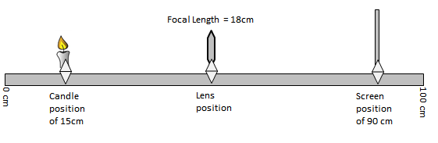
Students discover that there are two different positions that the lens can be placed that create a real, focused image on the screen.

Q16: The two positions that the lens can be placed to create a real, focused image are at ab centimeters, and at cd centimeters, where a, b, c, and d are ___, ___, ___, and ___.
(Record you four-digit answer in the numerical response boxes below.)

L09 – Diffraction, Interference, and Polarization
Use the following information to answer Q13 and Q17:
A student follows three procedures to study the properties of laser light. She uses a laser that emits monochromatic light that has a wavelength of 634 nm.
 | Procedure | Observation
I | The student first shines the laser light through the crystal that has an index of refraction of 1.53. | The path of the refracted ray is recorded.
II | The student shines the laser light through a diffraction grating that has 5.00 x 10⁵ lines/m. | An interference pattern is projected onto a screen.
III | The student shines the laser light upon a photovoltaic cell that is connected to an ammeter. | No electrical current is measured.

Q17: In procedure II, the angle between the central maximum and the first bright spot of the interference pattern is ______º.
(Record you three-digit answer in the numerical response boxes below.)

Use the following information to answer Q18:
In an investigation, a group of students directs light from a laser pointer at a diffraction grating that has a line spacing of 1.67 x 10⁻⁶ m. A series of bright spots appears on a screen placed 1.00 m from the grating. The students measure a distance of 43.9 cm based on the central bright spot and the first order bright spot.

Q18: Based on the students’ measurements, the wavelength of the light emitted by the laser pointer, expressed in scientific notation, is a.bc x 10^{-d} m. The values of a, b, c, and d are ___, ___, ___, and ___.
(Record you four-digit answer in the numerical response boxes below.)

