First Name:____________________________ Last Name:______________________________

L11 – Worksheet - Nuclear Physics Review 24 marks

PART 5 – Period Table
Use the following information to answer Q1:
Selected Elements from the Periodic Table
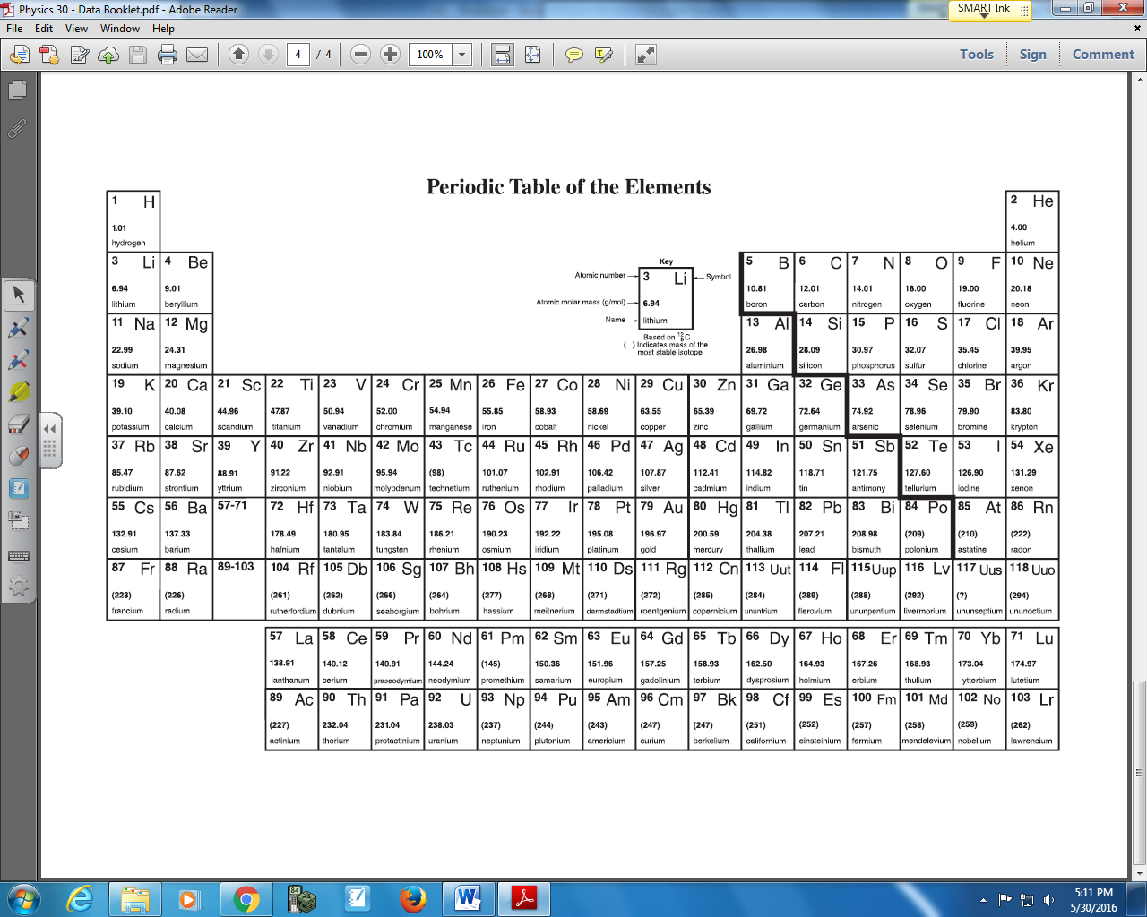

Q1: Boron-11 has __i__ protons and __ii__ neutrons in its nucleus.
 | i | ii
A. | 5 | 5
B. | 5 | 6
C. | 6 | 5
D. | 6 | 6

Q2: What is the approximate mass difference between Carbon-12 and Carbon-14?
- 9.11 x 10⁻³¹ kg
- 1.82 x 10⁻³⁰ kg
- 1.66 x 10⁻²⁷ kg
- 3.32 x 10⁻²⁷ kg

PART 6 – Alpha, Beta, and Gamma Decay
Q3: Which type of radiation would exhibit nodes and antinodes in a modified Young’s double-slit diffraction experiment?
I – Alpha Particles
II – Beta-positive particles
III – Beta-negative particles
IV – Gamma particles
- I and II
- II, III, and IV
- III and IV
- IV only
Use the following information to answer Q4 and Q5:
Household smoke detectors use a sample of 0.30μg of Americium-241. This sample has an activity of 37 kBq, and decays via Alpha-decay. Americium-241 has a half-life of 432.6 years.

Q4: Which of the following statements is false?
- Alpha particles are blocked by the plastic casing.
- Approximately 37,000 alpha particles are emitted per second.
- The radioactive sample is continuously losing mass.
- None of the above.
Q5: Write the radioactive decay for Americium-241.

Q6: When predicting products in a radioactive decay, which two physics principles are necessary?
(Record your two digit answer in the Numerical Response boxes below)

Q7: The most penetrating type of radiation is:
- Alpha
- Beta-negative
- Beta-positive
- Gamma
Q8: Which type of particle is emitted when an up quark changes to a down quark?
- Alpha
- Electron
- Gamma
- Positron
Use the following information to answer Q9:
Stable Isotopes
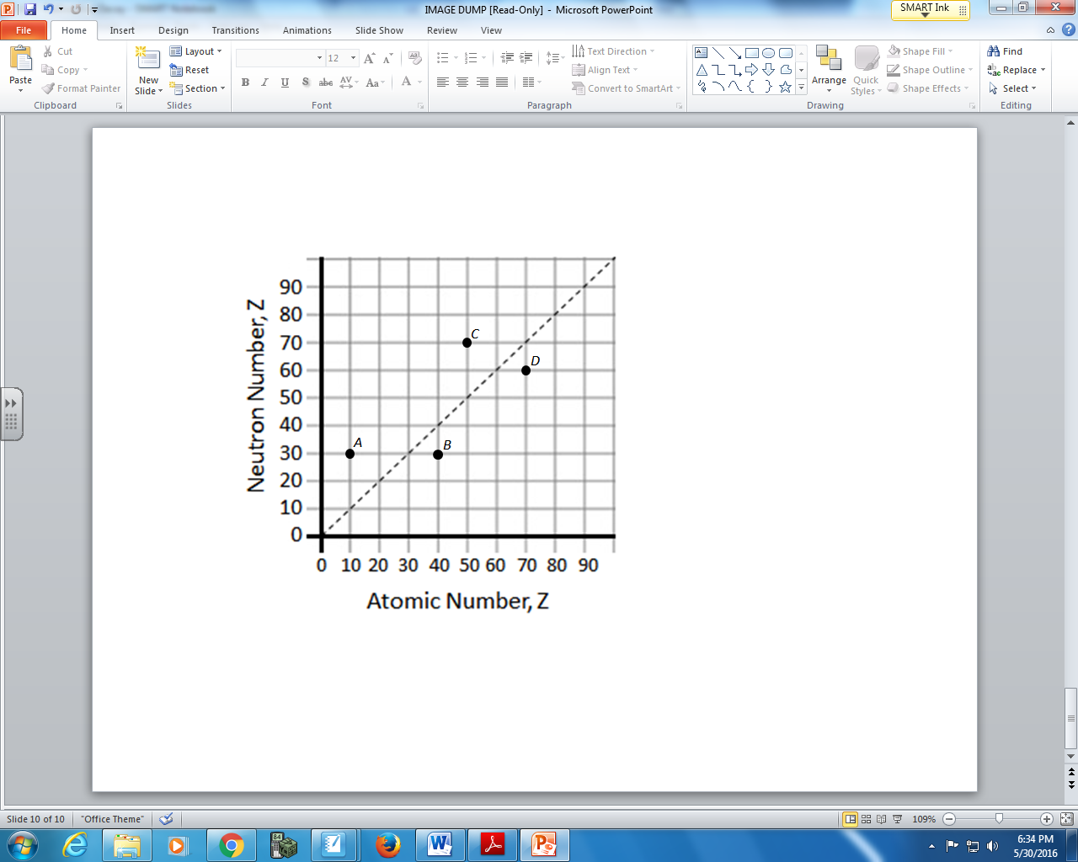

Q9: Which of the following isotopes would be stable?
- Isotope A
- Isotope B
- Isotope C
- Isotope D

Q10: When ⁵⁹Cu undergoes positron emission, what is the immediate nuclear product?
- ⁵⁹Ni
- ⁵⁸Ni
- ⁵⁸Cu
- ⁵⁹Zn
Q11: When ²³⁵U is bombarded with one neutron, fission occurs and the products are three neutrons, ⁹⁴Kr, and ___.
- ¹³⁹Ba
- ¹⁴¹Ba
- ¹³⁹Ce
- ¹³⁹Xe
Use the following information to answer Q12:
There are two possible sequences through which the unstable radioactive nucleus Polonium-218 can decay. They are shown below. The daughter nuclei are labelled 1, 2, 3, and 4.
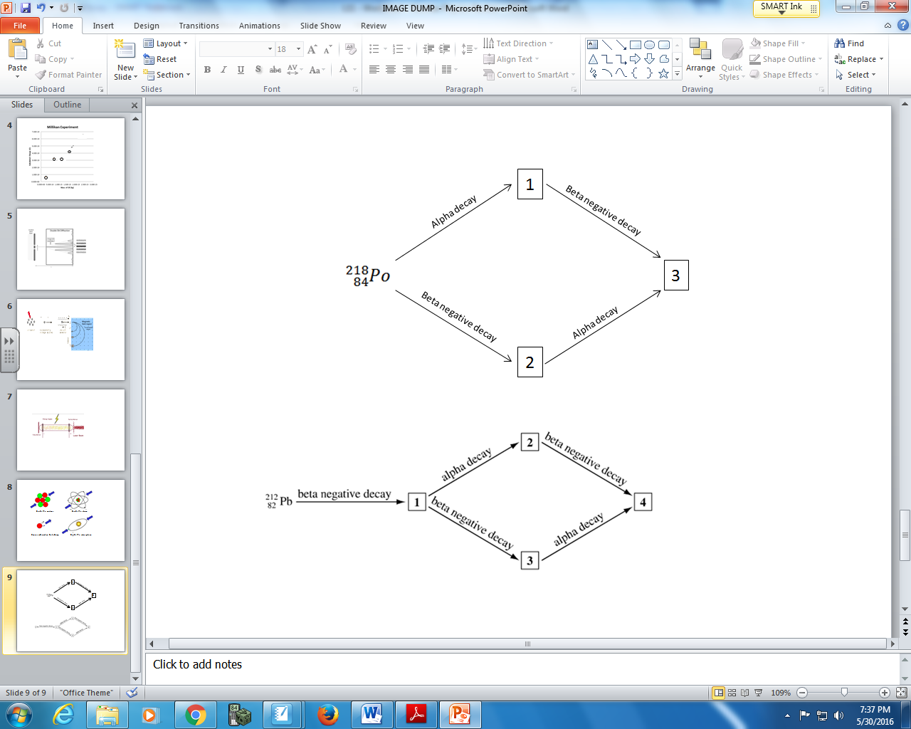

Q12: Match each of the boxed numbers above to the daughter nucleus that it represents, below.
Number: __________ __________ __________
Daughter Nucleus: ²¹⁸ At ²¹⁴ Bi ²¹⁴ Pb
(Record your three digit answer in the Numerical Response boxes below)

PART 7 – Radiation and Magnetic Fields, Cloud Chambers
Use the following information to answer Q13:
Household smoke detectors use a sample of 0.30μg of Americium-241. This sample has an activity of 37 kBq, and decays via Alpha-decay. Americium-241 has a half-life of 432.6 years.
The radioactive sample is placed in a cloud chamber, as depicted below:
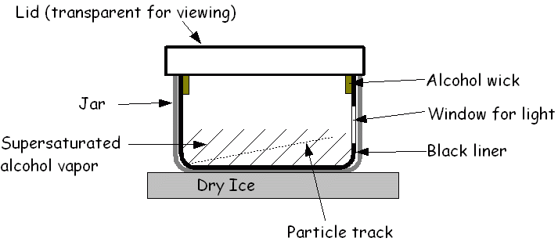
When the charged alpha particle interacts with the mixture, the fluid is ionized. The resulting ions act as condensation nuclei, around which a mist will form. The high energies of alpha particles mean that a trail is left, due to many ions being produced along the path of the charged particle.
A uniform magnetic field is applied across the cloud chamber, as depicted below.
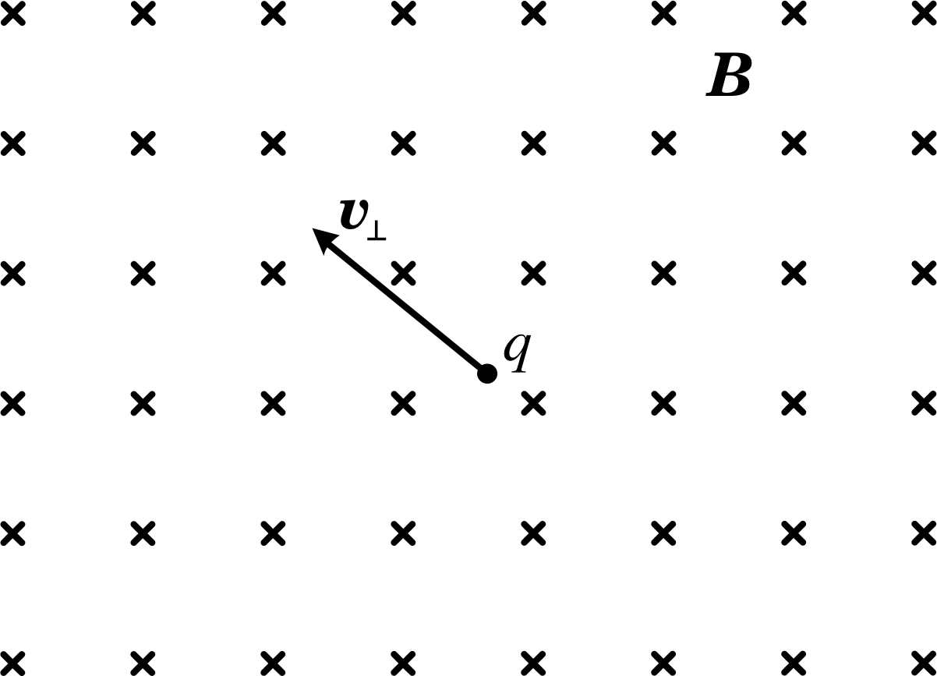

Q13: Explain how the path of the alpha particle would differ from that of Beta-negative radiation in the same cloud chamber.

PART 8 – Half-Life Graphs
Use the following information to answer Q14:
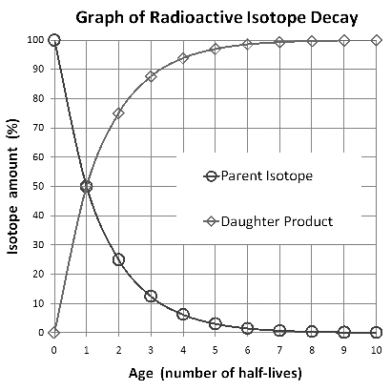

Q14: How many half-lives would it take for only 12.5% of a radioactive isotope to remain?
- ½
- 1
- 2
- 3
Q15: Carbon-14 decays via Beta-negative decay to form Nitrogen-14. If a sample is tested and 25% of the radioactive Carbon-14 is now Nitrogen-14, approximately how many half-lives have passed?
- ½
- 1
- 2
- 3

PART 9 – Half-Life Equations
Use the following information to answer Q16:
Household smoke detectors use a sample of 0.30μg of Americium-241. This sample has an activity of 37 kBq, and decays via Alpha-decay. Americium-241 has a half-life of 432.6 years.

Q16: The activity of the Americium-241 after 1000 years will be a.bc x 10^{d} Bq, where a, b, c, and d are ___, ___, ___, and ___.
(Record your three digit answer in the Numerical Response boxes below)

Q17: At time zero, there are 10.0 grams of W-187. If the half-life is 23.9 hours, then after 7.0 days there will be how much remaining?
- 0.0765 g
- 0.628 g
- 2.48 g
- 4.98 g

PART 10 – Fission, Fusion, Conservation of Mass-Energy, and Matter-Antimatter Annihilation
Use the following information to answer Q18-Q20:
Mass and Energy
Particle | Atomic Mass
Proton | 1.007276 u
Neutron | 1.008665 u
Carbon-14 | 14.003241 u
Rubidium-90 | 89.914802 u
Strontium-89 | 88.907451 u
Cesium-143 | 142.927352 u
Uranium-235 | 235.043924 u

Q18: Carbon-14 has an atomic mass of 14.003241 u. The mass defect of Carbon-14 is a.b x 10^{-cd} kg, where a, b, c, and d are ___, ___, ___, and ___.
(Record your four digit answer in the Numerical Response boxes below)

Use the additional information to answer Q19 and Q20:
The fission of Uranium-235 can occur as follows:
²³⁵U + ¹n → 3¹n + ¹⁴³Cs + X.

Q19: Predict the other product of the fission reaction.

Q20: The energy released in this process is a.b x 10^{-cd} J, where a, b, c, and d are ___, ___, ___, and ___.
(Record your four digit answer in the Numerical Response boxes below)

PART 11 – Miscellaneous Questions
Use the following information to answer Q21 and Q22:
The centers of two protons in a helium nuclear are separated by a distance of 2.30 femtometers.

Q21: The magnitude of the electrostatic repulsion between these protons is approximately a.bc x 10^{d} N, where a, b, c, and d are ___, ___, ___, and ___.
(Record your four digit answer in the Numerical Response boxes below)

Q22: Which of the following attractive forces overcomes this electrostatic repulsion?
- The gravitational force.
- The strong nuclear force.
- The weak nuclear force.
- A combination of all three forces.

Q23: A positron has a mass number of ___, a charge of ___, and a mass equal to that of a(an) ___.
- 0, 1+, proton
- 1, 2+, proton
- 0, 1+, electron
- 1, 2+, electron

Q24: Which of the following quark configurations best describes a proton?
- uuu
- uud
- udd
- ddd

