First Name:___________________________ Last Name:_____________________________

L12 – FQ – Projectile Motion in the Horizontal

Use the following information to answer Q1-Q3:
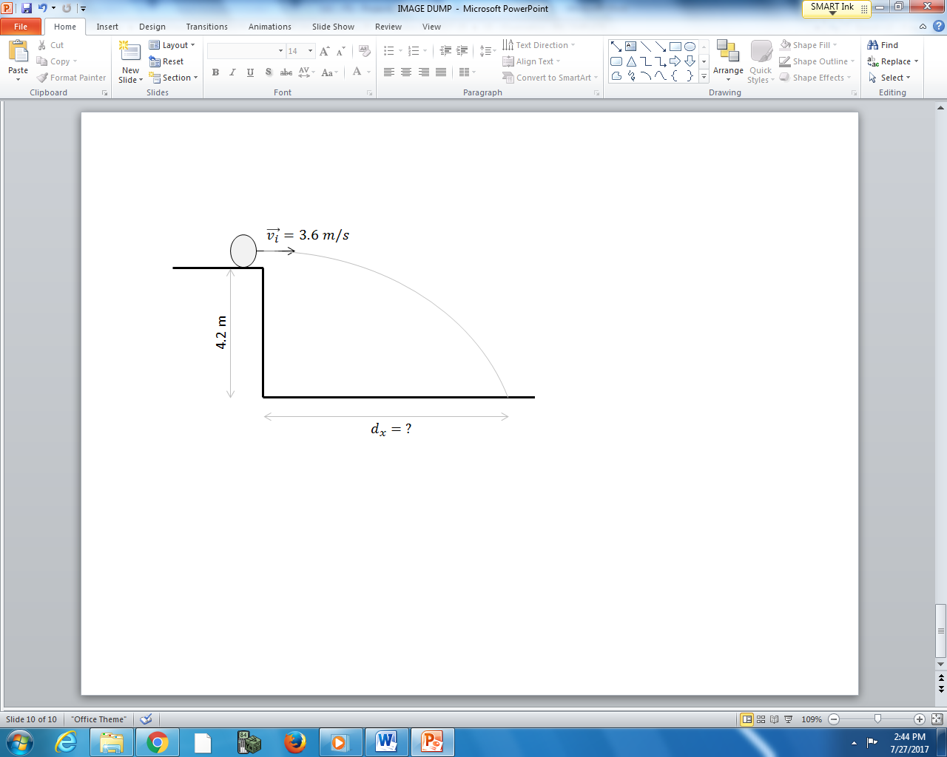

Q1: The ball takes a.bc x 10^{-d} seconds to reach the ground, where a, b, c, and d are ___, ___, ___, and ___.
(Record your four-digit answer in the Numerical Response boxes below)

Q2: How far away from the ledge does the ball land, in meters?
(Record your three-digit answer in the Numerical Response boxes below)

Use the following information to answer Q1-Q3:

Q3: How fast is the ball travelling after 0.5 seconds? (2 marks)

MARKING:
Beginning 0.0 – 1.5
Progressing 2.0 – 2.5
Competent 3.0 – 3.5
Exemplary 4.0

