First Name:______________________________ Last Name:______________________________

L12 – Unit Test - Practice

IMPORTANT: Do not open your tests until instructed to do so.

This test is broken into three sections, split up by competency. Each section corresponds to a summative quiz that was written in class. If you show improved knowledge on any of these sections, I will modify your quiz mark to show the same ability (percentage). In short, this test acts as a retest for each of your summative quizzes.
Competency 2 – Forces and Motion
Forces and Acceleration
Forces and Friction (Comprehensive)
Your score on this test will be recorded by competency, under each competency. The corresponding sections of this test will account for 40% of each competency.
Good luck!
_____________________________________________________________________________________
This section for the teacher’s use only.

Competency 3 – Forces and Acceleration _____ / 5 x2 = _____/ 10
Competency 3 – Forces and Friction (Comprehensive) _____ / 8 x2 = _____/ 16
Total Competency 2 _____ / 13

Competency 2 – Forces and Acceleration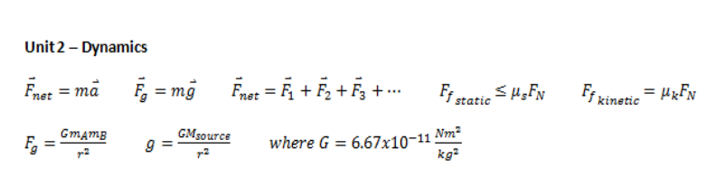
Q1: A 10kg box is being pulled by two individuals. The first individual applies a force of 300N [forward]. The second individual applies a force of 200N [forward]. The force of friction on the object is 150N [backward]. If the mass of the object is 10kg, how quickly will the object accelerate? (2 marks)
1 mark – Net Force
1 mark – Acceleration (Magnitude and Direction)
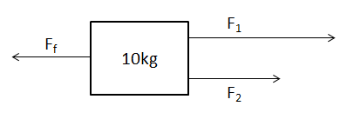

REMINDER: Did you remember to include direction and units?
Q2: An 8kg cat named Binky loves Dynamics. She wants to create a jungle gym, as depicted below, and hang from the rope for hours. How much tension must each rope be able to support? (3 marks)
1 mark – y-comp of Tension on Rope 1
1 mark – Tension on Rope 1
1 mark – Tension on Rope 2
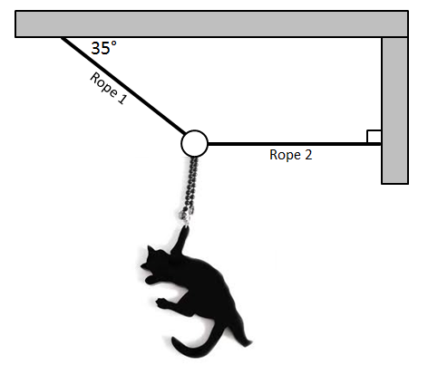

REMINDER: Did you remember to include units?
Competency 2 – Forces and Friction (Comprehensive)
Q3: A 5kg block is on a ramp inclines 25°. What is the minimum coefficient of static friction required to prevent the block from slipping? (4 marks)
1 mark – Force of Gravity (Parallel Component)
1 mark – Force of Gravity (Perpendicular Component)
1 mark – Minimum Force of Friction
1 mark – Minimum Coefficient of Static Friction
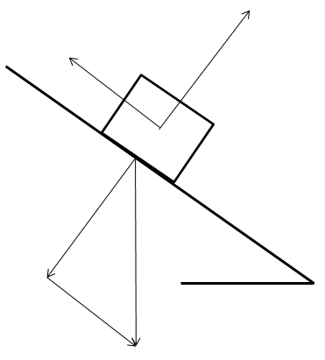

REMINDER: Did you remember to include units, when necessary?
Q4: A series of blocks are connected via cables. The blocks are released and start to accelerate. If the coefficient of kinetic friction between the 20kg block and the table is 0.55, what is the tension in the rope on the right side? (4 marks)
1 mark – Force of Friction on 20kg Block
1 mark – Net Force on System
1 mark – Acceleration of System
1 mark – Tension on RIGHT Rope
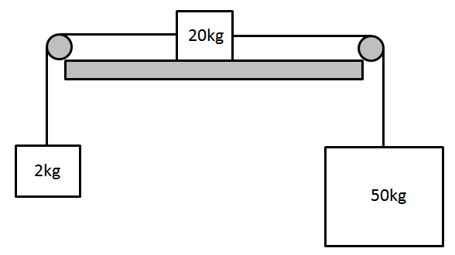

REMINDER: Did you remember to include units?
Question #1:
F_{net} = 350N
a = 35 m/s² [forward]
Question #2:
F_{1y} = 78.48N
F₁ = 136.82N
F₂ = 112.08N
Question #3:
F_{g-parallel} = 20.73N
F_{g-perpendicular} = 44.45N
F_{f} = 20.73N (It’s stationary, so this balances out F_{g-parallel})
µ_{s} ≥ 0.466
Question #4:
F_{fk} = 107.91N
F_{net-system} = 362.97N
a = 5.04m/s²
F_{T} = 238.44N

