First Name:______________________________ Last Name:______________________________
L12 – Worksheet – Magnetic Forces and Fields
Textbook Questions
Q1: Indicate the direction of the magnetic field lines and the direction of the current in the wire, as required.
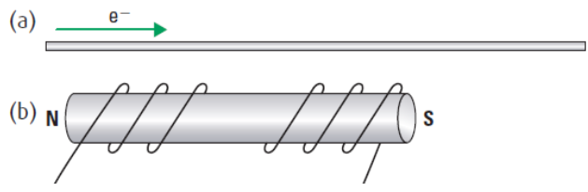
Textbook Questions
None
Diploma Worksheet Questions – Magnetic Forces and Fields (Bar Magnets)
Use the following information to answer Q231:
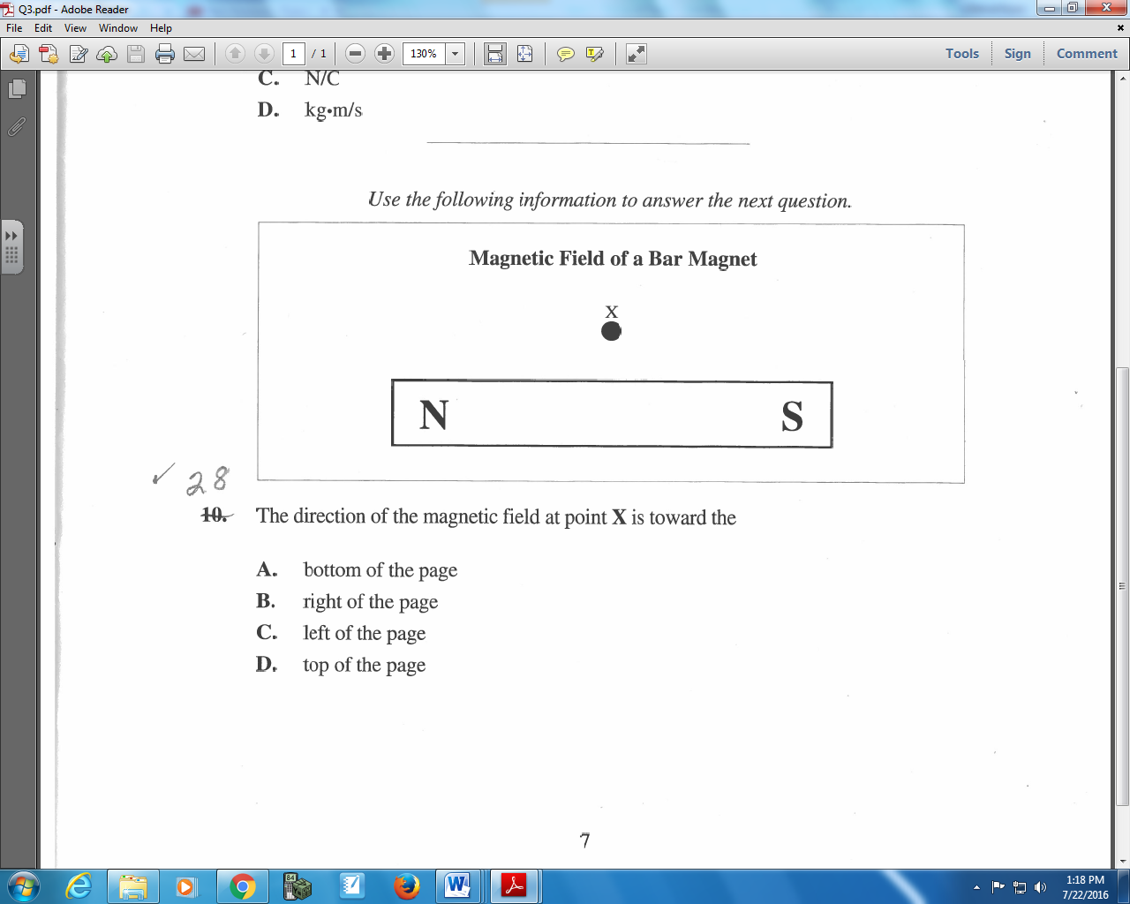

Q231: The direction of the magnetic field at point X is toward the
- Bottom of the page
- Right of the page
- Left of the page
- Top of the page

Q232: Magnets can be produced when small magnetic regions in a metal line up their poles. These magnetic regions are called magnetic
- Domains
- Fields
- Atoms
- Areas

Q233: Which of the following diagrams illustrates the magnetic field surrounding a bar magnet?
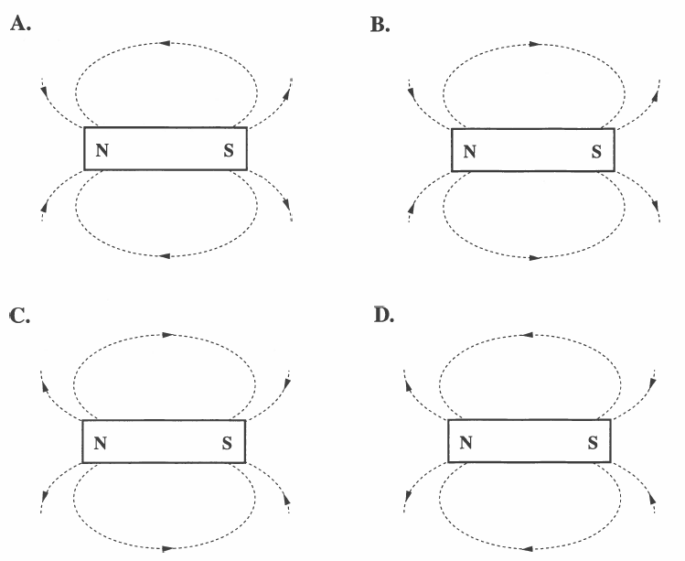

Use the following information to answer Q234:
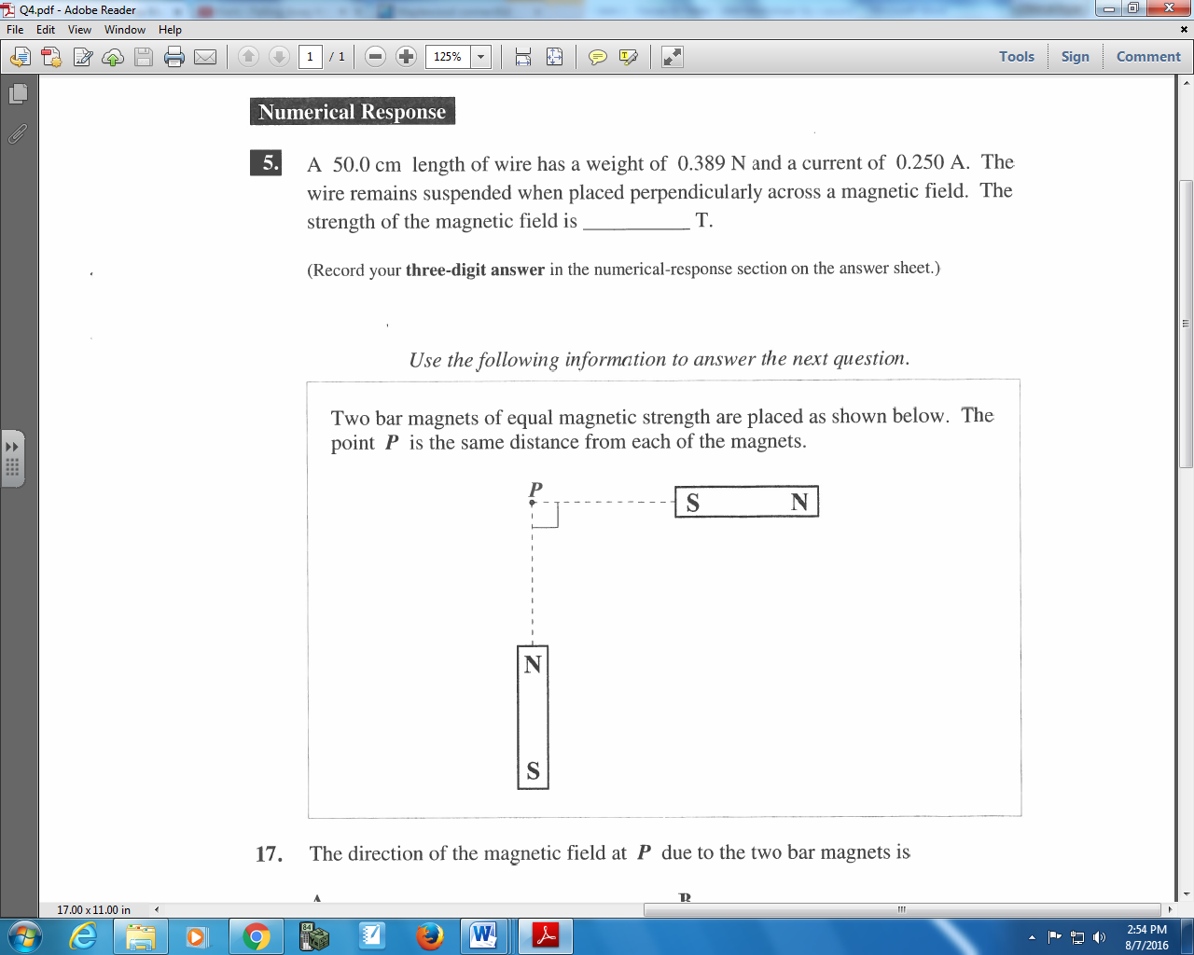

Q234: The direction of the magnetic field at P due to the two bar magnets is
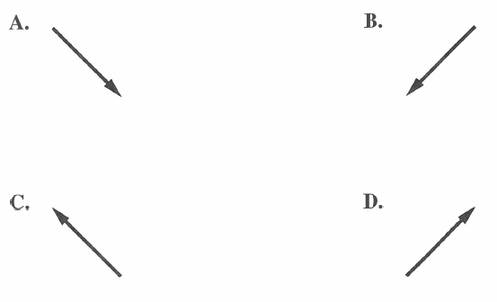

Diploma Worksheet Questions – Magnetic Forces and Fields (First Hand Rule)
Use the following information to answer Q236:
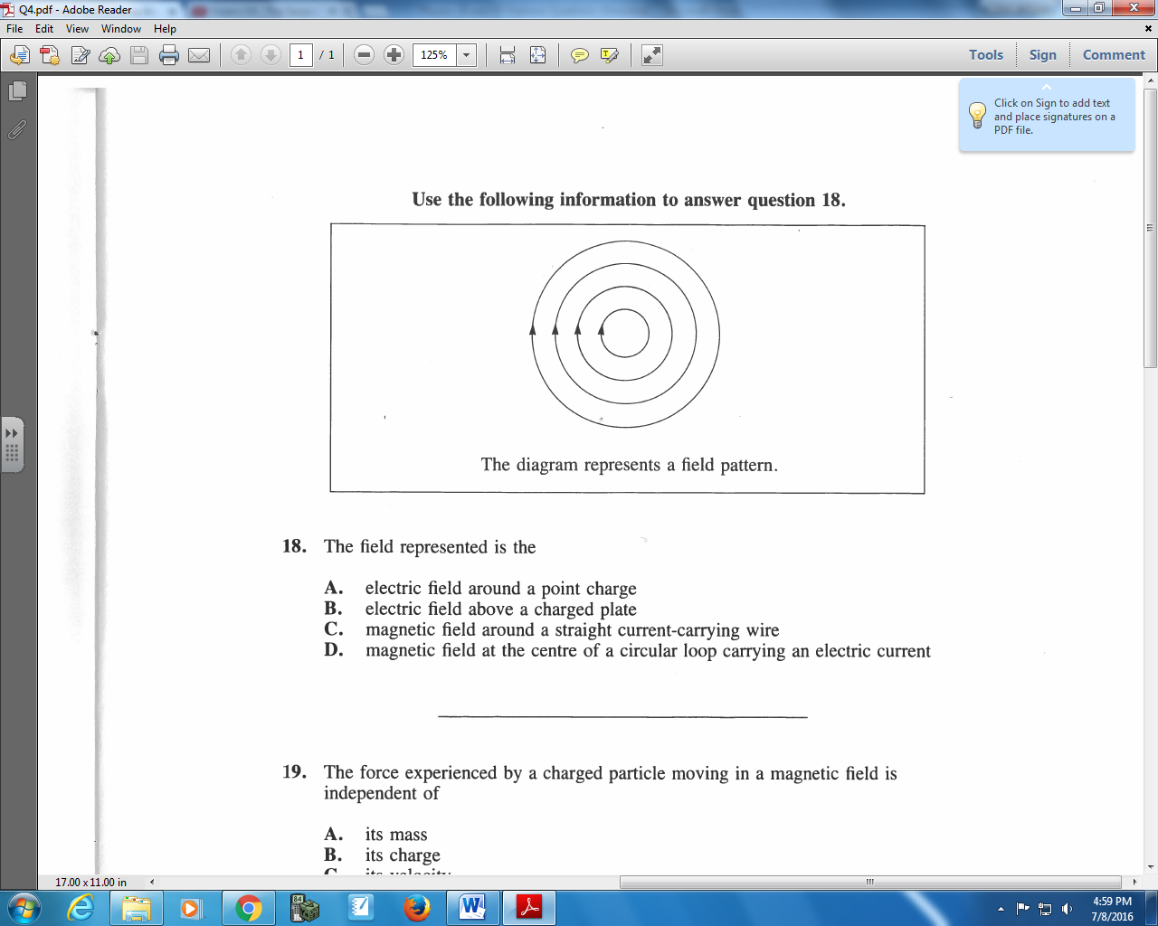

Q236: The field represented is the
- Electric field around a point charge
- Electric field above a charged plate
- Magnetic field around a straight current-carrying wire
- Magnetic field at the center of a circular loop carrying an electric current

Use the following information to answer Q237:
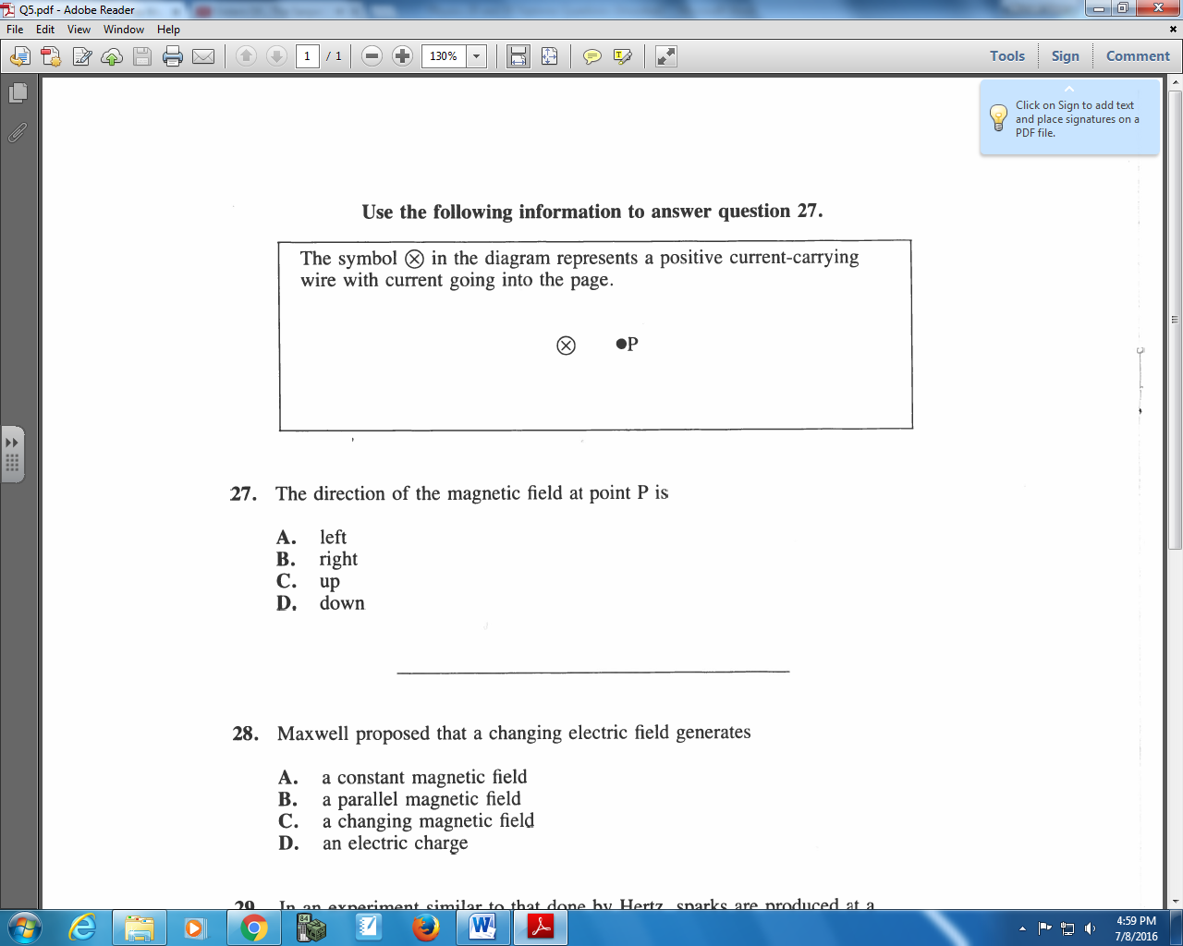

Q237: The direction of the magnetic field at point P is
- Left
- Right
- Up
- Down

Q238: If a proton were fired into the center of a page, which diagram would represent the appearance of its magnetic field?
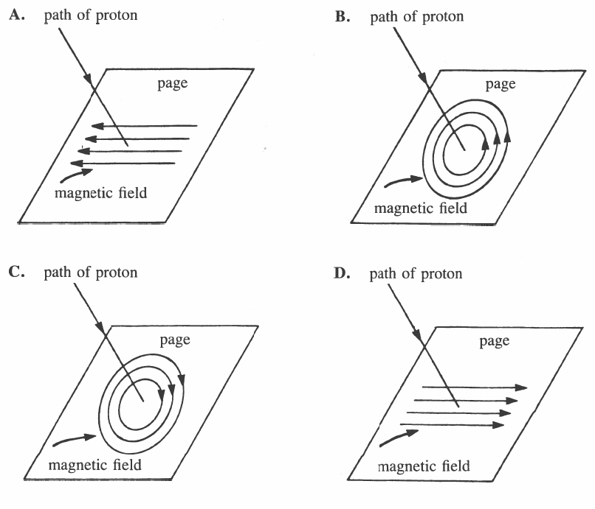

Use the following information to answer Q241:
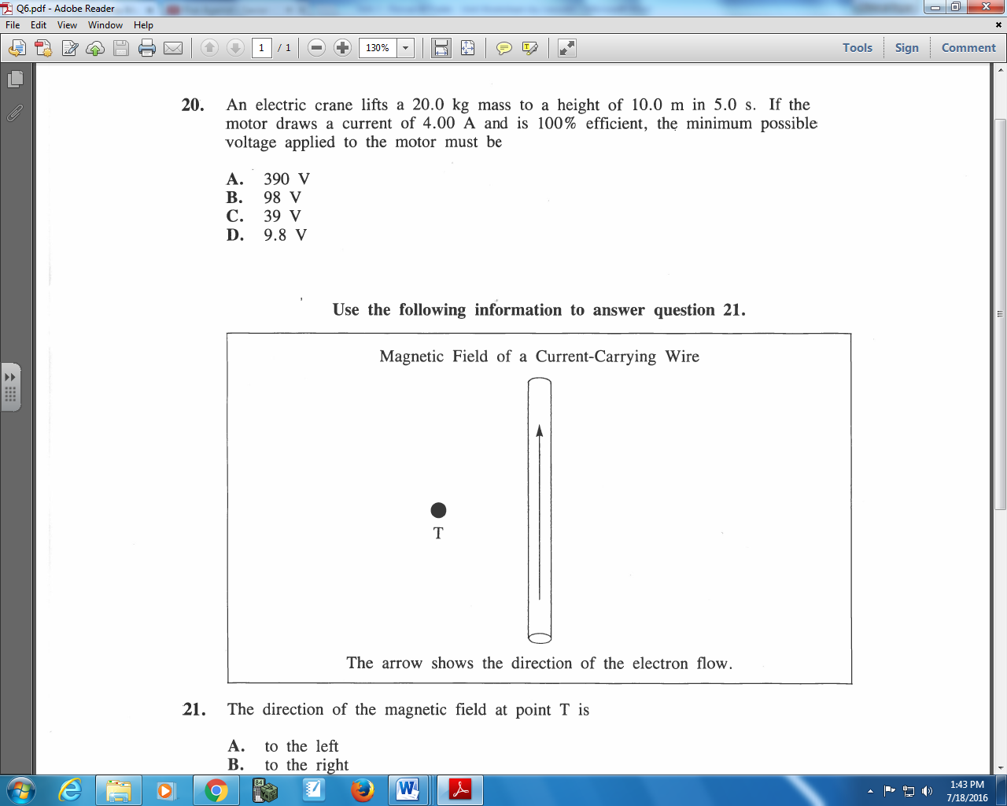

Q241: The direction of the magnetic field at point T is
- To the left
- To the right
- Into the page
- Out of the page

Use the following information to answer Q242:
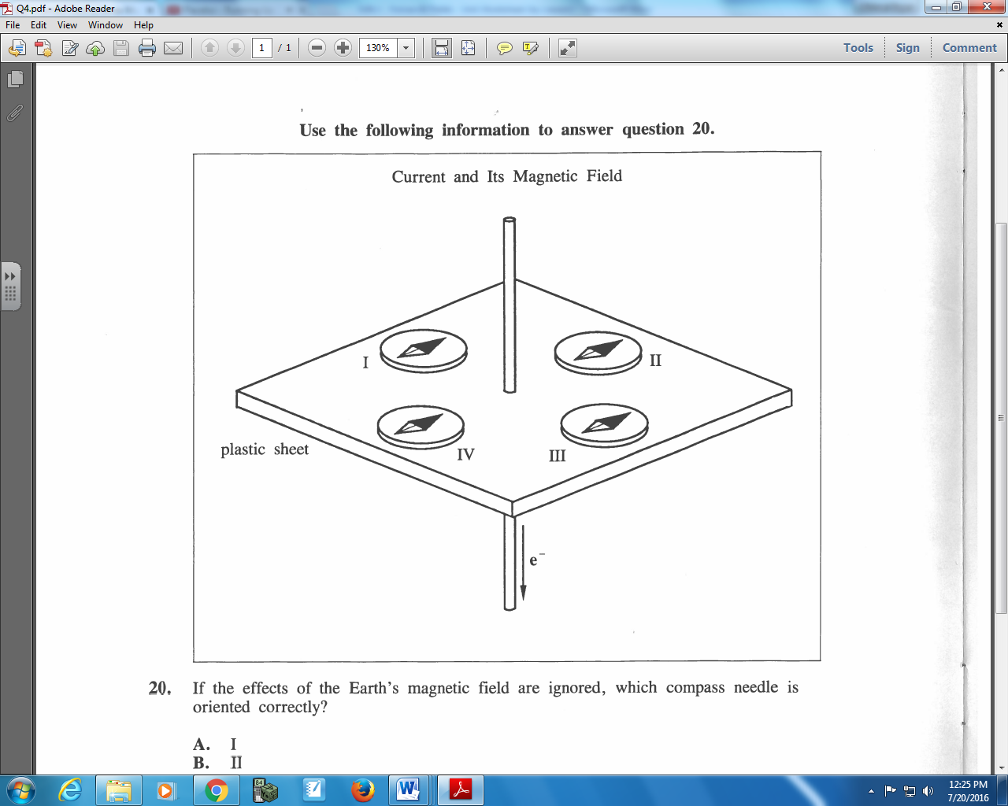

Q242: If the effects of the Earth’s magnetic field are ignored, which compass needle is oriented correctly?
- I
- II
- III
- IV

Use the following information to answer Q244:
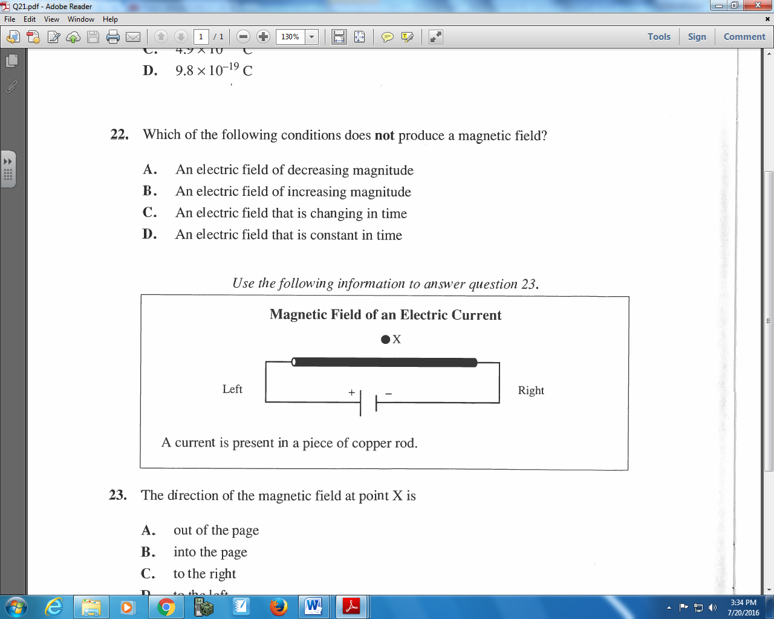

Q244: The direction of the magnetic field at point X is
- Out of the page
- Into the page
- To the right
- To the left

Q246: Which of the following diagrams best illustrates the magnetic field near a wire that carries an electron current out of the plane of the page?
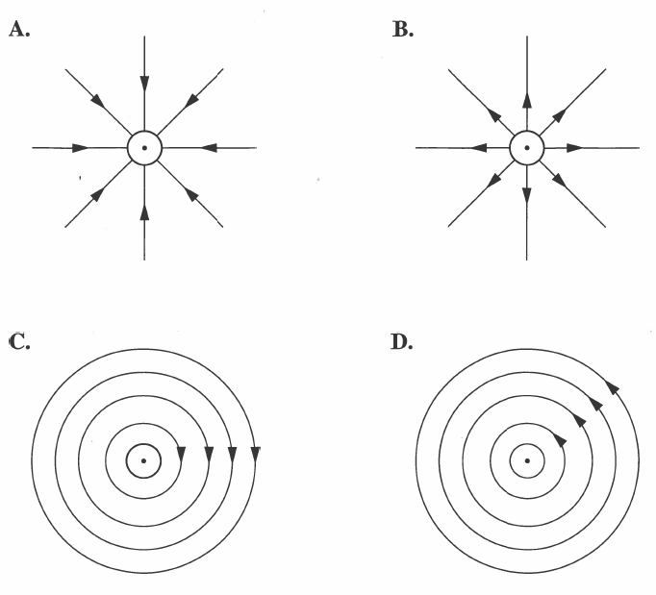
Diploma Worksheet Questions – Magnetic Forces and Fields (Second Hand Rule)
Q249: If the direction of the electron flow through the coils of an electromagnet is reversed, the electromagnet will
- Not be affected
- Decrease in strength
- Have its polarity reversed
- Lose its magnetic properties

Q250: The north pole of the solenoid shown below is at position
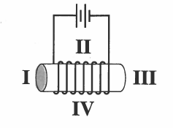
- I
- II
- III
- IV

Use the following information to answer Q251:
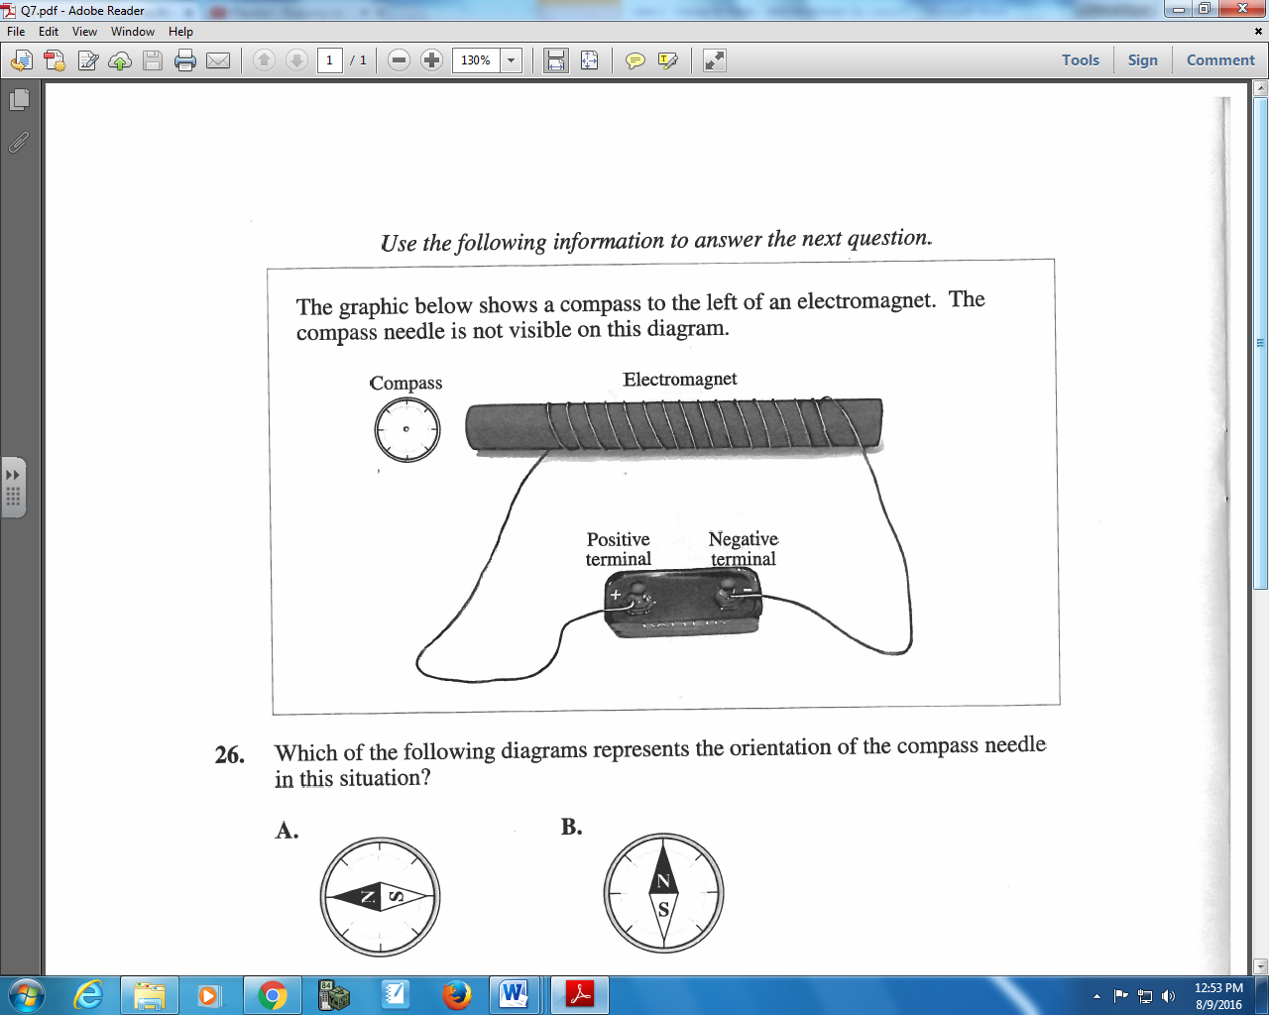

Q251: Which of the following diagrams represents the orientation of the compass needle in this situation?
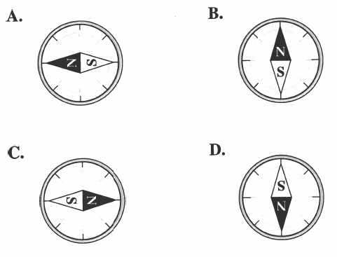

Challenge Questions
For Q1 though Q8, use the numerical response direction numbers to indicate the direction of the appropriate electric/magnetic field at the specified point, as instructed in each question.
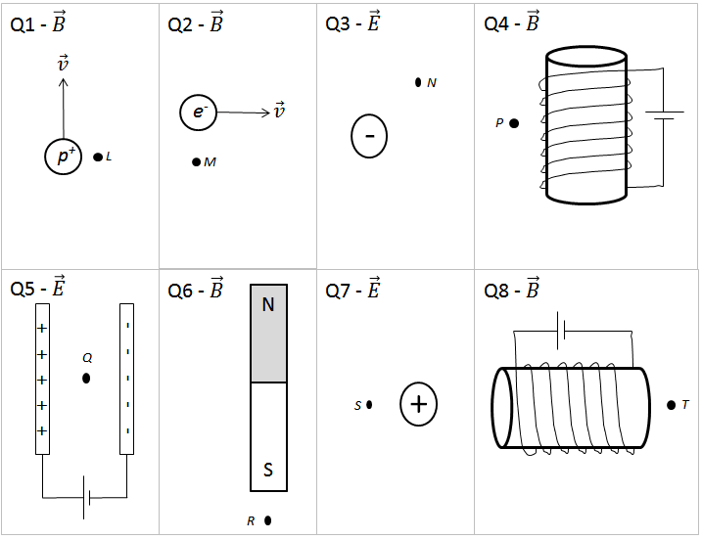
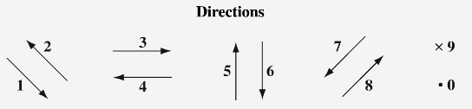
Q1: ____ Q2: ____ Q3: ____ Q4: ____
Q5: ____ Q6: ____ Q7: ____ Q8: ____

For Q9 through Q12, use the numerical response direction numbers to indicate the direction of the appropriate current.
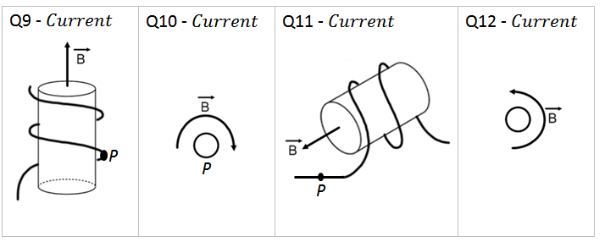
Q9: ____ Q10: ____ Q11: ____ Q12: ____

Cumulative Review from Previous Units
None

