First Name:__________________________________ Last Name:______________________________

L13 – FQ – Magnetic Forces and Fields

Q1: For each of the following, diagram the direction of electron flow. (4 marks)
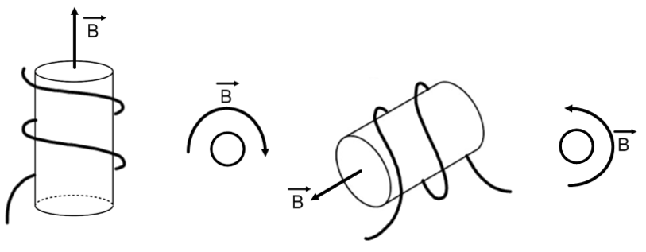

MARKING:
Beginning 0 – 1
Progressing 2
Competent 3
Exemplary 4

