First Name:____________________________ Last Name:______________________________

L13 –FQ – Pendulums

Q1: If a grandfather clock has a pendulum arm of length of 0.8m, what is its period?
- 0.56 s
- 1.25 s
- 1.79 s
- 22.0 s

Use the following information to answer Q2:
An astronaut of mass 75kg wants to find out the gravitational field strength of a mysterious planet. She creates a pendulum of length 1m and discovers that the period is 6 seconds.

Q2: The gravitational field strength on the surface of the planet is ____ N/kg.
(Record your three digit answer in the Numerical Response boxes below)

Use the following information to answer Q3-Q4:
A 3.00 kg pendulum bob is attached to a string of unknown length. The string is raised 60.0⁰ from the vertical and released. The period of the pendulum is measured to be 8.00 seconds.
NOTE: Diagram is not drawn to scale.
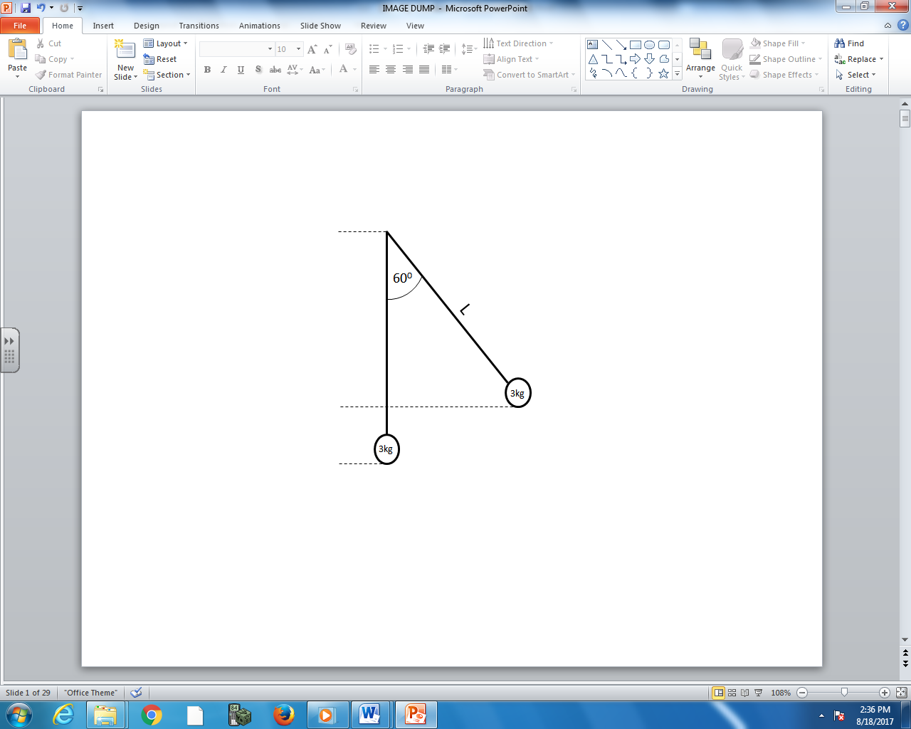

Q3: What is the restoring force experienced by the pendulum bob when it is initially released?
- 1.50 N
- 2.60 N
- 14.72 N
- 25.49 N

Q4: What is the maximum speed of the pendulum bob while oscillating? (3 marks)

MARKING:
Beginning 0 - 2.5
Progressing 3 - 4
Competent 4.5 - 5
Exemplary 5.5 - 6

