First Name:______________________________ Last Name:______________________________

L13 – Dynamics Unit Test – Practice 2

IMPORTANT: Do not open your tests until instructed to do so.

This test is broken into three sections, split up by competency. Each section corresponds to a summative quiz that was written in class. If you show improved knowledge on any of these sections, I will modify your quiz mark to show the same ability (percentage). In short, this test acts as a retest for each of your summative quizzes.
Competency 2 – Forces and Motion
Forces and Acceleration
Friction and Newton’s Third Law
Your score on this test will be recorded by competency, under each competency. The corresponding sections of this test will account for 40% of each competency.
Good luck!
_____________________________________________________________________________________
This section for the teacher’s use only.

Competency 2 – Forces and Acceleration _____ / 6 x1.67 = _____/ 10
Competency 2 – Friction and Newton’s Third Law _____ / 7 x1.43 = _____/ 10

Competency 2 – Forces and Acceleration
Q1: A 10kg box initially at rest is being pulled by two individuals. The first individual applies a force of 80N [forward]. The second individual applies a force of 60N [forward]. The force of friction on the object is 75N [backward]. If the mass of the object is 10kg and it travels for 5 seconds, what is the final velocity? (3 marks)
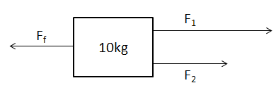

Q2: A 100kg Mr. Melnyk decides to test out the jolly-jumper he purchased for his baby. He hangs from the jumper, stationary. If the cables can only sustain 500N of tension each, determine if Mr. Melnyk breaks the cables. Show all of your work. (3 marks)
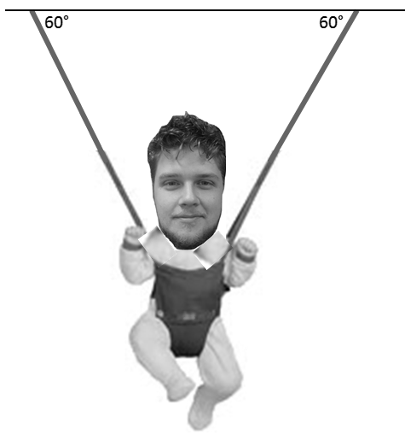

Competency 2 – Friction & Newton’s Third Law
Q3: A child on a sled (40kg combined) is being towed downhill by a snowmobile. The coefficient of kinetic friction between the sled and the hill is 0.04. If the sled is accelerating downhill at 8m/s², what is the force applied by the snowmobile (F_{APP})? (4 marks)

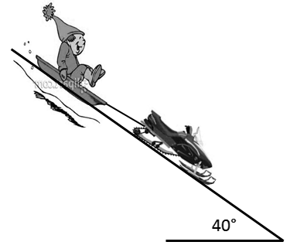

Q4: An 18kg block on the table is moving left with a constant speed of 2m/s. Calculate the coefficient of friction between the 18kg block and the table. (3 marks)
