First Name:______________________________ Last Name:______________________________
L13 – Worksheet – Motor Effect on a Point Charge
Concept Review
Hand Rules #1 & #2
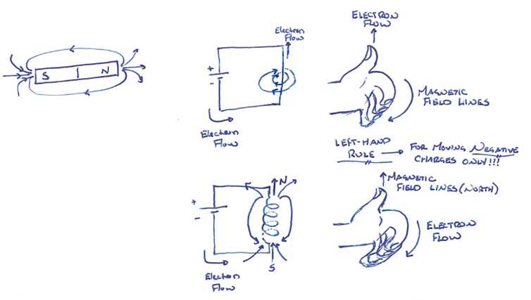
_____________________________________________________________________________________
Motor Effect (Hand Rule #3)
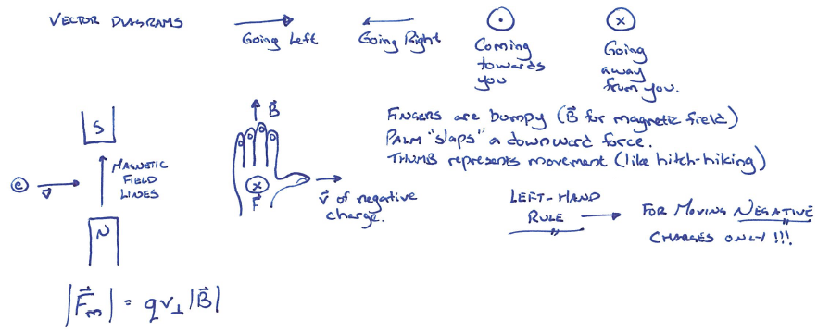

Textbook Questions
Pg 601 #3: An electron and a proton, both with the same perpendicular velocity, enter a region with a uniform external magnetic field. What can you state about the deflections of both particles?

Pg 601 #4: Describe the key differences in how magnetic and electric fields affect a moving charged particle.

Pg 601 #6a: A proton with a speed of 2.00 x 10⁵ m/s enters an external magnetic field of magnitude 0.200T. Calculate the magnitude of the deflecting force if the proton enters perpendicular to the magnetic field.

Pg 601 #7: A 0.020g metal ball with a charge of -3.0μC is thrown horizontally along Earth’s equator. How fast must the ball be thrown so that it maintains the same height, during tis motion tangential to Earth’s surface, if the magnitude of Earth’s magnetic field is 5.0 x 10⁻⁵ T?

Diploma Worksheet Questions – Motor Effect (Basic Definitions)
Q257: The force experienced by a charged particle moving in a magnetic field is independent of
- Its mass
- Its charge
- Its velocity
- The magnetic field strength

Q260: The charged particles in the Van Allen radiation belts most probably have been trapped there by
- An electric field
- A magnetic field
- A scalar light field
- A gravitational field

Q271: A magnetic field exerts no force on
- A magnet
- An iron bar
- An electric current
- A stationary electric charge

Diploma Worksheet Questions – Motor Effect (Moving Point Charge)
Q273: A particle experiences a deflecting force of 2.5 x 10⁻⁶ N as it passes perpendicularly across a magnetic field of strength 0.050 T. If the particle has a charge of 8.0 x 10⁻⁴ C, its speed is
- 1.6 x 10⁻⁴ m/s
- 6.2 x 10⁻³ m/s
- 6.2 x 10⁻² m/s
- 1.6 x 10⁻¹ m/s

Use the following information to answer Q275:
A Beam of Electrons Travels Through a Magnetic Field
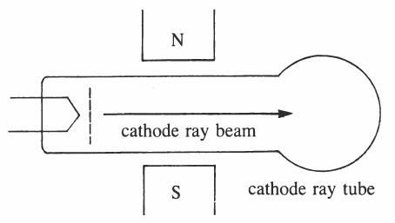

Q275: The cathode rays are deflected
- Toward S
- Toward N
- Into the page
- Out of the page

Q277: If a proton moves perpendicularly across a magnetic field of strength 2.0 x 10⁻² T at a speed of
5.0 x 10⁶ m/s, it would experience a force of
- 1.7 x 10⁻²² N
- 1.7 x 10⁻²⁰ N
- 1.6 x 10⁻¹⁴ N
- 1.6 x 10⁻¹² N

Use the following information to answer Q282:
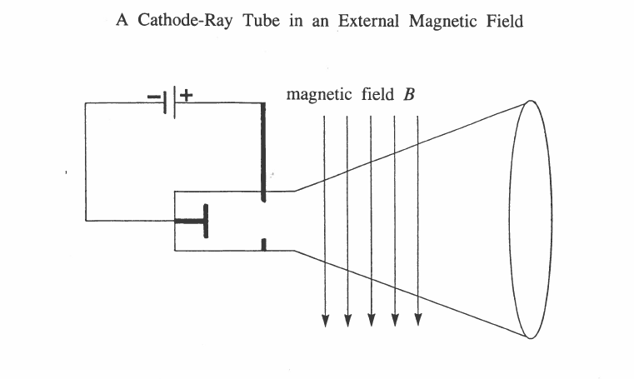

Q282: The particles in the cathode-ray tube will be deflected in the direction
- Into the page
- Out of the page
- Toward the top of the page
- Toward the bottom of the page

Use the following information to answer Q283:
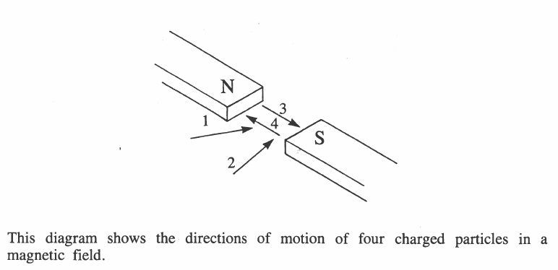

Q283: The magnetic field will deflect the particles labelled
- 1 and 2
- 1 and 3
- 2 and 4
- 4 and 3
Use the following information to answer Q286:
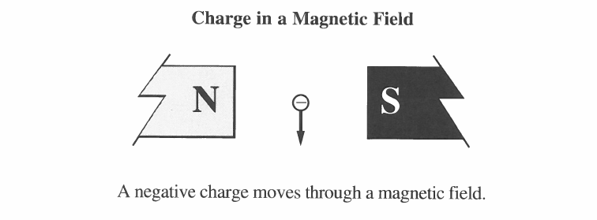

Q286: The charge will be deflected
- Toward the left side of the page
- Toward the right side of the page
- Out of the page
- Into the page

Use the following information to answer Q288:
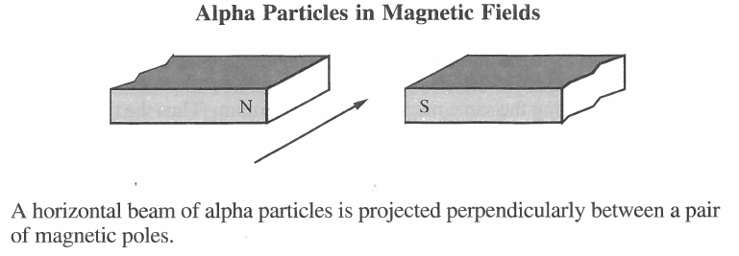

Q288: The ions will be deflected
- Upward
- Downward
- Toward the north pole
- Toward the south pole

Use the following information to answer Q295:
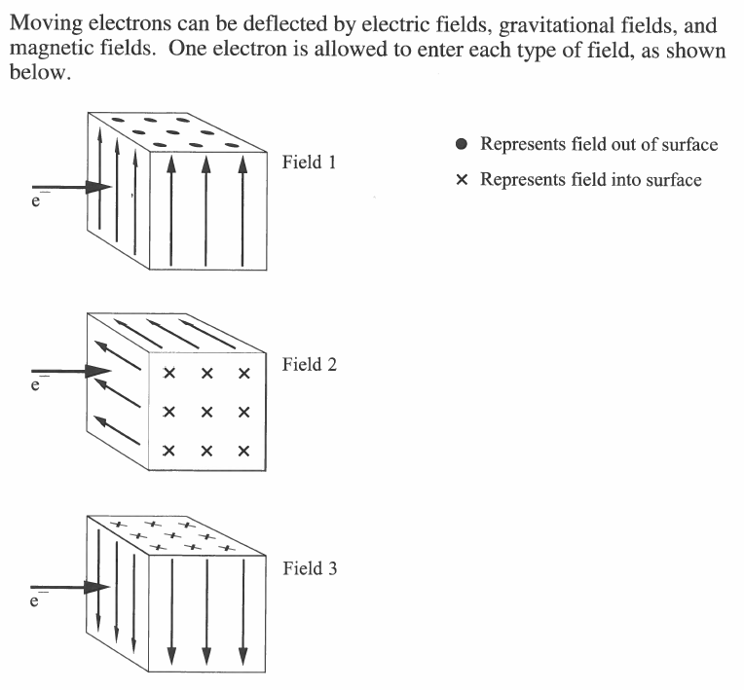

Q295: If the electron is deflected downward in each field, then field 1, field 2, and field 3 are, respectively,
- Electric, magnetic, and gravitational
- Gravitational, magnetic, and electric
- Magnetic, gravitational, and electric
- Magnetic, electric, and gravitational

Q296: The path followed by a moving proton in an external magnetic field is shown in
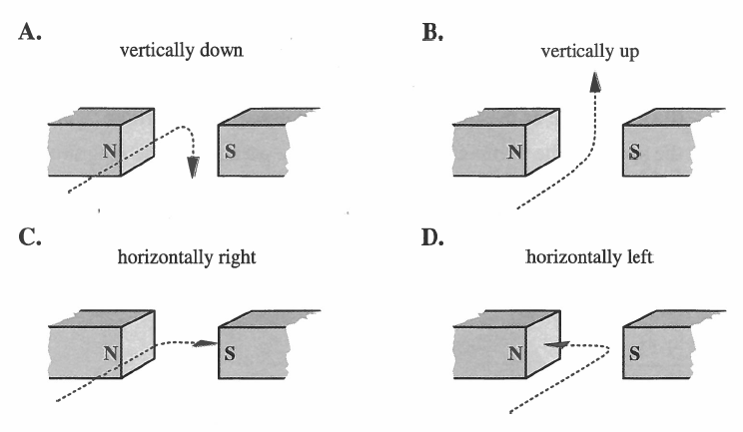

Challenge Questions
None

Cumulative Review from Previous Units
Use the following information to answer Q1:
A proton is placed between two parallel plates.
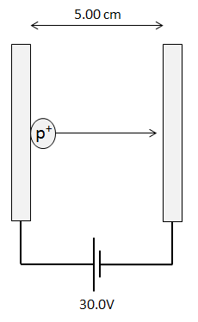

Q1: The impulse imparted to the proton is a.b x 10^{-cd} Ns, where a, b, c, and d are ___, ___, ___, and ___.
(Record your four digit answer in the Numerical Response boxes below)

