First Name:______________________________ Last Name:______________________________
L13 – Worksheet – Photons
Textbook Questions
Pg 706 #1: What is the energy of a photon of light of frequency 4.00 x 10¹⁴ Hz?

Pg 706 #2: What is the energy of a green photon of light of wavelength 555 nm?

Pg 707 #1: What is the frequency of a 10-nm photon?

Pg 707 #2: What is the energy of a 10-nm photon?

Pg 707 #3: How many photons of green light (λ = 550 nm) are required to deliver 10 J of energy?

Pg 708 #1: How much energy is delivered by a beam of 1000 blue-light photons (λ = 400 nm)?

Pg 708 #2: How many 400-nm blue-light photons per second are required to deliver 10 W of power?

Diploma Questions – Photons (Basic Concepts)
Q636: A quantum of electromagnetic radiation is called
- A proton
- A photon
- An electron
- A photoelectron

Diploma Questions – Photons (Photon Energy)
Use the following information to answer Q640– Q641:
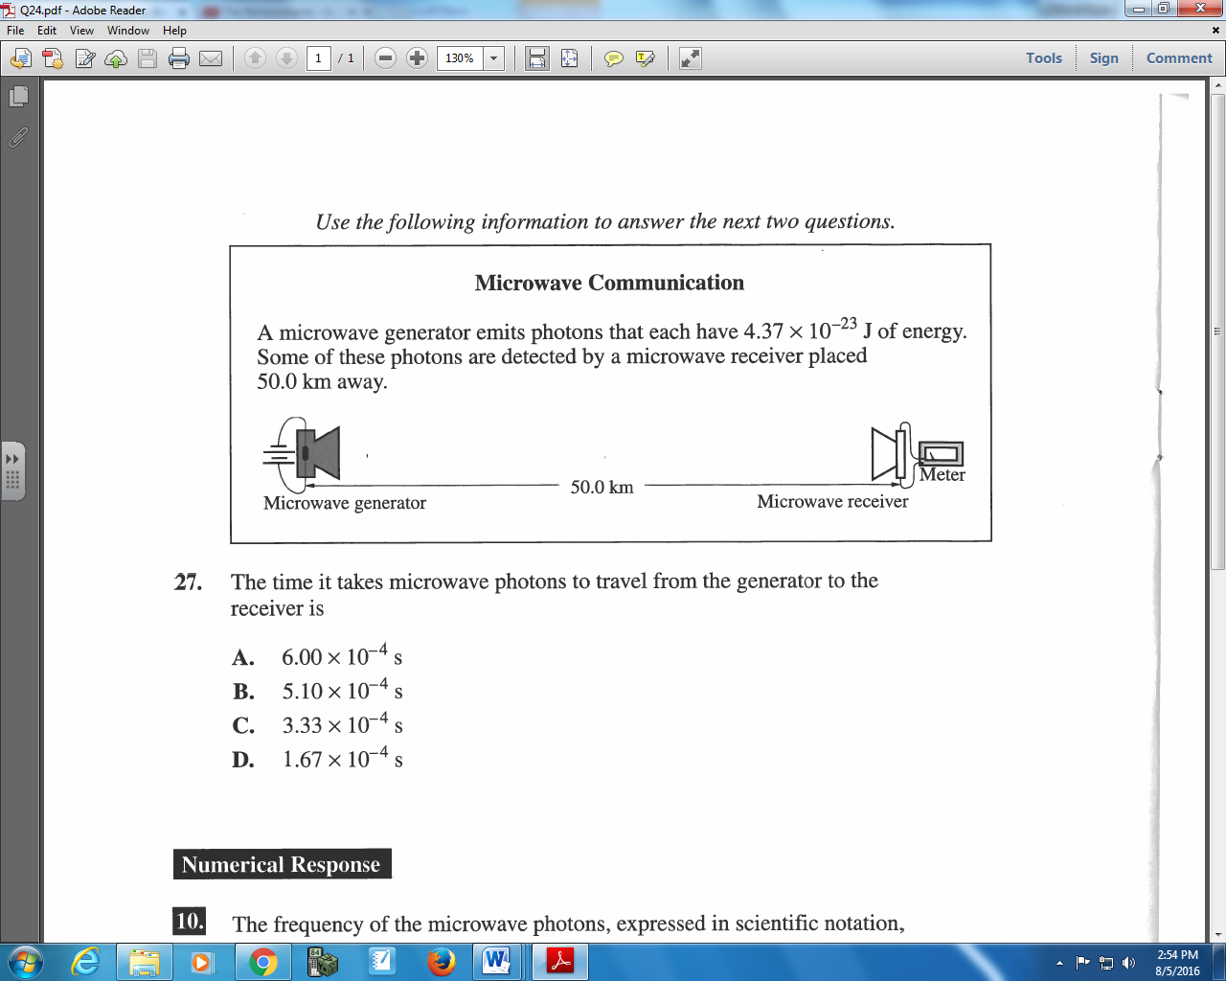

Q640: The time it takes microwave photons to travel from the generator to the receiver is
- 6.00 x 10⁻⁴ s
- 5.10 x 10⁻⁴ s
- 3.33 x 10⁻⁴ s
- 1.67 x 10⁻⁴ s

Q641: The frequency of the microwave photons, expressed in scientific notation, is b x 10^{w} Hz. The value of b is _____.
(Record your three digit answer in the Numerical Response boxes below)

Use the following information to answer Q642:
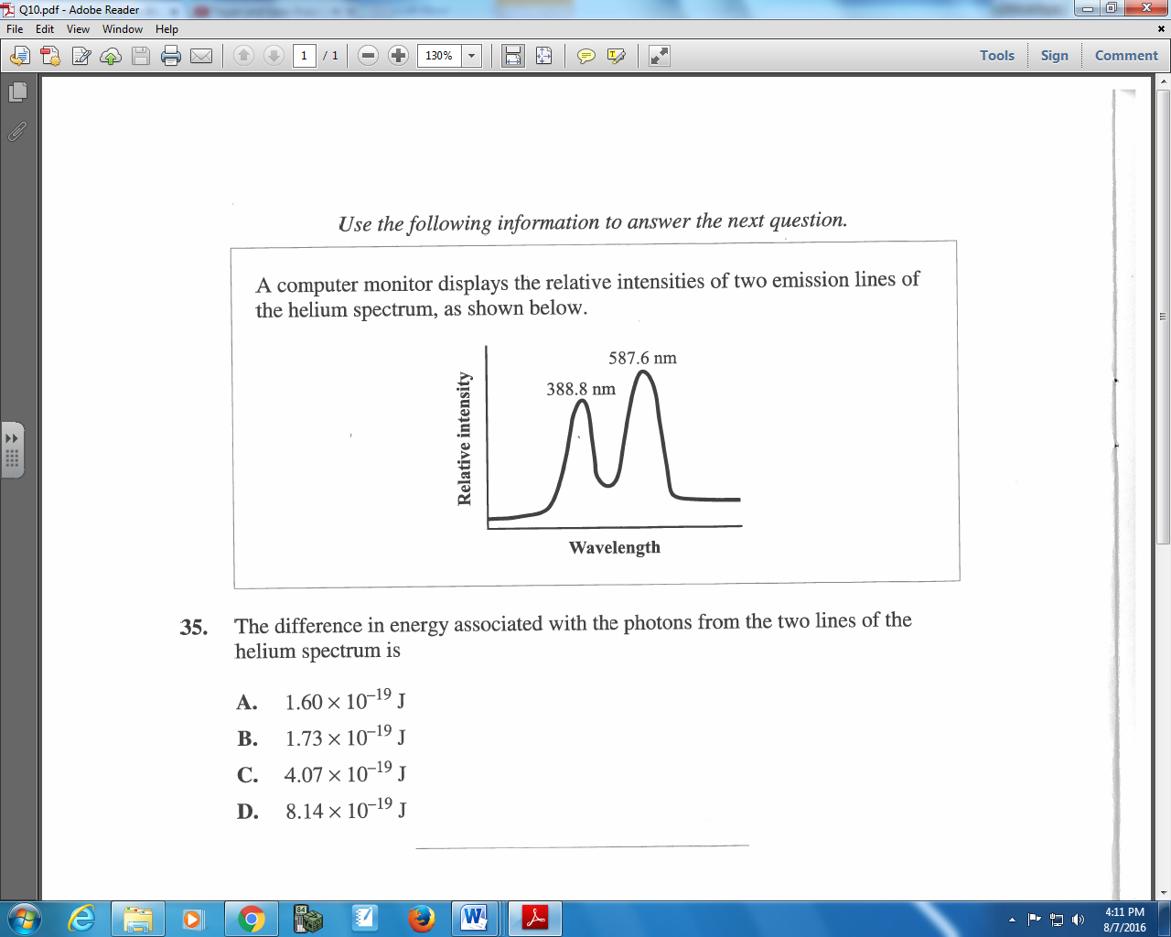

Q642: The difference in energy associated with the photons from the two lines of the helium spectrum is
- 1.60 x 10⁻¹⁹ J
- 1.73 x 10⁻¹⁹ J
- 4.07 x 10⁻¹⁹ J
- 8.14 x 10⁻¹⁹ J

Use the following information to answer Q645:
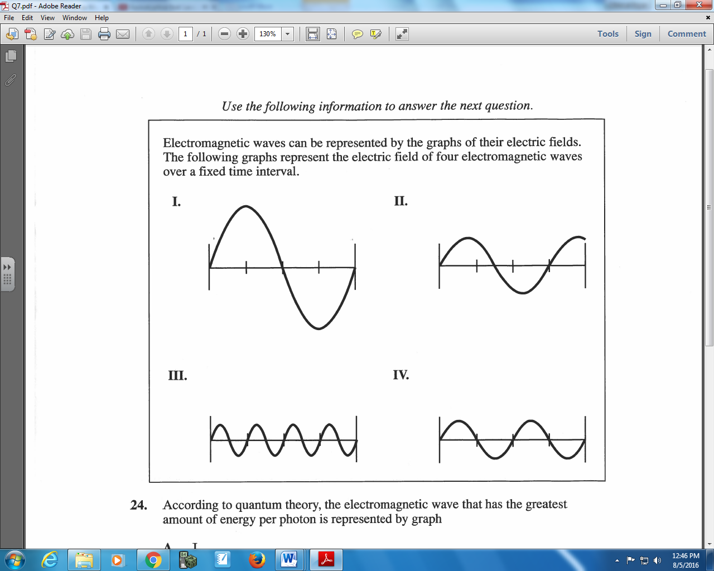

Q645: According to quantum theory, the electromagnetic wave that has the greatest amount of energy per photon is represented by graph
- I
- II
- III
- IV

Diploma Questions – Photons (Power and Number of Photons)
Use the following information to answer Q646 – Q647:
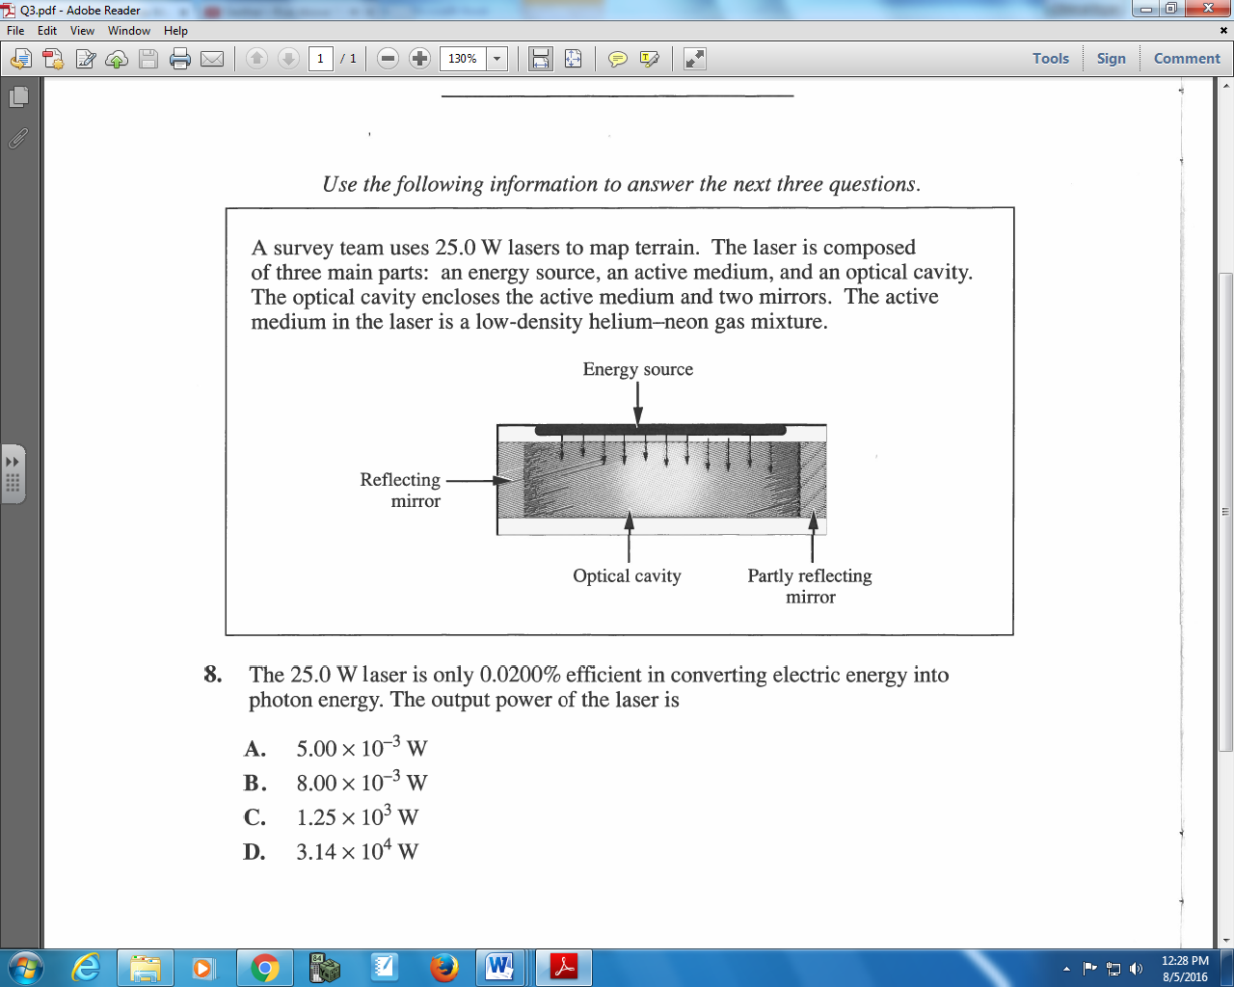

Q646: The 25.0 W laser is only 0.0200% efficient in converting electric energy into photon energy. The output power of the laser is
- 5.00 x 10⁻³ W
- 8.00 x 10⁻³ W
- 1.25 x 10³ W
- 3.14 x 10⁴ W

Q647: A beam of light from the laser has a wavelength of 633 nm. The number of photons per second emitted by the laser is
- 9.99 x 10²²
- 3.99 x 10²¹
- 2.55 x 10¹⁶
- 1.59 x 10¹⁶

Diploma Questions – Photons (X-Ray Production)
Q649: The maximum frequency of X-rays emitted from an electron tube operating at a potential difference of 4.0 x 10⁴ V would be
- 1.0 x 10¹⁹ Hz
- 9.7 x 10¹⁸ Hz
- 4.3 x 10¹⁷ Hz
- 1.6 x 10¹⁷ Hz

Q650: A high-energy cathode ray is stopped by a tungsten target. This is the fundamental process involved in the production of
- Beta radiation
- Radar radiation
- X-ray radiation
- Visible radiation

Use the following information to answer Q653:
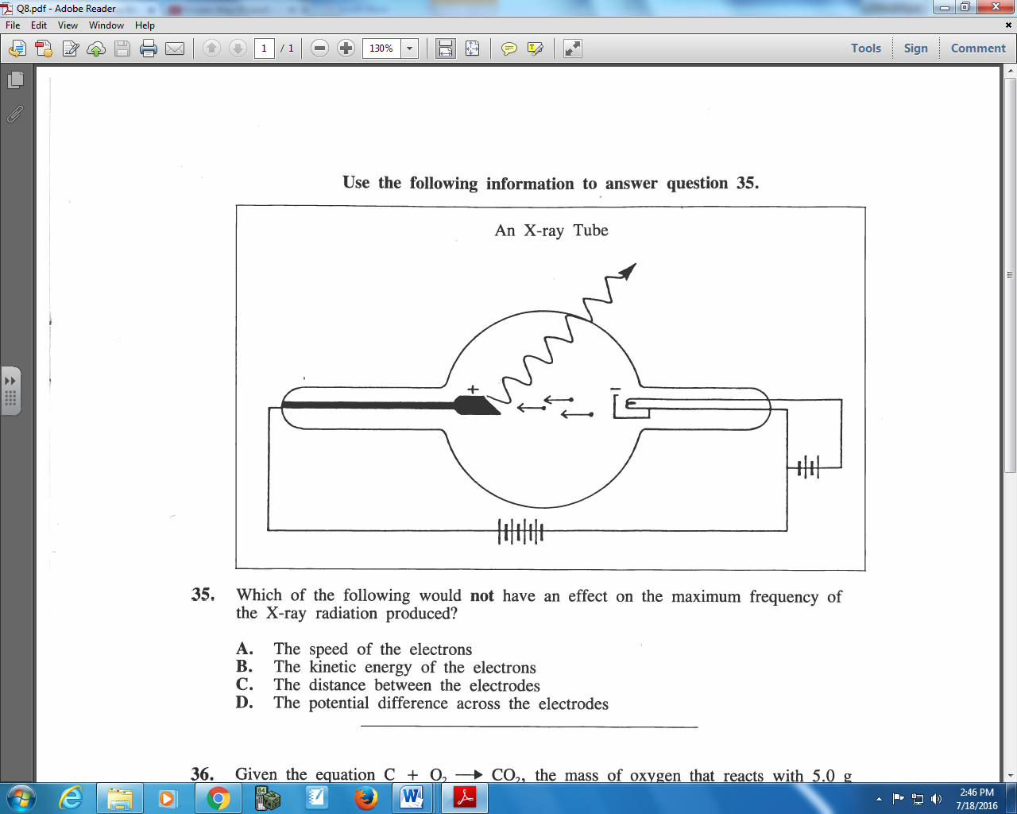

Q653: Which of the following would not have an effect on the maximum frequency of the X-ray radiation produced?
- The speed of the electrons
- The kinetic energy of the electrons
- The distance between the electrodes
- The potential difference across the electrodes

Q655: To produce X-rays of frequency 2.4 x 10¹⁷ Hz, an electron must have a speed of at least
- 9.9 x 10³ m/s
- 5.8 x 10⁶ m/s
- 1.3 x 10⁷ m/s
- 1.9 x 10⁷ m/s

Q656: A television picture tube operates with a potential difference of 3.0 x 10⁴ V. If X-rays are emitted from this picture tube, the minimum wavelength of the X-rays would be
- 7.2 x 10¹⁸ m
- 4.1 x 10⁻¹¹ m
- 2.4 x 10¹⁰ m
- 1.0 x 10⁻⁴ m
Use the following information to answer Q660:
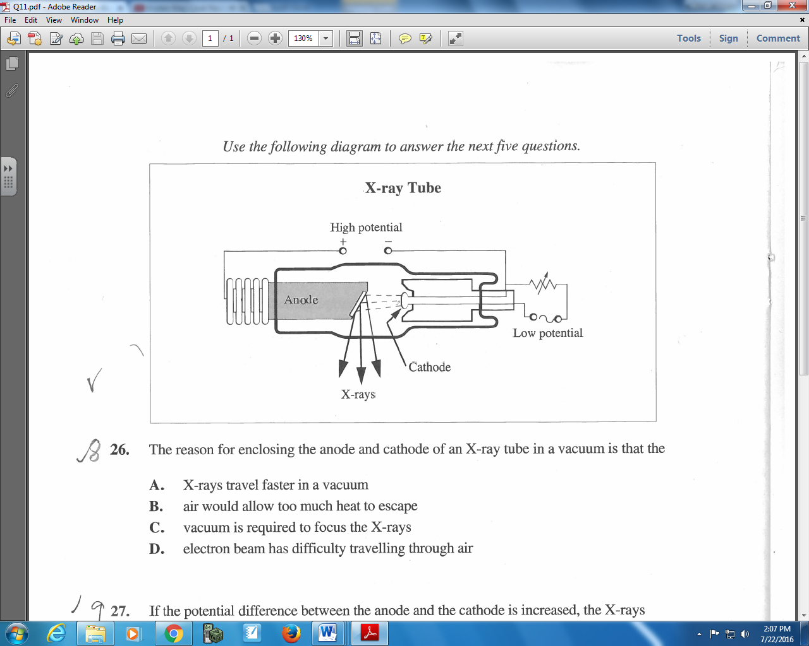

Q660: If the potential difference between the anode and the cathode is increased, the X-rays produced will have
- Shorter wavelengths and greater penetrating power
- Longer wavelengths and greater penetrating power
- Shorter wavelengths and less penetrating power
- Longer wavelengths and less penetrating power

Use the following information to answer Q666:
X-rays were discovered in 1895 by Roentgen. In the cathode ray tube that he used, a high electrical potential difference between the anode and the cathode accelerated the electrons. The electrons then collided with a copper target.
Three Types of Energy
1 electrical potential energy
2 electromagnetic energy
3 kinetic energy

Q666: In the production of X-rays, the three types of energy listed above occur in order from ___ to ___ to ___.
(Record your three digit answer in the Numerical Response boxes below)

Diploma Questions – Photons (Tabulated Data and Graph Analysis)
Use the following information to answer Q670:
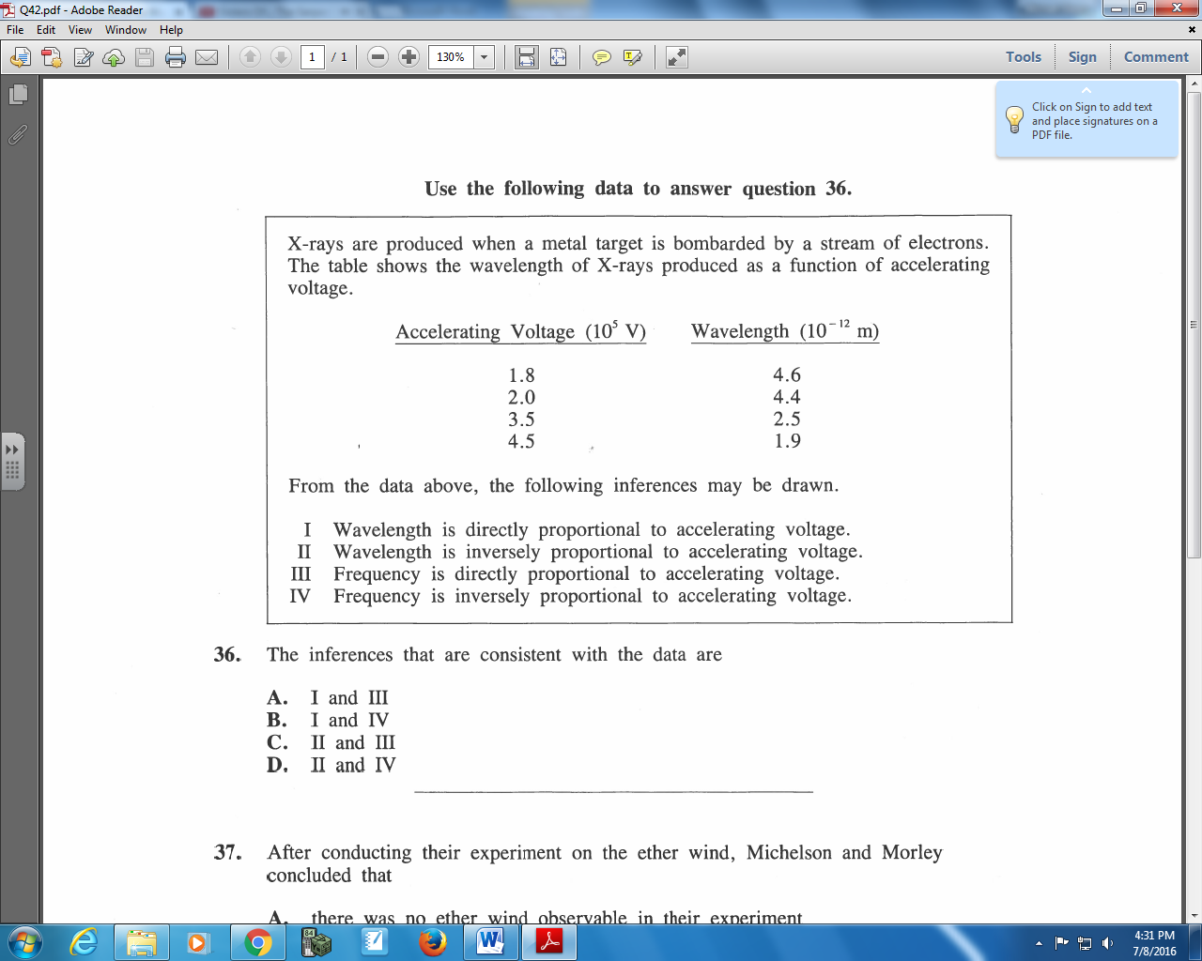

Q670: The inferences that are consistent with the data are
- I and III
- I and IV
- II and III
- II and IV

Cumulative Review from Previous Units
Q1: Coulomb started with two identically charged spheres separated by a distance r. The force between the spheres was F. If he changed the separation to $\frac{2}{3}r$, then the force between the spheres would have become
- $\frac{4}{9}F$
- $\frac{2}{3}F$
- $\frac{3}{2}F$
- $\frac{9}{4}F$
Use the following information to answer Q2:

Magnetic Fields around Current in a Wire
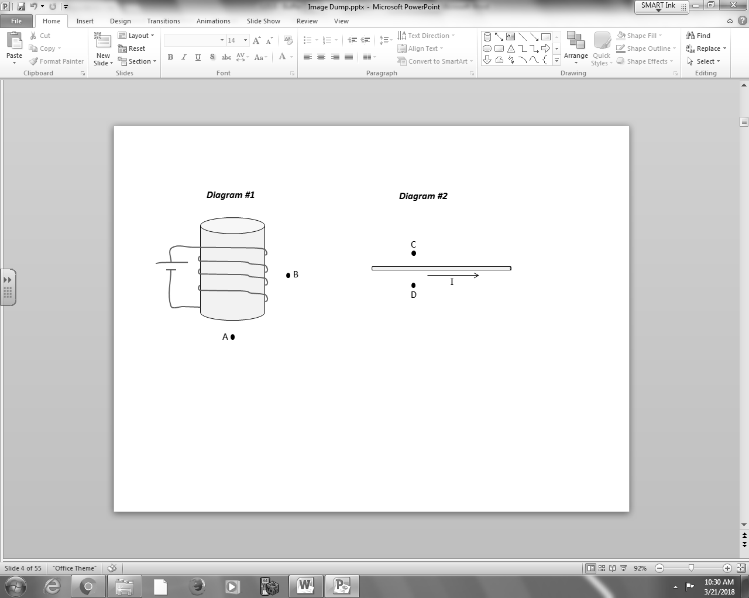
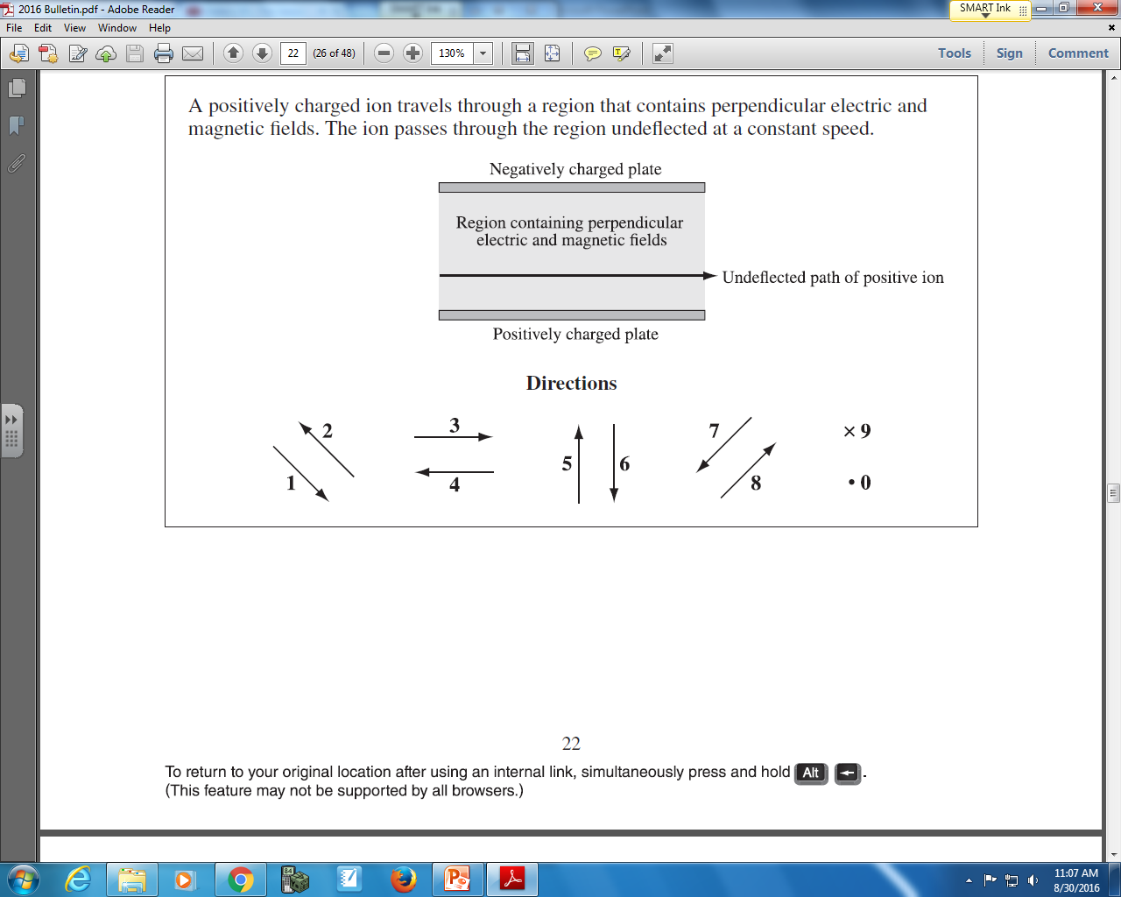

Q2: The directions of magnetic fields at various locations can be described using the numbers given above.
Direction: __________ __________ __________ __________
Field: Direction of Direction of Direction of Direction of
magnetic field magnetic field magnetic field magnetic field
at Position A at Position B at Position C at Position D
(Record your four digit answer in the Numerical Response boxes below)

