First Name:____________________________ Last Name:______________________________
L13 – Worksheet – Atomic & Nuclear Review 22 marks

Part 1 – Atomic ___/7 marks
Use the following information to answer Q1:
Possible Paths in a Bubble Chamber into an External Magnetic Field
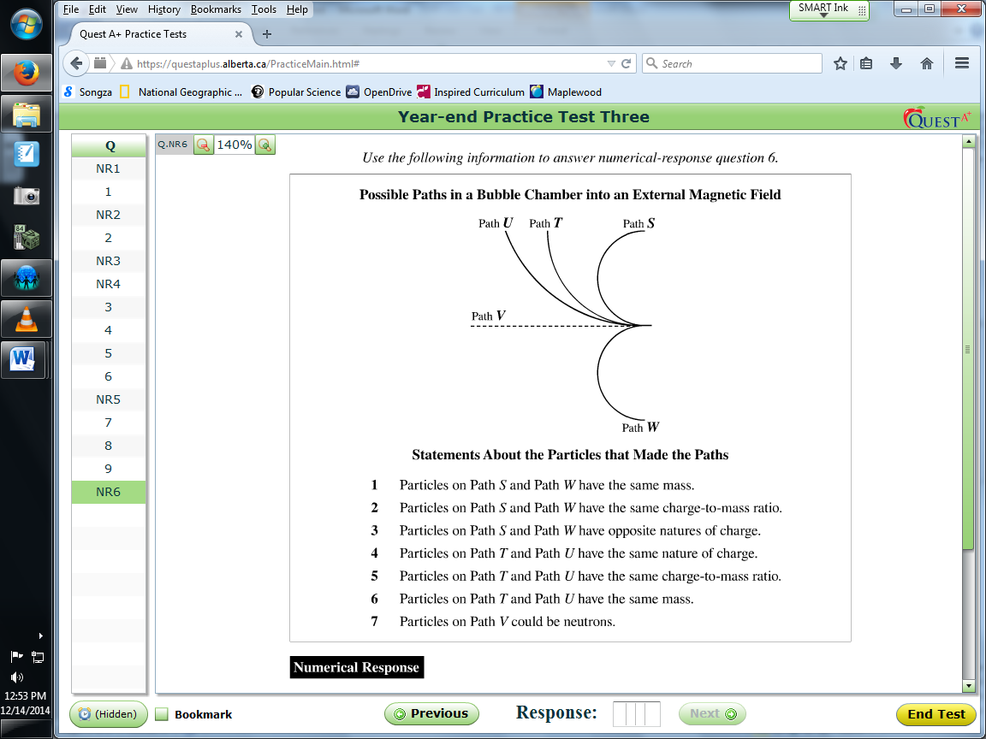
Statements About the Particles that Made the Paths
- Particles on Path S and Path W have the same mass.
- Particles on Path S and Path W have the same charge-to-mass ratio.
- Particles on Path S and Path W have opposite natures of charge.
- Particles on Path T and Path U have the same nature of charge.
- Particles on Path T and Path U have the same charge-to-mass ratio.
- Particles on Path T and Path U have the same mass.
- Particles on Path V could be neutrons.

Q1: If the particles all enter the bubble chamber with identical velocities, then the four statements that are supported by the possible paths shown above are ____, ____, ____, and ____.
(Record all four digits of your answer in the numerical-response boxes below)

Use the following information to answer Q2:
In a Scanning Electron Microscope (SEM), some of the electrons in the original beam knock electrons loose from lower energy levels of the atoms in the specimen. An electron in a higher energy level of these atoms then makes a transition to fill the vacated lower energy level.
The following energy level diagram shows two possible electron transitions in lead.
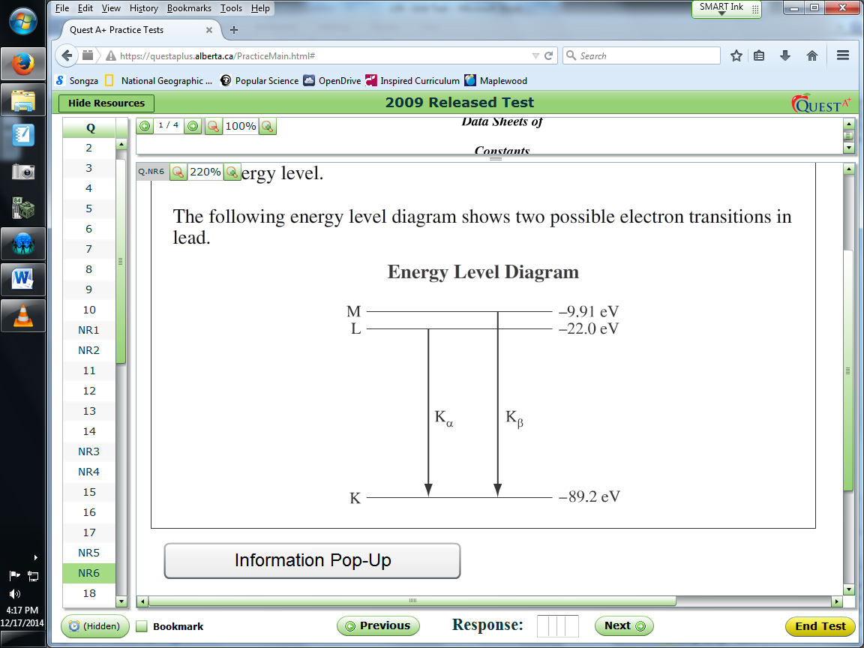

Q2: The frequency of the photons emitted in the K_{α} transition for lead, expressed in scientific notation, is _____ x 10^{w} Hz.
(Record your three-digit answer below)

Q3: Which of the following conclusions most closely followed the discovery that cathode rays consist of charged particles?
- J.J. Thomson’s conclusion that all atoms contained smaller parts called electrons.
- Bohr’s conclusion that electrons inhabit discrete energy levels around the nucleus.
- Maxwell’s conclusion that accelerating charges produce electromagnetic radiation.
- Rutherford’s conclusion that the atom has a dense, positively charged nucleus that electrons orbit.

Use the following information to answer Q4:
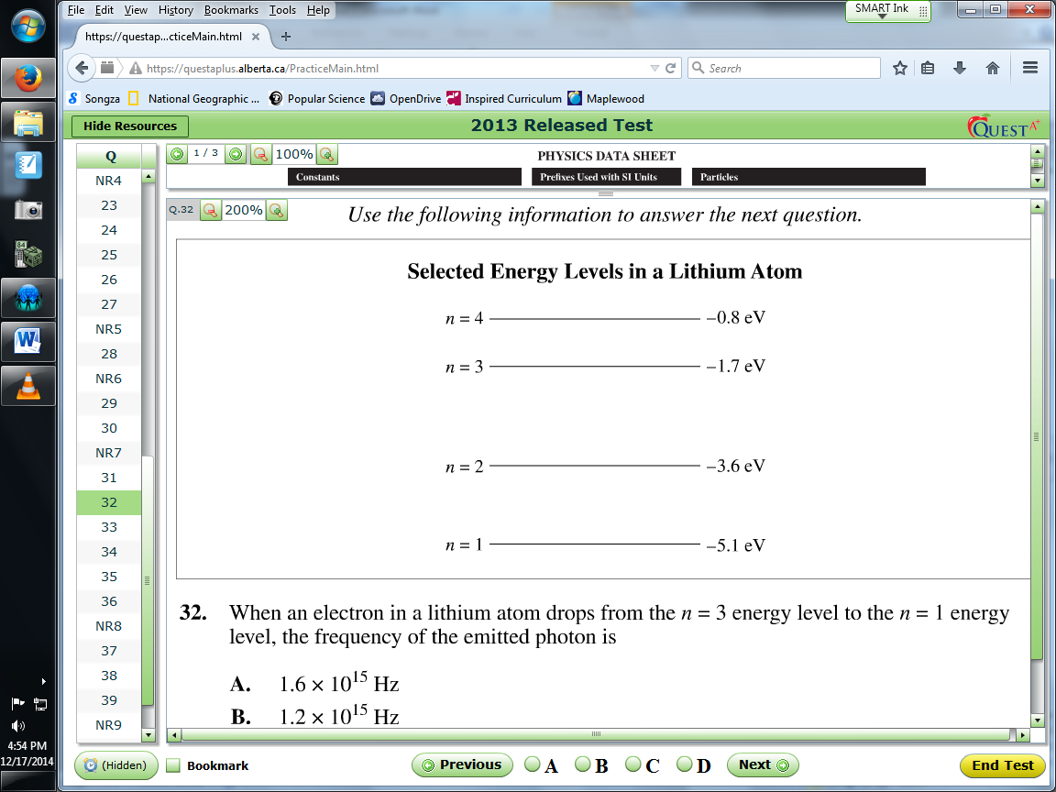

Q4: When an electron in a lithium atom drops from the n=3 energy level to the n=1 energy level, the frequency of the emitted photon is
- 1.6 x 10¹⁵ Hz
- 1.2 x 10¹⁵ Hz
- 8.2 x 10¹⁴ Hz
- 4.1 x 10¹⁴ Hz

Use the following information to answer Q5:
A refractometer is a device that can be used to identify gemstones by determining their index of refraction.
Monochromatic yellow light that has a wavelength of 589 nm is directed so that it passes through the prism and meets the prism-gemstone interface. When the angle of incidence, ϴ_{i}, is large enough, the light does not refract into the gemstone, and is reflected. This light leaves the prism through a curved edge and is incident on a calibrated scale. The yellow light illuminates the scale, indicating the index of refraction of the gemstone.
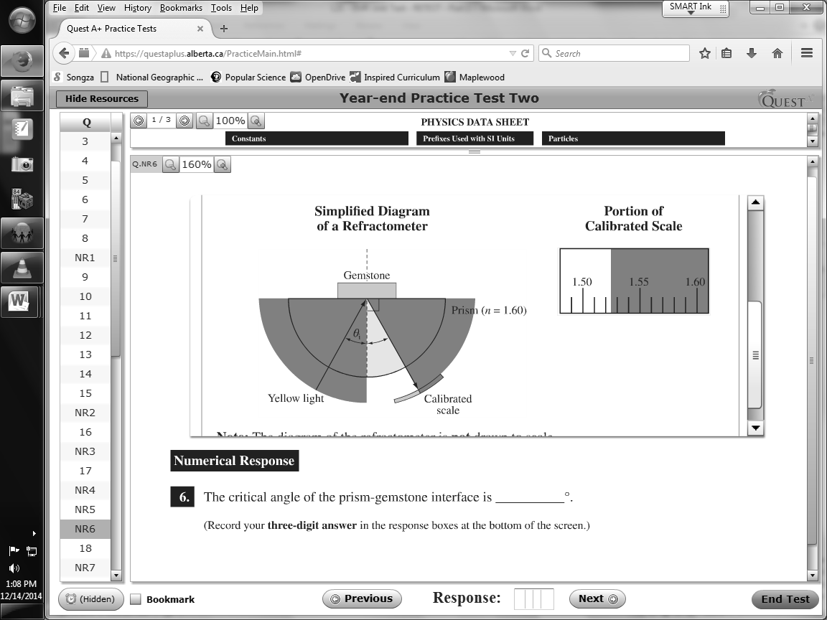
Historically, the light used by refractometers was produced by burning sodium chloride in a candle flame. The flame caused electrons in sodium to reach an excited energy state. As these electrons underwent transitions to a lower energy state, electromagnetic radiation that had a wavelength of 589 nm was emitted, as shown in the diagram below.
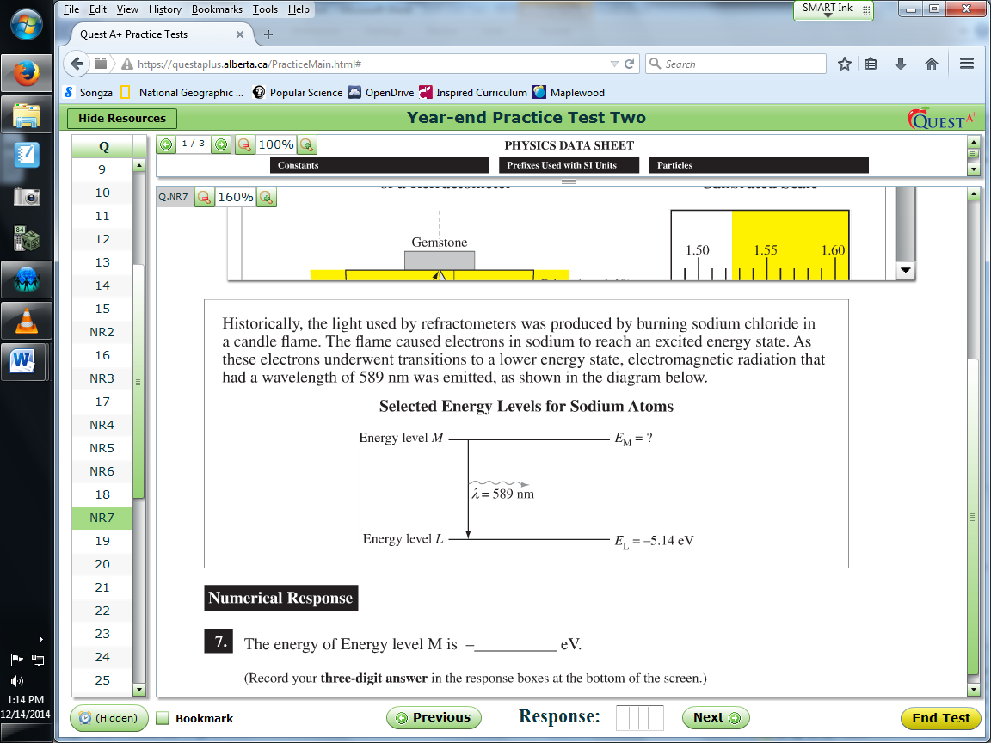

Q5: The energy of Energy level M is -_____ eV.
(Record your three-digit answer in the numerical response boxes below)

Use the following information to answer Q6:
Detection of Photons
Photons can be detected by using a proportional counter. The proportional counter is filled with argon gas. An electric potential difference is applied to the counter so that the anode, which is in the center of the counter, is positively charged. The exterior of the counter is the cathode, which is negatively charged, as shown below.
An atom of argon is located in Region Y. A photon collides with the atom, causing it to become singly ionized.
The free electron and the positive ion released by this process move in opposite directions within the counter. The motion of these charged particles constitutes a current, which can then be measured and used to determine the energy of the photon.
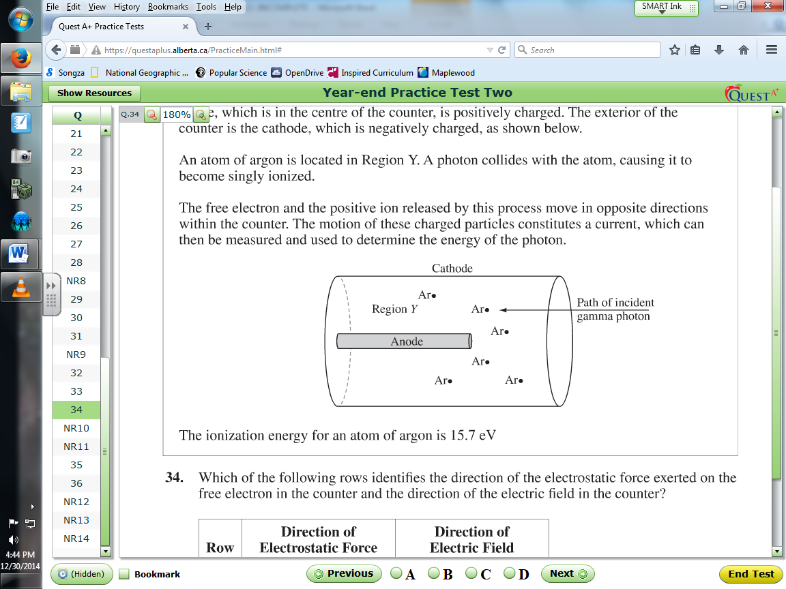
The ionization energy for an atom of argon is 15.7 eV.

Q6: The maximum wavelength of a photon capable of ionizing an atom of argon, expressed in scientific notation, is a.bc x 10^{-d} m. The values of a, b, c, and d are ____, ____, ____, and ____.
(Record your four-digit answer in the numerical response boxes below)

Q7: A sample of gas is bombarded with electrons that have an initial kinetic energy of 8.4 eV. Some of the electrons leaving the gas are found to have a kinetic energy of 3.8 eV. As a result of the bombardment, the gas is found to emit electromagnetic radiation. The frequency of the EMR emitted, expressed in scientific notation, is a.b x 10^{cd} Hz. The values of a, b, c, and d are ____, ____, ____, and ____.
(Record your four-digit answer in the numerical response boxes below)

Part 2 – Nuclear ___/15 marks
Q8: Which of the following types of radiation will have its path deflected by a perpendicular electric field?
- Alpha and beta only
- Beta and gamma only
- Alpha and gamma only
- Alpha, beta, and gamma

Q9: Two types of pions are modelled as consisting of either a down quark and an anti-up antiquark or an up quark and an anti-down antiquark. The only possible charges for these types of pions are
- $-\frac{2}{3}e or -\frac{1}{3}e$
- $+\frac{1}{3}e or +\frac{2}{3}e$
- $-1e or +1e$
- $-1e or 0$

Q10: When an electron and a positron collide, they annihilate and all of their mass is converted into energy. The energy released by the annihilation of an electron-positron pair is
- 1.64 x 10⁻¹³ J
- 8.20 x 10⁻¹⁴ J
- 5.47 x 10⁻²² J
- 2.73 x 10⁻²² J

Use the following to answer Q11-13:
Use the following information to answer Q1:
The element ununquandium (${}_{114}^{289}{Uuq}$) has been created by fusing calcium ions (${}_{20}^{48}{Ca}$) with plutonium nuclei (${}_{94}^{244}{Pu}$).
The calcium ions are doubly charged (+2e) and have a mass of 7.96 x 10⁻²⁶ kg. To accelerate these ions to a high enough energy to fuse with plutonium, they are repeatedly accelerated by an electric potential difference. They are contained in a magnetic field between these accelerations.
In one stage of the acceleration process, calcium ions enter the accelerating chamber at a speed of 1.00 x 10⁶ m/s and exit it at a speed of 2.75 x 10⁶ m/s. They immediately enter a magnetic field and follow a path that has a radius of 1.24m

Q11: Which of the following equations could be the nuclear reaction equation for the fusion of calcium and plutonium in the production of ununquandium?
- ${}_{20}^{48}{Ca}+{}_{94}^{244}{Pu}→{}_{114}^{289}{Uuq}+{}_{2}^{4}α$
- ${}_{20}^{48}{Ca}+{}_{94}^{244}{Pu}→{}_{114}^{289}{Uuq}+3{}_{-1}^{0}{β+\overline{ν}}$
- ${}_{20}^{48}{Ca}+{}_{94}^{244}{Pu}→{}_{114}^{289}{Uuq}+3{}_{0}^{1}n$
- ${}_{20}^{48}{Ca}+{}_{94}^{244}{Pu}+3{}_{0}^{1}n→{}_{114}^{289}{Uuq}$

Use the following additional information to answer Q12 and Q13:
The decay chain of ununquandium-289 is shown below.
$${}_{114}^{289}{Uuq}→{}_{112}^{285}{Uub}+X→{}_{110}^{281}{Ds}+Y$$
Ununquadium-289 has a half-life of 30.4 seconds.

Q12: The decay particles X and Y are
- Both alpha particles
- Both beta positive particles
- A beta positive particle and an alpha particle, respectively
- An alpha particle and a beta positive particle, respectively

Q13: If 1.00 μg of ununquandium-289 is initially produced, the mass of ununquandium-289 remaining after 1.00 min will be
- 0.255 μg
- 0.507 μg
- 0.703 μg
- 0.977 μg

Q14: A neutron and a proton can be modelled using quark combinations. Which of the following rows matches the quark combination to the nucleon?
Row | Neutron | Proton
A. | udd | uud
B. | uud | udd
C. | $$\overline{udd}$$ | $$\overline{uud}$$
D. | $$\overline{uud}$$ | $$\overline{udd}$$

- A.
- B.
- C.
- D.
Use the following information to answer Q15:
There are two possible sequences through which the unstable radioactive nucleus lead-212 can decay into a stable nucleus. They are shown below. The daughter nuclei are labelled 1, 2, 3, and 4.
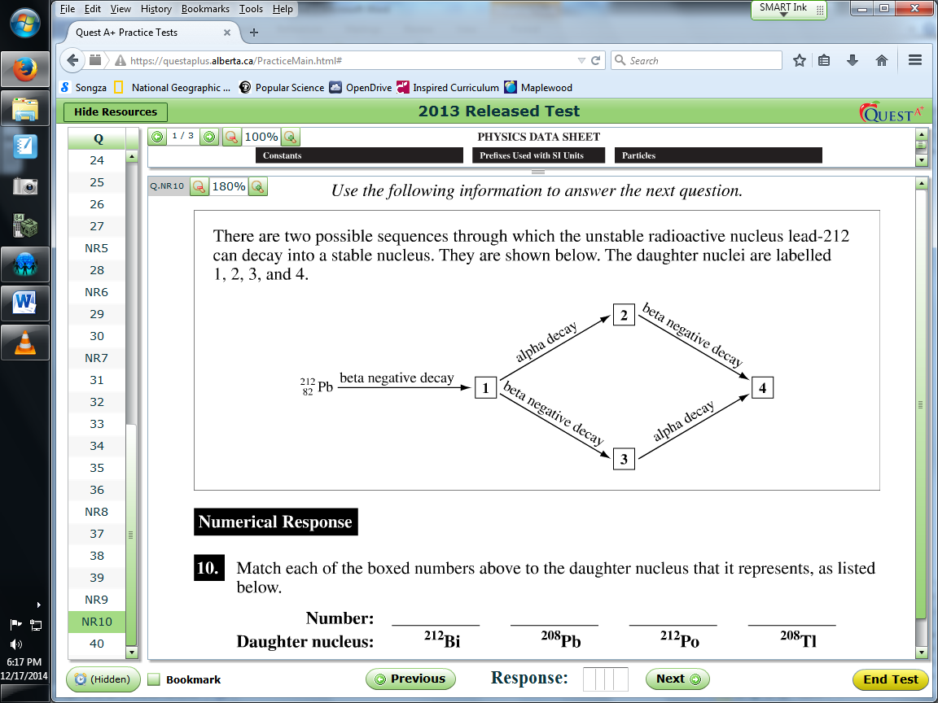

Q15: Math each of the boxed numbers above to the daughter nucleus that it represents, as listed below. (1 mark)
(Record all four digits of your answer in the numerical response boxes below)

Use the following information to answer Q16 – Q18:
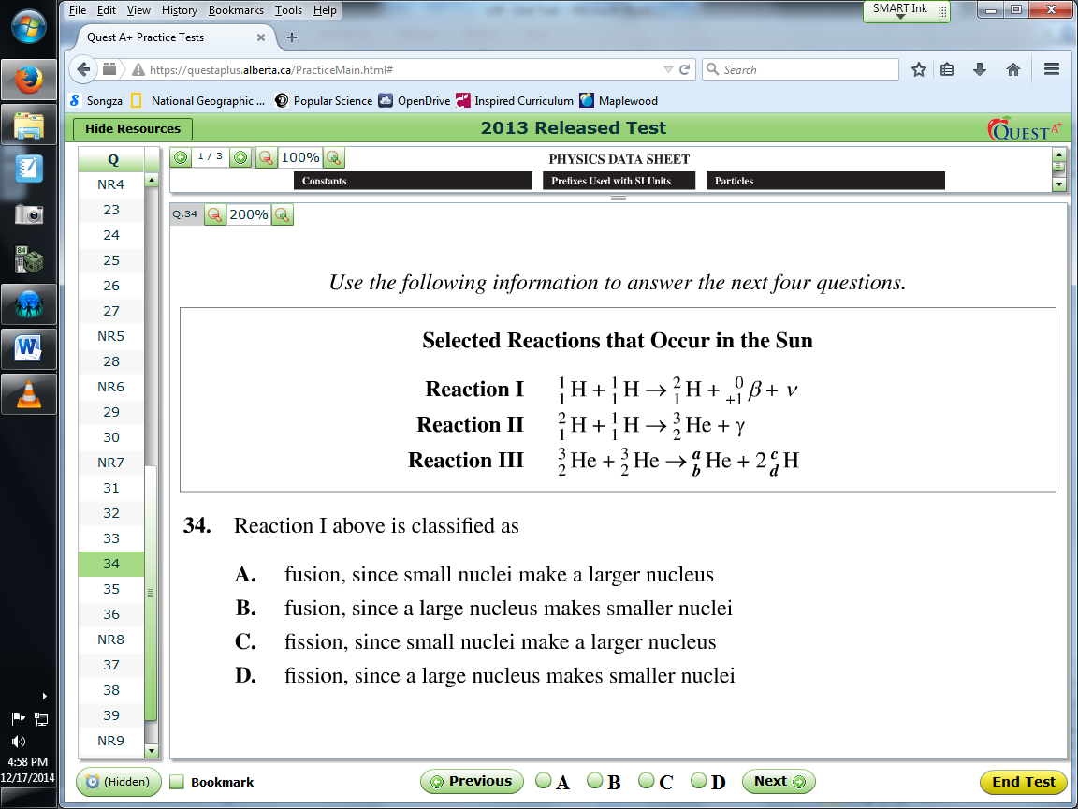

Text

Q16: Reaction I above is classified as
- Fusion, since small nuclei make a larger nucleus
- Fusion, since a large nucleus makes smaller nuclei
- Fission, since small nuclei make a larger nucleus
- Fission, since a large nucleus makes smaller nuclei
Q17: Which of the following statements describes the total measured mass as represented on the left side of reaction II as compared with the total measured mass represented on the right side?
- They are the same, since mass must be conserved.
- They are the same, since the number of nucleons must be conserved.
- The mass on the left side is smaller, because of the energy equivalence of the mass defect.
- The mass on the left side is greater, because of the energy equivalence of the mass defect.
Q18: To balance reaction III the numerical values of a, b, c, and d could be, respectively, ____, ____, ____, and ____. (1 mark)
(Record all four digits of your answer in the numerical response boxes below)

Use the following information for Q19:
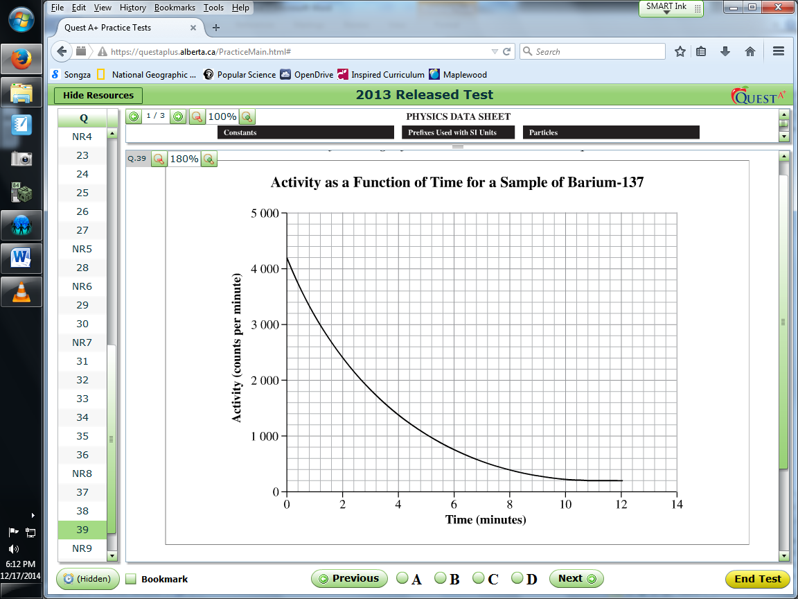

Q19: The activity of this sample after 3 half-lives have elapsed is approximately
- 260 counts/min
- 520 counts/min
- 1900 counts/min
- 2080 counts/min

Q20: The energy equivalence of the mass of one alpha particle, expressed in units of joules, in scientific notation to two significant digits, is a.b x 10^{-cd} J. The values of a, b, c, and d are ____, ____, ____, and ____. (1 mark)
(Record all four digits of your answer in the numerical boxes below)

Use the following information to answer Q21 and Q22:
Neutron activation analysis is a method that can be used to identify the elements in unknown samples.
There are three parts to neutron activation analysis: neutron production, the collision of a neutron with a nucleus, and the detection of the gamma photon.
Neutron Production
One way to produce neutrons is to use americium-241 and beryllium-9. Americium-241 undergoes alpha decay. The alpha particle interacts with a nucleus of beryllium-9 to produce a daughter nucleus, X, and a neutron. This interaction is represented by the following nuclear reaction equation.
$${}_{2}^{4}∝+{}_{4}^{9}{Be}→{}_{c}^{ab}X+{}_{0}^{1}n$$
Each of the neutrons released in this process has a kinetic energy of 4.00 MeV.
Collision of a Neutron with a Nucleus
The neutrons are then directed at a sample. If a neutron is absorbed by a nucleus, the nucleus will form a new, unstable isotope that is at a higher energy state then the original nucleus. The new isotope may then undergo a transition to a more stable energy state, releasing a gamma photon in the process.

Q21: When balancing the nuclear reaction equation above, the physics principle that is used to determine the values of a and b is __i__. The physics principle that is used to determine the value of c is __ii_.
The statements above are completed by the information in row
Row | i | ii
A. | Conservation of nucleons | Conservation of charge
B. | Conservation of nucleons | Conservation of nucleons
C. | Conservation of charge | Conservation of charge
D. | Conservation of charge | Conservation of nucleons

Q22: The speed of the neutrons produced by an alpha particle-beryllium interaction, expressed in scientific notation, is a.bc x 10^{d} m/s. The values of a, b, c, and d are ____, ____, ____, and ____. (2 marks)
(Record all four digits of your answer in the numerical response boxes below)

