First Name:__________________________________ Last Name:______________________________

L14 – Formative Quiz – Left Hand Rule

Q1: For each of the following, diagram the direction of electron flow. (2 marks)
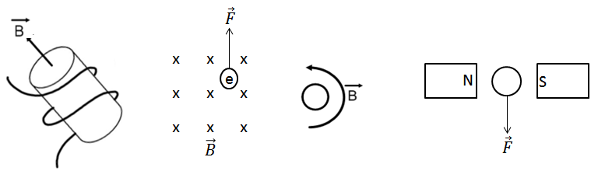
Q2: In the diagram below, an unknown charge moving out of the page at 5.0 x 10³ m/s experiences an upward magnetic force of 0.26 N when passing through a magnetic field of 2.0 T. What is the charge on the object? (2 marks)
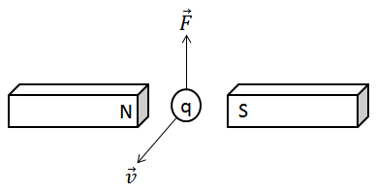

MARKING:
Beginning 0 – 1.5
Progressing 2 – 2.5
Competent 3 – 3.5
Exemplary 4

