First Name:______________________________ Last Name:______________________________

L14 - Phys20 – Dynamics – Practice 3

IMPORTANT: Do not open your tests until instructed to do so.

This test is broken into three sections, split up by competency. Each section corresponds to a summative quiz that was written in class. If you show improved knowledge on any of these sections, I will modify your quiz mark to show the same ability (percentage). In short, this test acts as a retest for each of your summative quizzes.
Competency 3 – Forces and Motion
Forces and Acceleration
Friction and Newton’s Third Law
Your score on this test will be recorded by competency, under each competency. The corresponding sections of this test will account for 40% of each competency.
Good luck!
_____________________________________________________________________________________
This section for the teacher’s use only.

Competency 3 – Forces and Acceleration _____ / 6 x1.67 = _____/ 10
Competency 3 – Friction and Newton’s Third Law _____ / 7 x1.43 = _____/ 10

Competency 3 – Forces and Acceleration
Q1: A 30kg box initially at rest is being pulled by three individuals. The first individual applies a force of 110N [30° N of W]. The second individual applies a force of 135 N [20° S of W]. The third individual applies a force of 60 N [E]. How long does it take for the box to travel 20 m? (3 marks)
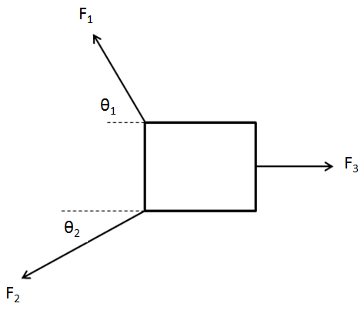

Q2: A sign of mass 15kg is hanging suspended, as shown below. If the angle between the left cable is 35°, what is the tension in each cable? Show all of your work. (3 marks)
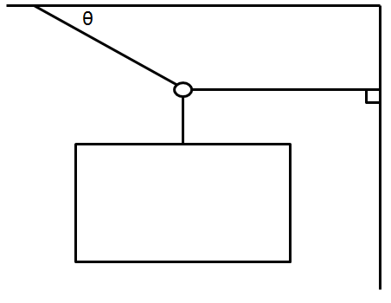

Competency 3 – Friction & Newton’s Third Law
Q3: A child on a sled (45kg combined) is being towed downhill by a snowmobile. The coefficient of kinetic friction between the sled and the hill is 1.10. If the sled is pulling the child at a constant speed of 10 m/s, what is the force applied by the snowmobile (F_{APP})? (4 marks)

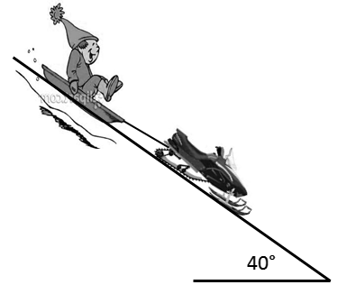

Q4: If m_{A} = 30 kg, m_{B} = 20kg, and the force that B applies on A is 60N [left], what is the force applied? (3 marks)
