First Name:______________________________ Last Name:______________________________

L14 - Phys20 – Circular Motion - REVIEW
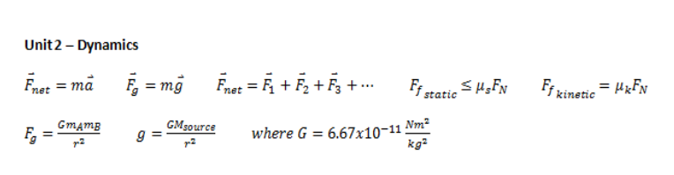
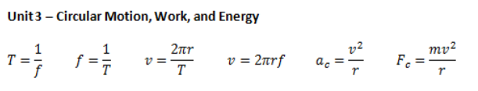

Your questions will be marked as follows, unless otherwise specified:
1 Mark Question
• 1 mark – Answer
3 Mark Question
• 1 mark – “What you know”
• 1 mark – Equation with units substituted in
• 1 mark - Answer

Q1: A ball spins in a tight loop with a frequency of 15.6 Hz. What is the Period of rotation? (1 mark)

Q2: A ball is attached to a 3m wire and swings at 15m/s. What is the frequency of rotation? (3 marks)

Q3: If a car is rounding a 10m radius corner at a steady 8m/s, what is the centripetal acceleration of the car? (3 marks)

REMINDER: Have you included your units with your answer?

Q4: The Moon (7.348x10²² kg) orbits the Earth (5.97x10²⁴ kg). If the distance between the center of masses is 3.8440x10⁸ m, how fast (m/s) does the Moon actually move? (4 marks)
1 mark – “What you know” 1 mark – Equation setup
1 mark – Force of Gravity OR 1 mark – Simplify equation
1 mark – Centripetal Force 1 mark – Equation with units
1 mark – Answer 1 mark - Answer

REMINDER: Have you included your units with your answer?
1kg = 1000g 1m = 100cm

Q5: A rubber stopper of mass 15g is attached to a string and swung in a circle. If the stopper moves with a speed of 5m/s and a radius of 80cm, what is the mass of the hanging washers at the bottom of the string?
1 mark – “What you know” in S.I. Units
1 mark – Centripetal Force
1 mark – Tension and Gravitational Force
1 mark – Mass of hanging washers
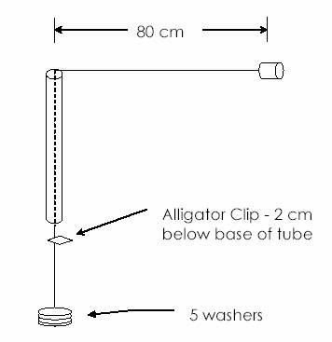

REMINDER: Have you included your units with your answer?
Use the following information to answer Q6-8.
A skateboarder of mass 50kg wants to skate through a loop of diameter 4m. 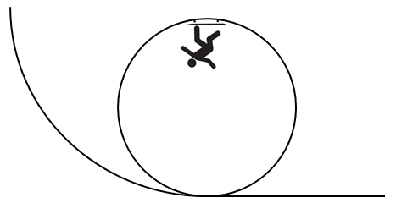
Q6: What is the minimum speed the skateboarder needs to complete this loop? (3 marks)

Q7: If the skateboarder was travelling at 7m/s, what is the normal force they experience at the top of the loop? (3 marks)

Q8: If the skateboarder was travelling at 7m/s, what is the normal force they experience at the bottom of the loop? (1 mark)

Q9: The diagram is a schematic of a ride at the Calgary Stampede. In this ride, the force of friction supports the passengers on the vertical walls of a spinning cage. The coefficient of friction between the wall and the passengers is 0.320. The cage has a diameter of 13.4m. What is the maximum period that the cage could have so that the passengers would not slide down the wall? (3 marks)
