First Name:_____________________________ Last Name:______________________________

L14 – Worksheet – Mass-Spring Systems and Pendulums /18 marks

Part 1: Mass-Spring Systems
Use the following information to answer Q1-Q2:
A mass of 200g is attached to a spring. The spring is held stretched at 50cm by a force of 200N. When the spring is released, it will oscillate back and forth.

Q1: What is the period of the oscillation?
- 1.57 x 10⁻⁶ s
- 2.51 x 10⁻⁵ s
- 1.40 x 10⁻¹ s
- 2.81 x 10⁻¹ s

Q2: How much potential energy is stored in the spring the moment before it is released?
- 50 J
- 100 J
- 200 J
- 400 J

Q3: The maximum speed of the mass as it oscillates is a.bc x 10^{d} m/s, where a, b, c, and d are ___, ___, ___, and ___.
(Record your four digit answer in the Numerical Response boxes below)

Use the following information to answer Q4-Q5:
A 5kg mass is attached to a spring of constant 15N/m at equilibrium (Position A). The spring is pulled 3m to the right (Position B), held stationary, and then released.
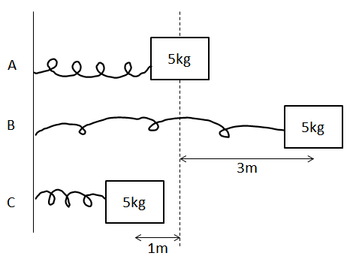

Q4: How much force is required to keep the mass held at Position B?
- 5.0 N
- 15.0 N
- 45.0 N
- 67.5 N

Q5: What is the speed of the 5kg mass when 1m to the left of equilibrium (Position C), in m/s?
(Record your three digit answer in the Numerical Response boxes below)

Part 2: Pendulums
Q6: Mathematically prove that the instantaneous acceleration of a pendulum is independent of the mass on the end of the pendulum arm. (2 marks)

Q7: An astronaut with a mass of 80kg travels to Pluto, and builds a pendulum of arm length 0.8m. If the pendulum oscillates with a period of 8.89 seconds. The Force of Gravity that the astronaut is experiencing is a.bc x 10^{d} N, where a, b, c, and d are ___, ___, ___, and ___.
(Record your four digit answer in the Numerical Response boxes below)

Use the following information to answer Q8-Q10:
A 4kg mass is attached to a pendulum with an arm length of 1.25m. The pendulum arm is raised 50⁰ from the vertical, then released.
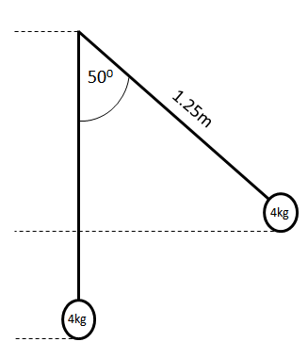

Q8: What is the restoring force acting on the pendulum the moment it is released?
- 25.22 N
- 30.06 N
- 39.24 N
- 46.76 N
Q9: The frequency of oscillation of the pendulum is a.bc x 10^{-d} Hz, where a, b, c, and d are ___, ___, ___, and ___.
(Record your four digit answer in the Numerical Response boxes below)

Q10: What is the maximum speed of the pendulum during oscillation, in m/s? (2 marks)
Part 3: Combination Questions (Hard)
Q11: What is the tension in the pendulum arm at the bottom of the swing? (3 marks)
HINT: The answer is not 19.62N.
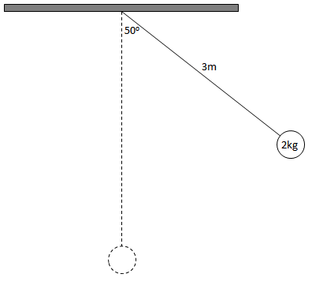

Q12: A pendulum arm is clipped when at equilibrium, as per the diagram below. What is the horizontal distance that the 2kg mass travels after being clipped from the pendulum arm? (3 marks)
