First Name:______________________________ Last Name:______________________________
L14 – Worksheet – Motor Effect on a Wire
Textbook Questions
Pg 605 #1: A 0.500-m length of conducting wire carrying a current of 10.0 A is perpendicular to an external magnetic field of magnitude 0.200 T. Determine the magnetic force on this wire.

Pg 605 #2: A thin conducting wire 0.75 m long has a mass of 0.060 kg. What is the minimum current required in the wire to make it “float” in a magnetic field of magnitude 0.15 T?

Pg 613 #8: A wire lying perpendicular to an external magnetic field carries a current in the direction shown in the diagram below. In what direction will the wire move due to the resulting magnetic force?
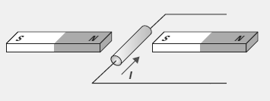
Pg 613 #9: A battery supplies a current of 5.20 mA to a circuit. Determine the quantity of charge that flows through the circuit in 2.00s.

Pg 613 #10: Two conducting wires are parallel to each other carrying currents in opposite directions. Using the appropriate hand rule, determine whether the wires will attract of repel each other.

Pg 613 #11: A wire 50 cm long and carrying a current of 0.56 A is perpendicular to an external magnetic field of 0.30 T. Determine the magnitude of the magnetic force on the wire.

Diploma Worksheet Questions – Motor Effect (Basic Definitions)
Q259: Electric current is a measure of the
- Rate at which charge passes a point
- Force that moves a charge past a point
- Energy required to move a charge past a point
- Resistance to the movement of a charge past a point

Q263: If the beam of high-speed protons produced by a cyclotron is equivalent to a current of 3.2 x 10⁻³ A, the number of protons that will leave the cyclotron each second is
- 2.0 x 10¹⁶
- 6.3 x 10¹⁸
- 2.0 x 10²¹
- 5.1 x 10²²

Q268: A current of 0.403 A flows for 3.04 min. The quantity of charge transferred is _____ C.
(Record your three digit answer in the Numerical Response boxes below)

Diploma Worksheet Questions – Motor Effect (Charge in a Wire)
Use the following information to answer Q302:
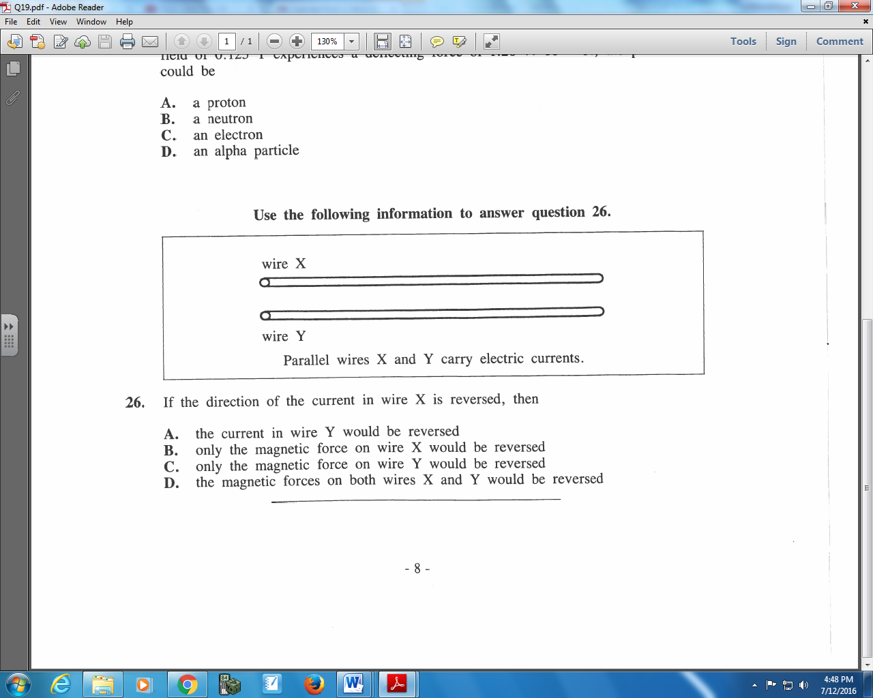

Q302: If the direction of the current in wire X is reversed, then
- The current in wire Y would be reversed
- Only the magnetic force on wire X would be reversed
- Only the magnetic force on wire Y would be reversed
- The magnetic forces on both wires X and Y would be reversed

Use the following information to answer Q303:
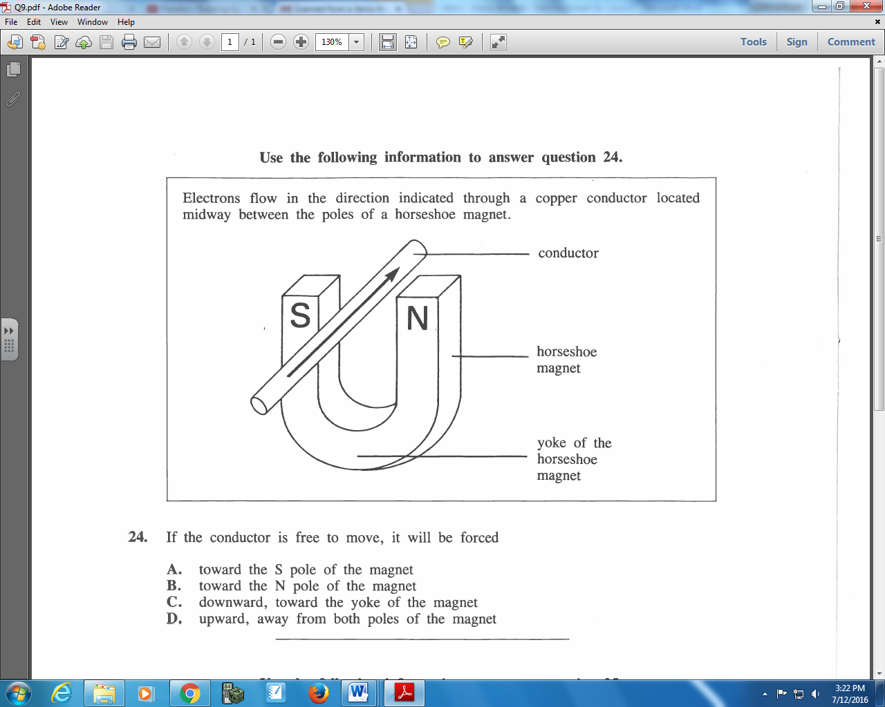

Q303: If the conductor is free to move, it will be forces
- Toward the S pole of the magnet
- Toward the N pole of the magnet
- Downward, toward the yoke of the magnet
- Upward, away from both poles of the magnet
Use the following information to answer Q304:
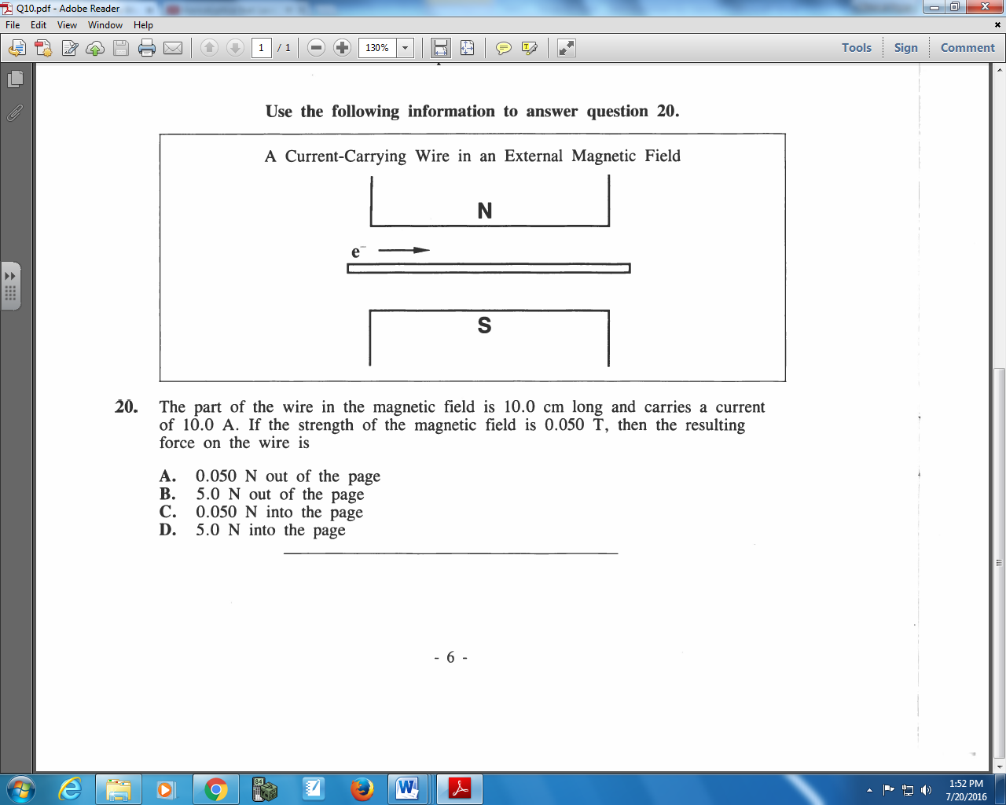

Q304: The part of the wire in the magnetic field is 10.0 cm long and carries a current of 10.0 A. If the strength of the magnetic field is 0.050 T, then the resulting force on the wire is
- 0.050 N out of the page
- 5.0 N out of the pate
- 0.050 N into the page
- 5.0 N into the page

Challenge Questions
Use the following information to answer Q1:
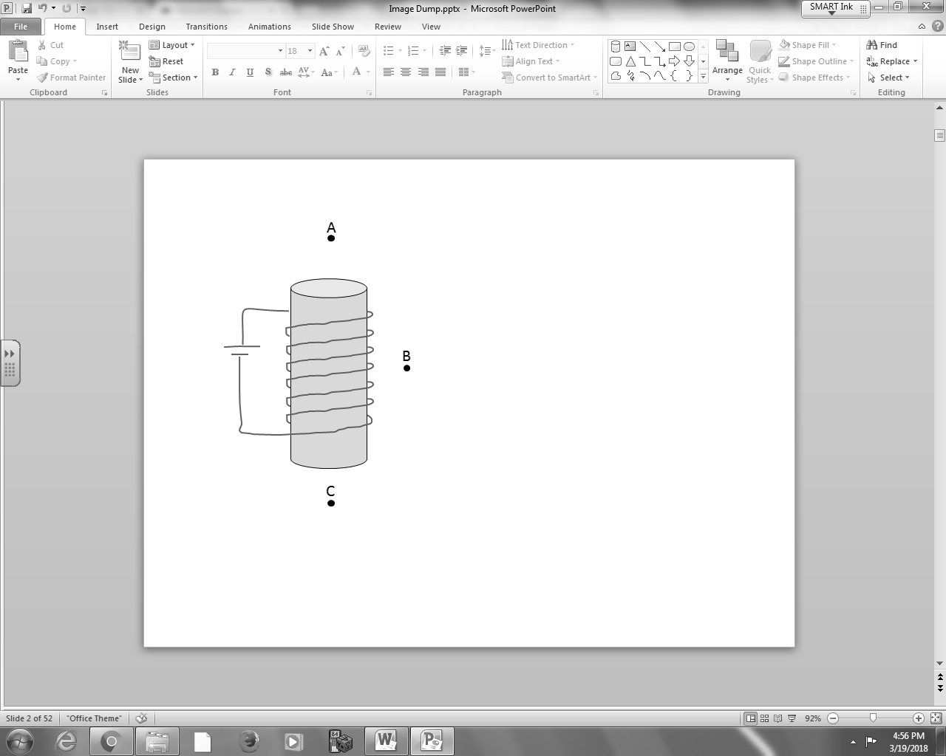
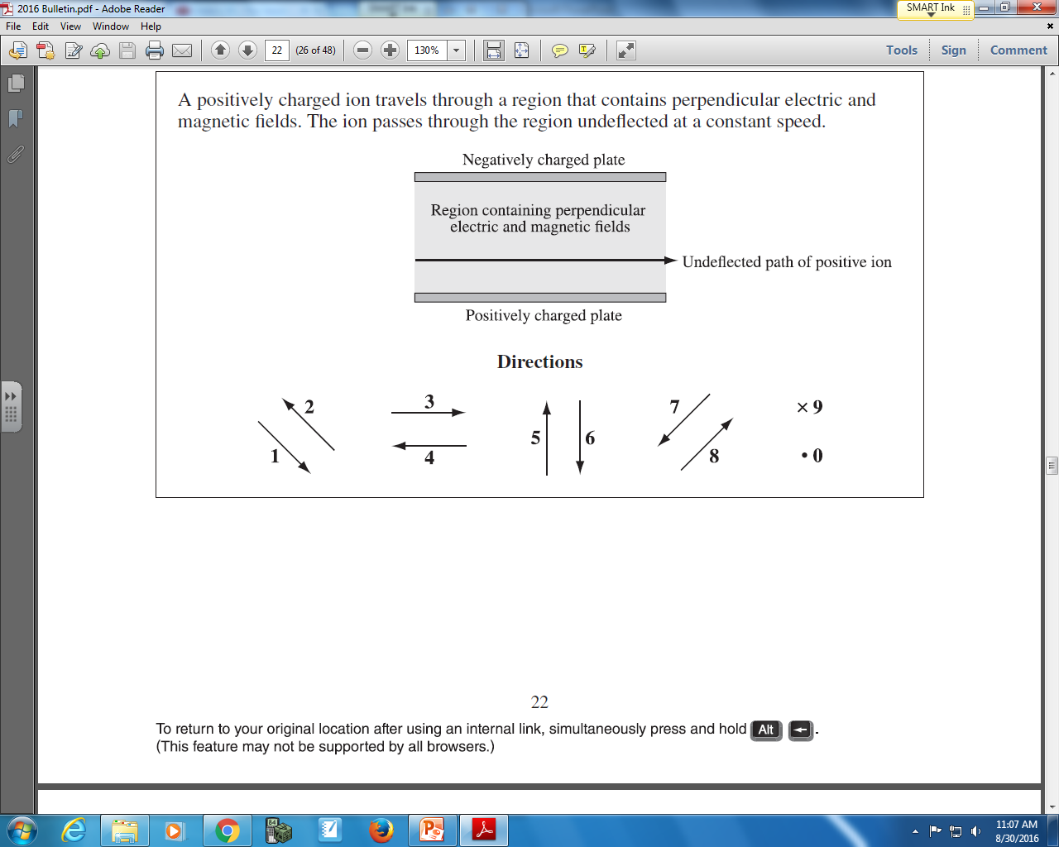

Q1: The directions of magnetic field at various points can be described using the numbers given above.
Direction: __________ __________ __________
Force: Magnetic field Magnetic field Magnetic field
at Point A at Point B at Point C
(Record your three digit answer in the Numerical Response boxes below)

Cumulative Review from Previous Units
Use the following information to answer Q1:
Three Point Charges
Three point charges are arranged at a right angle according to the diagram below.
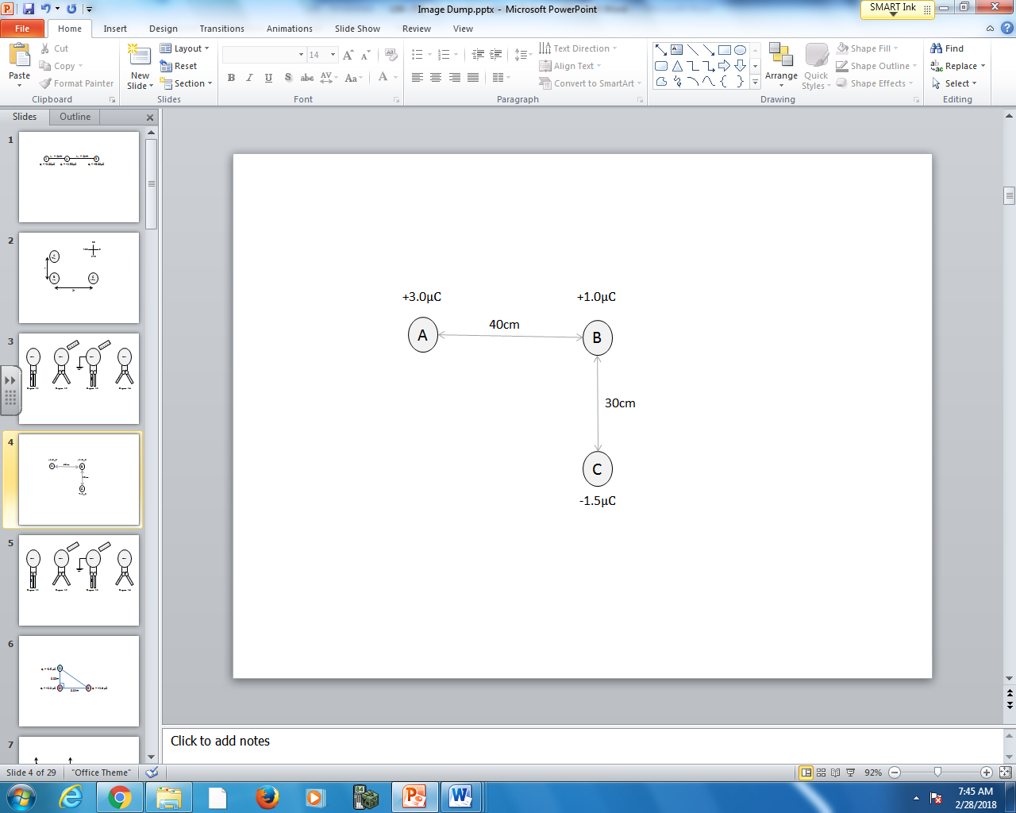
Directions
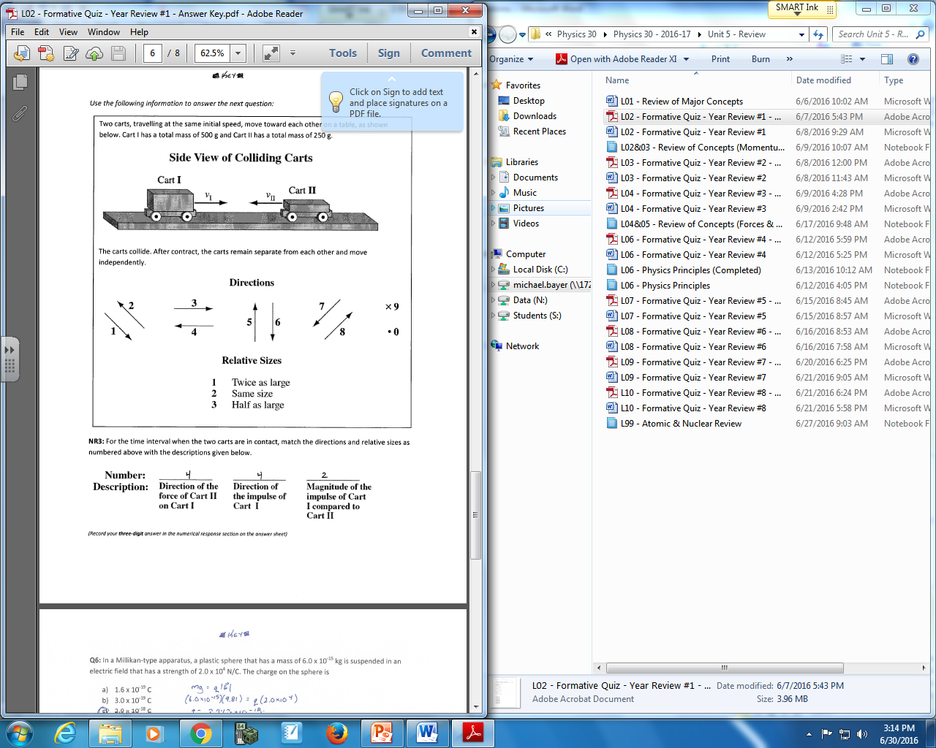

Q1: Use the vector directions above to fill in the blanks below.

Direction: __________ __________ __________
Description: Direction of Direction of Direction of
Force acting on Force acting on Net Force acting
Charge B due to Charge B due to on Charge B
Charge A Charge C

(Record your three-digit answer in the Numerical Response boxes below)

