First Name:______________________________ Last Name:______________________________
L14 – Worksheet – Photoelectric Effect 1
Overview
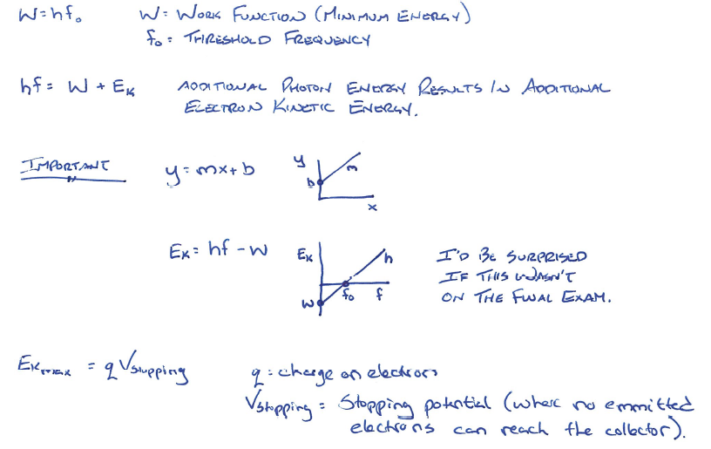
X-Ray Production versus Photoelectric Effect
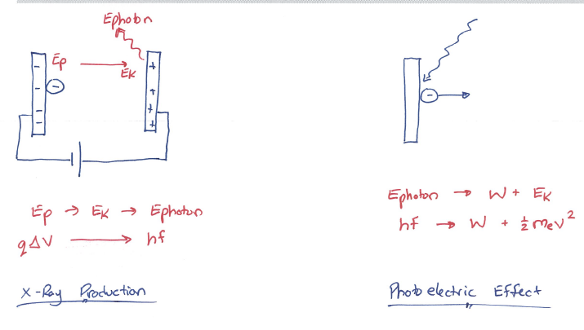
Textbook Questions
Pg 718 #1: Light of wavelength 480 nm is just able to produce photoelectrons when striking a metal surface. What is the work function of the metal?

Pg 718 #2: Blue light of wavelength 410 nm strikes a metal surface for which the work function is 2.10 eV. What is the energy of the emitted photoelectron?

Pg 719 #1: A photoelectron is emitted with a kinetic energy of 2.1 eV. How fast is the electron moving?

Pg 719 #2: What is the kinetic energy of a photoelectron emitted from a cesium surface when the surface is illuminated with a 400-nm light?

Pg 719 #3: What is the maximum speed of the electron described in Pg 719 #2?

Use the following information to answer Pg 720 #8-10
The following data are taken from an experiment in which the maximum kinetic energy of photoelectrons is related to the wavelength of the photons hitting a metal surface. Use these data to answer the following questions.
Wavelength (nm) | Frequency (Hz) | Kinetic Energy (eV)
500 |  | 0.36
490 |  | 0.41
440 |  | 0.70
390 |  | 1.05
340 |  | 1.52
290 |  | 2.14
240 |  | 3.025

Pg 720 #8: Convert the wavelength given in the data table to frequency units and sketch a quick graph of the kinetic energy of the photoelectrons versus frequency. Label important points.

Pg 720 #9: Give the value of the slope of the graph that you just drew. What is the significance of this value?

Pg 720 #10: What metal do you think was used in the previous example? Justify your answer.
Element | Work Function (eV)
Aluminium | 4.08
Beryllium | 5.00
Cadmium | 4.07
Calcium | 2.90
Carbon | 4.81
Cesium | 2.10
Copper | 4.70
Magnesium | 3.68
Mercury | 4.50
Potassium | 2.30
Selenium | 5.11
Sodium | 2.28
Zinc | 4.33

Cumulative Review from Previous Units
Use the following information to answer Q1:
Two parallel plates are 0.32m apart, with a uniform electric field of 2.5 N/C, as depicted below.
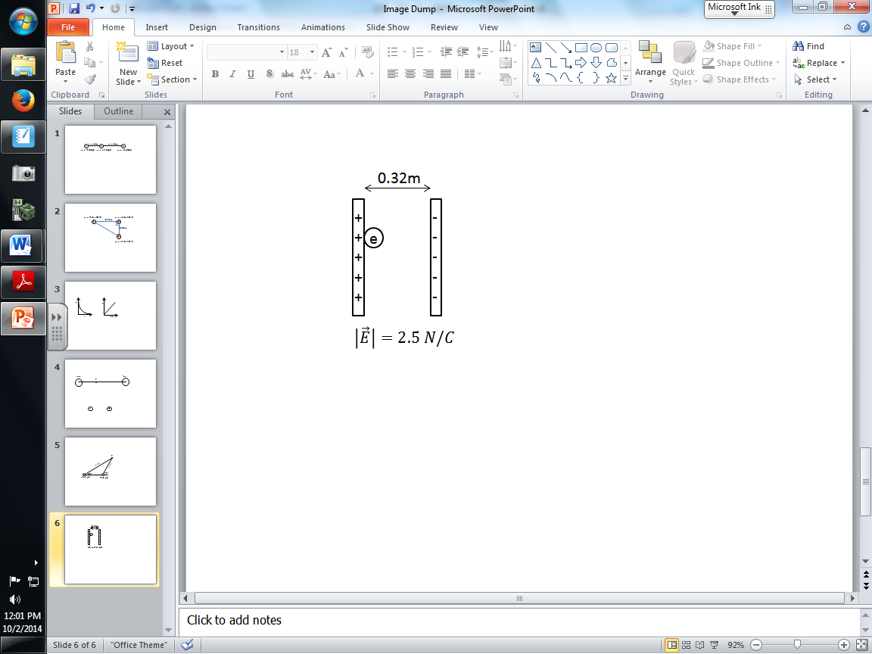
An electron is moved from the positively charged plate to the negatively charged plate.

Q1: Due to being moved from one plate to the next, the electron gains a.bc x 10^{-d} eV of Electric Potential Energy, where a, b, c, and d are ___, ___, ___, and ___.
(Record your four digit answer in the Numerical Response boxes below)

