First Name:__________________________________ Last Name:______________________________

L15 – FQ – Motor Effect on a Wire

Q1: In the diagram below, a sphere of unknown charge is moving upward at 3.0 x 10⁴ m/s though a magnetic field of 2.5 x 10² Tesla. If it experiences a magnetic force of 2.4 x 10⁻¹² N to the right, what is the charge on the sphere? (2 marks)
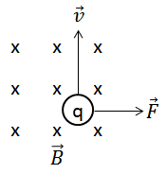

Q2: A battery produces 6 mA of current. If 1.5 cm of wire is passed through a magnetic field of strength 1.3 Tesla, what is the magnitude and direction of the magnetic force on the wire? (2 marks)
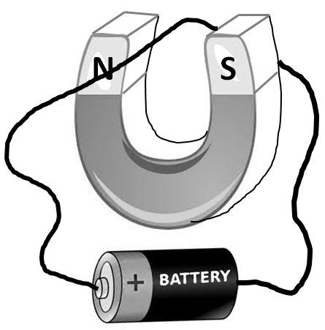

MARKING:
Beginning 0 – 1.5
Progressing 2 – 2.5
Competent 3 – 3.5
Exemplary 4

