First Name:___________________________ Last Name:______________________________

L15 - FQ – Photoelectric Effect 1

Q1: In the photoelectric effect the kinetic energy of emitted electrons is determined by the ________ of the incident light, and the number of emitted electrons is determined by the ________ of the incident light.
 | Kinetic energy of emitted electrons is determined by: | Number of emitted electrons is determined by:
A. | Frequency | Frequency
B. | Frequency | Intensity
C. | Intensity | Frequency
D. | Intensity | Intensity

Q2: An incident photon of wavelength 450nm is incident on a Sodium surface with a work function of 2.28eV. Determine the kinetic energy of the emitted electrons, measured in electronvolts.
(Record you three-digit answer in the numerical response boxes below.)

Use the following information to answer Q3 and Q4:
Graph of the Kinetic Energy of Emitted Electrons from a Zinc Target
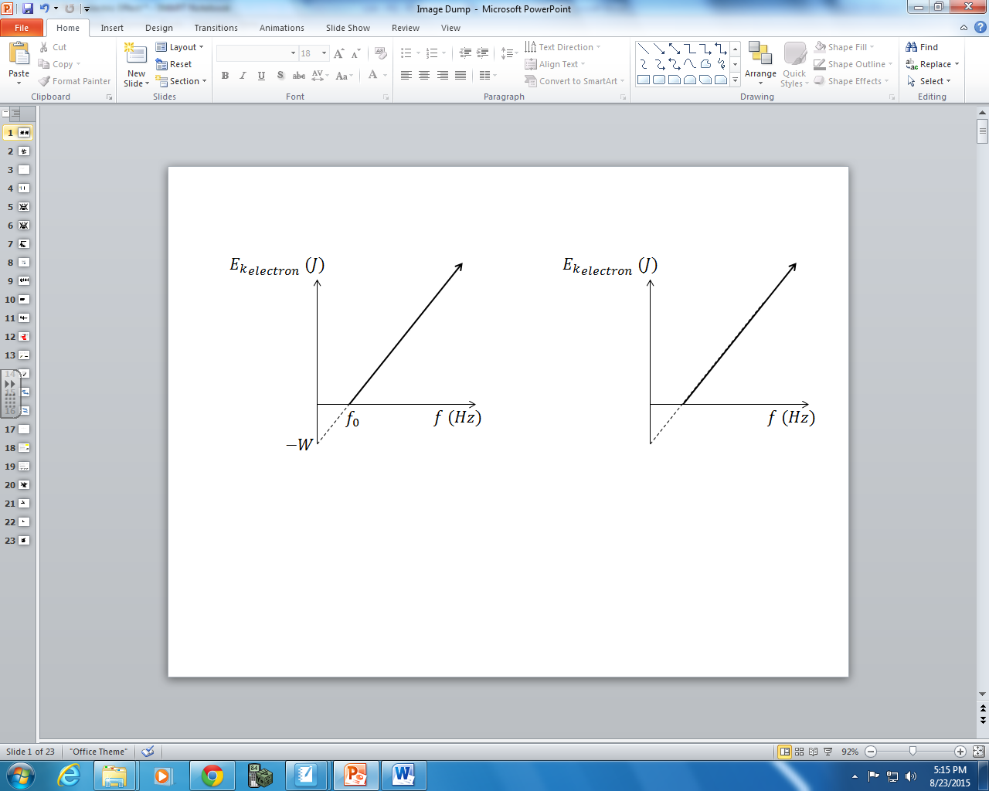
Zinc has a Work Function of 4.30eV.

Q3: The slope of this graph is a.b x 10^{-cd} Js, where a, b, c, and d are ____, ____, ____, and ____.
(Record you four-digit answer in the numerical response boxes below.)

Q4: The threshold frequency of the incident photons required for electron emission from a zinc target is a.b x 10^{cd} Hz, where a, b, c, and d are ___, ___, ___, and ___.
(Record you four-digit answer in the numerical response boxes below.)

Q5: The energy of a single red photon is
- 2.65 x 10⁻²⁸ J
- 4.97 x 10⁻²⁸ J
- 2.65 x 10⁻¹⁹ J
- 4.97 x 10⁻¹⁹ J
Use the following information to answer Q6:
White light is shown through a double-slit apparatus (Diagram #1) and a glass prism (Diagram #2).
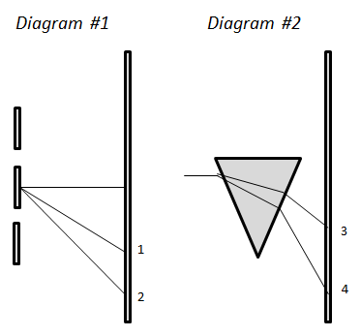
In both cases, a rainbow spectrum appears.

Q6: Text

Q6: The locations of blue and red light can be identified using the numbers given above.
Direction: __________ __________ __________ __________
Force: Location of blue Location of red Location of blue Location of red
light in Diagram #1 light in Diagram #1 light in Diagram #2 light in Diagram #2
(Record your four digit answer in the Numerical Response boxes below)

MARKING:
Beginning 0.0 – 2.5
Progressing 3.0 – 4.0
Competent 4.5 – 5.5
Exemplary 6.0

