First Name:_____________________________ Last Name:______________________________

L16 - Physics 20 – Practice Unit Test 2

Topic 1 – Interpreting Graphs – Version 2
The following is a Position vs. Time graph of a remote control car. Use the graph to answer Q1-4.

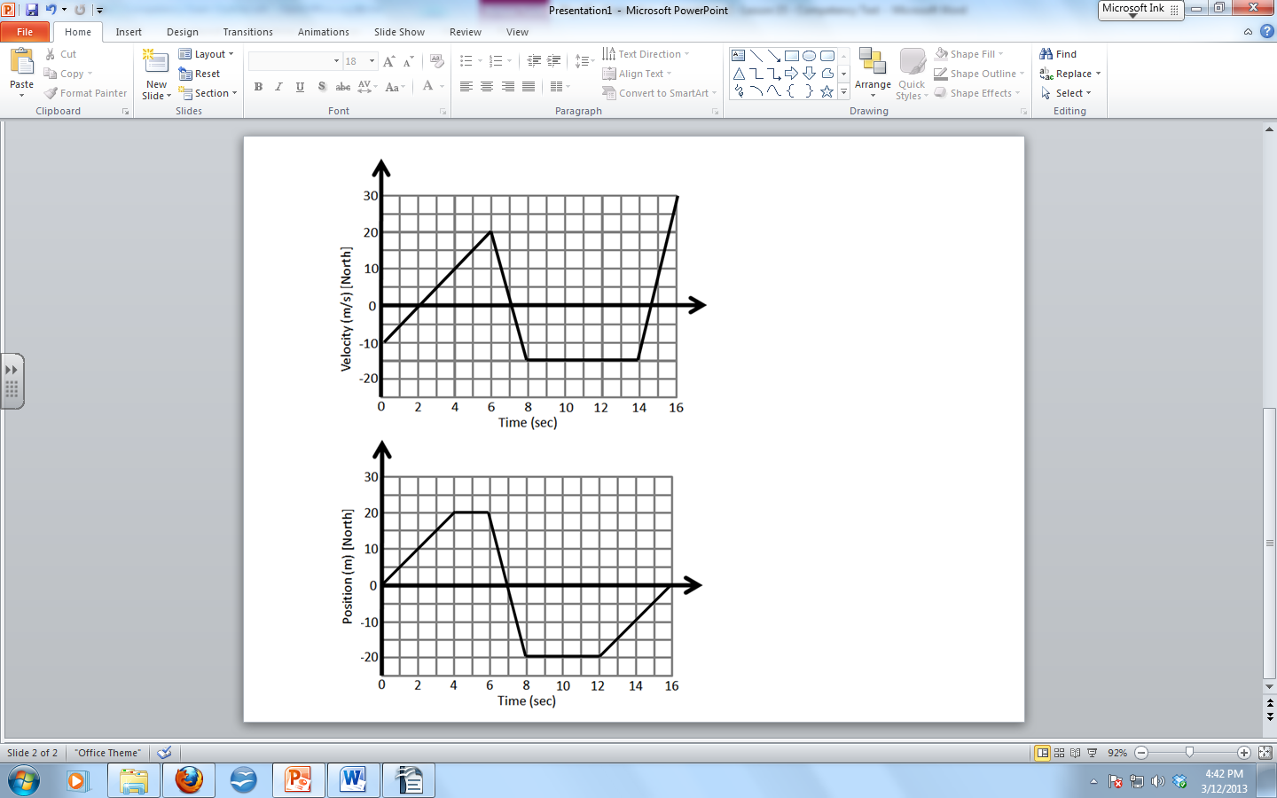
Q1: During what time(s) is the remote control car moving South? (1 mark)

Q2: What is the velocity of the car between 6 and 8 seconds? (1 mark)

Q3: What is the acceleration of the car between 12 and 16 seconds? (1 mark)

Q4: What is the displacement of the car between 6 and 8 seconds? (1 mark)

The following is a Velocity vs. Time graph of a remote control car. Use the graph to answer Q5-8.

Q5: During what time(s) is the remote control car moving South? (1 mark)

Q6: During what time(s) is the remote controlled car travelling with uniform motion? (1 mark)

Q7: What is the acceleration of the car between 6 and 8 seconds? (1 mark)

Q8: What is the displacement of the car between 0 and 6 seconds? (1 mark)

Topic 1 – Accelerated Motion – Version 2

Q9: Early Sunday morning Mr. Bayer’s two cats decide to fight. Nunzio decides to push David off of a 1.8 meter tall dresser. How fast is David going when he hits the ground? (3 marks)

Q10: Later that afternoon Nunzio is walking at 0.8m/s when Kepler, the hyper dog, decides he also wants to play. Nunzio accelerates to 2.6m/s after only 2 seconds. How much distance did it take Nunzio to accelerate? (3 marks)

Q11: A wild cheetah is resting on the ground when its natural prey, the kangaroo, runs by at a steady 2m/s. If the instant the kangaroo is beside the cheetah the cheetah accelerates at 1.2m/s², how long will it take the cheetah to catch the kangaroo again? (4 marks)
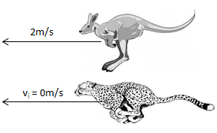

Topic 2 – Adding Vectors in 2-Dimensions Version 2
Q12: Mr. Siemens is very busy in FLEX class helping students. First he travels 3m [35° N of W] to help one student, then 4m [72° W of S] to help another. What is Mr. Siemens’ total displacement? (4 marks)

Q13: A Boeing 747 airplane wishes to travel 3000km [East], and is capable of travelling at 80.6m/s. If there exists a crosswind of 15m/s [South], and the plane is going to compensate for this, what will be the resultant ground speed of the plane if it weighs 442,253kg? (2 marks)

Topic 2 – Projectile Motion – Version 2
Q14: Mr. Bayer enjoys throwing his pet cats at swimmers. If he throws Nunzio horizontally at 3m/s from a 15m tall cliff, how far away should a swimmer be if Mr. Bayer wants Nunzio to land on their back?
(3 marks)
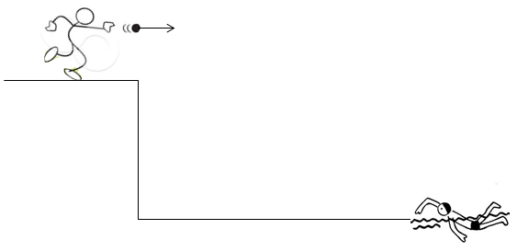

Q15: Mr. Siemens throws a ball at 8m/s [35°]. What is the velocity of the ball the instant before it is caught by Mr. Aspenes? Prove your answer mathematically. (3 marks)

