First Name:_____________________________ Last Name:______________________________

L15 - Physics 20 – Practice Unit Test

Topic 1 – Interpreting Graphs – Version 1
The following is a Position vs. Time graph of a remote control car. Use the graph to answer Q1-4.

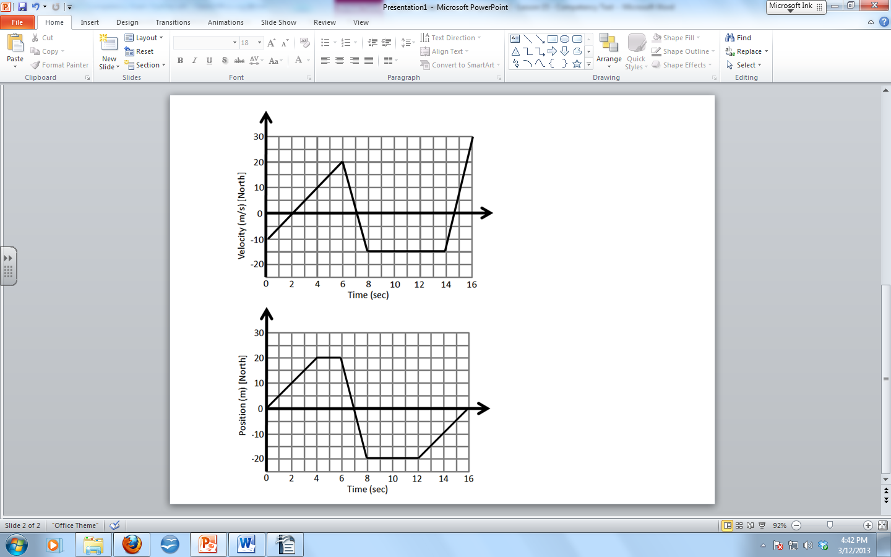
Q1: During what time(s) is the remote control car moving North? (1 mark)

Q2: What is the velocity of the car between 12 and 14 seconds? (1 mark)

Q3: What is the acceleration of the car between 0 and 4 seconds? (1 mark)

Q4: What is the displacement of the car between 0 and 6 seconds? (1 mark)

The following is a Velocity vs. Time graph of a remote control car. Use the graph to answer Q5-8.

Q5: During what time(s) is the remote control car moving North? (1 mark)

Q6: During what time(s) is the remote controlled car travelling with uniform motion? (1 mark)

Q7: What is the acceleration of the car between 14 and 16 seconds? (1 mark)

Q8: What is the displacement of the car between 6 and 10 seconds? (1 mark)

Topic 1 – Accelerated Motion – Version 1
The next 7 Questions tell a heroic tale of Police Chief Michael as he attempts to capture the notorious criminal called MARK.

Q9: One day, the notorious thief steals a rare and beautiful brown diamond. In order to escape he must throw a grappling hook on the roof of the building. The hook is thrown vertically upward, and reaches a maximum height of 25m above the launch point. How fast was the hook travelling when it left Mark’s hand? (3 marks)

Q10: Later on, Mark, with the brown diamond, gets into his car and speeds away. His car accelerates from 3m/s [East] to 15m/s [East] over 2 seconds. What is the acceleration of the car? (3 marks)

Q11: Mark, the famed jewel thief, is only seconds ahead of the police. Meanwhile, a cargo ship carrying boxes of soft pillows is passing under the bridge at a steady 6m/s. If Mark plans to step off the 50m tall bridge and land on the cargo ship, how far away from the bridge should the cargo ship be when Mark steps off? (4 marks)
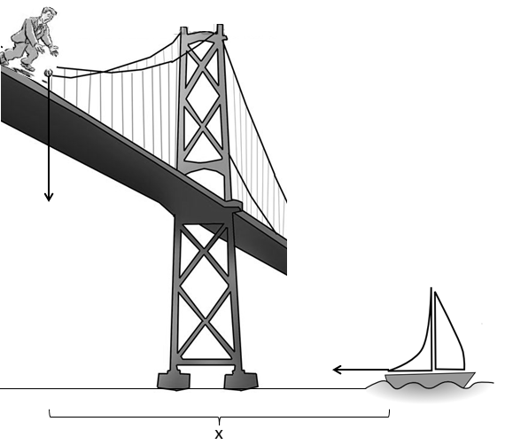

Topic 2 – Adding Vectors in 2-Dimensions Version 1
Q12: The workers on the boat aren’t very happy with Mark, and want to capture him for the police. Mark first zigs 5m [20° W of N] then zags 8m [60° S of W] before jumping into the river. What is Mark’s total displacement? (4 marks)

Use the following diagram to answer Q13.
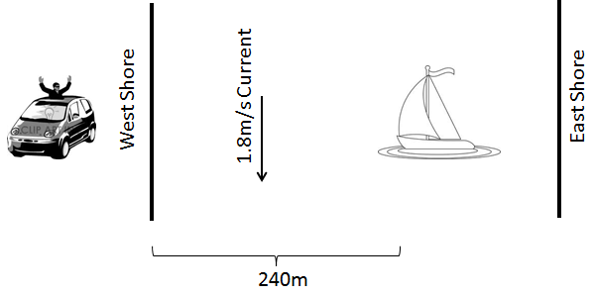
Q13: Now, Mark jumps off the boat 240 m from shore. Mark is facing the strong current of the Stettler River. Directly across from Mark is his getaway driver, Julie, waiting patiently on the West shore. If Mark is able to swim at a pace of 2.8m/s in still water, how long will it take Mark to swim to the West shore if he angles his body to compensate for the current? (2 marks)

Topic 2 – Projectile Motion – Version 1
Q14: On Mark’s swim to shore he begins to tire and struggle in the water. His getaway driver Julie tries throwing a piece of wood to Mark to help him float. If Julie is on a 15 m cliff and throws the wood in the horizontal direction, what speed should she throw the wood if Mark is 20 m from the base of the cliff?
(3 marks)
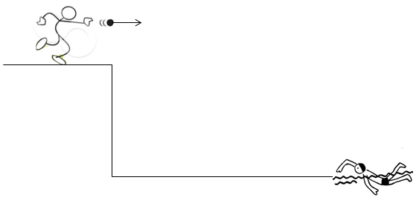

Q15: After swimming to shore with his wooden floatation device, Mark lays on the beach exhausted. Police Chief Michael has a special gun that fires a net to capture criminals. Michael fires his special net towards Mark with a homemade launcher. If Michael shoots the net with a velocity of 8m/s [25°] and it hits Mark at the same level it was launched from, how far away was Mark from Michael standing? (3 marks)

