First Name:______________________________ Last Name:______________________________
L15 – Worksheet – Motor Effect and Circular Motion
Textbook Questions
Pg 601 #9: Electrons in a picture tube of a television are accelerated to t a speed of 1.30 x 10⁶ m/s. As they travel through the tube, they experience a perpendicular magnetic field of 0.0700 T. What is the radius of deflection of the electrons in the tube?

Pg 601 #10: A cosmic ray proton travelling through space at 4.38 x 10⁶ m/s deflects in a circular arc with a radius of 5.50 x 10⁶ m. What is the magnitude of the magnetic field at that point in space?

Pg 623 #24: A magnetic field is used to bend a beam of electrons. What uniform magnetic field is required to bend a beam of electrons moving at 1.2 x 10⁶ m/s in a circular arc of 0.25 m?

Diploma Worksheet Questions – Motor Effect (Circular Motion)
Q313: An electron moves at 4.0 x 10⁶ m/s perpendicularly through a magnetic field of 1.6 x 10⁻³ T. The radius of curvature that the electron follows while in the field is
- 7.0 x 10⁻¹ m
- 4.4 x 10⁻¹ m
- 1.4 x 10⁻² m
- 2.3 x 10⁻²² m

Use the following information to answer Q318 – Q319:
A proton with an energy of 894 eV travels perpendicular to a magnetic field and moves in a circular path with a radius of 3.60 x 10⁻⁴ m.

Q318: The speed of the proton is
- 4.14 x 10⁵ m/s
- 1.77 x 10⁷ m/s
- 1.71 x 10¹¹ m/s
- 3.14 x 10¹⁴ m/s

Q319: The strength of the magnetic field, expressed in scientific notation, is a.bc x 10^{d} T. The values of
a, b, c, and d are ___, ___, ___, and ___.
(Record your four digit answer in the Numerical Response boxes below)

Diploma Worksheet Questions – Motor Effect (Graphs and Algebra)
Q323: A wire that carries a constant current is placed perpendicularly in a magnetic field. The magnetic field B is varied, and the force F is measured. The graph of F as a function of B can be represented by
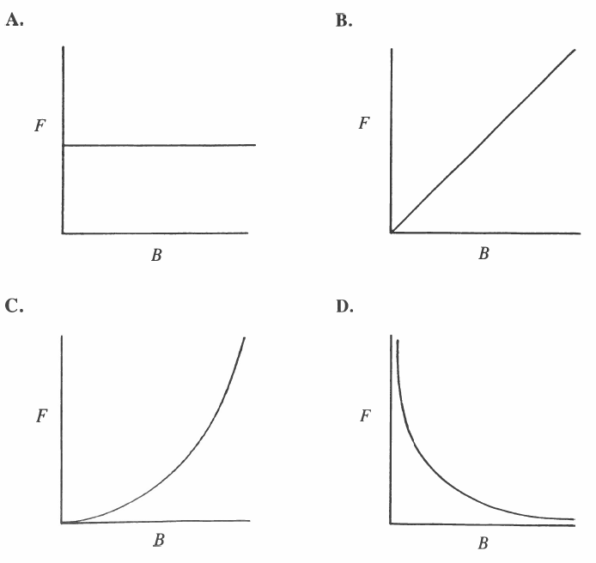
Q325: An electron experiences a force F as it moves across a magnetic field. When its speed is doubled and the magnetic field is tripled, the force on the electron is
- F/6
- 2F/3
- 3F/2
- 6F

Q327: A proton and an electron travelling at the same velocity enter a magnetic field at right angles to the field. Compared to the electron’s deflection, the proton’s deflection will be in the
- Same direction, with a smaller radius of curvature
- Opposite direction, with a smaller radius of curvature
- Opposite direction, with a larger radius of curvature
- Same direction, with a larger radius of curvature

Use the following information to answer Q330:
An alpha particle and an electron travelling at the same speed enter perpendicularly into a uniform magnetic field.

Q330: Which of the following statements concerning the force on the particles is true?
- The force on the alpha particle is greater because it carries the higher charge.
- The force on the alpha particle is greater because its mass is greater.
- The force on the electron is greater because its mass is smaller.
- The force on the particles is equal.

Q334: The period T for a particle of charge q in a magnetic field of strength B is
- $\frac{2πm}{qB}$
- $\frac{πm}{qB}$
- $\frac{qB}{2π}$
- $\frac{qB}{πm}$

Q337: In a certain experiment, the speed of a charged particle is made to increase as it moves at right angles to a uniform magnetic field. A graph that represents the relationship between magnetic force and speed is
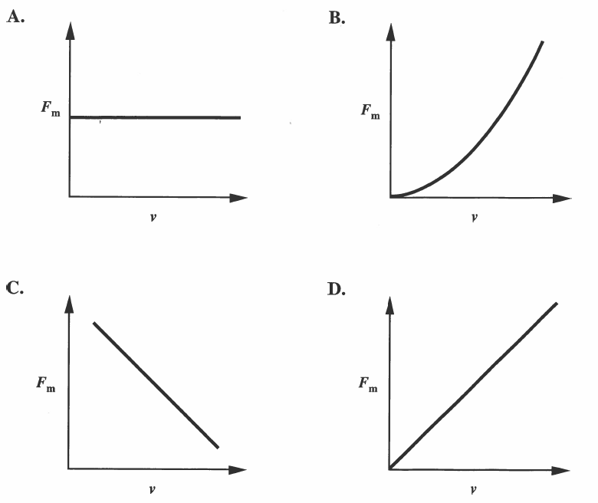

Challenge Questions
Use the following information to answer Q1-Q3:
A cyclotron is a particle accelerator that is constructed of two hollow metal shells shaped like Ds in a perpendicular magnetic field created by magnets, as shown below. The entire apparatus is placed in a vacuum. An alternating voltage is maintained across the D separation. Positively charged particles such as protons are injected near the center of the Ds and travel in circular paths caused by the external perpendicular magnetic field. The frequency of the alternating voltage is adjusted to increase speed of the particles each time they move across the Ds’ separation.
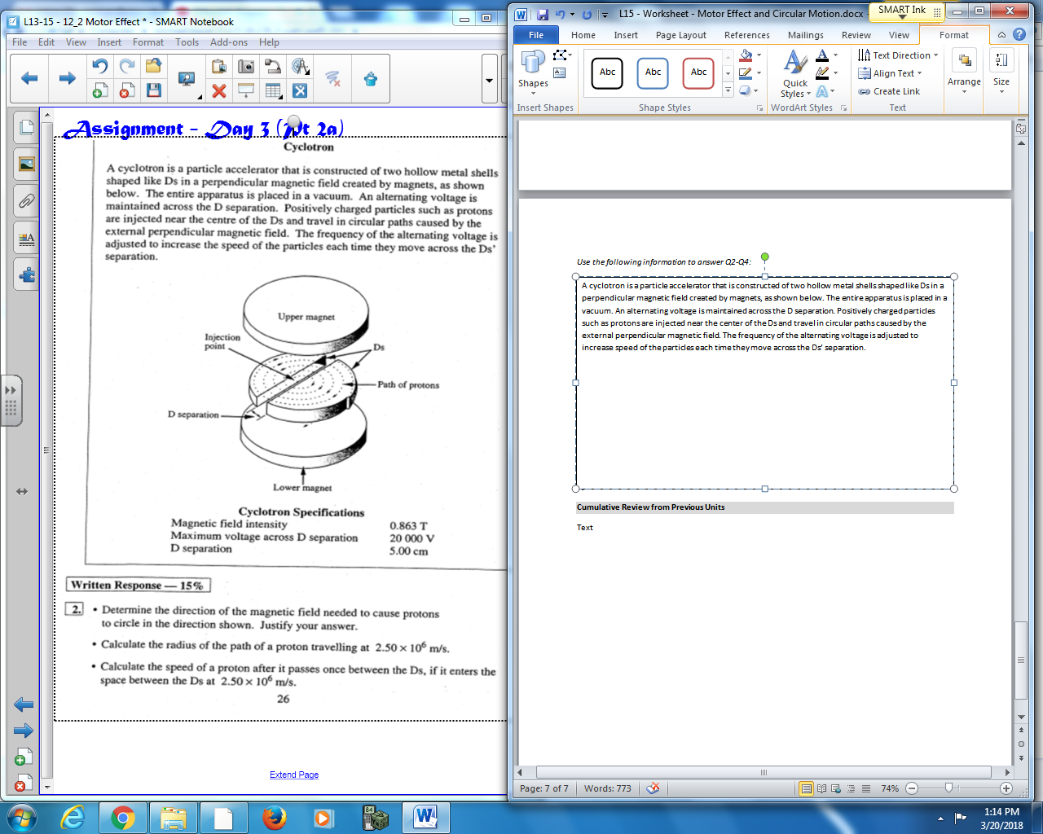
Cyclotron Specifications
Magnetic field intensity 0.863 T
Maximum voltage across D separation 20,000 V
D separation 5.00 cm

Q1: The direction of the magnetic field needed to cause protons to circle in the clockwise direction shown is
- Up
- Down
- Toward center
- Away from center

Q2: The radius of the path of a proton travelling at 2.50 x10⁶ m/s is a.bc x 10^{-d} m, where a, b, c, and d are ___, ___, ___, and ___.
(Record your four-digit answer in the Numerical Response boxes below)

Q3: A proton that enters the Ds at 2.50 x 10⁶ m/s will exit the Ds at a speed of a.bc x 10^{d} m/s, where a, b, c, and d are ___, ___, ___, and ___.
(Record your four-digit answer in the Numerical Response boxes below)

Use the following information to answer Q4:
VENN Diagram for Fields
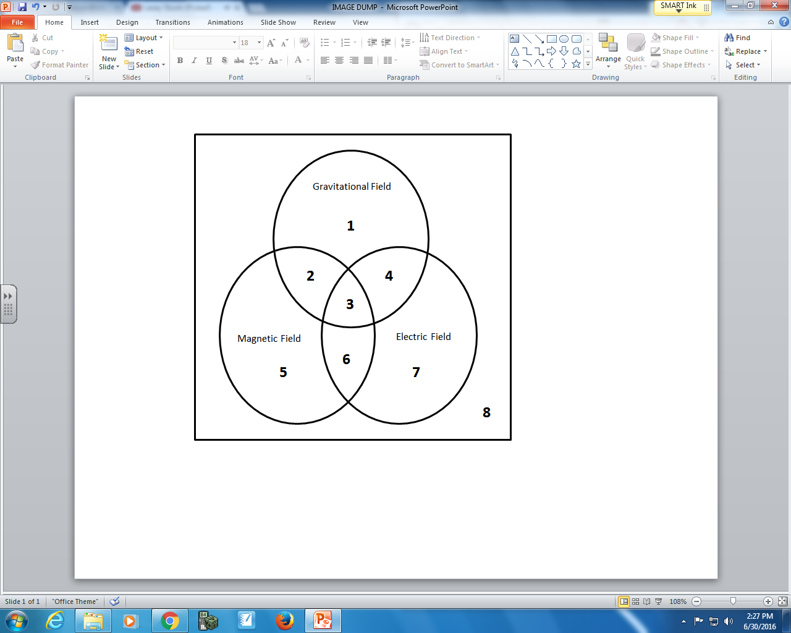

Q4: Using the VENN diagram above, determine which field(s) is/are present for each object.

Field(s): __________ __________ __________ __________
Object: Bar Magnet Stationary Stationary Moving
Electron Neutron Proton
(Record your four-digit answer in the Numerical Response boxes below)

Cumulative Review from Previous Units
Use the following information to answer Q5:
A 12g airsoft pellet strikes a 0.2 kg mass on the end of a 1.0m string. The pendulum arm swings 30⁰ after the impact.
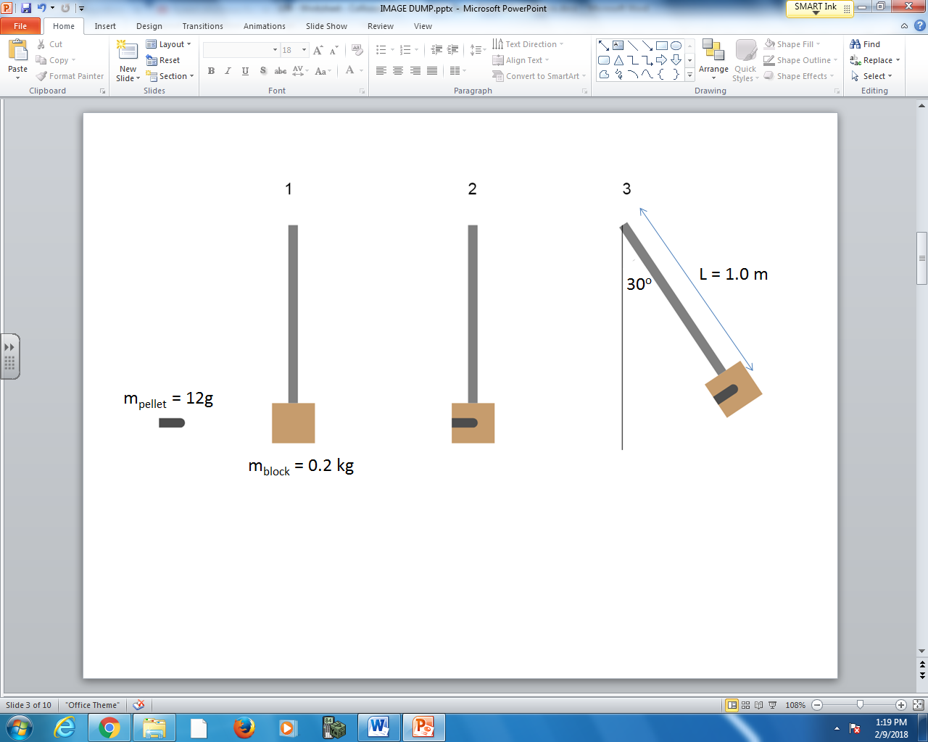

Q5: The initial speed of the airsoft pellet, prior to impact, is a.bc x 10^{d} m/s, where a, b, c, and d are ___, ___, ___, and ___.
(Record your four digit answer in the Numerical Response boxes below)

(Yes, you’ve done this exact question before… but it’s good practice to try it again)

