First Name:______________________________ Last Name:______________________________
L15 – Worksheet – Photoelectric Effect 2
Diploma Questions – Photoelectric Effect (Basic Concepts)
Q673: The wave theory of light can account for all of the following EXCEPT
- Reflection
- Refraction
- Polarization
- Photoelectric effect

Q679: A metal surface has a threshold frequency of f_{o}. If the metal surface is illuminated with radiation of a frequency of 3.5f_{o}, then the maximum kinetic energy of emitted photoelectrons is
- 4.5hf_{o}
- 3.5hf_{o}
- 2.5hf_{o}
- 1.0hf_{o}

Q680: If a photoelectric device is illuminated by light with a frequency greater than threshold frequency, what will happen as the frequency of the light is increased?
- The photoelectric current will increase.
- More photoelectrons will be emitted.
- The work function of the device will increase.
- Photoelectrons will be emitted with greater energy.

Q682: In a photoelectric experiment, the maximum kinetic energy of photoelectrons does not depend on the
- Work function of the emitted material
- Wavelength of the incident light
- Intensity of the incident light
- Energy of an incident photon

Diploma Questions – Photoelectric Effect (Calculations)
Q685: Sodium used in a photoelectric cell is irradiated by EM radiation of frequency 6.2 x 10¹⁵ Hz. If the threshold frequency for sodium is 5.6 x 10¹⁴ Hz, then the maximum E_{k} of the photoelectrons produced is
- 1.1 x 10⁻¹⁹ J
- 4.1 x 10⁻¹⁸ J
- 3.7 x 10⁻¹⁸ J
- 5.6 x 10⁻¹⁵ J

Q687: If light with a frequency of 1.0 x 10¹⁵ Hz causes a metal to emit electrons with kinetic energy of
1.0 x 10⁻¹⁹ J, the work function of the metal is
- 1.0 x 10⁻⁴ J
- 6.6 x 10⁻¹⁹ J
- 5.6 x 10⁻¹⁹ J
- 1.0 x 10⁻¹⁹ J

Q697: Copper has a work function of 4.46 eV. What is the maximum kinetic energy of the ejected electrons if the metal is illuminated by light with a wavelength of 450 nm?
- 2.72 x 10⁻¹⁹ J
- 4.42 x 10⁻¹⁹ J
- 7.14 x 10⁻¹⁹ J
- 0 J, because no electrons are ejected

Diploma Questions – Photoelectric Effect (Order of EMR)
Use the following information to answer Q706 and Q707:
Observations in Photoelectric Experiments
- The magnitude of the current increases.
- The magnitude of the current decreases.
- The magnitude of the current is constant.
- The energy of the photoelectrons increases.
- The energy of the photoelectrons decreases.
- The energy of the photoelectrons is constant.

Q706: In a photoelectric experiment, a student increases the intensity of the incident light while maintaining a constant frequency. What are the effects on the magnitude of the photoelectric current and on the energy of the photoelectrons?
- I and IV
- I and VI
- II and IV
- III and IV

Q707: In a photoelectric experiment, a student decreases the intensity of the incident light while increasing its frequency. What are the effects on the magnitude of the photoelectric current and on the energy of the photoelectrons?
- II and IV
- II and V
- III and IV
- III and VI

Q709: When a blue laser beam is incident upon the surface of the metal of a photoelectric cell, there is no photoemission. A second beam of radiation causes photoelectrons to be emitted. The second beam may consist of
- Ultraviolet radiation
- Infrared radiation
- Red laser radiation
- Microwave radiation
Q710: Violet light striking the negative electrode in a phototube causes a current to flow in the tube. Under the same conditions, another form of light that will always cause a current to flow is
- Blue
- Green
- Infrared
- Ultraviolet

Diploma Questions – Photoelectric Effect (Graphs)
Use the following information to answer Q711:
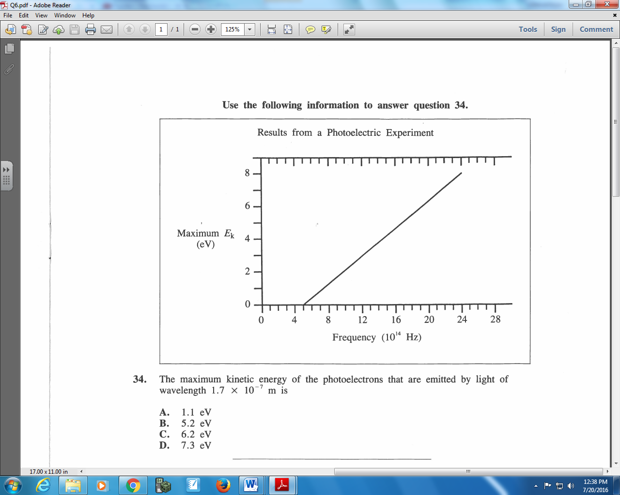

Q711: The maximum kinetic energy of the photoelectrons that are emitted by light of wavelength
1.7 x 10⁻⁷ m is
- 1.1 eV
- 5.2 eV
- 6.2 eV
- 7.3 eV

Use the following information to answer Q712:
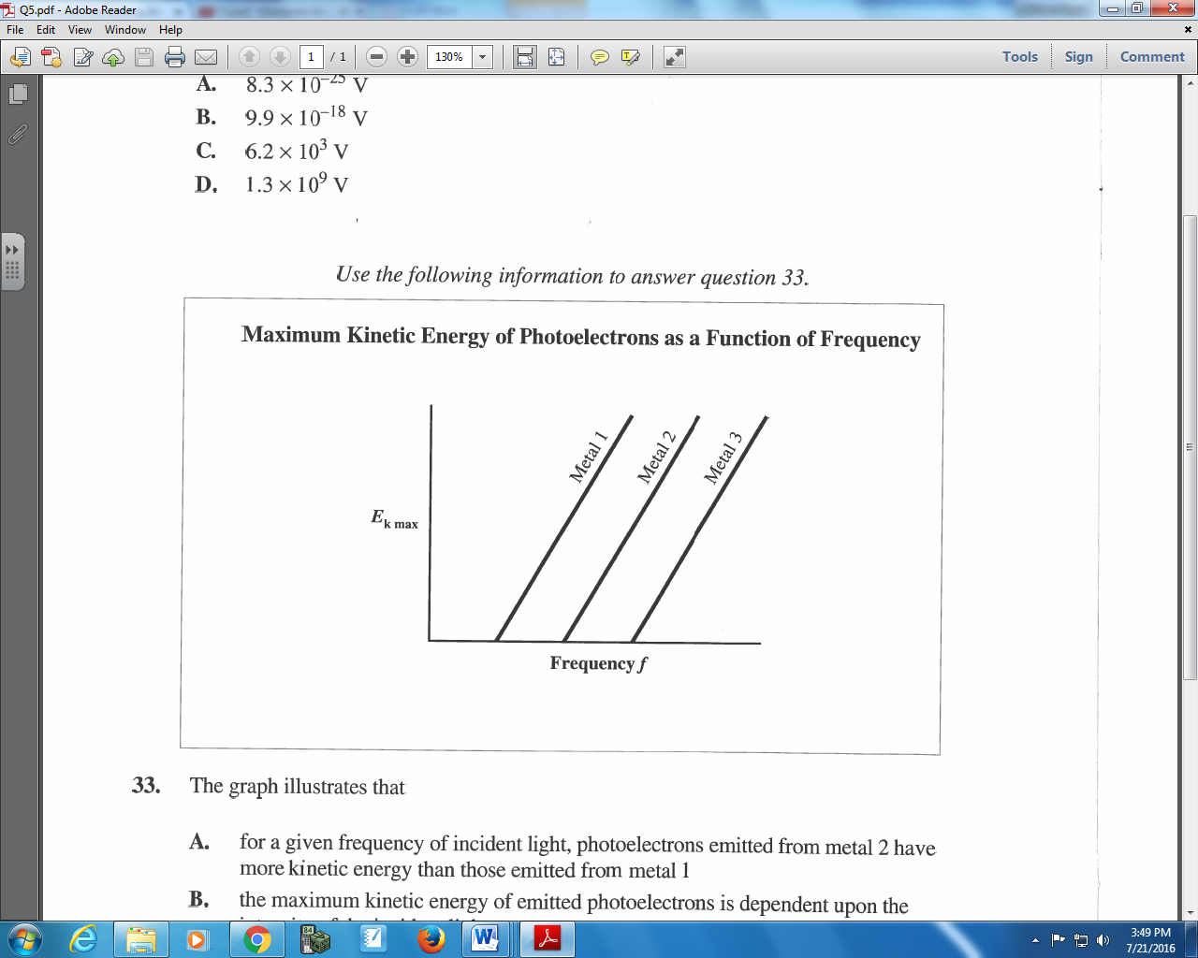

Q712: The graph illustrates that
- For a given frequency of incident light, photoelectrons emitted from metal 2 have more kinetic energy than those emitted from metal 1
- The maximum kinetic energy of emitted photoelectrons is dependent upon the intensity of the incident light
- Metals will emit photoelectrons only if the intensity of the incident light is greater than some critical value
- Metals will emit photoelectrons only if the frequency of incident light is greater than some critical value

Use the following information to answer Q713:
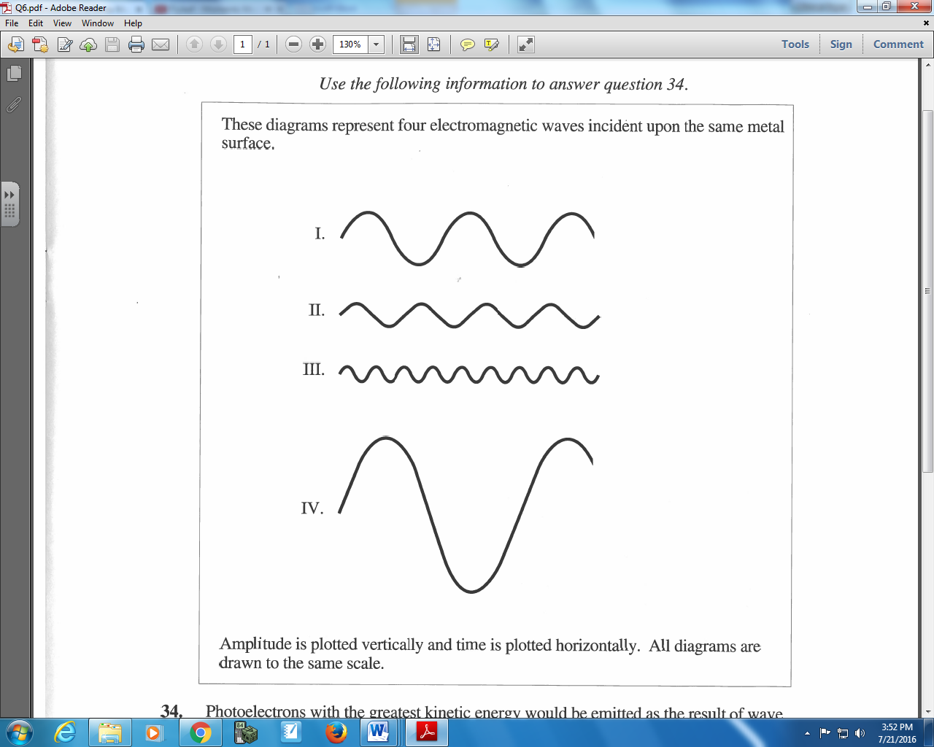

Q713: Photoelectrons with the greatest kinetic energy would be emitted as the result of wave
- I
- II
- III
- IV

Diploma Questions – Photoelectric Effect (in Technology)
Use the following information to answer Q725 – Q726:
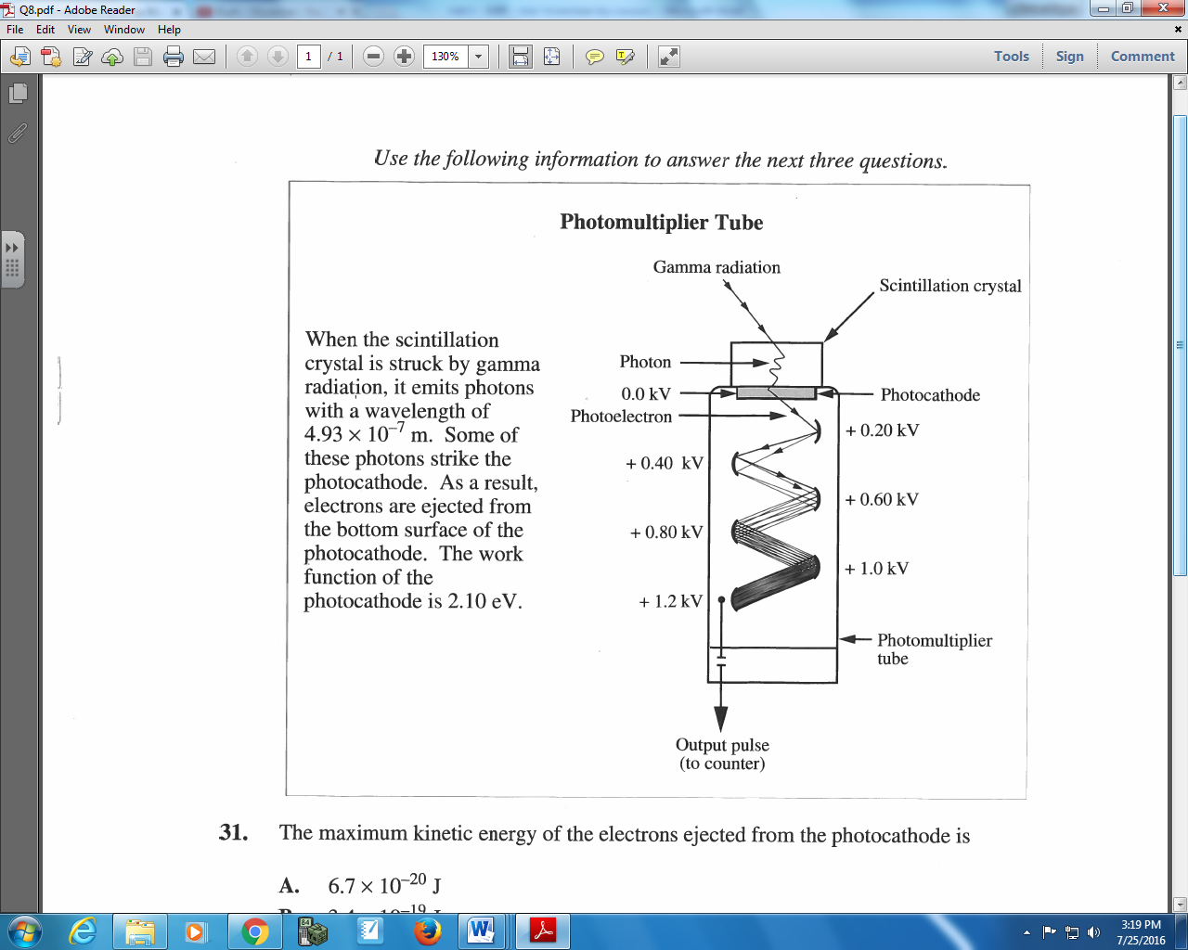

Q725: The maximum kinetic energy of the electrons ejected from the photocathode is
- 6.7 x 10⁻²⁰ J
- 3.4 x 10⁻¹⁹ J
- 4.0 x 10⁻¹⁹ J
- 7.4 x 10⁻¹⁹ J
Q726: The electrons leaving the photocathode are attracted by the 0.20 kV electrode. The maximum speed they attain is
- 8.6 x 10⁵ m/s
- 8.4 x 10⁶ m/s
- 7.0 x 10¹³ m/s
- 2.1 x 10¹⁵ m/s

Use the following information to answer Q734:
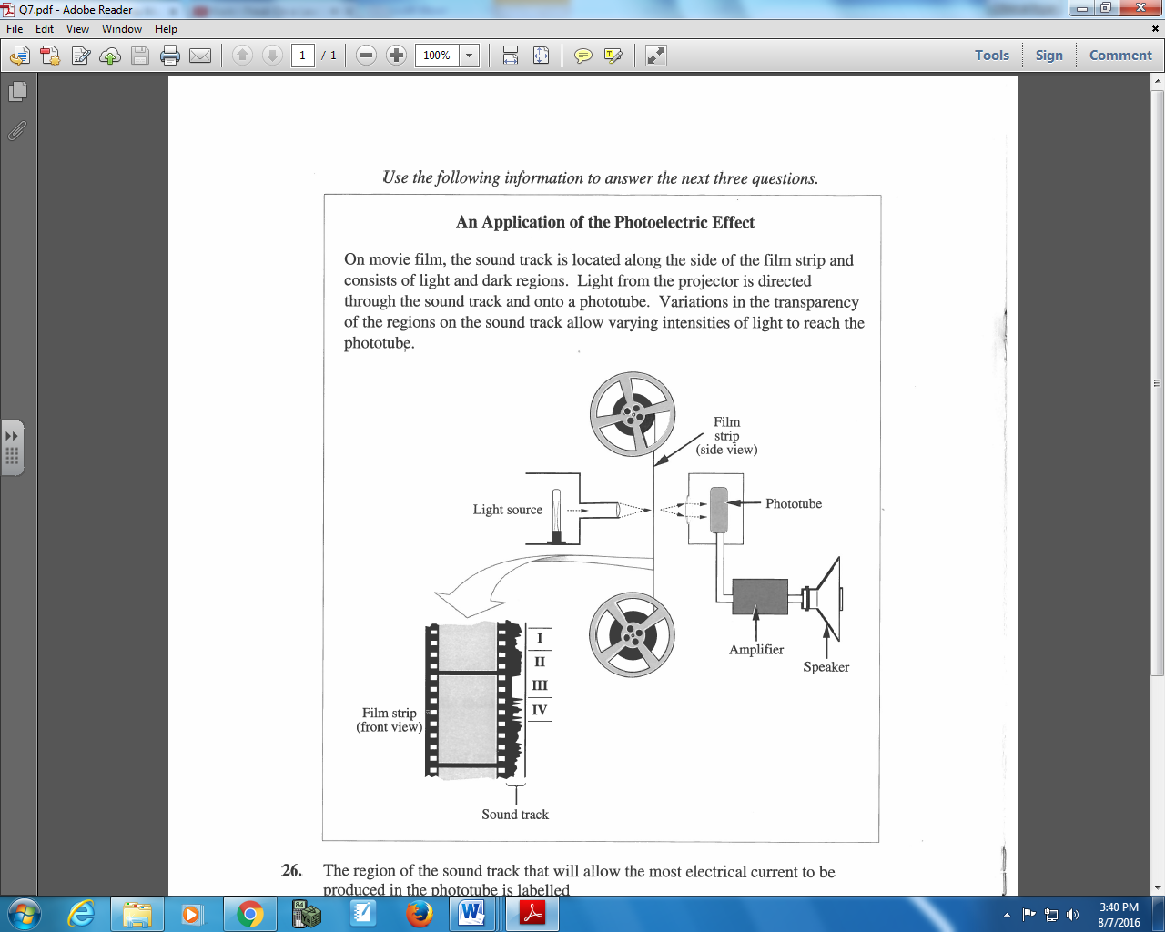

Q734: The region of the sound track that will allow the most electrical current to be produced in the phototube is labelled
- I
- II
- III
- IV

