First Name:______________________________ Last Name:______________________________
L15.5 – Buffer Day Worksheet – Cumulative Review
Unit 1 – Part 1 – Momentum, Net Force, Impulse and Impulse Graphs
Use the following information to answer Q1:
A 50g rigid sphere, initially travelling at 1.5m/s [W], strikes a wall. The force-time graph is depicted below.
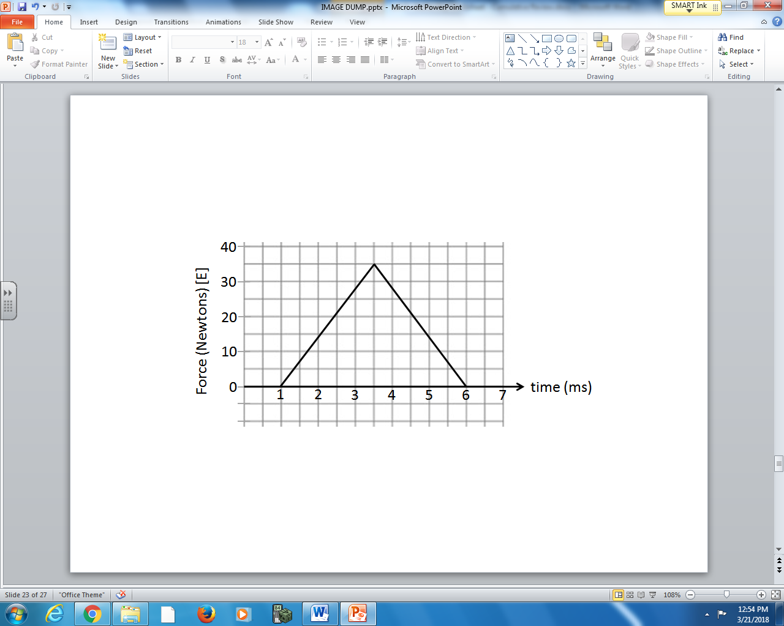

Q1: The ball rebounds with a velocity of _____ m/s [E].
(Record your three digit answer in the Numerical Response boxes below)

Use the following information to answer Q2:
Velocity-Time Graph for a 20g Ball.
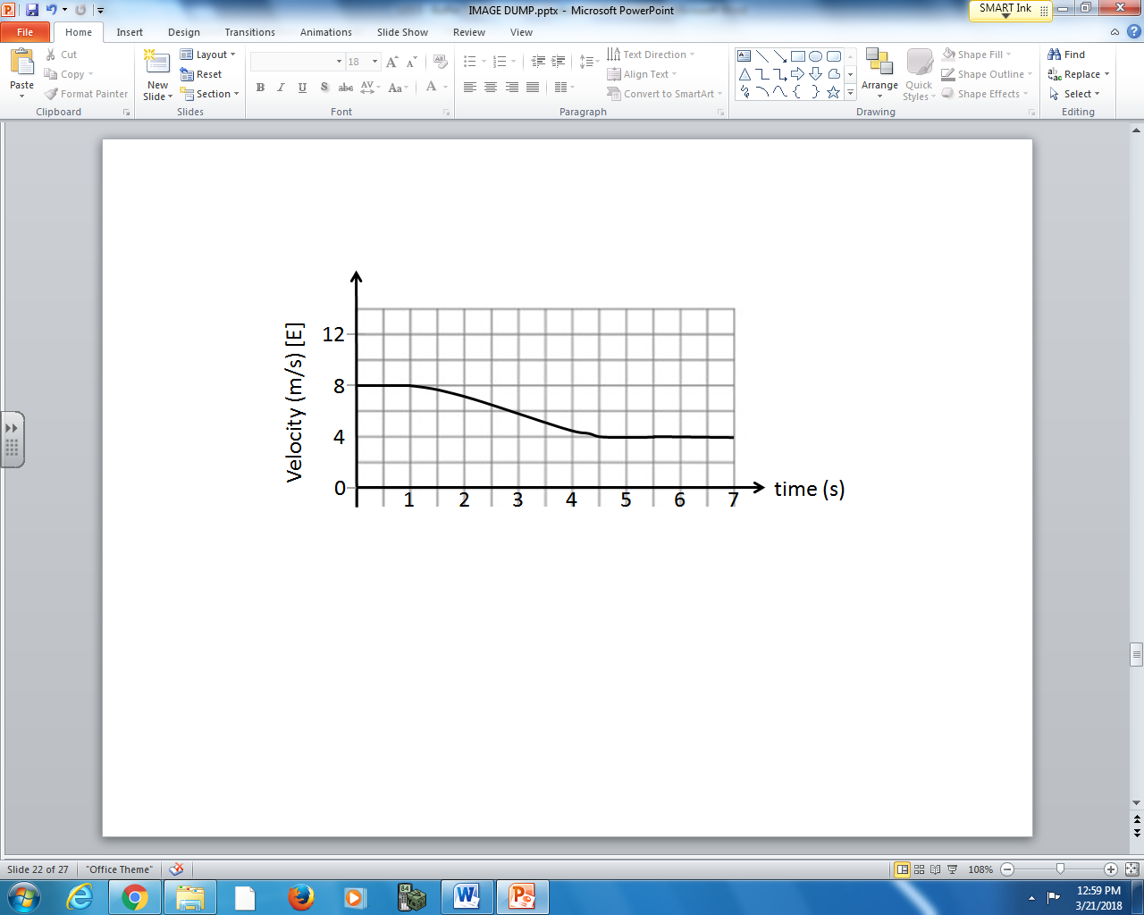

Q2: The impulse acting on the ball over this time period is a.bc x 10^{-d} Ns, where a, b, c, and d are ___, ___, ___, and ___.
(Record your four digit answer in the Numerical Response boxes below)

Unit 1 – Part 2 – Momentum Collisions in 1-Dimension and 2-Dimensions
Use the following information to answer Q3:

Two objects strike and rebound as below:
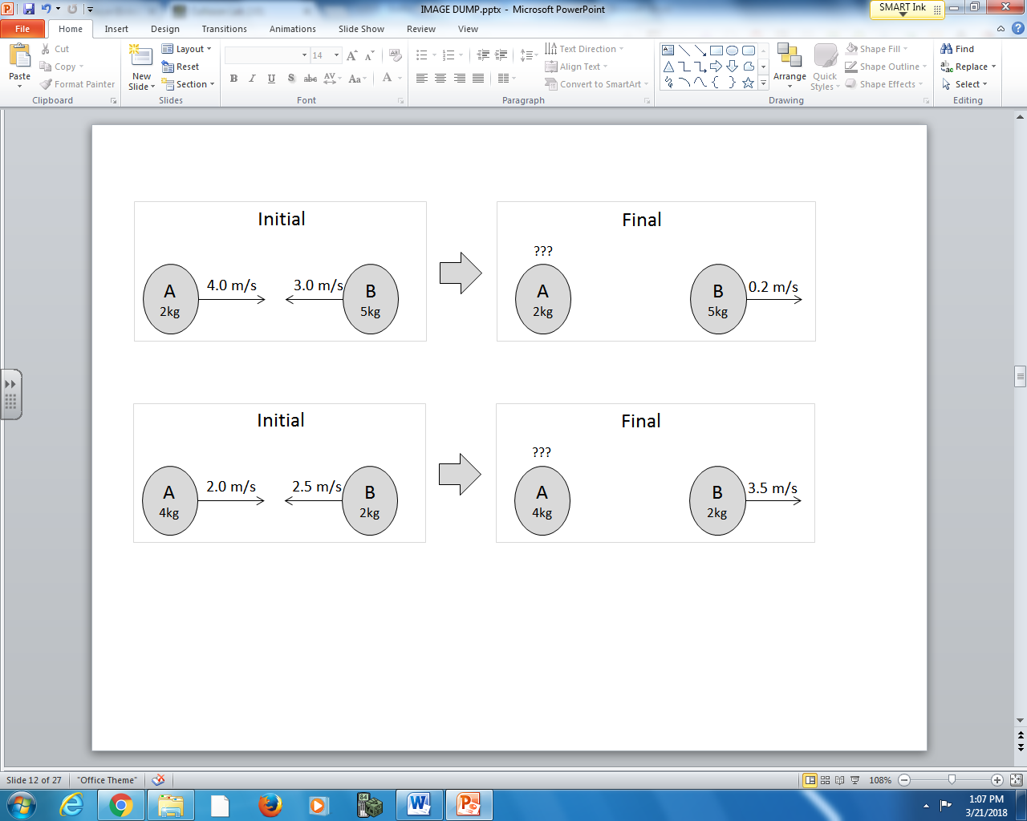

Q3: The final velocity of Object A is _____ m/s [Left].

(Record your three digit answer in the Numerical Response boxes below)

Use the following information to answer Q4:

A 6.0kg object moving at 2.5 m/s [0⁰] strikes a stationary 4.0 kg object, as depicted below.
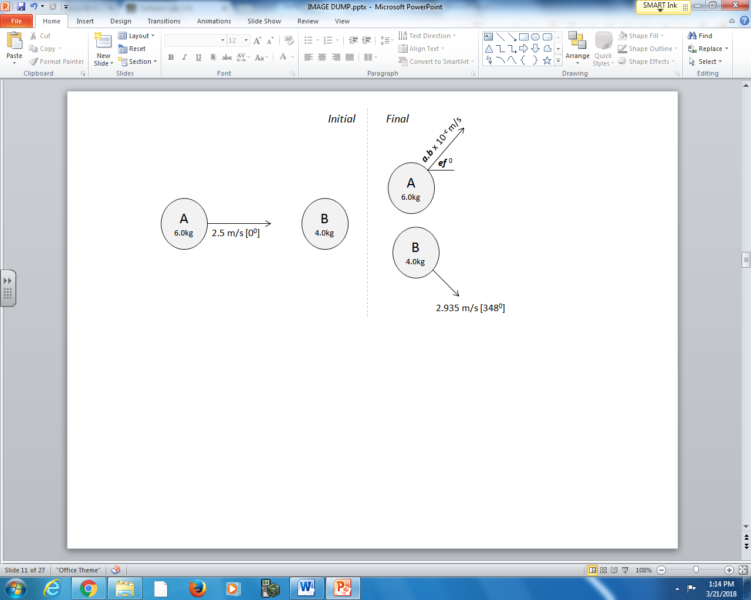

Q4: The final velocity of Object B is a.b x 10^{-c} m/s [ef ⁰], where a, b, e, and f are ___, ___, ___, and ___.

(Record your four digit answer in the Numerical Response boxes below)

Unit 2 – Part 1 – Coulomb’s Law, Electric Fields, and Parallel Plates
Use the following information to answer Q5:

An initially neutral electroscope has a positive rod placed near the electroscope without making contact (Diagram #2). The positive charge is then removed (Diagram #3.
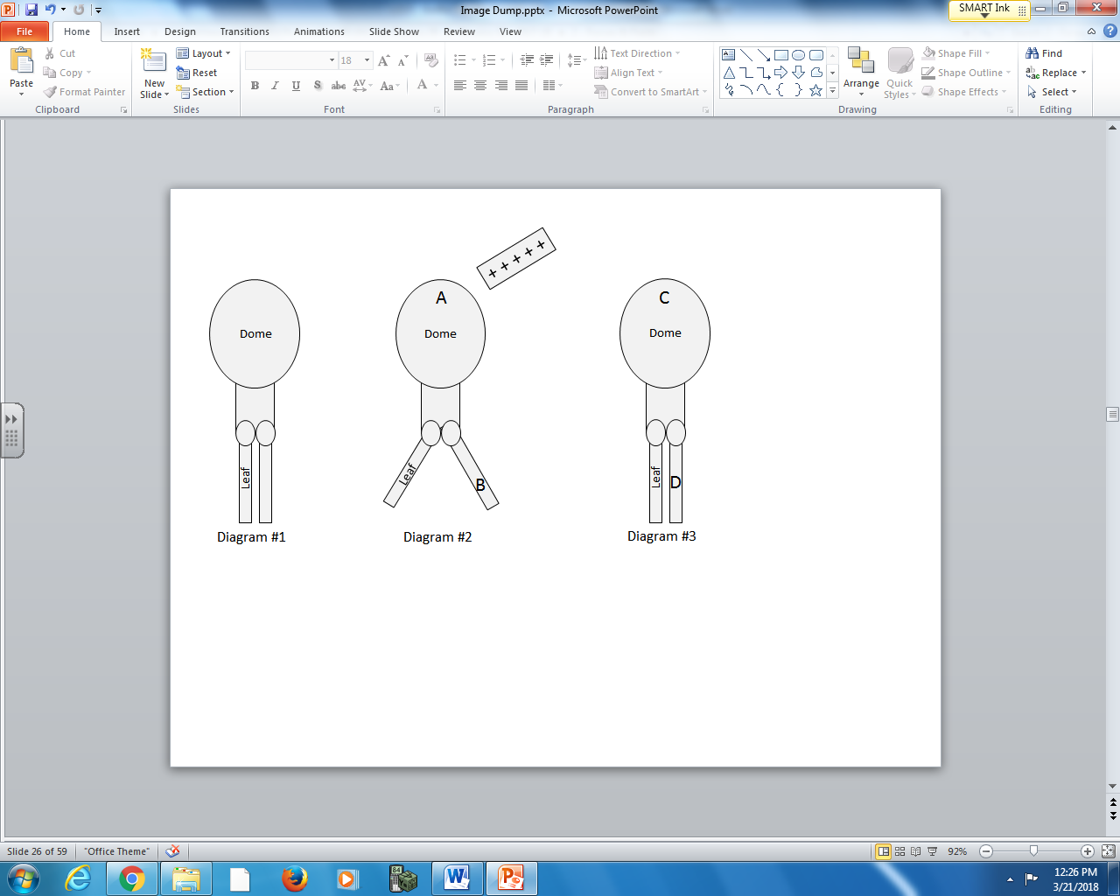
Nature of Charge
1 – Positive
2 – Negative
3 – Neutral

Q5: The nature of the charge at various locations on an electroscope can be described using the numbers given above.
Charge: __________ __________ __________ __________
Location: Nature of Nature of Nature of Nature of
charge at charge at charge at charge at
location A location B location C location D
in Diagram #2 in Diagram #2 in Diagram #3 in Diagram #3
(Record your four digit answer in the Numerical Response boxes below)

Use the following information to answer Q6:

Two charges are initially placed 40cm apart, per the diagram below.
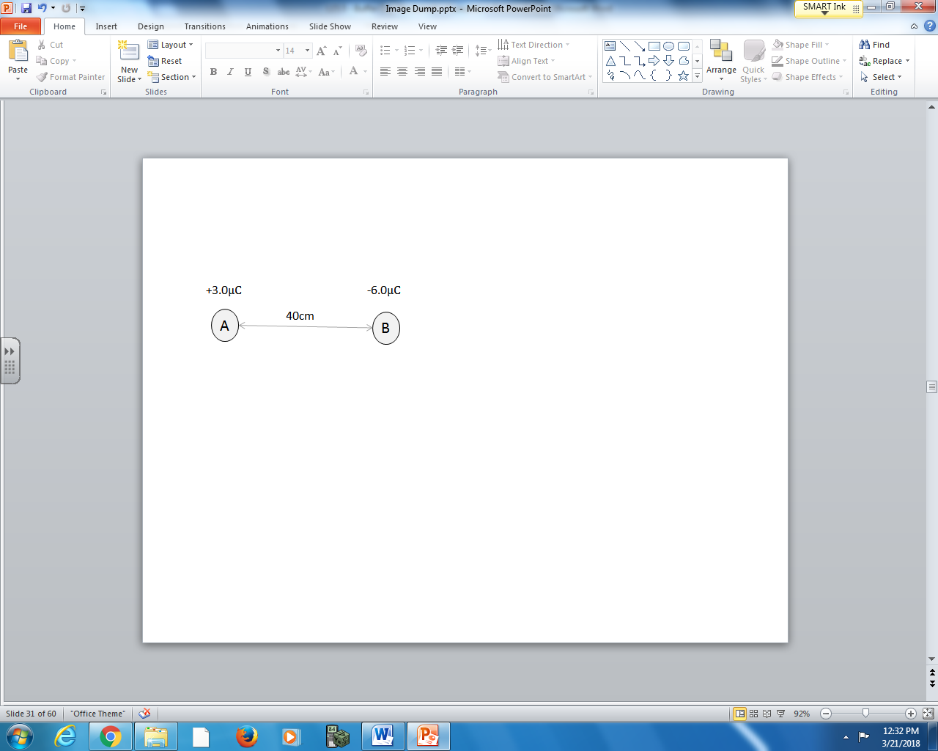
The charges are momentarily brought into contact before returning them to their original positions.

Q6: The electrostatic force between the two charged spheres is
- 0.13 N [attractive]
- 0.13 N [repulsive]
- 1.01 N [attractive]
- 1.01 N [repulsive]

Use the following information to answer Q7:

Two charges are placed at right angles to each other, per the diagram below.
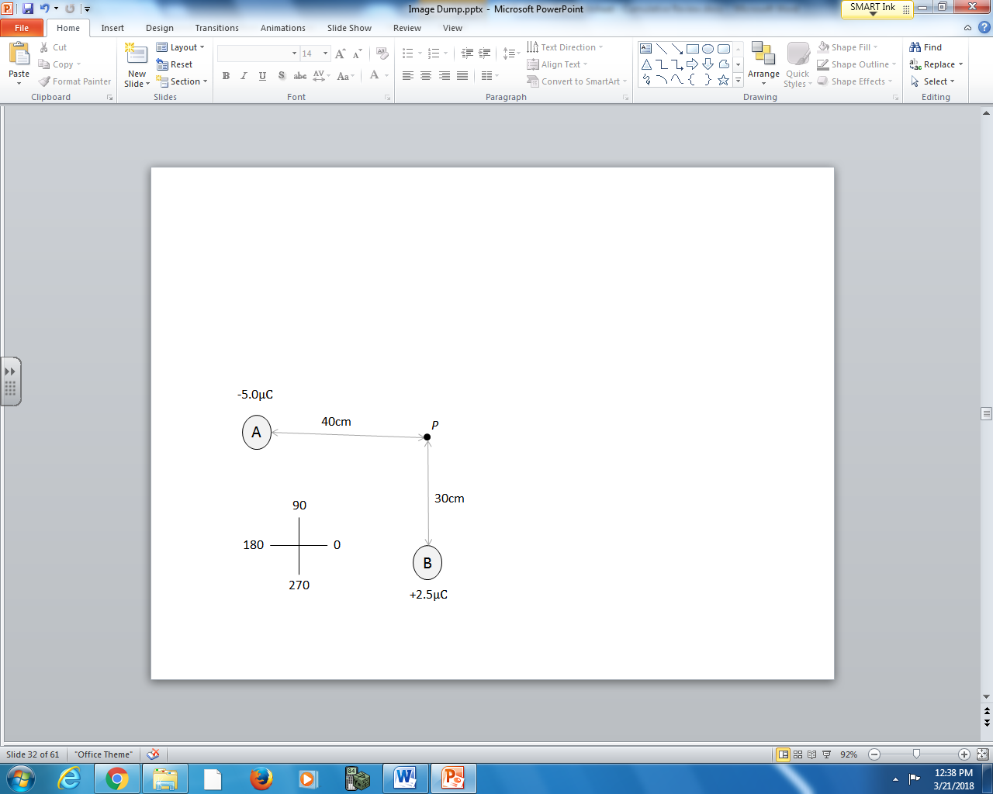

Q7: The net electric field at Point P is at _____ degrees, in polar coordinates.
(Record your three digit answer in the Numerical Response boxes below)

Use the following information to answer Q8-Q10:

An electron is injected into a parallel plate apparatus per the diagram below:
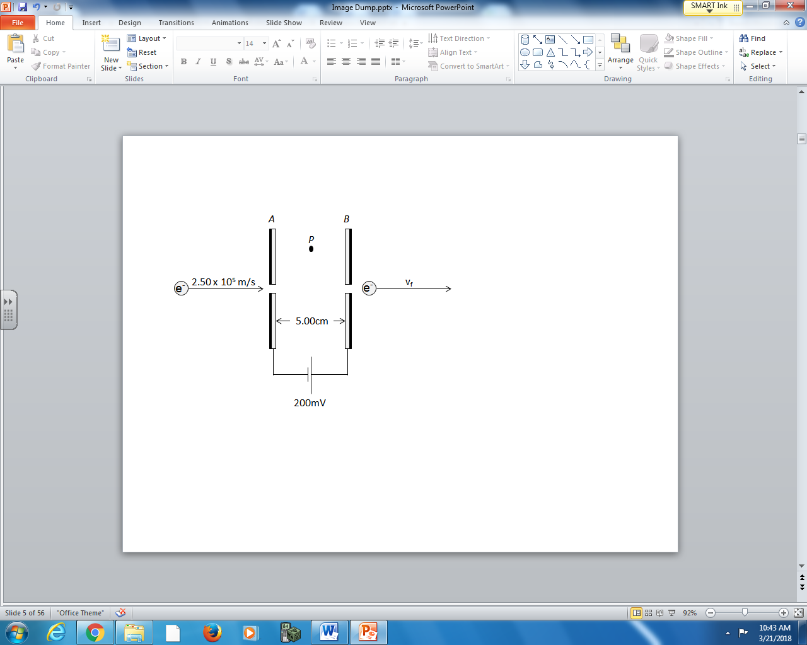

Q8: In the diagram above, Plate A is __i__ charged and the electric field at Point P is to the __ii__.

 | i. | ii.
A. | positively | right
B. | positively | left
C. | negatively | right
D. | negatively | left

Q9: Upon exiting the plates, the final velocity of the electron is a.bc x 10^{d} m/s, where a, b, c, and d are ___, ___, ___, and ___.

(Record your four digit answer in the Numerical Response boxes below)

Q10: The impulse experienced by the electron while in this region is a.b x 10^{-cd} Ns, where a, b, c, and d are ___, ___, ___, and ___.

(Record your four digit answer in the Numerical Response boxes below)

Use the following information to answer Q11:
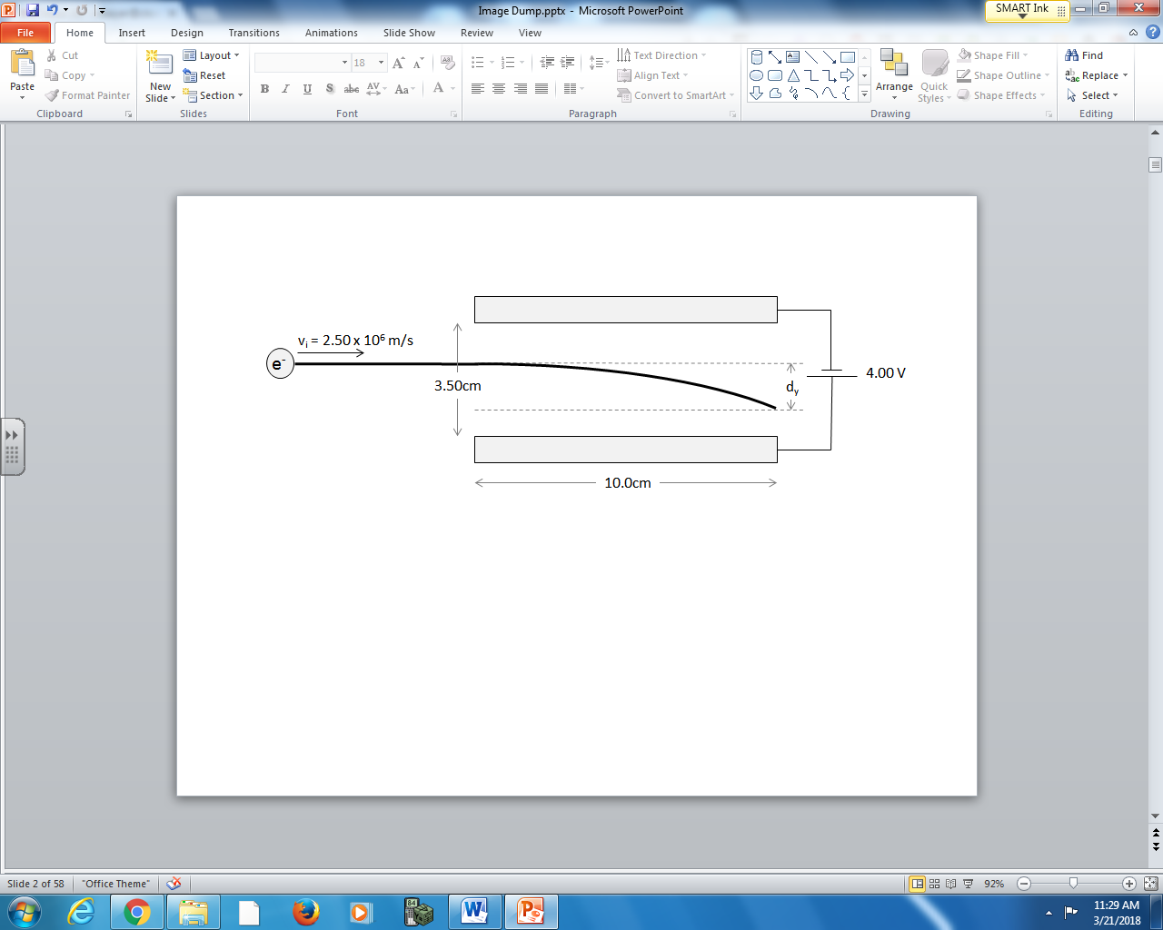

Q11: The vertical displacement of the electron, while between the parallel plates, is _____ cm.
(Record your three digit answer in the Numerical Response boxes below)

Unit 2 – Part 2 – Magnetic Forces and Fields, Motor and Generator Effect, Millikan Experiment
Use the following information to answer Q12:

Magnetic Fields around Current in a Wire
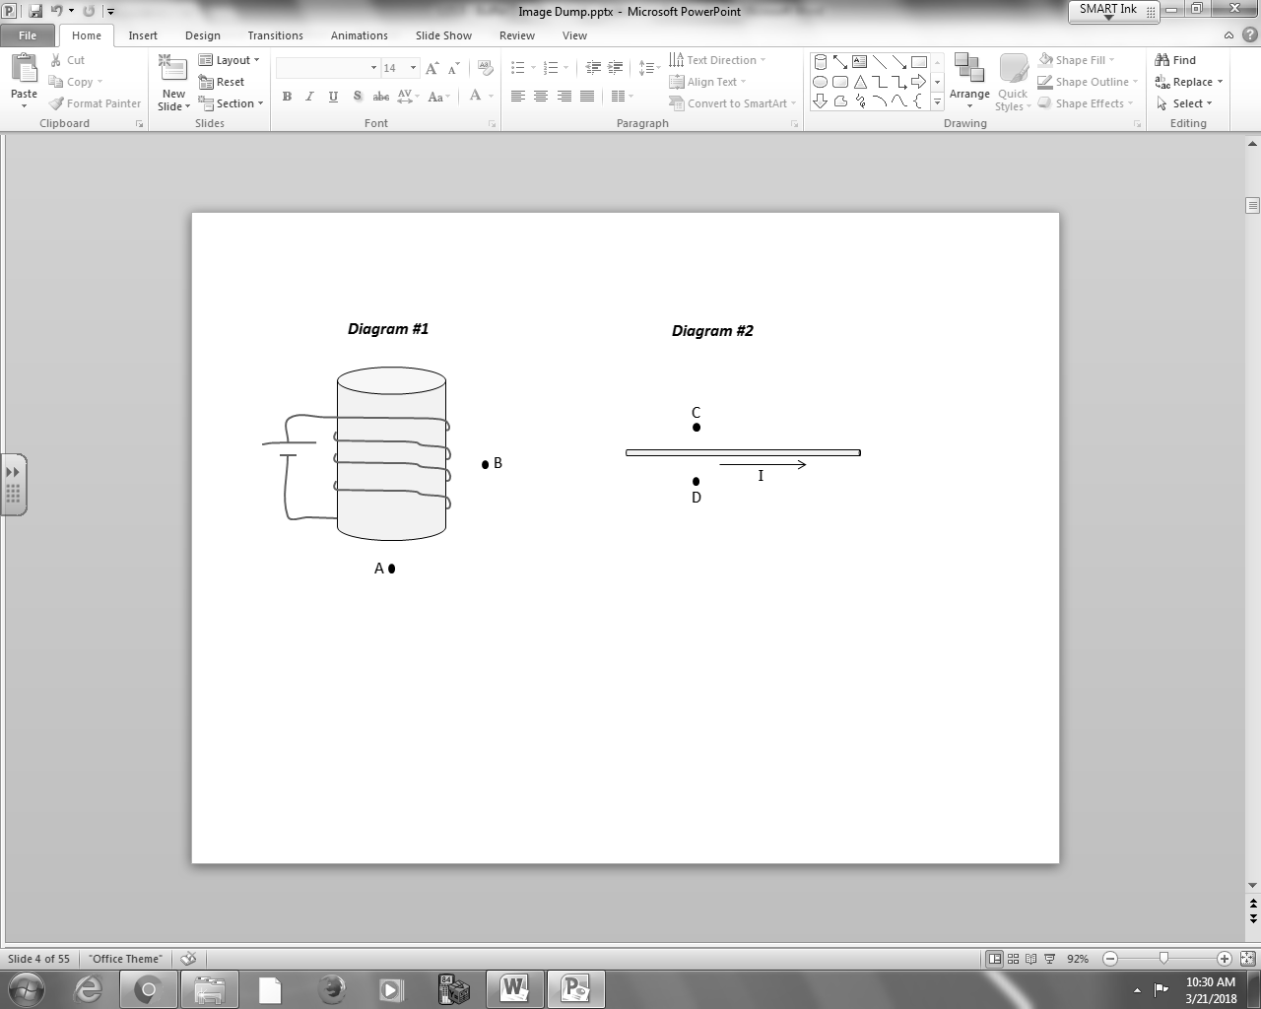
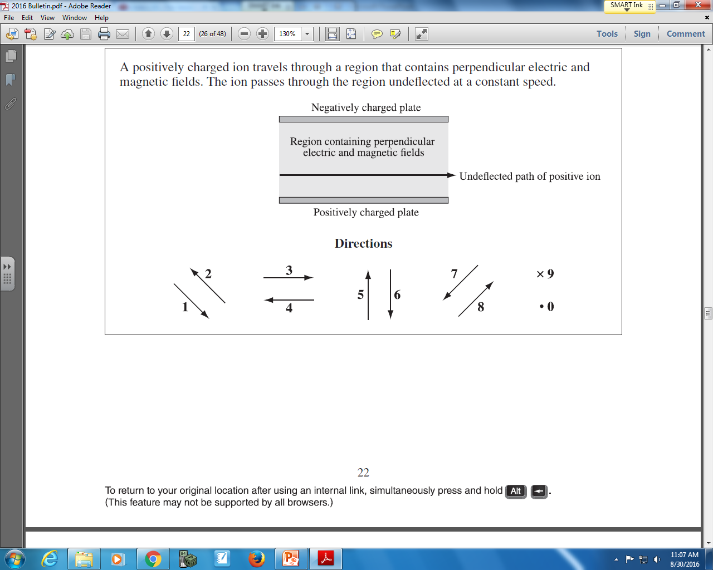

Q12: The directions of magnetic fields at various locations can be described using the numbers given above.
Direction: __________ __________ __________ __________
Field: Direction of Direction of Direction of Direction of
magnetic field magnetic field magnetic field magnetic field
at Position A at Position B at Position C at Position D
(Record your four digit answer in the Numerical Response boxes below)

Use the following information to answer Q13:

A moving electron is subject to three different types of fields, per the diagram below.
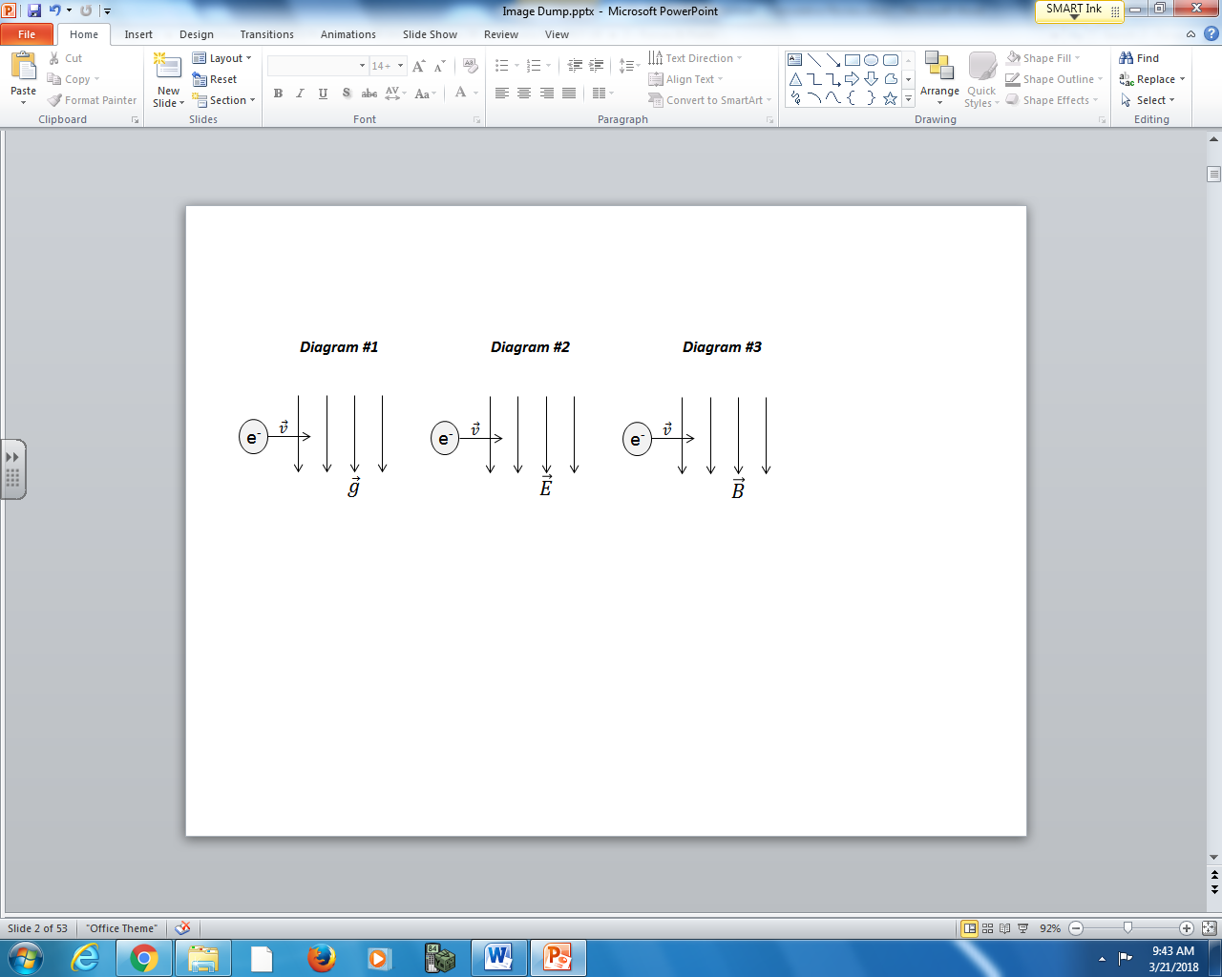

Q13: The directions of forces can be described using the numbers given above.
Direction: __________ __________ __________
Force: Gravitational Electrostatic Magnetic
force acting on force acting on force acting on
the electron in the electron in the electron in
Diagram #1 Diagram #2 Diagram #3
(Record your three digit answer in the Numerical Response boxes below)

Use the following information to answer Q14:
A student designs a simple “rail gun”, where a sliding rod completes a circuit loop. Because the sliding rod is subject to an external magnetic field, it experiences a magnetic force which accelerates it to the right. When at the end of the rails, it launches from the rail gun as a projectile.
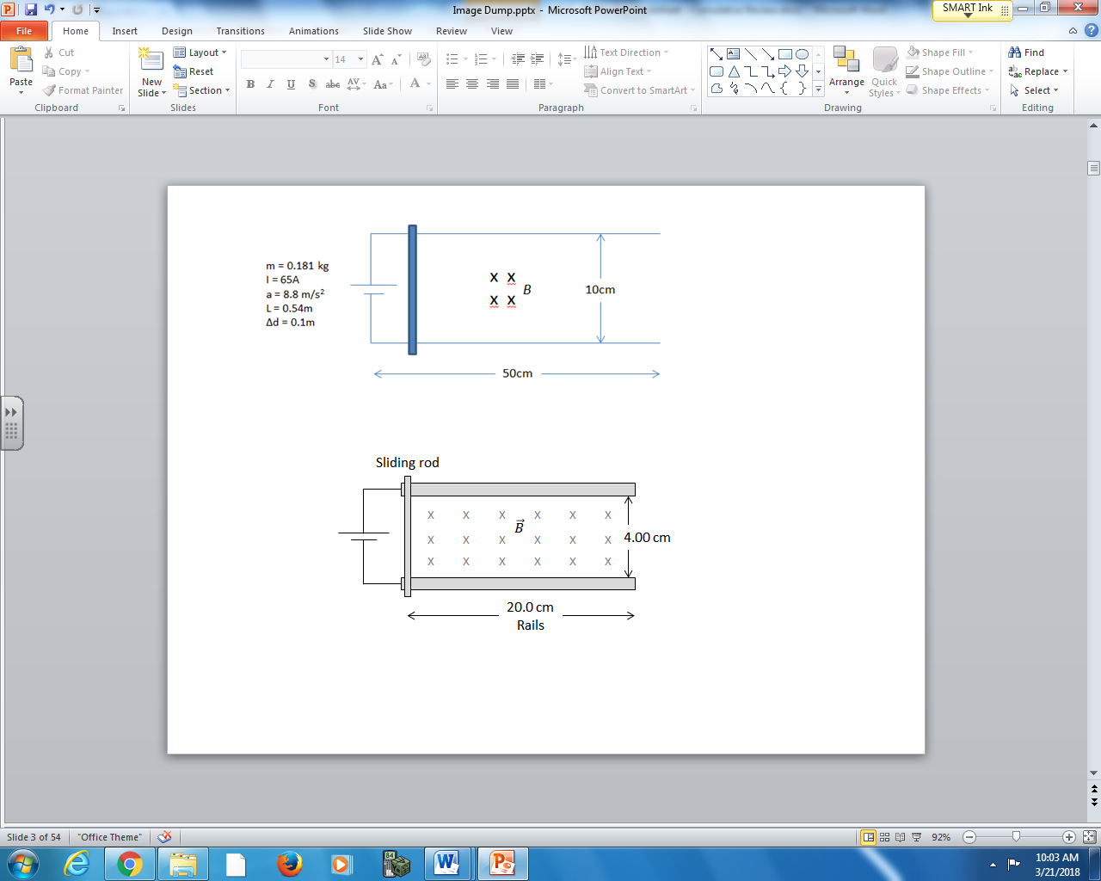
In the diagram above, the sliding rod has a mass of 10.0g and the magnetic field strength is 5.00T. The battery supplies a current of 4.00A.

Q14: The sliding rod leaves the rails travelling at a speed of ____ m/s.
(Record your three digit answer in the Numerical Response boxes below)

Use the following information to answer Q15:

An electron is travelling at 1.00 x 10⁵ m/s through the air when it enters a region of space, depicted with a grid, which has a uniform magnetic field of 11.4μT [into the page]. The moving electron experiences a magnetic force that bends its path.
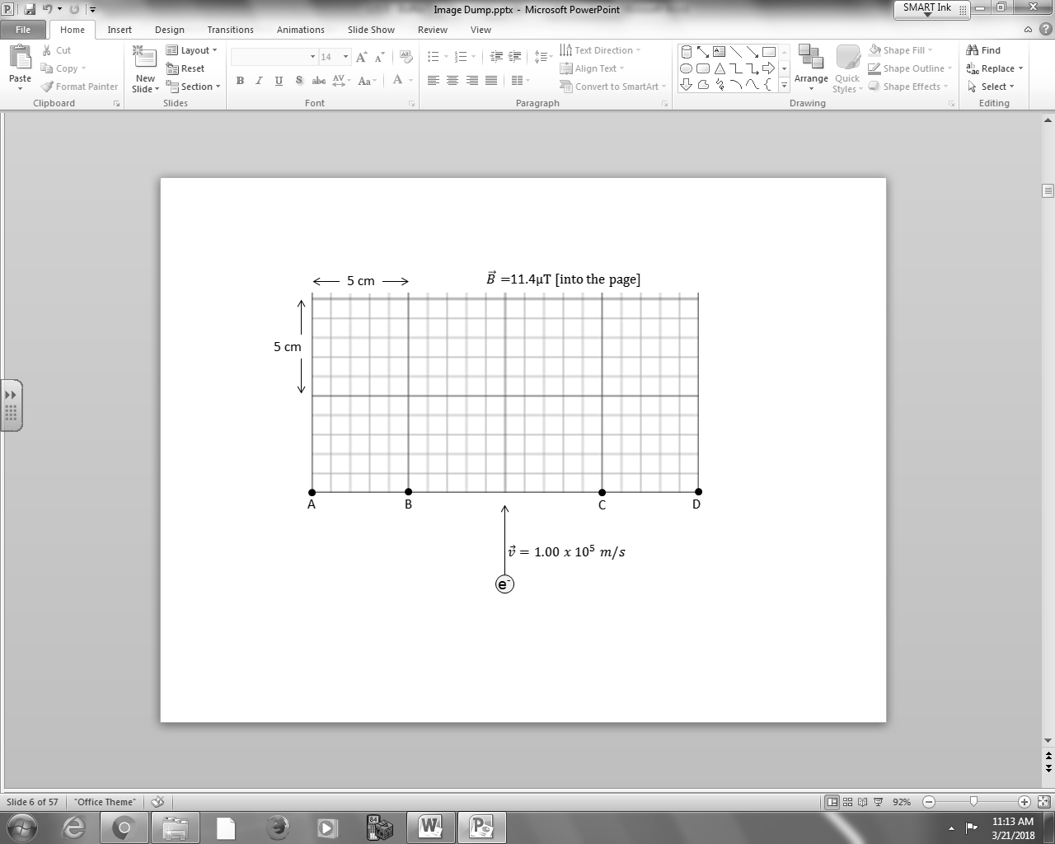

Q15: The electron leaves this region of space at
- Position A
- Position B
- Position C
- Position D

