First Name:__________________________________ Last Name:______________________________

L16 – FQ – Motor Effect and Circular Motion

Use the following information to answer Q1-Q2:
An electron, moving at 6.0 x 10⁴ m/s, enters a magnetic field of 2.3 x 10⁻² T, as per the diagram below.
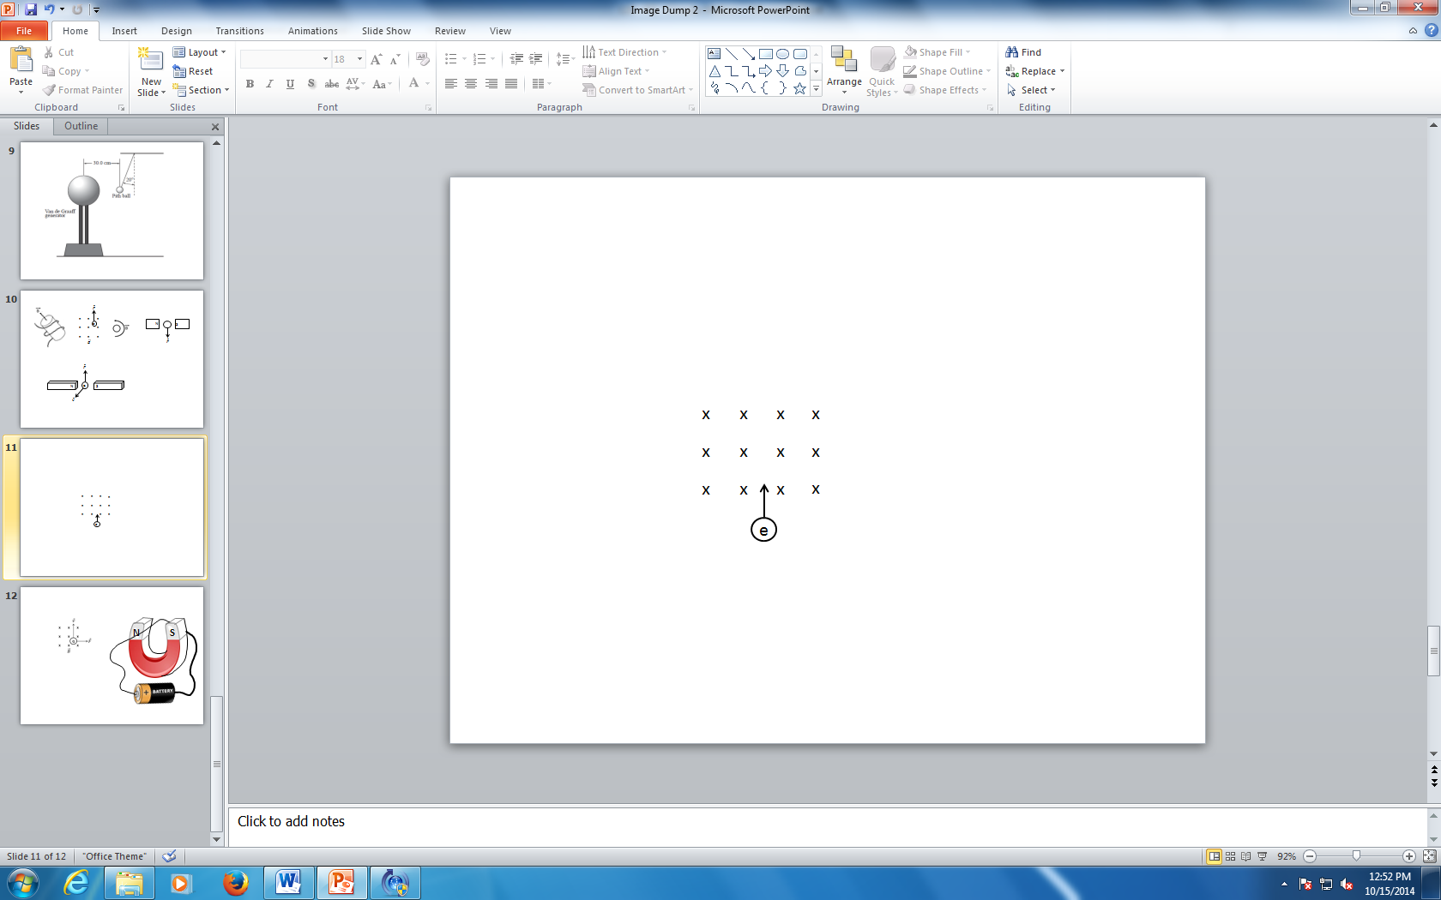

Q1: The electron experiences a force to the __i__ and therefore rotates __ii__.
 | i. | ii.
A. | left | clockwise
B. | left | counter-clockwise
C. | right | clockwise
D. | right | counter-clockwise

Q2: The radius of curvature of the electron is a.bc x 10^{-d} m, where a, b, c, and d are ___, ___, ___, and ___.
(Record your four digit answer in the Numerical Response boxes below)

Use the following information to answer Q3:

A moving proton is subject to three different types of fields, per the diagram below.
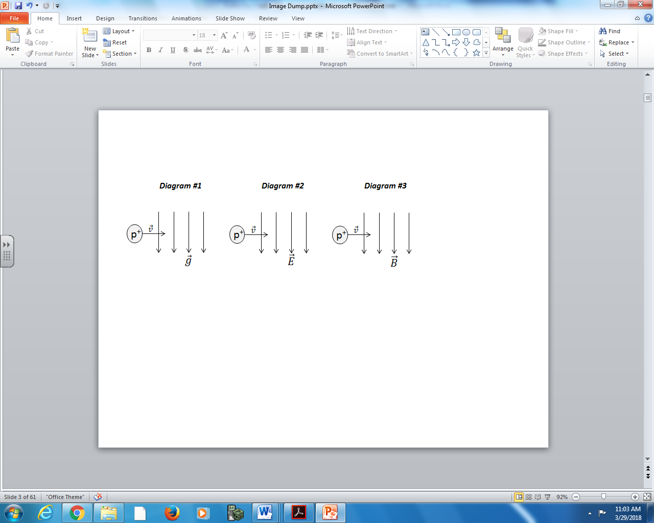
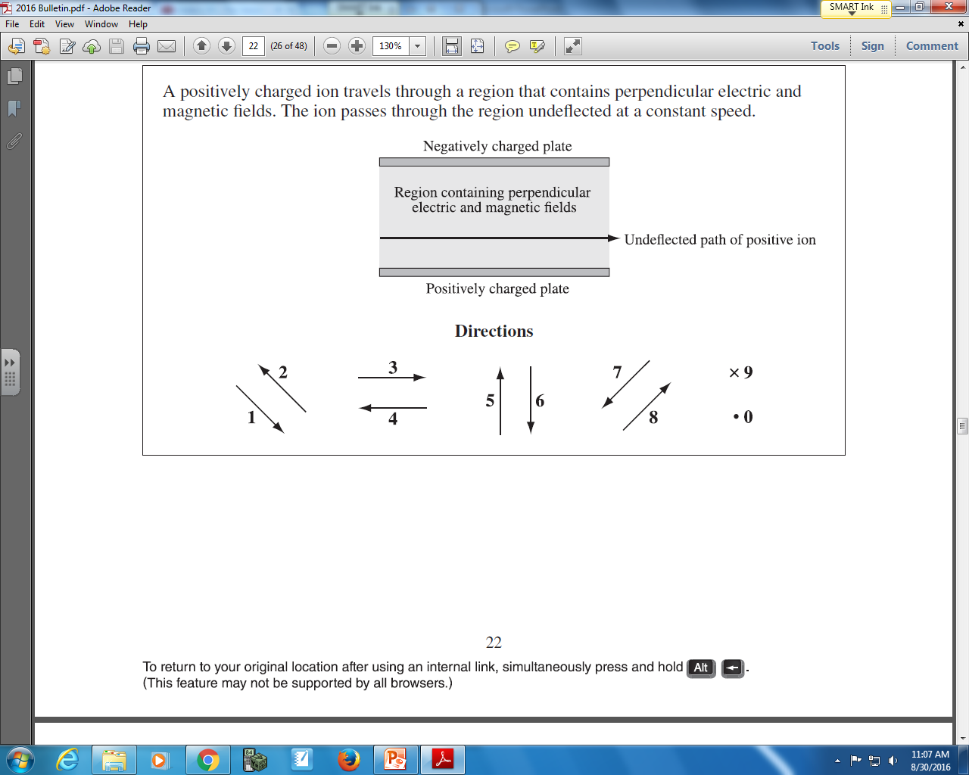

Q3: The directions of forces can be described using the numbers given above.
Direction: __________ __________ __________
Force: Gravitational Electrostatic Magnetic
force acting on force acting on force acting on
the proton in the proton in the proton in
Diagram #1 Diagram #2 Diagram #3
(Record your three digit answer in the Numerical Response boxes below)

MARKING:
Beginning 0.0 – 1.0
Progressing 1.5 – 2.0
Competent 2.5
Exemplary 3.0

