First Name:___________________________ Last Name:______________________________

L16 - FQ – Photoelectric Effect 2

Use the following diagram to answer Q1:
The Photoelectric Effect and Stopping Potential
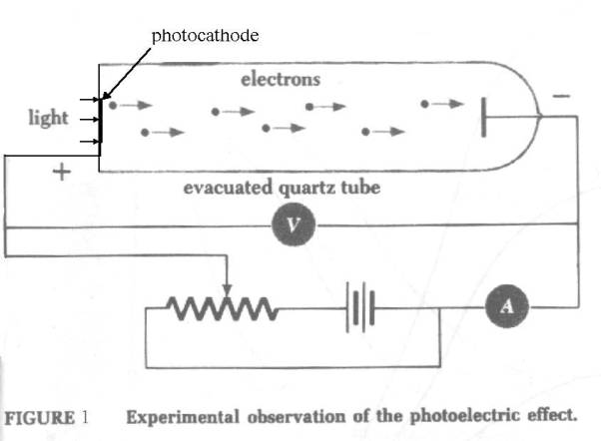
The sodium target has a work function of 2.28eV.

Q1: If incident light of wavelength 415nm causes the emission of photoelectrons, determine the required stopping voltage to prevent the completion of the circuit, in Volts. (1 mark)
(Record you three-digit answer in the numerical response boxes below.)

Use the following information to answer Q2 to Q4:
Photoelectron Emission from a Sodium Target
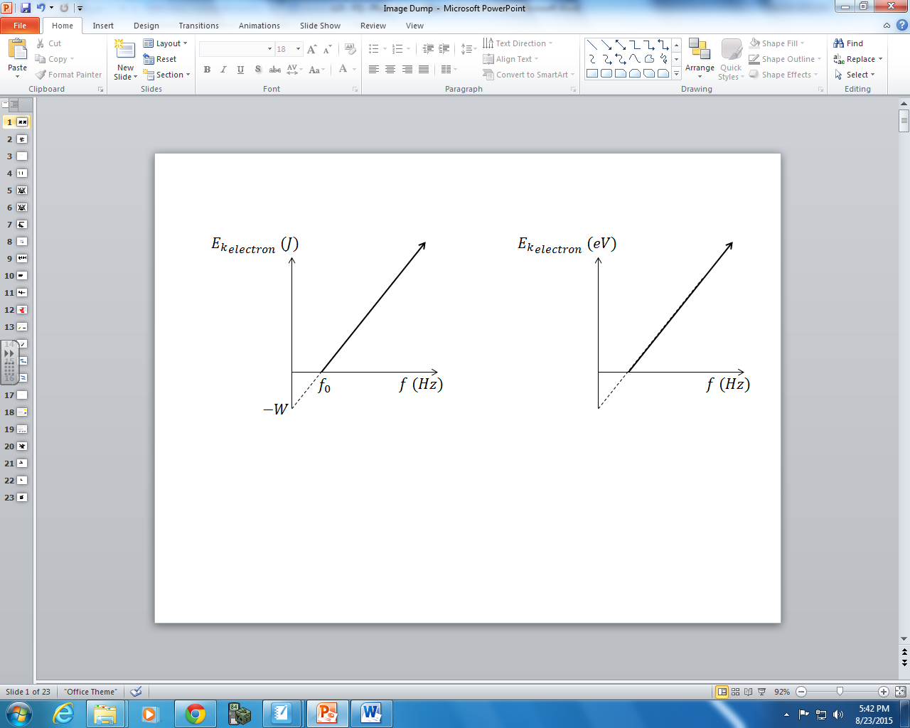
Sodium has a work function of 2.28eV.

Q2: Determine the absolute value of the y-intercept, in eV. (1 mark)
(Record you three-digit answer in the numerical response boxes below.)

Q3: The x-intercept has a value of a.b x 10^{cd} Hz, where the values of a, b, c, and d are ____, ____, ____, and ____. (1 mark)
(Record you four-digit answer in the numerical response boxes below.)

Q4: The slope of this graph has a value of a.b x 10^{-cd} eVs, where the values of a, b, c, and d are ____, ____, ____, and ____. (1 mark)
(Record you four-digit answer in the numerical response boxes below.)

MARKING:
Beginning 0.0 – 1.5
Progressing 2.0 – 2.5
Competent 3.0 – 3.5
Exemplary 4

