First Name:______________________________ Last Name:______________________________
L16 – Worksheet – Compton Effect
Textbook Questions
Pg 723 #1: What is the energy of an X-ray of wavelength 10nm?

Pg 723 #2: What is the momentum of an X-ray of wavelength 10nm?

Pg 723 #3: If a 10-nm X-ray scattered by an electron becomes an 11-nm X-ray, how much energy does the electron gain?

Pg 724 #1: An X-ray of wavelength 0.010 nm scatters at 90⁰ from an electron. What is the wavelength of the scattered photon?

Pg 725 #1: What is the momentum of a 500-nm photon?

Pg 725 #3: A photon has a momentum of 6.00 x 10⁻²¹ kg*m/s. What is the wavelength and energy of this photon?

Diploma Questions – Compton Scattering (Basic Concepts)
Q737: The wave model of light is deficient because by itself it CANNOT explain the
- Reflection of light
- Diffraction of light
- Polarization of light
- Interaction of light with some atomic particles
Q738: In the Compton effect, a stream of photons, all of the same energy and momentum, strikes the scattering material. Some photons bounce off with reduced
- Wavelength
- Velocity
- Energy
- Mass
Q739: A process that changes both the frequency and the wavelength of an electromagnetic wave is
- Refraction
- Polarization
- Compton scattering
- Double-slit interference
Use the following information to answer Q740:
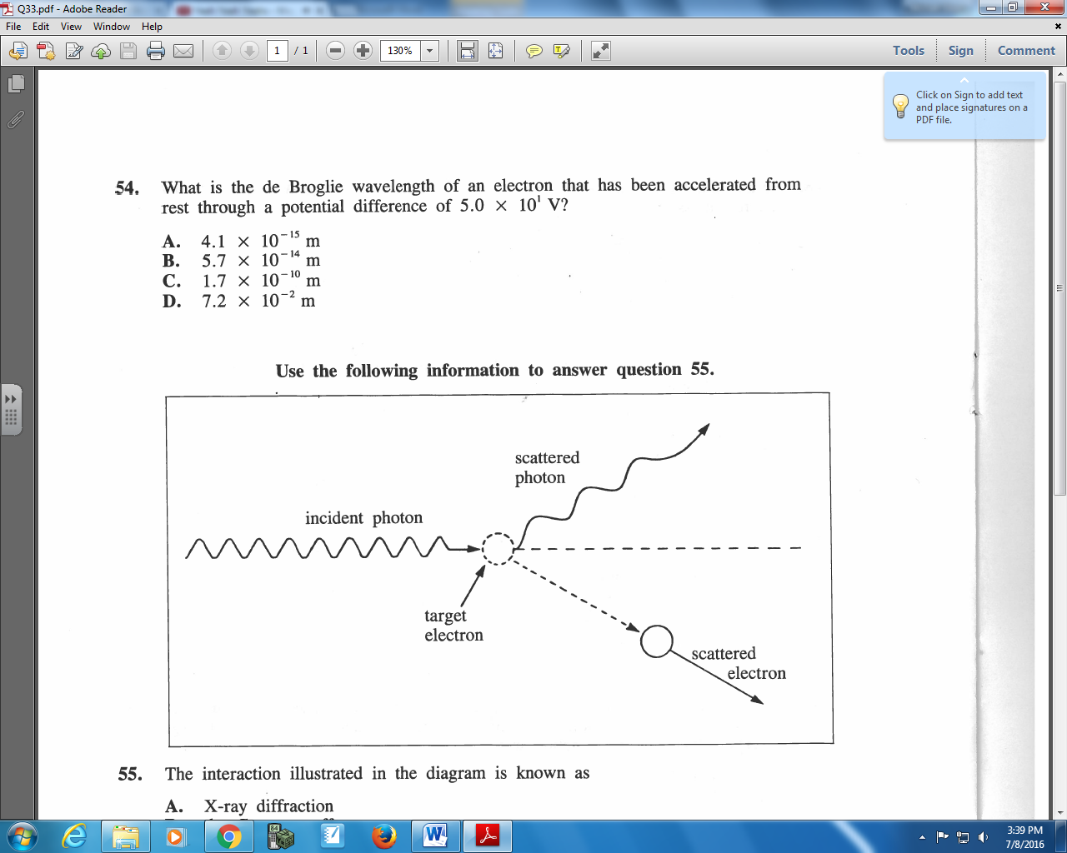

Q740: The interaction illustrated in the diagram is known as
- X-ray diffraction
- The Compton effect
- Rutherford scattering
- The photoelectric effect
Q741: The BEST description of the Compton effect is that
- Photons transfer momentum to electrons
- Electrons strike metal atoms and produce photons
- Electrons exist as standing waves around the nucleus
- Alpha particles strike gold foil and pass through unaffected

Q743: In Compton’s X-ray scattering experiment, the analysis of the collision of X-ray photons with electrons involves the use of the law(s) of the conservation of
- Energy only
- Momentum only
- Both momentum and energy
- Neither momentum nor energy

Q750: When the frequency of electromagnetic radiation is doubled, each photon’s momentum
- Doubles and its energy doubles
- Doubles and its energy does not change
- Remains the same but its energy doubles
- Remains the same but its energy quadruples

Diploma Questions – Compton Scattering (Momentum of a Photon Calculations)
Q756: If the momentum of a photon is 2.2 x 10⁻³⁸ kg*m/s, its frequency is a.bc x10^{d} Hz, where a, b, c, and d are ___, ___, ___, and ___.
(Record you four-digit answer in the numerical response boxes below.)

Q757: A photon of period 5.0 x 10⁻¹⁶ s has a momentum of
- 1.3 x 10⁻¹⁸ kg*m/s
- 4.4 x 10⁻²⁷ kg*m/s
- 3.3 x 10⁻⁴⁸ kg*m/s
- 1.1 x 10⁻⁵⁷ kg*m/s

Q759: A photon of wavelength 5.0 x 10⁻⁷ m has the same momentum as an electron. The speed of this electron is
- 6.9 x 10⁻⁴ m/s
- 3.8 x 10⁻¹ m/s
- 2.7 x 10² m/s
- 1.5 x 10³ m/s

Diploma Questions – Compton Scattering (Conservation of Energy)
Use the following information to answer Q762:
In an experiment similar to the Compton effect experiment, X-ray photons of energy 1.0 x 10⁵ eV strike target electrons. Each electron gains 4.0 x 10⁴ eV of kinetic energy and X-ray photons are scattered. The collision is one dimensional and perfectly elastic.

Q762: The frequency of a scattered photon is
- 1.0 x 10¹⁹ Hz
- 1.4 x 10¹⁹ Hz
- 2.4 x 10¹⁹ Hz
- 3.4 x 10¹⁹ Hz

Q763: A photon of wavelength 7.86 x 10⁻¹¹ m strikes an electron at rest and imparts 1.47 x 10⁻¹⁶ J of energy to the electron. The wavelength of the departing photon is
- 1.3 x 10⁻⁹ m
- 8.3 x 10⁻¹¹ m
- 7.4 x 10⁻¹¹ m
- 2.4 x 10⁻¹⁵ m

Diploma Questions – Compton Scattering (Conservation of Momentum)
L15 - Compton Effect (Collisions using Conservation of Momentum) – None

Challenge Questions
Use the following information to answer Q1:
In an observation of the Compton Effect, a photon is incident on a free electron. The scattered photon is detected, as shown below. The scattered electron is not shown.
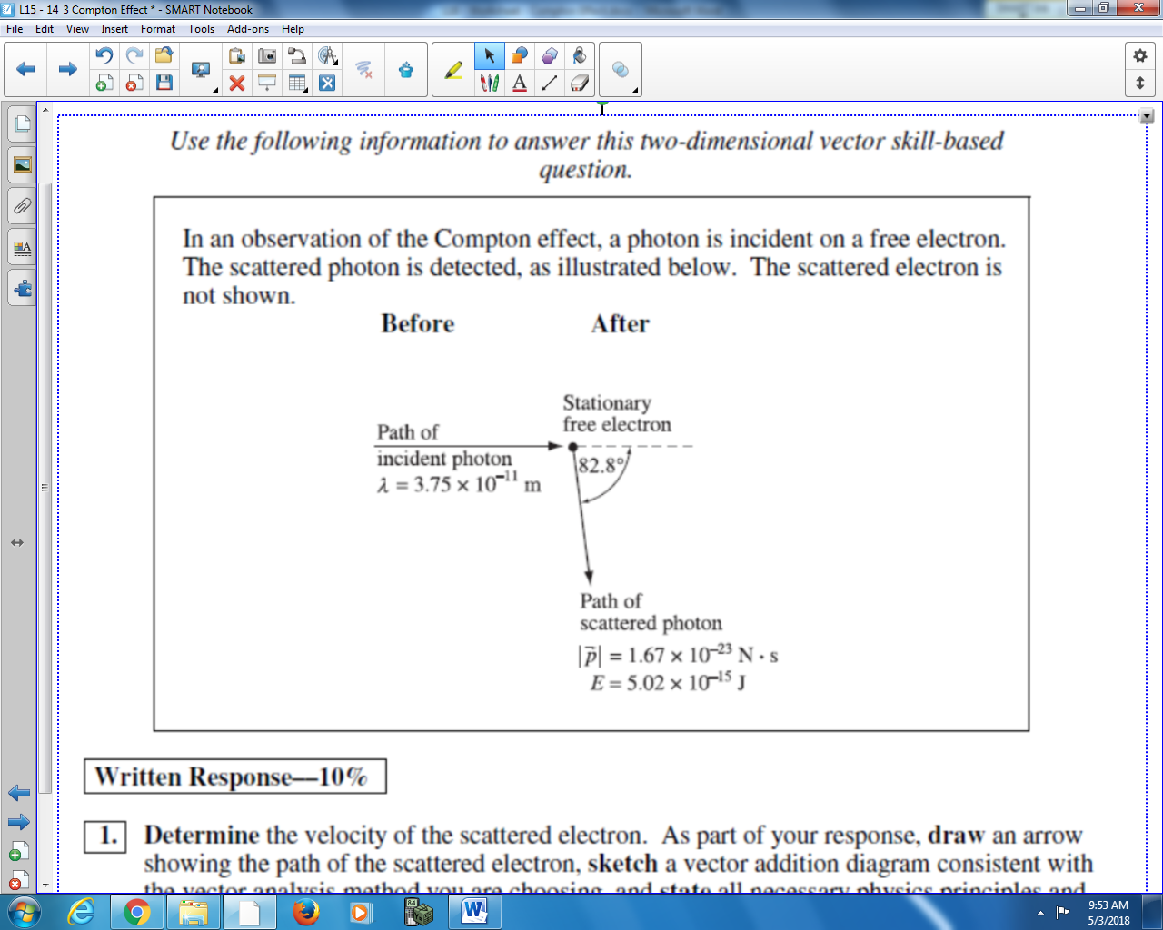

Q1: What is the velocity of the electron, in Polar Coordinates?

Q2: In a Compton - like experiment, a photon is directed towards a stationary electron and is scattered at an angle of 75º. If the initial wavelength of the photon was 2.50 x 10⁻¹¹ m, calculate the speed of the electron.

Cumulative Review from Previous Units
Use the following information to answer Q3:
An electron travelling at a constant speed enters a parallel plate, at which point the electron accelerates before leaving the parallel plates again.
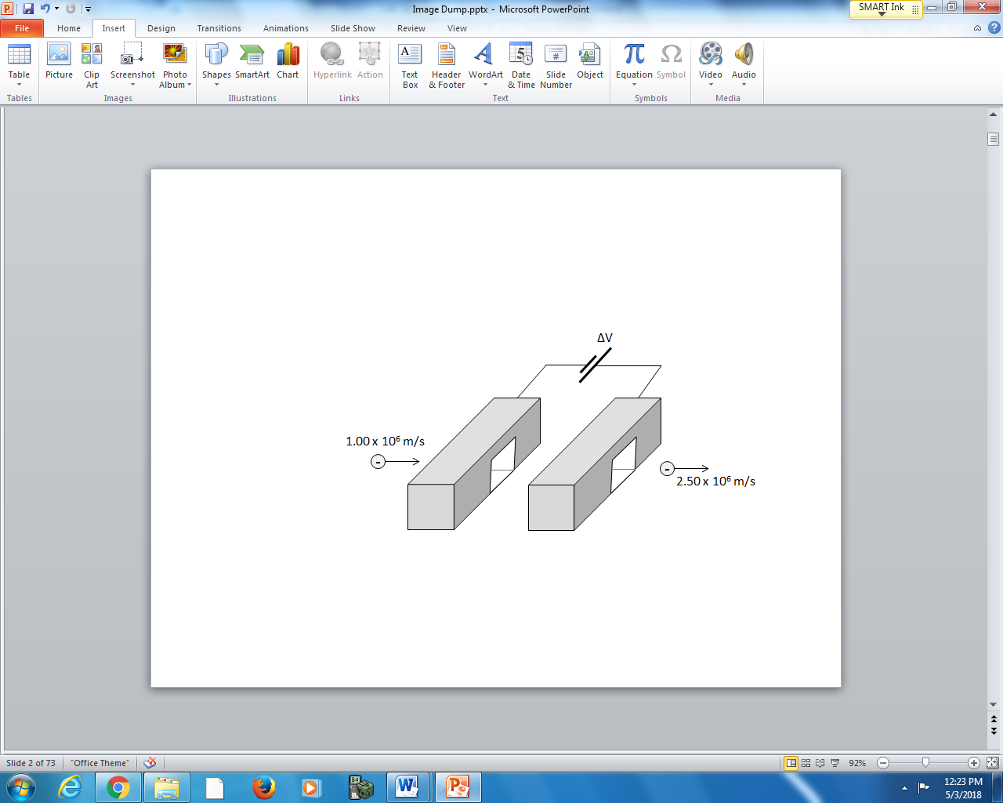
The separation distance of the plates is 5.00 cm.

Q3: What is the magnitude of the accelerating voltage, in Volts?

